

**Functional Requirements Specification**

**(FRS)**

***Authenticated Collections***

**STRICTLY CONFIDENTIAL**

This document and any attachments are proprietary to the Payments Association of South Africa and the information transmitted is intended for the person or entity to which it is addressed and may contain confidential and/or privileged material. If you have received this in error, please inform the sender, delete the material from computer, and remove the material from your possession. Members or persons rightfully receiving these documents and supportive attachments shall not reproduce, redistribute or make available to any persons other than to those employees in its permanent employment and who require access to it for its official and intended purpose unless written approval by PASA has been obtained.

Version 18

Dated: January 2019

Table of Contents

1. Background summary 12

2. Purpose of the document 12

3. Out of Scope 13

4. Authenticated Collections Value Chain 13

5. Pre-Payment 14

5.1 Authorise mandate – non card, authentication key not included in request, real time request and response (TT1) 15

5.2 Authorise mandate – non card, authentication key not included in request, batched request & response (TT2) 22

5.3 Authorise mandate – card, authentication key included in request, real time request & response (TT3) 27

5.4 Authorise mandate – card not present, authentication key included in request, real time request & response (TT4) (Optional Transaction Type for the Paying Bank to cater for) 32

6. Mandate Management 38

6.1 Amendment of a Mandate 39

6.2 Cancellation of a Mandate 51

6.3 Suspension of Mandate 57

6.4 Request for Mandate Information 61

7. Payment 65

7.1 Collections 66

7.2 Settlement Process 72

7.3 Cancellations (Recalls) 75

8. Post Payment (After Clearing and Settlement) 80

8.1 Disputes 80

9. Bank Error 83

9.1 Cancellations of Direct Debits (Reversals) 83

10. Alternative Scenarios 88

10.1 RealTime Pre Payments Alternative Cases 88

10.1.1 TT1 Delayed Authorisation - Mandate Initiation 89

10.1.2 TT1 and TT3 Real-time Authorisation – Mandate Initiation 108

10.1.3 TT1 Delayed Authorisation - Amendment of a Mandate 127

10.1.4 TT1 and TT3 Real-time Authorisation - Amendment of a Mandate 135

10.1.5 TT1 and TT3 Real-time Authorisation - Cancellation of a Mandate 143

10.2 TT3 - Real Time Card Pre Payments Alternative Cases 149

10.2.1 TT3 – Mandate Initiation – card 149

10.3 Batch Pre Payments Alternative Cases 151

10.3.1 TT2 – Mandate Initiation 151

10.3.2 TT2 - Amendment of a Mandate (Authorisation required) 161

10.3.3 TT2 - Cancellation of a Mandate 168

10.3.4 TT2 - Mandate Request for Information 170

10.4 Payment Alternate Case Scenarios 172

11. BIC ISO Message Templates 173

11.1 Authentication Request (BIC ISO 0200 message) 173

11.2 Authentication Response (BIC ISO 0210 message) 175

12. ISO20022 Mandate Message Templates 178

12.1 Mandate Initiation Request <pain.009> 179

12.2 Mandate Acceptance Report <pain.012> for Mandate Initiation <pain.009> 179

12.3 Mandate Amendment Request <pain.010> 180

12.4 Mandate Acceptance Report <pain.012> for Mandate Amendment <pain.010> 180

12.5 Mandate Cancellation Request <pain.011> 181

12.6 Mandate Acceptance Report <pain.012> for Mandate Cancellation <pain.011> 181

12.7 Status Report <pacs.002> for Status of Real Time Mandate Requests 182

12.8 Status Report <pacs.002> for response to real time mandate acceptance messages <pain.012> 182

12.9 Status Report <pacs.002> for Status of Batch Mandate Requests and Responses 183

12.10 Customer Payment Cancellation <camt.055> (Notification to Suspend Mandate) 183

12.11 Status Report <pacs.002> for Mandate Suspension Confirmations 183

12.12 Request for Mandate Information <mdte.001> 184

12.13 Response from Mandate Information Request <mdte.002> 184

13. ISO20022 Collection Message Templates 184

13.1 Direct Debit Transaction <pacs.003> 184

13.2 Status Report <pacs.002> for Debit Responses 184

13.3 Payment Return <pacs.004> for Direct Debits 185

13.4 Payment Cancellation Request <camt.056> for Direct Debits 185

13.5 Resolution of Investigation <camt.029> as Response to Cancellation Message 187

14. ISO20022 PSO Message Templates 187

14.1 Status Report <pacs.002> for Real Time Mandate Messages 187

14.2 Status Report <pacs.002> for Batch Mandate Messages 188

14.3 Status Report <pacs.002> for Payment messages 189

14.4 Status Report <pacs.002> for Payment Exception Processing 190

14.5 Real Time Message rltm.800: Network Management Request 191

14.6 Message rltm.810: Network Management Response 192

14.7 Batch Transmission Control Message 192

14.8 Start of Transmission Message 192

14.9 End of Transmission Message 192

14.10 Settlement Obligation Report <secl.010> 193

15. Validation Rules 193

15.1 Direct Debit Message Structure Rules 193

15.2 Payment Return Message Structure Rules 201

15.3 Mandate Initiation Message Element Rules 204

15.4 Mandate Amendment Message Structure Rules 211

15.5 Mandate Cancellation Message Structure Rules 219

15.6 Mandate Acceptance Report Message Element Rules 222

15.7 Mandate Suspension validation rules 231

15.8 Cancellation Request Message Element Rules 233

15.9 Mandate Download Request Rules 235

15.10 Response to mandate information request rules 237

15.11 Response to debit request rules 239

15.12 Confirmation of Mandate Suspension validation rules 241

15.13 Mandate Rejection at Debtor Bank rules for confirmation status report message 243

15.14 Responses by Creditor Bank to Real Time Mandate Acceptance Report message 245

16. ISO20022 TABLES 247

16.1 Payment Status Group Code 247

16.2 Transaction Status 247

16.3 External Return Reason Code – Mandates 247

16.4 Tracking Period 248

16.5 Debit Entry Class Codes 248

16.6 Mandate Suspension Reason Codes 249

16.7 Mandate Cancellation Reason Codes 249

16.8 Payment Cancellation Reason Codes 249

16.9 Mandate Frequency Codes 250

16.10 Mandate Amendment Reason Codes 251

16.11 Local Instrument Codes 251

16.12 Investigation Status Confirmation Codes 252

16.13 Transaction Cancellation Status 254

16.14 Cancellation Status Reason 254

16.15 Service Identification Codes 254

16.16 Clearing System Identifiers 256

16.17 Table of Error Codes 256

16.18 Debit Sequence Types 263

16.19 Account Types 264

16.20 Mandate Reject Reason Codes 264

16.21 Mandate Status Reason Codes 264

16.22 Network Response Codes 264

16.23 Return Reason Codes 266

16.24 Message Element Name table 266

Appendix A – Glossary 269

Appendix B – Data Elements To Be Presented To The Payer 279

Appendix C – Required Business Data Elements Aligned To Mandate Initiation 282

Appendix D – Business Requirements For Data Elements For Storage, Validation On Clearing And Re-Authorisation (to manage the state of the Mandate) 287

Appendix E – Mandate States on the Mandate Register 295

Appendix F – Disputes Rules 297

Appendix G – Additional Rules 297

Appendix H – Real Time and Batch Element Combinations 302

Appendix I – Participating Banks 303

Appendix J – Generating a Message Authentication Code (MAC) 304

Appendix K – Permitted Character Set 306

Appendix L – gzip 307

Appendix M – 6 and 7 Day Collections Processing 308

Appendix N – BankservAfrica file delivery validation 310

Appendix O – Dispute Reason Codes for MIS (internal use only) 311

Appendix P – Cancellations of inflight and registered Mandates 312

History of Modifications

| **Version** | **Date** | **Description** | **Contributors** | **Author** |
| --- | --- | --- | --- | --- |
| Draft 1 | 12/08/2014 | This being the first strawman draft, there are no modifications to describe. |  | Revashnie Govender |
| Draft 1.1 | 21/08/2014 | Updated as per comments from the project team | Arif Ismail  Calosha Ramlall | Revashnie Govender  Calosha Ramlall |
| Draft 1.2 | 03/09/2014 | Updates to Strawman Draft from work sessions on the 26/08/2014 to 03/09/2014 | Small Work Group | Revashnie Govender  Calosha Ramlall |
| 1 | 09/09/2014 | Strawman Draft discussed and updated in work session on the 08/09/2014 and became AC TRS version 1 | Martin Suchecki  TRS WG | Revashnie Govender  Calosha Ramlall |
| 2 | 26/09/2014 | Updates from project team and TRS WG that were incorporated into AC TRS Version 1 during work sessions from the 09/09/2014 to 25/09/2014, were accepted for new version. | Martin Suchecki  TRS WG | Revashnie Govender  Calosha Ramlall |
| 3 | 03/10/2013 | Updates from project team and TRS WG after session on the 29/09/2014. AC TRS Version 3 was distributed for comment. | Martin Suchecki  TRS WG | Revashnie Govender  Calosha Ramlall |
| 4 | 15/10/2014 | All TRS WG comments to Version 3 were incorporated  Signed Off version by TRS WG. | Martin Suchecki  TRS WG | Revashnie Govender  Calosha Ramlall |
| 5 | 22/10/2014 | The length of the Date Adjustment Rule Indicator was updated from 2AN to 1AN which will be populated with ‘Y’ (Yes) or ‘N’ (No); in line with business requirements.  Data element validation for Creditor Abbreviated Short Name.  Addition of Appendix A – Glossary  Addition of Appendix B – TRS Signoff sheet  Minor editorial adjustments were also included.  Table of contents updated accordingly. | Martin Suchecki  TRS WG | Revashnie Govender  Calosha Ramlall |
| 24/11/2014 | Updates from AC Combined Session (19/11/2014) | Martin Suchecki  Andy Davies  TRS WG | Revashnie Govender |
| 09/12/2014 | Updates from AC TRS WG (08/12/2014) | Martin Suchecki  TRS WG | Revashnie Govender |
| 6 | 16/01/2015 | Updates from AC Combined Session (16/01/2015 & 29/01/2015) and the investigations that the requirements resulted in. | Martin Suchecki  TRS WG | Revashnie Govender |

|  |  |  |  |  |
| --- | --- | --- | --- | --- |
| **Version** | **Date** | **Description** | **Contributors** | **Author** |
| 7 | 21/02/2015 | Acceptance of version 6 Tracked Changes and Formatting.  Alignment of naming conventions e.g. Threshold Amount, now Maximum Collection Amount.  Updated ISO message layouts based on ISO standards.  Updated ISO message versioning.  Updates as per approved BRD to cater for AC Scope Change Request and Dispute Process.  TRS WG sessions (24/02/2015 & 25/02/2015)  Inserted new mandate download request and response messages, and related tables | Martin Suchecki  TRS WG | Revashnie Govender |
| 8 | 27/03/2015 | Acceptance of tracked changes/updates from TRS version 7 | Martin Suchecki  TRS WG | Revashnie Govender |
| 15/03/2015 | Updates/Comments to distributed AC TRS_Version 8 updates | Martin Suchecki  Calosha Ramlall | Revashnie Govender |
| 9 | 20/04/2015 | Updates from comments/recommendations from TRS WG participants on TRS Version 8.  Updates as per impacts of the SteerCo resolutions (13/04/2015)  Updates from decisions made in the combined session (23/04/2015) | Martin Suchecki | Revashnie Govender  Calosha Ramlall |
| 10 | 11/05/15 | Incorporation of final comments provided by BRD WG in line with decisions taken by the SteerCo or WG. | Martin Suchecki  TRS WG | Calosha Ramlall |
| 10.1 | 24/06/2015 | Incorporate editorial changes RFC 079, 113, 114, 115, 116, 154, 166, 175, 214 | BRS and TRS Clarification WG | Mariekie Mincher |
| 10.2 | 02/07/2015 | Updates as per SteerCo approval of Clarification enhancements : RFC 002, 003, 004, 011, 041, 048, 086, 088, 093, 094, 095, 096, 097, 098, 101, 112, 122, 128, 198, 201, 207, 222, 224, 225, | BRS and TRS Clarification WG | Revashnie Govender |

|  |  |  |  |  |
| --- | --- | --- | --- | --- |
| **Version** | **Date** | **Description** | **Contributors** | **Author** |
| 10.3 | From 16/07/2015 to 17/08/2015 | Acceptance of changes from TRS versions 10.1 & 10.2.  Updates as per Editorial changes/Confirmation with SME’s/ Alignment with Interface Spec : RFC 053, 054, 055, 056, 057, 093, 132, 179, 193, 198, 199, 201, 203, 204, 206, 208, 210, 211, 212, 213, 215, 221, 223, 232, 235, 236, 237, 238, 242, 244, 246, 247, 248, 249, 250, 251, 254, 255, 256, 258, 260, 261, 262, 264, 266, 268, 269, 270, 271  Updates as per SteerCo approval of RFCs for Dispute Clarification : RFC 027, 030, 031, 045, 103, 130, 160, 177  Updates as per SteerCo approval of General Clarification : RFC 006, 026, 036, 089, 117, 118, 119, 123, 124, 125, 155, 201, 216, 229, 231, 233, 252  Updates as per SteerCo approval of RFCs for Dispute Clarification : RFC 103, 130, 160, 177  Updates as per SteerCo approval of Validation Rules Clarification : RFC 034, 045, 140, 151, 159, 161, 209, 218, 219, 253, 256  Updates as per Alternative Use Case Scenarios and RFC Clarification : RFC 060, 068, 069, 070, 071, 074, 078, 090, 091, 092, 099, 195, 202, 205, 220, 241, 257 (entire doc of changes), 259, | Individual and WG Clarification Sessions | Revashnie Govender |
| 11 | 17/08/2015 | Acceptance of all changes from TRS version 10.3. |  | Revashnie Govender |
| 11.1 | 25/08/2015 | Updates as per RFCs : 277, 278, 279, 280, 281, 282, 283, 284, 285, 286, 288, 289, 290, 295, 296, 297, 298, 309, 315, 316, 324, 326, 327, 328, 331, 332, 335, 342, 343, 344, 345, 346  RFC 325 (NED Scope change request: Dispute Rules when Collection Amount is less than Instalment Amount) | Martin Suchecki  Andy Davies | Revashnie Govender |
| 11.2 | 30/09/2015 | Updates as per RFCs : 304, 340, 343, 348, 349, 350, 356, 357, 358 |  | Revashnie Govender |
| 12 | 08/10/2015 | Acceptance of all changes from TRS version 11.1 and 11.2. |  | Revashnie Govender |
| 12.1 | 27/10/2015 | Modifications for non-face-to-face authentication |  | Martin Suchecki |
| 12.2 | 15/12/2015 | Updated non face-to-face processes |  | Andy Davies |
| **Version** | **Date** | **Description** | **Contributors** | **Author** |
| 12.3 | 22/12/2015 | Updates as per RFCs : 276 (SCR23), 292 (SCR24), 312 (SCR25), 320 (SCR26), 373 (SCR27), 384 (SCR28), 388 (SCR29), 389 (SCR46) 393 (SCR25), 394 (SCR26), 395 (SCR25), 396 (SCR26), 397 (SCR26), 399 (SCR30), 400 (SCR31), 401 (SCR32), 417 (SCR33), 418 (SCR34), 419 (SCR35), 421 (SCR36), 422 (SCR37), 423 (SCR38), 426 (SCR39), 432 (SCR50), 433 (SCR51), 437 (SCR53), 438 (SCR54), 439 (SCR55), 455 (SCR56), 442 (SCR57), 443 (SCR58), 444 (SCR59), 445 (SCR59), 448 (SCR62), RFC449 (SCR63) | Scope Changes | Andy Davies |
| 13 | 8/02/2016 | Acceptance of all changes from TRS version 12.1, 12.2, 12.3 and editorial changes |  | Andy Davies  Martin Suchecki |
| 13.1 | 20/04/2016 | Alignment to the Interface Specifications (as per the Industry XSDs). Included list of changes in Appendix H |  | Andy Davies |
| 13.2 | 29/04/2016 | Include Scope Changes 83, 88 & 89 | Scope Changes | Andy Davies |
| 13.3 | 06/05/2016 | Updated during workshop Sessions 1 & 2 for alignment to XSDs | Combined Workgroup | Andy Davies |
| 13.4 | 09/05/2016 | Updated during workshop Sessions 3 & 4 for alignment to XSDs | Combined Workgroup | Andy Davies |
| 13.5 | 27/05/2016 | Updated after workshop Session (25/5/2016) for alignment to XSDs | Combined Workgroup | Andy Davies |
| 13.6 | 06/07/2016 | Updated after industry feedback from above sessions. Removed list of changes as per 31.1 (previously Appendix H) | Combined Workgroup | Andy Davies |
| 13.7 | 18/07/2016 | Updated after industry feedback from Technical Design Authority workshop 1 | TDA Workgroup | Andy Davies |
| 13.8 | 22/07/2016 | Updated after industry feedback from Technical Design Authority workshop 2 | TDA Workgroup | Andy Davies |
| 13.9 | 01/08/2016 | Updated after industry feedback from Technical Design Authority workshop 3 | TDA Workgroup | Andy Davies |
| 13.10 | 02/08/2016 | Updated after industry feedback from Technical Design Authority workshop 44 | TDA Workgroup | Andy Davies |
| 13.11 | 12/08/2016 | Incorporating comment received from Technical Design Authority representatives | TDA Workgroup | Andy Davies |
| **Version** | **Date** | **Description** | **Contributors** | **Author** |
| 13.12 | 16/08/2016 | Incorporating comment received from Technical Design Authority representatives | TDA Workgroup | Andy Davies |
| 13.13 | 17/08/2016 | Incorporating comment received from Technical Design Authority representatives | TDA Workgroup | Andy Davies |
| 13.14 | 23/08/2016 | Incorporating comment received from Technical Design Authority workshop (24/8/2016) | TDA Workgroup | Andy Davies |
| 14 | 26/08/2016 | Incorporating feedback from Technical Design Authority (26/08/2016) and accept all changes from Version 13.1 – 13.14 | TDA Workgroup | Martin Suchecki |
| 14.1 | 29/08/2016 | Incorporating feedback from AC SteerCo | AC SteerCo | Naushin Kader  Andy Davies |
| 15 | 30/08/2016 | Accepted all changes from Version 14.1 |  | Andy Davies |
| 15.1 | 08/09/2016 | Simplification as per AC workshop 8/9/2016 | AC SteerCo, Business & Technical workgroup | Andy Davies |
| 15.2 | 14/09/2016 | Simplification as per AC workshop 14/9/2016 | AC SteerCo, Business & Technical workgroup | Andy Davies |
| 15.3 | 15/09/2016 | Simplification as per AC workshop 14/9/2016 and agreed in workshop 15/9/2016 | AC Technical workgroup | Andy Davies |
| 16.0 | 15/09/2016 | Accepted all changes from Version 15.3 |  | Andy Davies |
| 16.1 | 10/6/2017 | Applied all TDA defined and Steerco approved Scope Change Requests from 95 to 195  (Scope Change Request: 95v2, 96v2, 97v2, 98v2, 99v2, 100v2, 101, 102, 103v2, 104v2, 106av3, 106b, 106c, 106d, 108v2, 112, 113, 116v2, 117, 118v2, 119, 120, 121 123, 124, 126, 128, 129v3, 130, 131v2, 132, 134v2, 136, 140, 141v2, 145, 146, 147v2, 148v2, 149v2, 150v2, 151v3, 152, 153v2, 154, 155v3, 156v4, 157v2, 158v3, 159, 160, 162, 163, 164, 165, 166v2, 168, 169v2, 170, 171v2, 173, 175v2, 176v, 177, 179, 180, 181, 182v2, 184, 185, 186, 187, 188v2, 189v2, 190v2, 191v2, 194v2, 195)  *** SCR 158v3, 163 & 168 are only for implementation February 2018 | TDA | Andy Davies |
| 16.2 | 12/10/2017 | TDA changes as supplied by 19/6/2017 | SBSA & BsvA | Andy Davies |
| **Version** | **Date** | **Description** | **Contributors** | **Author** |
| 16.3 | 20/6/2017 | TDA changes as supplied in the TDA meeting on 20/6/2017 | TDA | Andy Davies |
| 16.4 | 19/7/2017 | TDA changes as supplied in the Technical workshop on 19/7/2017 | Technical Team | Andy Davies |
| 16.5 | 3/8/2017  & 28/8/2017 | Incorporated changes as supplied by Nedbank on 2/8/2017. Removed embedded powerpoint presentations in Appendix F – Dispute Rules & Appendix G – Additional Rules  Included Scope Changes 196, 197, 200, 201, 202 & SCR 203 as per TDA meeting 25/8/2017. | Nedbank & TDA | Andy Davies |
| 17 | 07/09/2017 | Accepted all changes from Version 16.1 to 16.5 |  | Andy Davies |
| 18 | 03/01/2022 | Rename TRS to FRS and create FRS version 18 from the accepted TRS version 17  Remove all messages as this is accommodated in MyStandards  Incorporated all relevant approved Change Requests as follows  CR 204 – 283 | Industry & TDA | Project Team |
| 19 | 12/07/2022 | Incorporated all relevant approved Change Requests as follows  CR 285v4 – 288 | Industry & TDA | Project Team |

|  |  |
| --- | --- |
| Distribution: | **PASA Membership and PASA Authorised Stakeholders** |

# Background summary

The South African Reserve Bank (SARB) reviewed the Early Collections environment during 2011-2013 aiming to address a set of main issues prompting the strategic review of the Early Collections environment. The outcome of the strategic review process by the SARB was an instruction issued through a SARB Terms of Reference to PASA during July 2013 to initiate a project whose goal is to address, in essence, authentication of mandates for debit transactions by Accountholders (Payers).

Subsequent to the AC project initiation, the AC Business Requirements Document Work Group (BRD WG) documented the minimum, interbank business requirements for the AC solution. The AC BRD had then been provided to the AC Technical Requirements Specification Work Group (TRS WG) to put forward the following AC TRS.

The AC TRS WG have chosen to use the ISO20022 methodology and respective message layouts for certain use cases in order to cater for the Industry messaging needs of the AC solution. Further to the use of ISO20022, the TRS incorporates the BIC IS0 message layout for particular components of an AC authentication transaction type (referred to later in the document).

When referring to the terminology used in this document, please note the following more commonly used PASA Clearing Rules terms with the equivalent used in ISO2022:

|  |  |
| --- | --- |
| **PASA Clearing Rules** | **ISO20022** |
| Payer | Debtor |
| Paying Bank | Debtor Bank |
| PCH System Operator (PSO) | Automated Clearing House (ACH) |
| Sponsoring Bank | Creditor Bank |
| User | Creditor |

Please note, in accordance with the ISO20022 standards, the following three message types are utilised in this document:

|  |  |
| --- | --- |
| **Business area codes** |  |
| camt | cash management (non-financial message) |
| pacs | payment clearing and settlement (financial message and ISO 20022 message responses) |
| pain | payments initiation (non-financial message) |

Please note that error codes used in camt and pain messages will reflect the ISO (4 character) codes, while those used in pacs.002 will be South Africa specific (6 digit) codes.

# Purpose of the document

This document serves to capture the detailed interbank technical requirements related to the Authenticated Collections (AC) business requirements that have been decided.

**Note:** The process flows are depicted at a high level in the most complex *scenario i.e. from Creditor to Debtor Bank (Debtor engagement would be at either end depending on the Use Case)*.

The Creditor and Creditor Bank could in instances thus be one and the same.

# Out of Scope

* 1. Debtor Bank to check Debtor’s affordability.
  2. Normal EFT Debit processing.
  3. Debtor authorisation mechanisms/channels and definitions between Debtor Bank and Debtor.
  4. Creditor validation mechanisms and definitions between Creditor Bank and Creditor.
  5. Current AEDO operational issues (addition of Debtor account number to the BIC ISO message is an AEDO PCH matter to deal).
  6. Settlement will follow current processes.
  7. SteerCo Resolution: Authentication of non-natural persons (entities that have multiple signatories i.e. mandates that require more than one authoriser) is out of scope. Note: This resolution can be reconsidered at a later stage, if necessary.

# Authenticated Collections Value Chain

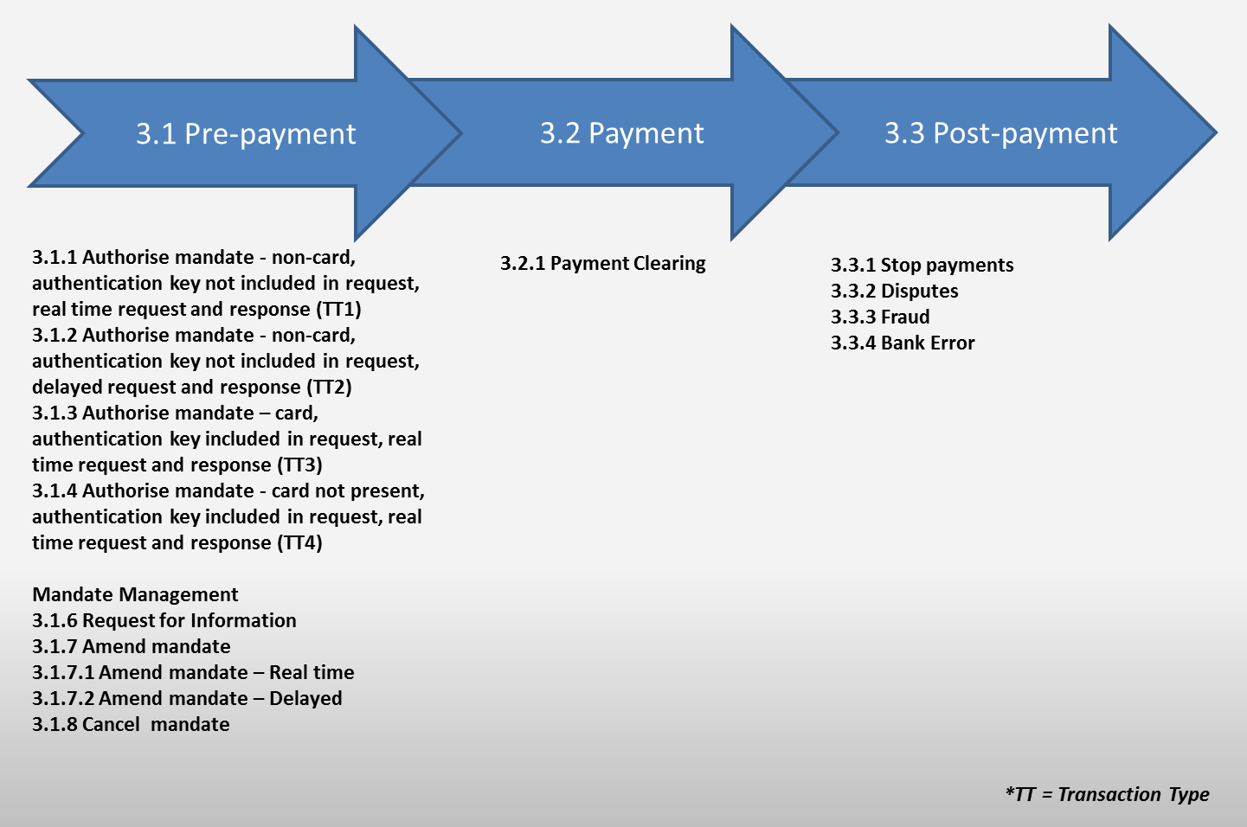

***Figure One: Summary end to end AC Payment Value Chain***

Please note that the above diagram directly references the Use Cases in the Authenticated Collections BRD. In order to guide the reader through the document, the following framework is used. Each of the interbank use cases related to pre-payment, payment and post-payment is covered systematically in turn.

# Pre-Payment

Mandate initiation requests (Transaction Type (TT1 to TT4)), amendments and cancellations are sent from Creditors (or their service providers/collecting agents) via Creditor Banks to Debtor Banks.

Debtor Banks receive mandate initiation, amendment and cancellation requests and after processing, return mandate acceptance messages/reports to the Creditor via the Creditor Bank.

In all cases, all inter-bank mandate management message flows pass through the Automated Clearing House (ACH).

The interbank request message may:

* Have an authentication key (e.g. card PIN or OTP) coupled in the request message
* Not have an authentication key in the request message

The interbank request and response message may be required:

* In a real time manner
* In a delayed manner

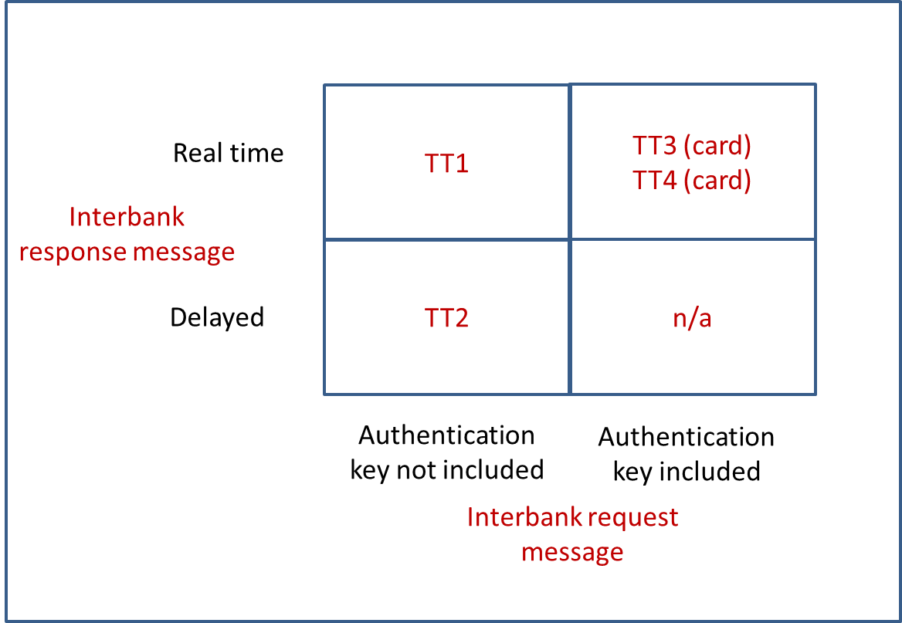

***Figure Two: Summary matrix of authentication option***

The use case diagrams (from the AC BRD) and the process diagrams used per section in this document aim to illustrate the flow of the messages to each stakeholder and not the number of messages required per Use Case.

## Authorise mandate – non card, authentication key not included in request, real time request and response (TT1)

**Description** - This scenario relates to a Payer/Debtor needing to authorise future debit orders initiated by a User/Creditor. The Payer/Debtor though has ***no authentication key*** to be included in the request message. The process of requesting the Authorisation of mandate must be in **real time** and the response must in **real time**. The Payer must be given the option by the Paying Bank to respond in **real time**.

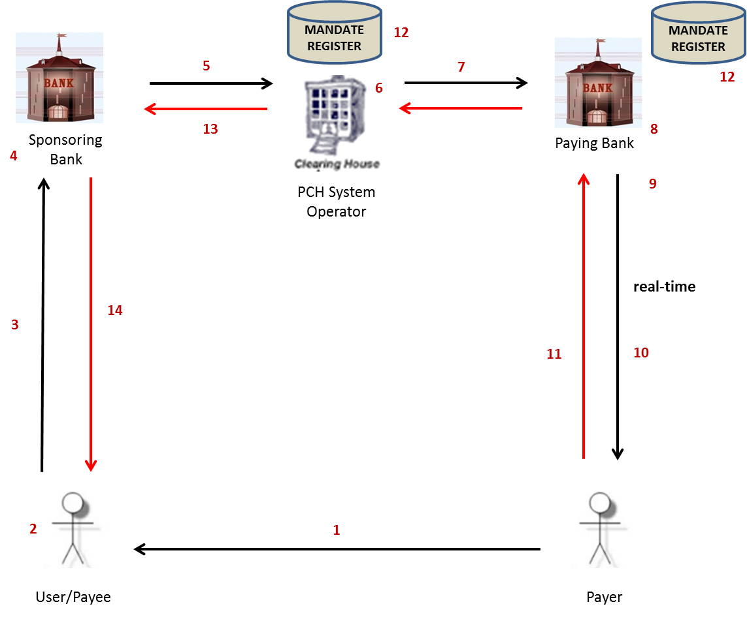

**Additional note for figure above:** TRS WG agree that technical terminology dictates that this is an online transaction not true Real Time (potential delay between Debtors responding to Debtor Bank).

Interbank is Real Time but Debtor is able to authorise mandate as soon as he/she receives authorisation request but it is at their discretion of time period to respond before end of day of the Debtor Bank, thus not Real Time as per full circle of both transactions (request and response).

**Technical Requirements:**

* Creditor Bank must have real time processing capabilities.
* Debtor Bank must have real time processing capabilities
* Online delivery mechanisms

The following delivery mechanisms will be available for online delivery of ISO 20022 messages between participants and the ACH:

* MQ (set as sync)
* Web services https
* TCP/IP

**Messages used:**

* Mandate Initiation Request (pain.009)
* Mandate Acceptance Report (pain.012)
* Status Report (pacs.002) for Confirmation of Mandate Initiation Request (from Debtor Bank)
* Status Report (pacs.002) for Mandate Messages

**Processing Windows:**

**TT1 Real Time Authentication**

| Message | Service Code | Originating | Receiving | Start Time | End Time | Extra |
| --- | --- | --- | --- | --- | --- | --- |
| Pain.009 | MANIN | Creditor Bank | ACH | 00:30 | 23:30 |  |
| Pain.009 | MANIN | ACH | Debtor Bank | 00:30 | 23:30 |  |
| Pain.012 | MANIR | Debtor Bank | ACH | 00:30 | 23:30 | Immediate Response |
| Pain.012 | MANIR | ACH | Creditor Bank | 00:30 | 23:30 | Immediate Response |
| Pacs.002 | STMVF | ACH | Creditor Bank | 00:30 | 23:30 |  |
| Pacs.002 | STMDF | Debtor Bank | ACH | 00:30 | 23:30 |  |
| Pacs.002 | STMDF | ACH | Creditor Bank | 00:30 | 23:30 |  |

**TT1 Delayed Authentication**

| Message | Service Code | Originating | Receiving | Start Time | End Time | Extra |
| --- | --- | --- | --- | --- | --- | --- |
| Pain.009 | MANIN | Creditor Bank | ACH | 00:30 | 22:30 |  |
| Pain.009 | MANIN | ACH | Debtor Bank | 00:30 | 22:30 |  |
| Pain.012 | MANIR | Debtor Bank | ACH | 00:30 | 22:30 | Immediate Response |
| Pain.012 | MANIR | ACH | Creditor Bank | 00:30 | 22:30 | Immediate Response |
| Pacs.002 | STMAN | Debtor Bank | ACH | 00:30 | 22:30 |  |
| Pacs.002 | STMAN | ACH | Creditor Bank | 00:30 | 22:30 |  |
| Pacs.002 | STMVF | ACH | Creditor Bank | 00:30 | 22:30 |  |
| Pacs.002 | STAVF | ACH | Debtor Bank | 00:30 | 22:30 | 23:45 for final |
| Pain.012 | MANDR | Debtor Bank | ACH | 00:30 | 22:30 | 23:45 for final |
| Pain.012 | MANDR | ACH | Creditor Bank | 00:30 | 22:30 | 23:45 for final |
| Pacs.002 | ST012 | Creditor Bank | ACH | 00:30 | 22:30 | 23:45 for final |
| Pacs.002 | ST012 | ACH | Debtor Bank | 00:30 | 22:30 | 23:45 for final |
| Pacs.002 | STMDF | Debtor Bank | ACH | 00:30 | 22:30 |  |
| Pacs.002 | STMDF | ACH | Creditor Bank | 00:30 | 22:30 |  |

**Clarification of Timings above:**

Creditor Bank sends Mandate Initiation Requests to Debtor Bank via ACH from 03H00 to 21H00.

Debtor Bank sends Mandate Initiation Responses via ACH to Creditor Bank from 03H00 to 21H00.

Single, real time Mandate response messages with Final Fate Status “no response”( as Debtor has not responded to the authorisation request by Debtor Bank) will be sent to ACH by Debtor Bank by 21H00 (end of day).

ACH to Creditor Bank will complete by 22:00 (additional hour to provide for manual intervention for mandate responses not received by 21:00)

ACH is able to handle real time/online messages 24/7 but cut off times have been agreed for TT1 as Debtor Bank is required to get authorisation from Debtor then register mandate and provide Creditor Bank with feedback sameday.

Creditor Bank must pass this feedback on to Creditor sameday as well.

Banks to close off window to debtors not earlier than 20:00 based on input to BsvA by 21:00

**Real-time Timout Sessings**

The following time-out settings shall apply to the sets of real-time message flows for the initiating, receiving and responding parties and the ACH. A set of message flows is defined as the pair of messages that make up the initial request and immediate relevant response.

|  |  |  |  |  |  |  |
| --- | --- | --- | --- | --- | --- | --- |
| **TT1 Real-time Authorization Mandate Initiation** | |  |  |  |  |  |
|  | | | **Time Out Setting (s)** | | | **Note** |
| **Debtor Authorization Required Code** | **Initiating Service** | **Response Service** | **Initiation Party** | **Receiving and Responding Party** | **ACH** |
| 229 230 | MANIN | MANIR | 120 | 100 | 140 | In the cases where the debtor does not respond to the USSD authorisation request the debtor bank must send back the pain.012 response within 100s. |
| 229 230 | MANIN | STMVF | 60 | 50 | N/A | ACH is the receiving and responding party in this flow and must send the pacs.002 response within 50s. |
| 229 230 | MANIN | STMDF | 60 | 50 | 140 | The debtor bank must send back the pacs.002 response within 50s. |
|  |  |  |  |  |  |  |
| **TT1 Delayed Authorization Mandate Initiation** | |  |  |  |  |  |
|  | | | **Time Out Setting (s)** | | | **Note** |
| **Debtor Authorization Required Code** | **Initiating Service** | **Response Service** | **Initiation Party** | **Receiving and Responding Party** | **ACH** |
| 227 | MANIN | STMAN | 60 | 50 | 140 | The debtor bank must send back the pacs.002 response within 50s. |
| 227 | MANDR | ST012 | 60 | 50 | 140 | The creditor bank must send back the pacs.002 response within 50s. |
| 227 | MANIN | STMVF | 60 | 50 | N/A | ACH is the receiving and responding party in this flow and must send the pacs.002 response within 50s. |
| 227 | MANIN | STMDF | 60 | 50 | 140 | The debtor bank must send back the pacs.002 response within 50s. |
| 227 | MANDR | STAVF | 60 | 50 | N/A | ACH is the receiving and responding party in this flow and must send the pacs.002 response within 50s. |
|  |  |  |  |  |  |  |

**Mandate Initiation Request Real Time Process – Real Time Authorisation:**

**(Where Debtor Authentication Required = 0229 or 0230)**

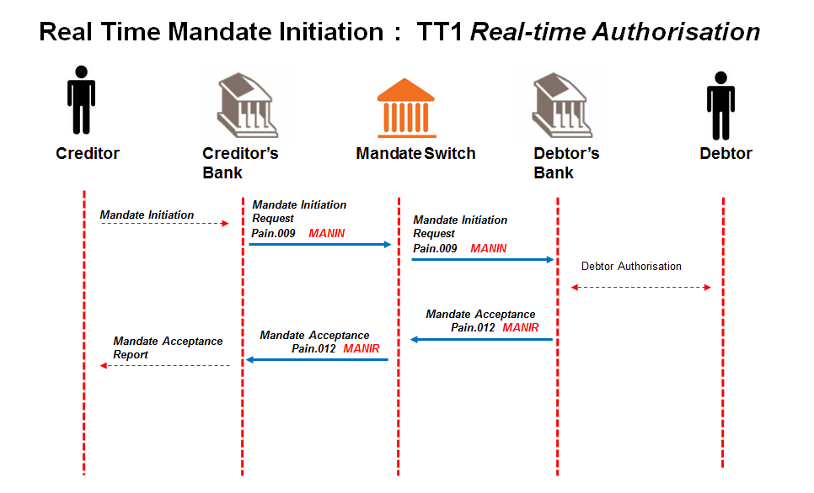

## Creditor sends mandate initiation request to Creditor Bank.

Message format to be determined by the Creditor Bank, but message sent to Creditor Bank must contain all the data elements needed to create the mandate initiation request (pain.009) and must include a request for real time authorisation.

## Creditor Bank sends mandate initiation request (pain.009) to ACH.

Creditor Bank validates the Creditor and confirms that he is in good standing and submits mandate initiation request to the ACH. The Debtor Authentication Required field contains 0229 or 0230.

## ACH validates mandate initiation request (pain.009)

ACH performs the following minimum validation:

* Message structure
* Member banks
* Date check

## ACH sends valid mandate initiation request (pain.009) to Debtor Bank.

## Debtor Bank validates mandate initiation request (pain.009).

Debtor Bank performs the following minimum validation:

* the account is a valid account for AC;
* the account is “open” and “active” (not frozen; closed etc.);
* the Debtor’s ID number matches the account details provided;
* if the Debtor Bank uses the mobile service as the authorisation channel, check if the supplied number matches the mobile number of the Debtor as registered by the Debtor Bank. It is at the Debtor Bank’s discretion to use this number for alternate communication but the Debtor Bank will use their registered Payer’s details for authorisation of the mandate.

## Debtor Bank engages with the Debtor via USSD.

Method of communicating with the Debtor is to be determined by the Debtor bank, but for real time non face-to-face authentication, debtor banks must at least support a basic USSD technology using mobile phones. The channel chosen must cater for an immediate/real time request and response message from Debtor and contain the data elements specified in Appendix B that are required for authorisation.

Two real time authorisations may be requested using USSD, namely:

* 0229 - If the cell number in the message matches the registered cell number at the Paying Bank and the message contains an authorisation code of 0229, the authorisation request will be sent to Payer. If cell number provided in message is not matched, the request is rejected.
* 0230 - If the cell number in the message does not match the registered cell number at the Paying Bank and the message contains an authorisation code of 0230, the authorisation request will be sent to Payer using the registered cell number.

The message must time out from the Creditor Bank after:

* 120 seconds if the bank initiates a USSD push
* 120 seconds if the bank insists the client initiates a USSD pull

## Debtor responds to authorisation request from Debtor Bank.

Debtor’s response could be either positive or negative.

## Debtor Bank updates Mandate Register on positive response from Debtor.

Once Debtor authorises mandate, Debtor Bank creates unique mandate reference number per mandate initiation request to include in mandate response.

## Debtor Bank responds with mandate acceptance report (pain.012) to ACH.

Debtor Bank responds with mandate acceptance report to ACH with “authorised” (AAUT) or “not authorised” (NAUT) Debtor responses indicated in the “Authentication Status Indicator”.

This indicates the outcome of the mandate authentication process between Debtor Banks and their clients.

**The Debtor Bank must immediately generate the mandate acceptance report and reply to the ACH once the Debtor responds, without delay**. The mandate acceptance report will contain the unique mandate reference number.

## ACH forwards mandate acceptance report (pain.012) to Creditor Bank.

## Creditor Bank engages with Creditor.

Message format of mandate response to Creditor to be determined by the Creditor Bank.

**Note** that the content of the USSD message must adhere to the rules as defined in Appendix Q.

**Alternative InApp Authorisation Channel:**

As an alternative to the USSD push authorisation channel, banks may use an InApp push notification to request for a mandate authorisation. All banks must however have the USSD authorisation channel capability. The following requirements are defined for this solution:

|  |  |
| --- | --- |
| **Req ID** | **Description** |
| RQACINAPP001 | When a debtor bank receives a real-time mandate initiation of amendment authorisation request with a 0229 or 0230 Debtor Authentication Required code, they may choose to first check whether a customer has been registered for banking app function on their phone. |
| RQACINAPP002 | If a customer has their banking app installed they may choose to initiate an InApp push notification authorisation request to the customer’s App. |
| RQACINAPP003 | If a customer does not have their banking app installed or the debtor bank does not support an InApp push notification, then a USSD authorisation request shall be initiated as per the current AC functional requirements. |
| RQACINAPP004 | The InApp push authorisation request message shall provide the customer with the same mandatory information as specified for the USSD message and shall provide the customer with the ability to authorise or decline the mandate. |
| RQACINAPP005 | An InApp push notification request and response times must adhere to the current SLAs. |
| RQACINAPP006 | The InApp push notification authorisation channel shall make use of the existing TT1 real-time AC message flows. |

**Mandate Initiation Request Real Time Process – Delayed Authorisation:**

**(Where Debtor Authentication Required = 0227)**

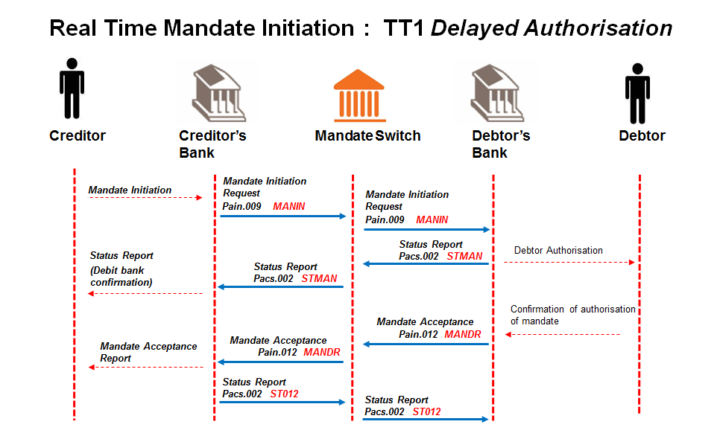

## Creditor sends mandate initiation request to Creditor Bank.

Message format to be determined by the Creditor Bank, but message sent to Creditor Bank must contain all the data elements needed to create the mandate initiation request (pain.009).

## Creditor Bank sends mandate initiation request (pain.009) to ACH.

Creditor Bank validates the Creditor and confirms that he is in good standing and submits mandate initiation request to the ACH.

## ACH validates mandate initiation request (pain.009) and responds to Creditor Bank with rejections (pacs.002).

ACH performs the following minimum validation:

* Message structure
* Member banks
* Date check

## ACH sends valid mandate initiation request (pain.009) to Debtor Bank.

## Debtor Bank validates mandate initiation request (pain.009).

Debtor Bank performs the following minimum validation:

* the account is a valid account for AC;
* the account is “open” and “active” (not frozen; closed etc.);
* the Debtor’s ID number matches the account details provided;
* *Optional requirement*: if the Debtor Bank uses the mobile service as the authorisation channel, check if the supplied number matches the mobile number of the Debtor as registered by the Debtor Bank. It is at the Debtor Bank’s discretion to use this number for alternate communication but the Debtor Bank will use their registered Payer’s details for authorisation of the mandate.

## Debtor Bank engages with the Debtor via their chosen authorisation channel.

Method of communicating with the Debtor is to be determined by the Debtor bank and is delayed in the authorisation response (i.e. not “Real Time”).

## Debtor Bank responds with a status report (pacs.002) to ACH.

The message from Debtor Bank is a confirmation and acknowledgment that validations as per 5.1.5 have been successful and engagement with Debtor has been initiated.

The initial response (Status Report) to Creditor Bank needs to be a real time response; only the Debtors’ authorisation response can be delayed as the response to the Debtor Bank is at the Debtor’s discretion.

## ACH forwards status report (pacs.002) to Creditor Bank.

## Creditor Bank engages with Creditor as per status of mandate.

Message format of status of mandate to Creditor to be determined by the Creditor Bank.

## Debtor responds to authorisation request from Debtor Bank.

Debtor’s response could be either positive or negative.

## Debtor Bank updates Mandate Register on positive response from Debtor.

Once Debtor authorises mandate, Debtor Bank creates unique mandate reference number per mandate initiation request to include in mandate response.

## Debtor Bank responds with mandate acceptance report (pain.012) to ACH.

Debtor Bank responds with mandate acceptance report to ACH with “authorised” (AAUT) or “not authorised” (NAUT) Debtor responses indicated in the “Authentication Status Indicator”.

This indicates the outcome of the mandate authentication process between Debtor Banks and their clients.

**The Debtor Bank must immediately generate the mandate acceptance report and reply to the ACH once the Debtor responds, without delay**. The mandate acceptance report will contain the unique mandate reference number.

On Expiration (End of Day) - the Debtor Bank will change the status of all mandate initiation requests that the Debtor has not responded to, from “Pending” to “No Responses”. Debtor Bank will reply in real time with mandate acceptance report messages with all outstanding authorisations from Debtors to ACH.

**If a positive or negative response is received from Debtor, Debtor Bank MUST deliver responses to ACH by end of day.**

**TT1 Use Case timing windows for request and response messages per day are illustrated in the diagrams below.**

## ACH forwards mandate acceptance report (pain.012) to Creditor Bank.

## Creditor Bank engages with Creditor.

Message format of mandate response to Creditor to be determined by the Creditor Bank.

## Creditor sends receipt of response message to Creditor Bank.

Message format of receipt to mandate response message to be determined by the Creditor Bank, but message sent to Creditor Bank must contain all the data elements needed to create the status report (pacs.002).

## Creditor Bank responds with a status report (pacs.002) to ACH as receipt of mandate acceptance report (pain.012).

## ACH forwards status report (pacs.002) to Debtor Bank as receipt of mandate acceptance report (pain.012).

**IMPORTANT NOTE:**

**Alignment of AC BRD fields to Mandate Request and Response messages in ISO20022 can be found in** **Appendix C****:**

## Authorise mandate – non card, authentication key not included in request, batched request & response (TT2)

**Description** - This scenario relates to a Payer/Debtor needing to authorise future debit orders initiated by a User/Creditor. The process of authorising the mandate by the Payer/Debtor is ***delayed and submitted in batch*** by the User/Creditor. Further, the Payer/Debtor has ***no authentication key*** to be included in the request message.

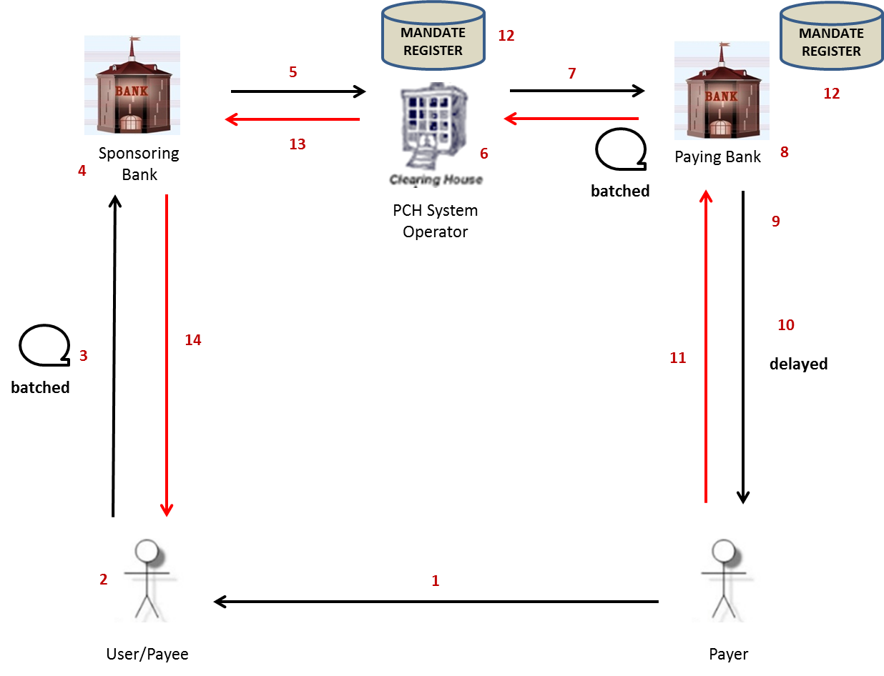

**Technical Requirements:**

* Creditor Bank must have batch processing capabilities.
* Debtor Bank must have batch processing capabilities.

The following data delivery mechanisms will be available for the delivery of ISO 20022 messages in batch between participants and the ACH:

* ConnectDirect;
* XCOM;
* Web-based https (secure FTP) upload via extranet over dedicated connections; and
* SWIFTNet FileAct.

gzip is to be used for file compression & decompression

**Messages used:**

* Mandate Initiation Request (pain.009)
* Mandate Acceptance Report (pain.012)
* Status Report (pacs.002) for Mandate Messages

**Processing Windows:**

| Message | Service Code | Originating | Receiving | Start Time | End Time | Extra |
| --- | --- | --- | --- | --- | --- | --- |
| Pain.009 | MANIN | Creditor Bank | ACH | 03:00 | 20:00 | Day 0 |
| Pain.009 | MANOT | ACH | Debtor Bank | 03:00 | 20:30 | Day 0 |
|  |  |  |  |  |  |  |
| Pain.012 | MANAC | Debtor Bank | ACH | 03:00  03:00 | 21:00  21:00 | Day 1 & 2  Day 2 – Final Responses |
| Pain.012 | MANOC | ACH | Creditor Bank | 03:00  03:00 | 21:30  21:30 | Day 1 & 2  Day 2 – Final Responses |
|  |  |  |  |  |  |  |
| Pacs.002 | ST101 | Debtor Bank | ACH | 03:00 | 21:00 | Day 0 & 1 |
| Pacs.002 | ST103 | ACH | Creditor Bank | 03:00 | 21:30 | Day 0 & 1 |
|  |  |  |  |  |  |  |
| Pacs.002 | ST100 | ACH | Creditor Bank | 03:00 | 20:30 | Day 0 |
| Pacs.002 | ST102 | ACH | Debtor Bank | 03:00 | 21:30 | Day 1 |
| Pacs.002 | ST104 | ACH | Debtor Bank | 03:00  03:00 | 21:30  21:30 | Day 1  Day 2 |

**Clarification of Timings above:**

**Day 0:**

Creditor Bank must send Mandate Initiation requests to ACH between 03H00 to 20H00

ACH to send Status Reports (containing rejections) to Creditor Bank (Status Report) until 20:30

ACH must send requests to Debtor Bank between 03H00 & 20H30

ACH trickle feeds messages as they receive it.

**Day 1:**

Debtor Bank to respond to ACH by 08H00 the following morning (Status Report)

Authorisation Responses from Debtor Bank to ACH between 03H00 to 21H00

ACH to Debtor Bank (Status Report) between 03H00 to 21H30

Authorisation Responses from ACH to Creditor Banks between 03H00 to 21H30

Banks to close off window to debtors not earlier than 20:00 based on input to BsvA by 21:00

* Discretion of Creditor Bank when they will accept their files – times and file-size as per cost factors.

* Status Reports (like VET file) are responses to any files received that is a service provided from ACH.

**Mandate Initiation Request Batch Process:**

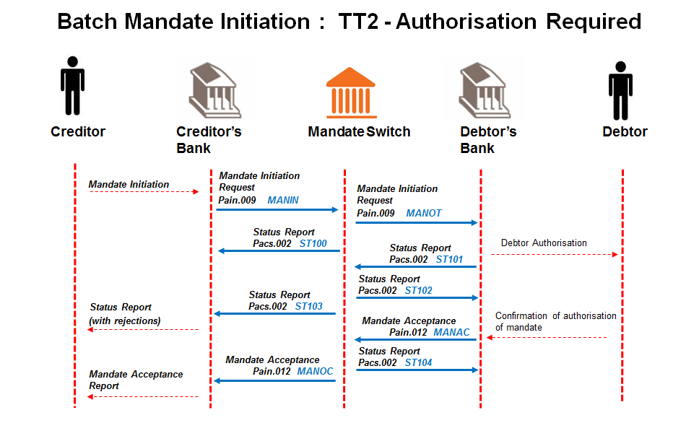

## Creditor sends batch of mandate initiation requests to Creditor Bank.

Message format to be determined by the Creditor Bank, but messages sent to Creditor Bank must contain all the data elements needed to create the mandate initiation requests (pain.009).

## Creditor Bank sends batch of mandate initiation requests (pain.009) to ACH.

Creditor Bank validates the Creditors and confirms that they are in good standing and submits batch of mandate initiation requests to the ACH.

## ACH validates requests and sends status report (pacs.002) to Creditor Bank.

ACH performs the following minimum validation:

* Message structure
* Member banks
* Date check

## ACH sends valid batch mandate initiation requests (pain.009) to Debtor Banks.

## Debtor Bank validates batch mandate initiation requests (pain.009).

Debtor Bank performs the following minimum validation:

* the account is a valid account for AC,
* the account is “open” and “active” (not frozen; closed etc.);
* the Debtor’s ID number matches the account details provided.
* *Optional requirement*: if the Debtor Bank uses the mobile service as the authorisation channel, check if the supplied number matches the mobile number of the Debtor as registered by the Debtor Bank. It is at the Debtor Bank’s discretion to use this number for alternate communication but the Debtor Bank will use their registered Payer’s details for authorisation of the mandate.

## Debtor Bank responds with status report (pacs.002) to ACH.

The report from Debtor Bank will provide responses to all requests (both positive and negative)

## ACH replies with status report (pacs.002) to Debtor Bank.

ACH validates and matches responses to original request.

## ACH forwards status report (pacs.002) to Creditor Banks.

## Creditor Bank engages with Creditor with upfront rejections provided by the Debtor Banks.

Message format of status of mandate to Creditor to be determined by the Creditor Bank.

## Debtor Bank engages with the Debtor through their chosen authorisation channel.

Method of communicating with the Debtor to be determined by the Debtor Bank, but must contain the data elements specified in Appendix B that are required for authorisation.

## Debtor responds to authorisation request from Debtor Bank.

Debtor’s response could be either positive or negative.

## Debtor Bank updates Mandate Register on positive response from Debtor.

Once Debtor authorises mandate, Debtor Bank creates unique mandate reference number per mandate initiation request to include in mandate response.

## Debtor Bank responds with batch mandate acceptance report (pain.012) to ACH.

Debtor bank responds with batch mandate acceptance report to ACH with “authorised” (AAUT) or “not authorised” (NAUT) Debtor responses, indicated in the “Authentication Status Indicator”.

This indicates the outcome of the mandate authentication process between Debtor Banks and their clients.

The batch mandate acceptance report will contain unique mandate reference numbers per mandate initiation requests.

Mandate acceptance reports will be batched as per the processing times; with an expiration of the request after 2 days beginning from the presentment of the original batch mandate initiation request i.e. cut-off on day 2 is the final response from the Debtor Bank.

On Expiration Day (Day 2) - Debtor Bank will send a FINAL batch mandate acceptance report with all outstanding positive and negative (not authenticated and no responses) authorisations from Debtors per mandate initiation requests that were batched.

**If authorisation is not received from Debtor, Debtor Bank MUST deliver non-responses to ACH by Expiration Day (Day 2).**

## ACH responds with status report (pacs.002) to Debtor Bank.

Status report is confirmation of receipt of mandate acceptance report.

## ACH forwards batch mandate acceptance report (pain.012) per Creditor Bank.

## Creditor Bank engages with Creditor.

Message format of mandate response to Creditor to be determined by the Creditor Bank.

**IMPORTANT NOTE:**

**Alignment of BRD fields to Mandate Request and Response messages in ISO20022 can be found in** **Appendix C****:**

## Authorise mandate – card, authentication key included in request, real time request & response (TT3)

**Description** - This scenario captures the process of authenticating the Payer/Debtor and the mandate through a Card and PIN mechanism, where the Payer/Debtor is typically face-to-face with the User/Creditor and a card accepting device is utilised. The process of authorising the mandate needs to be completed in ***real time***. The Payer’s/Debtor’s ***authentication key*** is already coupled within the message.

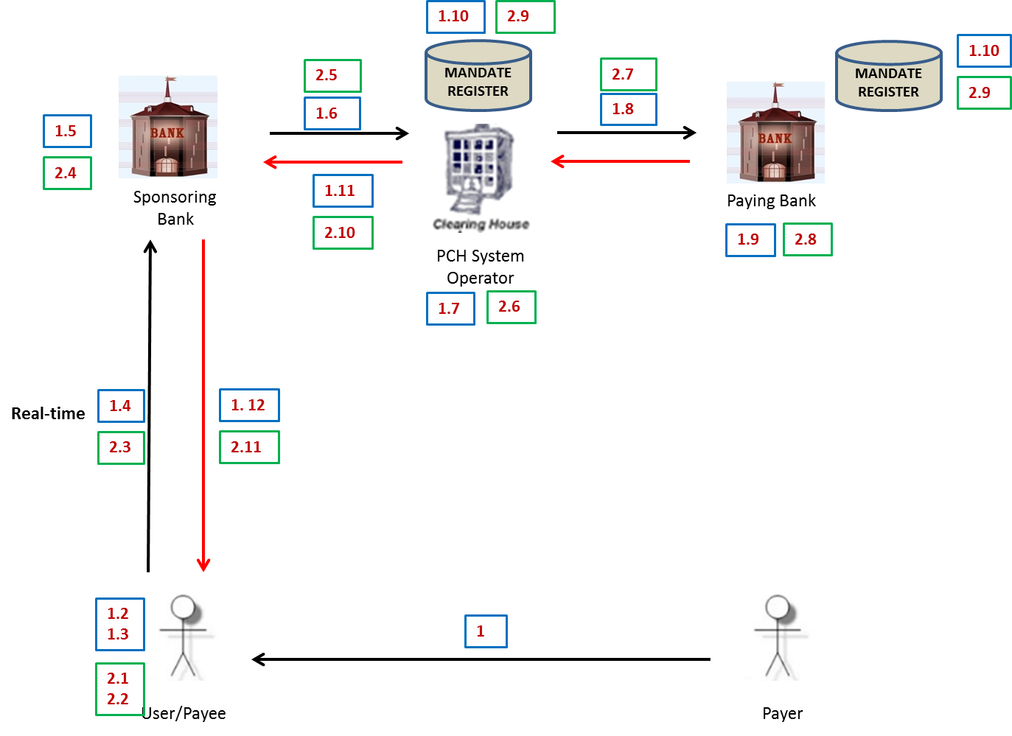

**IMPORTANT NOTE:**

Conceptual flow TT3 indicates that there are two messaging processes required:

1. Debtor Authentication Request Leg shown in the blue blocks, and

2. Mandate Registration Initiation Request Leg shown in the green blocks.

**Technical Requirements:**

* Online delivery mechanisms

The following delivery mechanisms will be available for online delivery of ISO 20022 messages between participants and the ACH:

* MQ (set as sync)
* Web services https
* TCP/IP

The following delivery mechanisms will be available for online delivery of BIC ISO messages between participants and the ACH:

* Card Switch

**Mandate Registration Process is completed in two legs:**

**Messages used for Debtor Authentication Request Leg (BIC ISO):**

* Card Authorisation Request/Authentication Request (0200)
* Card Acceptance Response/ Authentication Response (0210)

**Messages used for Mandate Registration Initiation Request Leg (ISO20022):**

* Mandate Initiation Request (pain.009)
* Mandate Acceptance Report (pain.012)
* Status Report (pacs.002) for Mandate Messages

**Processing Windows:**

**BIC ISO**

|  |  |  |  |  |  |  |
| --- | --- | --- | --- | --- | --- | --- |
| Message | Service Code | Originating | Receiving | Start Time | End Time | Extra |
| BIC ISO | 200 | Creditor Bank | ACH | 00:30 | 23:30 |  |
| BIC ISO | 200 | ACH | Debtor Bank | 00:30 | 23:30 |  |
| BIC ISO | 210 | Debtor Bank | ACH | 00:30 | 23:30 |  |
| BIC ISO | 210 | ACH | Creditor Bank | 00:30 | 23:30 |  |

**Mandates**

| Message | Service Code | Originating | Receiving | Start Time | End Time | Extra |
| --- | --- | --- | --- | --- | --- | --- |
| Pain.009 | MANIN | Creditor Bank | ACH | 00:30 | 23:30 |  |
| Pain.009 | MANIN | ACH | Debtor Bank | 0:30 | 23:30 |  |
| Pain.012 | MANIR | Debtor Bank | ACH | 0:30 | 23:30 |  |
| Pain.012 | MANIR | ACH | Creditor Bank | 00:30 | 23:30 |  |
| Pacs.002 | STMVF | ACH | Creditor Bank | 00:30 | 23:30 |  |
| Pacs.002 | STAVF | ACH | Debtor Bank | 00:30 | 23:30 |  |

IMPORTANT NOTE: Card Switch

Even though the card switch is available 24 hours, the mandate functionality will operate as per above processing windows.

**TT3 Timout Sessings**

The following time-out settings shall apply to the sets of real-time message flows for the initiating, receiving and responding parties and the ACH. A set of message flows is defined as the pair of messages that make up the initial request and immediate relevant response.

|  |  |  |  |  |  |  |
| --- | --- | --- | --- | --- | --- | --- |
| **TT3** |  |  |  |  |  |  |
|  | | | **Time Out Setting (s)** | | | **Note** |
| **Debtor Authorization Required Code** | **Initiating Service** | **Response Service** | **Initiation Party** | **Receiving and Responding Party** | **ACH** |
| 228 | MANIN | MANIR | 60 | 50 | 140 | The debtor bank must send back the pacs.002 response within 50s. |
| 228 | MANIN | STMVF | 60 | 50 | N/A | ACH is the receiving and responding party in this flow and must send the pacs.002 response within 50s. |
| 228 | MANIN | STMDF | 60 | 50 | 140 | The debtor bank must send back the pacs.002 response within 50s. |

**Mandate Initiation Request Real Time with Card Present Process:**

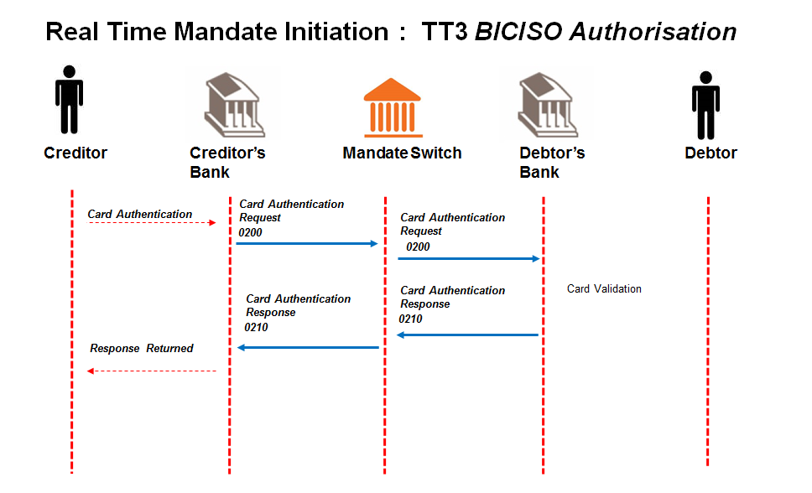

## Creditor obtains all required information for contract and mandate registration via Creditor User Interface.

Debtor is face to face with Creditor.

## Creditor initiates mandate registration process.

Debtor swipes/dips card and enters pin to authorise the mandate at Creditor.

## Debtor authentication request leg of mandate registration process is initiated.

## Creditor sends card authorisation request (0200) to Creditor Bank.

## Creditor Bank validates the Creditor and sends card authorisation request (0200) to the ACH.

Creditor Bank validates the Creditor and confirms that he is in good standing and submits card authorisation request to the ACH.

## ACH validates card authorisation request (0200).

ACH performs the following minimum validation:

* Financial institution
* BINs
* Switching codes
* Message format

## ACH sends card authorisation request (0200) to Debtor Bank.

## Debtor Bank validates card authorisation request (0200)

Debtor Bank does validation as per card, PIN, account and Debtor ID and generates an authentication (MAC) key to return to Creditor Bank.

## Debtor Bank responds with a card acceptance response (0210) to the ACH.

The message must include the authentication (MAC) key generated by the Debtor Bank.

The message from Debtor Bank is a confirmation and acknowledgment the Debtor’s card and pin has been validated.

## ACH forwards the card acceptance response (0210) to Creditor Bank.

## Creditor Bank provides the Creditor with the card acceptance response (0210).

## 

## The Creditor initiates the mandate registration initiation request leg once the card authorisation response is successfully received i.e. card and pin is valid and authentication key (MAC) was received.

Creditor extracts the authentication (MAC) key from card acceptance response and couples it to mandate initiation request as it confirms that Debtor has authorised the mandate.

## Creditor sends mandate initiation request to Creditor Bank.

## The Creditor must indicate in the mandate initiation request that authorisation has been done.

## 

## Creditor Bank sends mandate initiation request (pain.009) to ACH.

Creditor Bank validates the Creditor and confirms that he is in good standing and submits mandate initiation request to the ACH.

## ACH validates mandate initiation request (pain.009).

ACH performs the following minimum validation:

* Message structure
* Member banks
* Date check

## ACH sends valid mandate initiation request (pain.009) to Debtor Bank.

## Debtor Bank validates mandate initiation request (pain.009).

Debtor Bank performs the following minimum validation:

* Authentication (MAC) key validation (comparison as to what was sent);
* the account is a valid account for AC;
* the account is “open” and “active” (not frozen; closed etc.);

## Debtor Bank updates Mandate Register on receipt of successfully validated mandate initiation request message (pain.009).

Debtor Bank creates unique mandate reference number per mandate initiation request.

## Debtor Bank responds with mandate acceptance report (pain.012) to ACH.

Debtor Bank responds in Real Time with mandate acceptance report to ACH with the unique mandate reference number included as proof the mandate was registered by the Debtor Bank on their Mandate Register as requested.

## ACH forwards mandate acceptance report (pain.012) to Creditor Bank.

## Creditor Bank engages with Creditor.

Message format of mandate response to Creditor to be determined by the Creditor Bank.

**IMPORTANT NOTE:**

**Alignment of AC BRD fields to Mandate Request and Response messages in ISO20022 can be found in** **Appendix C****:**

**MAC expiry will be at end of day**

Note: - the Card processing is available for the full 24 hours, but any MAC generated after 21:00 will not be accepted on the Mandate message leg and expires

Even though the card switch is available 24 hours, the mandate functionality will operate as per above processing windows.

## Authorise mandate – card not present, authentication key included in request, real time request & response (TT4) (Optional Transaction Type for the Paying Bank to cater for)

**Description** - This scenario captures the process of authenticating the Payer/Debtor and authorisation of the mandate through an authentication key deemed acceptable by the Paying/Debtor Bank, where the Payer/Debtor is typically NOT face-to-face. A remote authentication capability is utilised. The process of authorising the mandate needs to be completed in ***real time***. The Payer’s/Debtor’s ***authentication key*** is already coupled with the authorisation request message.

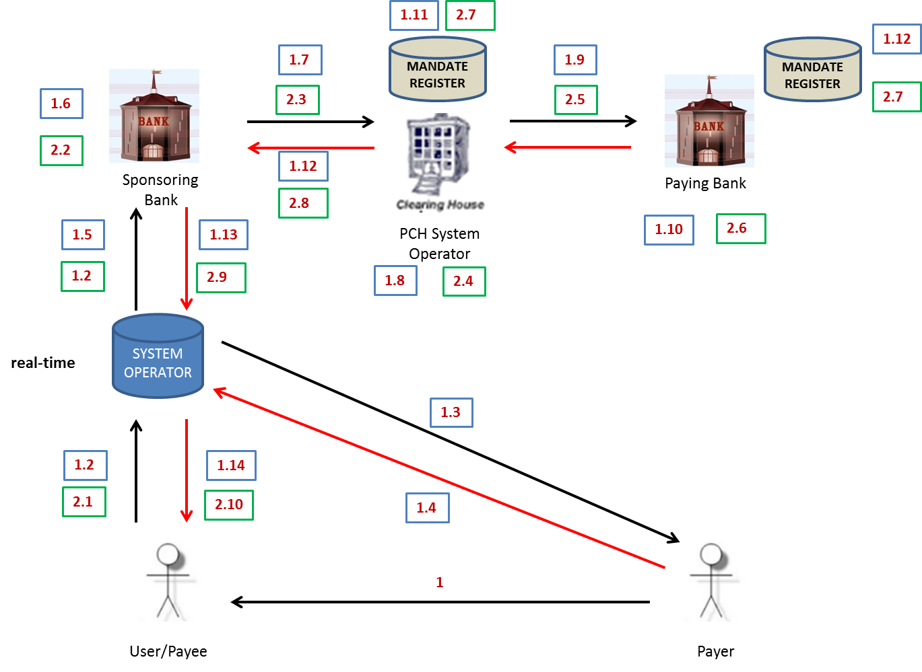

**IMPORTANT NOTE:**

Conceptual flow TT4 indicates that there are two messaging processes required:

1. Debtor Authentication Request Leg shown in the blue blocks, and

2. Mandate Registration Initiation Request Leg shown in the green blocks.

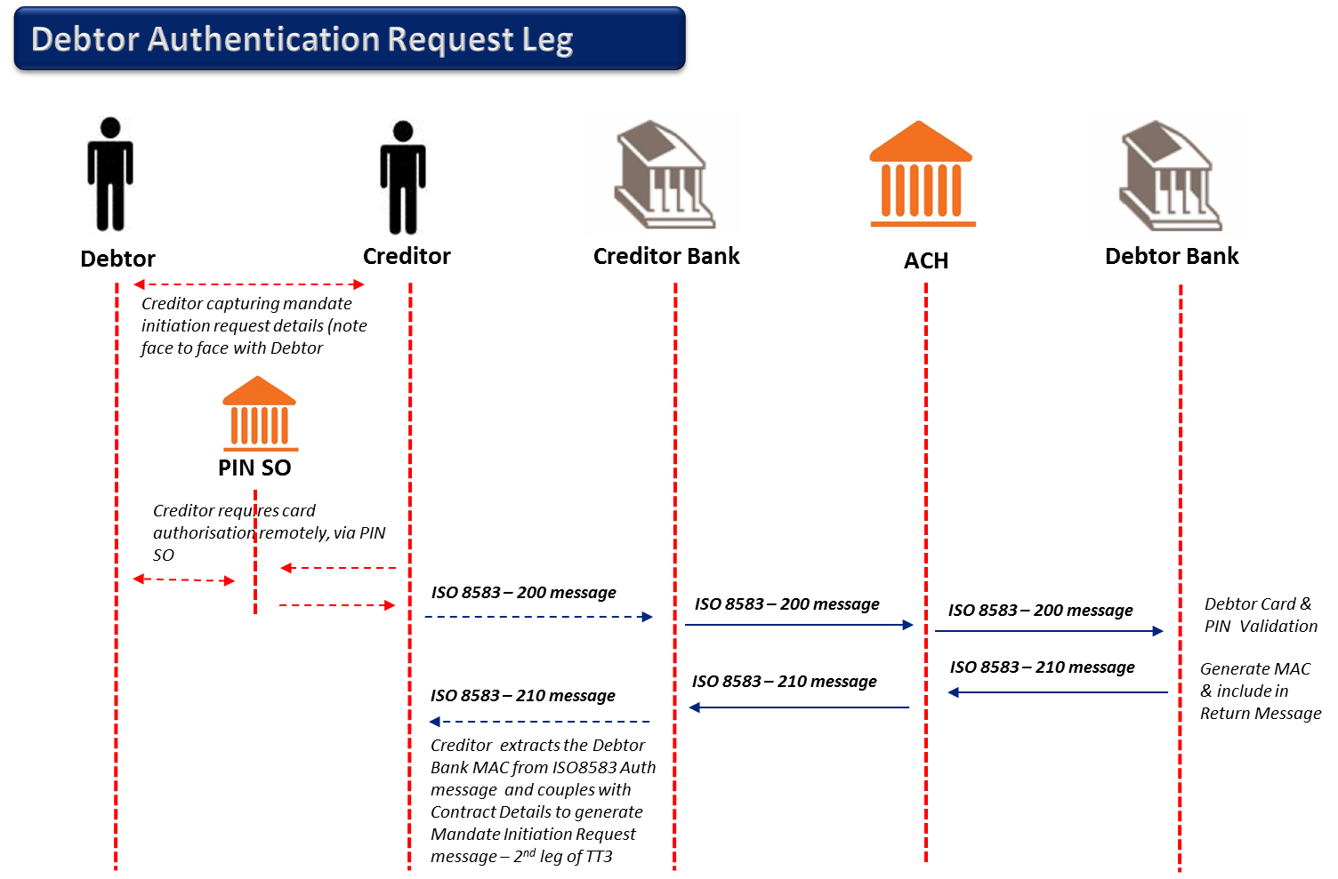

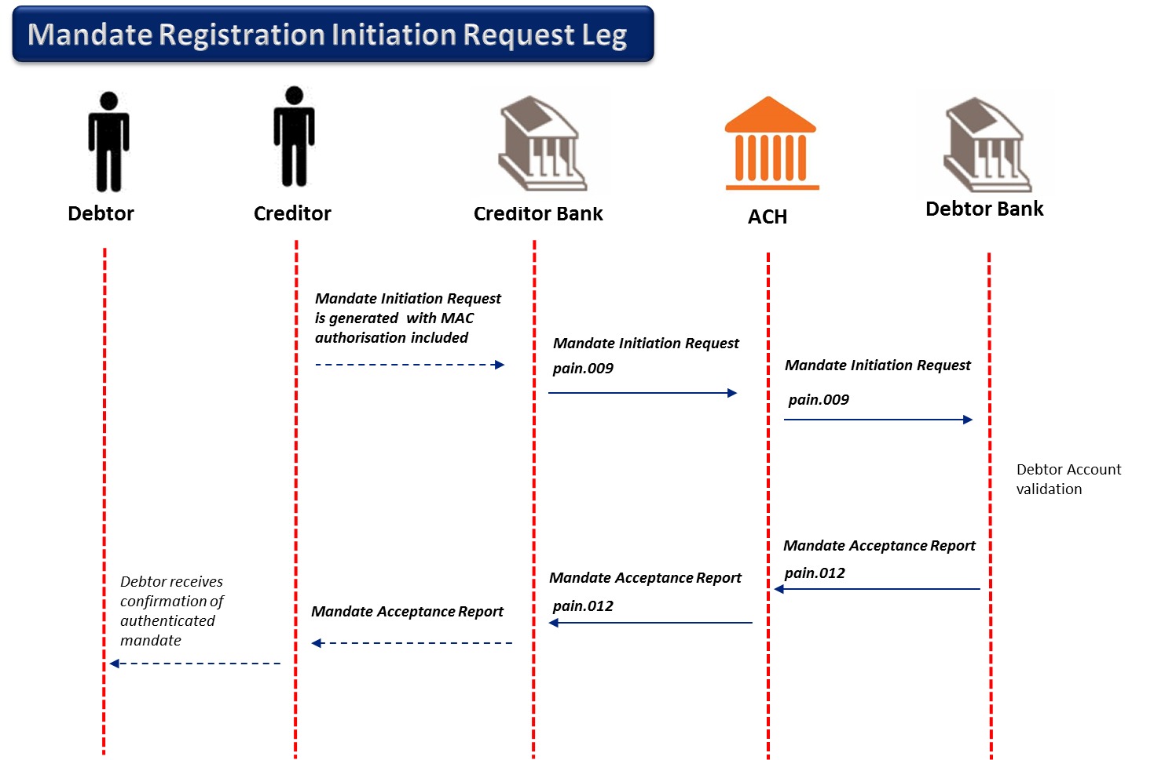

**Technical Requirements:**

Online delivery mechanisms

The following delivery mechanisms will be available for online delivery of ISO 20022 messages between participants and the ACH:

* MQ (set as sync)
* Web services https
* TCP/IP

The following delivery mechanisms will be available for online delivery of BIC ISO messages between participants and the ACH:

* Card Switch

**Mandate Registration Process is completed in two legs:**

**Messages used for Debtor Authentication Request Leg (BIC ISO):**

* Card Authorisation Request/Authentication Request (0200)
* Card Acceptance Response/ Authentication Response (0210)

**Messages used for Mandate Registration Initiation Request Leg (ISO20022):**

* Mandate Initiation Request (pain.009)
* Mandate Acceptance Report (pain.012)
* Status Report (pacs.002) for Mandate Messages

**Processing Windows:**

**BIC ISO**

|  |  |  |  |  |  |  |
| --- | --- | --- | --- | --- | --- | --- |
| Message | Service Code | Originating | Receiving | Start Time | End Time | Extra |
| BIC ISO | 200 | Creditor Bank | ACH | 03:00 | 21:00 | 00:00 to 24:00 |
| BIC ISO | 200 | ACH | Debtor Bank | 03:00 | 21:00 | 00:00 to 24:00 |
| BIC ISO | 210 | Debtor Bank | ACH | 03:00 | 21:00 | 00:00 to 24:00 |
| BIC ISO | 210 | ACH | Creditor Bank | 03:00 | 21:00 | 00:00 to 24:00 |

**Mandates**

| Message | Service Code | Originating | Receiving | Start Time | End Time | Extra |
| --- | --- | --- | --- | --- | --- | --- |
| Pain.009 | MANIN | Creditor Bank | ACH | 03:00 | 21:00 |  |
| Pain.009 | MANIN | ACH | Debtor Bank | 03:00 | 21:00 |  |
|  |  |  |  |  |  |  |
| Pain.012 | MANIR | Debtor Bank | ACH | 03:00 | 21:00 |  |
| Pain.012 | MANIR | ACH | Creditor Bank | 03:00 | 21:00 |  |
|  |  |  |  |  |  |  |
| Pacs.002 | STMVF | ACH | Creditor Bank | 03:00 | 21:00 |  |
| Pacs.002 | STAVF | ACH | Debtor Bank | 03:00 | 21:00 |  |

**Mandate Initiation Request Real Time with Card Not Present Process:**

## Creditor obtains information for contract and mandate registration via Creditor User Interface.

Debtor is not face to face with Creditor.

## Creditor initiates card authorisation request to PIN Service provider (PIN Service Operator).

## PIN Service provider engages with Debtor to obtain Card PIN.

## Debtor is unaware of PIN Service provider as it is part of Creditor process.

## PIN Service provider returns encrypted PIN and card details to the Creditor.

## Creditor initiates mandate registration process.

## Debtor authentication request leg of mandate registration process is initiated.

## Creditor sends card authorisation request (0200) to Creditor Bank.

## Creditor Bank validates the Creditor and sends card authorisation request (BIC ISO 0200) to the ACH.

Creditor Bank validates the Creditor and confirms that he is in good standing and submits card authorisation request to the ACH.

## ACH validates card authorisation request (0200).

ACH performs the following minimum validation:

* Financial institution
* BINs
* Switching codes
* Message format

## ACH sends card authorisation request (0200) to Debtor Bank.

## Debtor Bank validates card authorisation request (0200)

Debtor Bank does validation as per card, PIN, account and Debtor ID and generates a MAC key to return to Creditor Bank.

## Debtor Bank responds with a card acceptance response (0210) to the ACH.

The message must include the authentication (MAC) key generated by the Debtor Bank.

The message from Debtor Bank is a confirmation and acknowledgment the Debtor’s card and pin has been validated.

## ACH forwards the card authorisation message (0210) to Creditor Bank.

## Creditor Bank provides the Creditor with the card authorisation message (0210).

## The Creditor initiates the mandate registration initiation request leg once the card authorisation message is successfully received i.e. card and pin is valid and MAC was received.

Creditor extracts the authentication (MAC) key from card authorisation message and couples it to mandate initiation request as it confirms that Debtor authorised mandate.

## Creditor sends mandate initiation request to Creditor Bank.

## Creditor Bank sends mandate initiation request (pain.009) to ACH.

Creditor Bank validates the Creditor and confirms that he is in good standing and submits mandate initiation request to the ACH.

## ACH validates mandate initiation request (pain.009) and replies (pacs.002) to Creditor Bank.

ACH performs the following minimum validation:

* Message structure
* Member banks
* Date check

## ACH sends valid mandate initiation request (pain.009) to Debtor Bank.

## Debtor Bank validates mandate initiation request (pain.009).

Debtor Bank performs the following minimum validation:

* Authentication (MAC) key validation (comparison as to what was sent);
* the account is a valid account for AC;
* the account is “open” and “active” (not frozen; closed etc.);

## Debtor Bank updates Mandate Register on receipt of successfully validated mandate initiation request message (pain.009).

Debtor Bank creates unique mandate reference number per mandate initiation request.

## Debtor Bank responds with mandate acceptance report (pain.012) to ACH.

Debtor Bank responds in Real Time with mandate acceptance report to ACH with the unique mandate reference number included as proof the mandate was registered by the Debtor Bank on their Mandate Register as requested.

## ACH forwards mandate acceptance report (pain.012) to Creditor Bank.

## Creditor Bank engages with Creditor.

Message format of mandate response to Creditor to be determined by the Creditor Bank.

**IMPORTANT NOTE:**

**Alignment of AC BRD fields to Mandate Request and Response messages in ISO20022 can be found in** **Appendix C****:**

# Mandate Management

Two scenarios for the housing of the mandate database were considered:

1. Mandate database housed centrally at the ACH/Service Provider.
2. Mandate database housed at the Creditor.

Two scenarios for the housing of the mandate register were considered.

1. Mandate register housed centrally at the ACH.
2. Mandate register housed at the Debtor Bank.

**IMPORTANT NOTE:**

*It is ultimately the decision of the Debtor Bank to determine the location of the mandate register which is most appropriate in terms of practicality and processing efficiency, internally.*

*(There are however, strong counter arguments for a centralised approach; as well as a model where the two approaches could co-exist with the System Operator providing a service to some Debtor Banks.)*

*It is ultimately the decision of the Creditor to determine the location of the mandate database which is most appropriate in terms of practicality and processing efficiency, internally.*

**IMPORTANT NOTE:** The AC TRS WG has catered for the more complex scenario of the mandate database being housed at the Creditor and the mandate register housed at the Debtor Bank.

## Amendment of a Mandate

**Description -** This scenario captures the process of amending a mandate by a User. Changes in the contractual relationship between the User and the Payer would require periodic amendments to elements of the electronic mandate stored in the mandate register.

**Business scenario applicable –** This scenario applies to any User wanting to amend a mandate that is already housed in the system.

**IMPORTANT NOTE: Amendments are allowed in Real Time or Batch.**

**T**he Debtor would have to re-authorise a mandate in certain instances as indicated per validation rules (Appendix D). Depending on re-authorisation Use Case (TT1 to TT4), the Use Case Window Timings would apply.

If a mandate amendment request has not been authorised, then the old mandate MUST remain in effect

Creditor Abbreviated Short Name a mandatory field for security matches by the debtor bank. Mismatches have to reported (fraud report) by the debtor bank

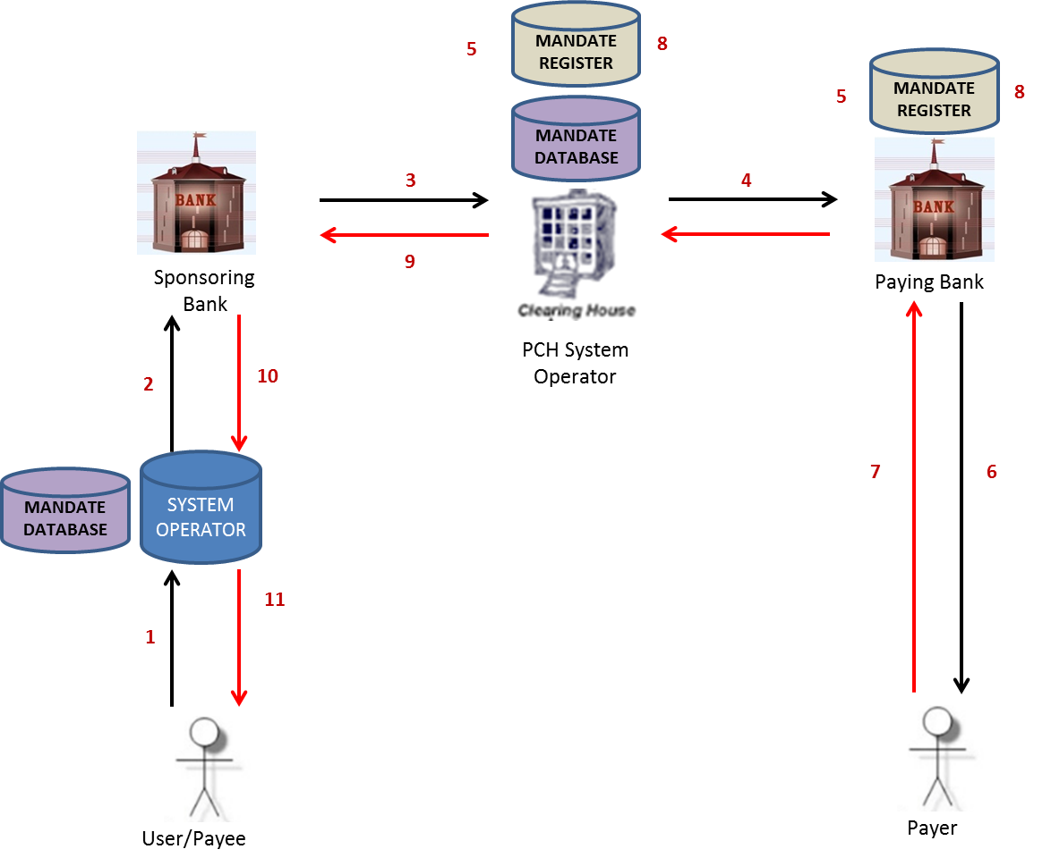

**IMPORTANT NOTE:** If re-authorisation for mandate amendment is required via a Card Present (TT3) or Card Not Present (TT4) then the first leg of Authorisation via BIC ISO is required.

**Technical Requirements:**

* Creditor Bank must have real time processing capabilities.
* Debtor Bank must have real time processing capabilities.
* Online delivery mechanisms

The following delivery mechanisms will be available for online delivery of ISO 20022 messages between participants and the ACH:

* MQ (set as sync)
* Web services https
* TCP/IP

**Messages used**:

* Mandate Amendment Request (pain.010)
* Mandate Acceptance Report (pain.012)
* Status Report (pacs.002) for Mandate Messages

**Processing Windows:**

| Message | Service Code | Originating | Receiving | Start Time | End Time | Extra |
| --- | --- | --- | --- | --- | --- | --- |
| Pain.010 | MANAM | Creditor Bank | ACH | 03:00 | 21:00 |  |
| Pain.010 | MANAM | ACH | Debtor Bank | 03:00 | 21:00 |  |
|  |  |  |  |  |  |  |
| Pain.012 | MANIR | Debtor Bank | ACH | 03:00 | 21:00 |  |
| Pain.012 | MANIR | ACH | Creditor Bank | 03:00 | 21:00 |  |
|  |  |  |  |  |  |  |
| Pacs.002 | STMAN | Debtor Bank | ACH | 03:00 | 21:00 |  |
| Pacs.002 | STMAN | ACH | Creditor Bank | 03:00 | 21:00 |  |
|  |  |  |  |  |  |  |
| Pacs.002 | STMVF | ACH | Creditor Bank | 03:00 | 21:00 |  |
| Pacs.002 | STAVF | ACH | Debtor Bank | 03:00 | 21:00 | 22:00 for final |
|  |  |  |  |  |  |  |
| Pain.012 | MANDR | Debtor Bank | ACH | 03:00 | 21:00 | 22:00 for final |
| Pain.012 | MANDR | ACH | Creditor Bank | 03:00 | 21:00 | 22:00 for final |
|  |  |  |  |  |  |  |
| Pacs.002 | ST012 | Creditor Bank | ACH | 03:00 | 21:00 | 22:00 for final |
| Pacs.002 | ST012 | ACH | Debtor Bank | 03:00 | 21:00 | 22:00 for final |
|  |  |  |  |  |  |  |
| Pacs.002 | STMDF | Debtor Bank | ACH | 03:00 | 21:00 |  |
| Pacs.002 | STMDF | ACH | Creditor Bank | 03:00 | 21:00 |  |
|  |  |  |  |  |  |  |

**Clarification of Timings above:**

Creditor Bank sends Mandate Amendment Requests to Debtor Bank via ACH from 03H00 to 21H00.

Debtor Bank sends Mandate Amendment Responses via ACH to Creditor Bank from 03H00 to 21H00.

Single, real time Mandate response messages with Final Fate Status “no response”( as Debtor has not responded to the authorisation request by Debtor Bank) will be sent to ACH by Debtor Bank by 21H00 (end of day).

ACH to Creditor Bank will complete by 22:00 (additional hour to provide for manual intervention for mandate responses not received by 21:00)

ACH is able to handle real time/online messages 24/7 but cut off times have been agreed for TT1 as Debtor Bank is required to get authorisation from Debtor then register mandate and provide Creditor Bank with feedback sameday.

Creditor Bank must pass this feedback on to Creditor sameday as well.

Banks to close off window to debtors not earlier than 20:00 based on input to BsvA by 21:00

**Real-time Timout Sessings**

The following time-out settings shall apply to the sets of real-time message flows for the initiating, receiving and responding parties and the ACH. A set of message flows is defined as the pair of messages that make up the initial request and immediate relevant response.

|  |  |  |  |  |  |  |
| --- | --- | --- | --- | --- | --- | --- |
| **TT1 Real-time Authorization Mandate Amendment** | | |  |  |  |  |
|  | | | **Time Out Setting (s)** | | | **Note** |
| **Debtor Authorization Required Code** | **Initiating Service** | **Response Service** | **Initiation Party** | **Receiving and Responding Party** | **ACH** |
| 229 230 | MANAM | MANIR | 120 | 100 | 140 | In the cases where the debtor does not respond to the USSD authorisation request the debtor bank must send back the pain.012 response within 100s. |
| 229 230 | MANIN | STMVF | 60 | 50 | N/A | ACH is the receiving and responding party in this flow and must send the pacs.002 response within 50s. |
| 229 230 | MANIN | STMDF | 60 | 50 | 140 | The debtor bank must send back the pacs.002 response within 50s. |
|  |  |  |  |  |  |  |
| **TT1 No Authorization Required Mandate Amendment** | | |  |  |  |  |
|  | | | **Time Out Setting (s)** | | | **Note** |
| **Debtor Authorization Required Code** | **Initiating Service** | **Response Service** | **Initiation Party** | **Receiving and Responding Party** | **ACH** |
| 226 | MANAM | MANIR | 60 | 50 | 140 | The debtor bank must send back the pacs.012 response within 50s. |
| 226 | MANAM | STMVF | 60 | 50 | N/A | ACH is the receiving and responding party in this flow and must send the pacs.002 response within 50s. |
| 226 | MANAM | STMDF | 60 | 50 | 140 | The debtor bank must send back the pacs.002 response within 50s. |
|  |  |  |  |  |  |  |
| **TT1 Delayed Authorization Mandate Amendment** | | |  |  |  |  |
|  | | | **Time Out Setting (s)** | | | **Note** |
| **Debtor Authorization Required Code** | **Initiating Service** | **Response Service** | **Initiation Party** | **Receiving and Responding Party** | **ACH** |
| 227 | MANAM | STMAN | 60 | 50 | 140 | The debtor bank must send back the pacs.002 response within 50s. |
| 227 | MANDR | ST012 | 60 | 50 | 140 | The creditor bank must send back the pacs.002 response within 50s. |
| 227 | MANAM | STMVF | 60 | 50 | N/A | ACH is the receiving and responding party in this flow and must send the pacs.002 response within 50s. |
| 227 | MANAM | STMDF | 60 | 50 | 140 | The debtor bank must send back the pacs.002 response within 50s. |
| 227 | MANDR | STAVF | 60 | 50 | N/A | ACH is the receiving and responding party in this flow and must send the pacs.002 response within 50s. |
|  |  |  |  |  |  |  |

**Adjustment Cycle Calculation:**

The following describes how the adjustment cycle is calculated if the adjustment category in the mandate information is not equal to “never” or “repo”.

The adjustment cycle start date must be calculated from the date on which the first amendment to the instalment amount or the maximum collection amount if the instalment amount is not present, which does not require reauthorisation, is received.

Subsequent adjustment dates must then be calculated based on the adjustment cycle start date and the adjustment category.

Any adjustment to the instalment amount that does not require authorisation on the mandate that falls before the next adjust date must be rejected with error code 901169.

Any amendment to the mandate that requires reauthorisation, except for adjustment category, must not re-set the adjustment cycle start date. This includes amendments to the instalment amount.

If an amendment to the adjustment category is received, for all categories excluding “never” and “repo”, then the adjustment cycle start date is re-set and must only be set again once the next amendment to the instalment amount, which does not require reauthorisation, is received.

**Mandate Amendment Process (Real Time) No Authorisation Required (if tag “Debtor Authentication Required” = 0226)**:

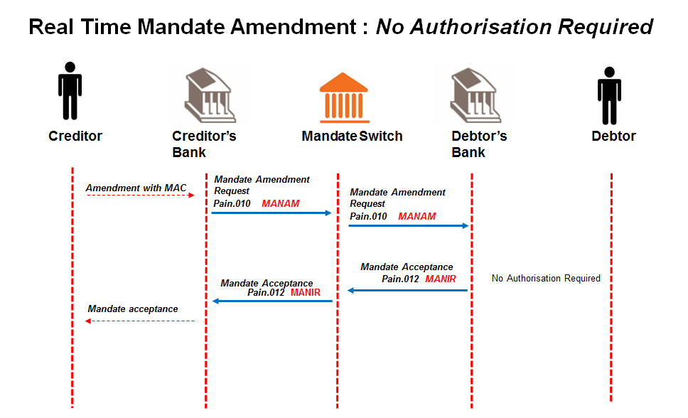

* + 1. **Creditor sends mandate amendment request** **to Creditor Bank; containing the unique mandate reference number of the mandate that it needs to amend.**

Message format to be determined by the Creditor Bank, but message sent to Creditor Bank must contain all the data elements needed to create the mandate amendment request (pain.010). Must indicate that Authorisation is not required.

* + 1. **The Creditor Bank sends mandate amendment request** (pain.010) **to ACH.**

Creditor bank validates the Creditor and confirms that he is in good standing and submits amendment request to the ACH.

* + 1. **The ACH validates the mandate amendment request** (pain.010) **and forwards it to the Debtor Bank.**
    2. **The Debtor Bank validates and processes the mandate amendment request** (pain.010)**.**

The Debtor Bank compares the mandate information stored in the mandate register with the corresponding unique mandate reference number.

* + 1. **The successful or unsuccessful amendment to the mandate is then submitted to the ACH as part of the mandate acceptance report** (pain.012)**.**

Re-authorisation is not required from the Debtor based on the data element to be amended as part of the Debtor’s mandate authorised (refer to Appendix D ).

The Debtor Bank would update the successful amendment request in the mandate register and the change would be noted as part of the audit log.

* + 1. **ACH forwards mandate acceptance report** (pain.012) **to Creditor Bank.**
    2. **Creditor Bank engages with Creditor.**

Message format of mandate response to Creditor to be determined by the Creditor Bank.

**Mandate Amendment Process (Real Time) Authorisation Required (Debtor Authentication Required = 0227):**

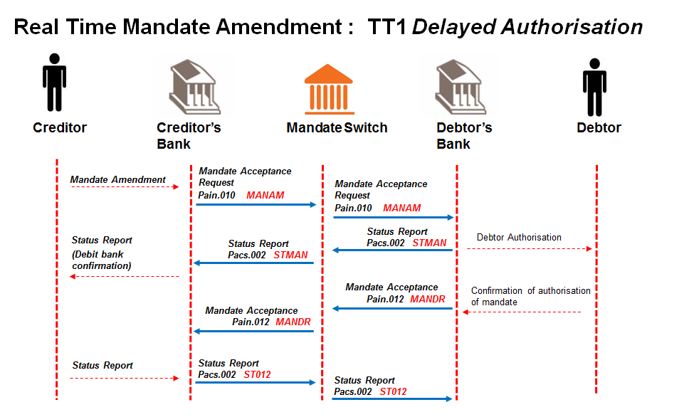

* + 1. **Creditor sends mandate amendment request** **to Creditor Bank; containing the unique mandate reference number of the mandate that it needs to amend.**

Message format to be determined by the Creditor Bank, but message sent to Creditor Bank must contain all the data elements needed to create the mandate amendment request (pain.010). Must indicate that Authorisation is required

* + 1. **The Creditor Bank sends mandate amendment request** (pain.010) **to ACH.**

Creditor bank validates the Creditor and confirms that he is in good standing and submits amendment request to the ACH.

* + 1. **The ACH validates the mandate amendment request** (pain.010) **and forwards it to the Debtor Bank.**
    2. **The Debtor Bank validates and processes the mandate amendment request** (pain.010)**.**

Re-authorisation is required from the Debtor as defined by the data element to be amended (refer to Appendix D ) and the Debtor Authentication Required code of 0227.

The rules per Real Time Use Cases (TT1, TT3 and TT4) defined for AC apply

The Debtor Bank compares the mandate information stored in the mandate register with the corresponding unique mandate reference number.

* + 1. **The Debtor Bank sends a status report** (pacs.002) **to ACH.**

Both negative (no match to mandate) and positive (matched to mandate) acknowledgement responses to the mandate amendment are returned to the ACH

* + 1. **ACH sends this status report** (pacs.002) **to Creditor Bank.**

ACH sends on the acknowledgement responses to the Creditor Bank

* + 1. **Debtor authorises, declines or time elapses on the amendment request**
    2. **The successful or unsuccessful amendment to the mandate is then submitted to the ACH as part of the mandate acceptance report** (pain.012)**.**

When authorised by the Debtor, the Debtor Bank will update the successful amendment request in the mandate register and the change would be noted as part of the audit log.

* + 1. **ACH forwards mandate acceptance report** (pain.012) **to Creditor Bank.**
    2. **Creditor Bank engages with Creditor.**

Message format of mandate response to Creditor to be determined by the Creditor Bank.

* + 1. **Creditor sends receipt of response message to Creditor Bank.**

Message format of receipt to mandate response message to be determined by the Creditor Bank, but message sent to Creditor Bank must contain all the data elements needed to create the status report (pacs.002).

* + 1. **Creditor Bank responds with a status report (**pacs.002**) to ACH as receipt of mandate acceptance report (**pain.012**).**
    2. **ACH forwards status report (**pacs.002**) to Debtor Bank as receipt of mandate acceptance report (**pain.012**).**

**Mandate Amendment Process (Batch):** **Technical Requirements:**

The following data delivery mechanisms will be available for the delivery of ISO 20022 messages in Batch between participants and the ACH:

* ConnectDirect;
* XCOM;
* Web-based https (secure FTP) upload via extranet over dedicated connections; and
* SWIFTNet FileAct.

gzip is to be used for file compression & decompression

**Messages used**:

* Mandate Amendment Request (pain.010)
* Mandate Acceptance Report (pain.012)
* Status Report (pacs.002) for Mandate Messages

**Processing Windows:**

| Message | Service Code | Originating | Receiving | Start Time | End Time | Extra |
| --- | --- | --- | --- | --- | --- | --- |
| **Pain.010** | MANAM | Creditor Bank | ACH | 03:00 | 20:00 | Day 0 |
| **Pain.010** | MANOM | ACH | Debtor Bank | 03:00 | 20:30 | Day 0 |
|  |  |  |  |  |  |  |
| **Pain.012** | MANAC | Debtor Bank | ACH | 03:00  03:00 | 21:00  21:00 | Day 1 & 2  Day 2 – Final Responses |
| **Pain.012** | MANOC | ACH | Creditor Bank | 03:00  03:00 | 21:30  21:30 | Day 1 & 2  Day 2 – Final Responses |
|  |  |  |  |  |  |  |
| **Pacs.002** | ST101 | Debtor Bank | ACH | 03:00 | 21:00 | Day 1 |
| **Pacs.002** | ST103 | ACH | Creditor Bank | 03:00 | 21:30 | Day 1 |
|  |  |  |  |  |  |  |
| **Pacs.002** | ST100 | ACH | Creditor Bank | 03:00 | 20:30 | Day 0 |
| **Pacs.002** | ST102 | ACH | Debtor Bank | 03:00 | 21:30 | Day 1 |
| **Pacs.002** | ST104 | ACH | Debtor Bank | 03:00  03:00 | 21:30  21:30 | Day 1  Day 2 |
|  |  |  |  |  |  |  |

**Clarification of Timings above:**

**Day 0:**

Creditor Bank must send Mandate Amendment requests to ACH between 03H00 to 20H00

ACH to send Status Reports (containing rejections) to Creditor Bank (Status Report) until 20:30

ACH must send requests to Debtor Bank between 03H00 & 20H30

ACH trickle feeds messages as they receive it.

**Day 1:**

Debtor Bank to respond to ACH by 08H00 the following morning (Status Report)

Authorisation Responses from Debtor Bank to ACH between 03H00 to 21H00

ACH to Debtor Bank (Status Report) between 03H00 to 21H30

Authorisation Responses from ACH to Creditor Banks between 03H00 to 21H30

Banks to close off window to debtors earlier than 20:00 based on input to BsvA by 21:00

Note: - Banks and BsvA must have the ability to process the pain.012 on day 1 and day 2

**Mandate Amendment Process (Batch):**

**No Authorisation Required (if tag “Debtor Authentication Required” = 0226)**

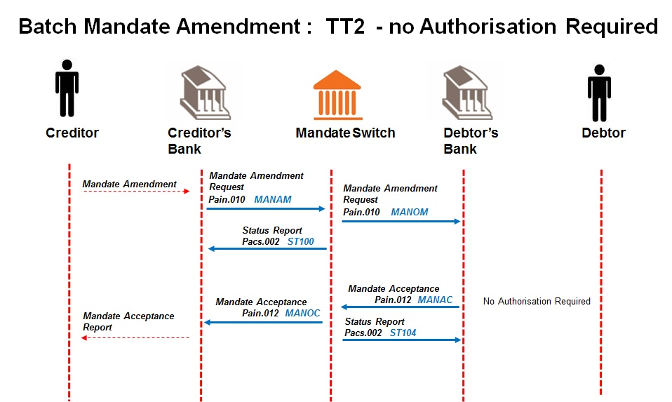

* + 1. **Creditor sends mandate amendment requests to Creditor Bank; containing the unique mandate reference numbers of the mandates that it needs to amend.**

Message format to be determined by the Creditor Bank, but message sent to Creditor Bank must contain all the data elements needed to create the mandate amendment requests (pain.010). Must indicate that Authorisation is **not** required.

* + 1. **The Creditor Bank sends mandate amendment requests** (pain.010) **to ACH.**

Creditor bank validates the Creditor and confirms that he is in good standing and submits amendment requests to the ACH.

* + 1. **ACH validates the mandate amendment requests and sends status report** (pacs.002) **to Creditor Bank.**
    2. **The ACH validates the mandate amendment requests** (pain.010) **and forwards it to the Debtor Bank.**
    3. **The Debtor Bank validates and processes the mandate amendment requests.**

The Debtor Bank compares the mandate information stored in the mandate register with the corresponding unique mandate reference numbers.

As well as a notification of all mandate reference numbers that do not match the original request as per the mandate register.

* + 1. **The successful and unsuccessful amendments to mandates are then submitted to the ACH as part of the mandate acceptance report** (pain.012)**.**

The Debtor Bank would update all successful amendment requests in the mandate register and the change would be noted as part of the audit log.

* + 1. **ACH replies with status report (**pacs.002**) to Debtor Bank.**
    2. **ACH forwards mandate acceptance report** (pain.012) **to Creditor Bank.**
    3. **Creditor Bank engages with Creditor.**

Message format of mandate response to Creditor to be determined by the Creditor Bank.

**Mandate Amendment Process (Batch):**

**Authorisation Required (Debtor Authentication Required = 0227)**

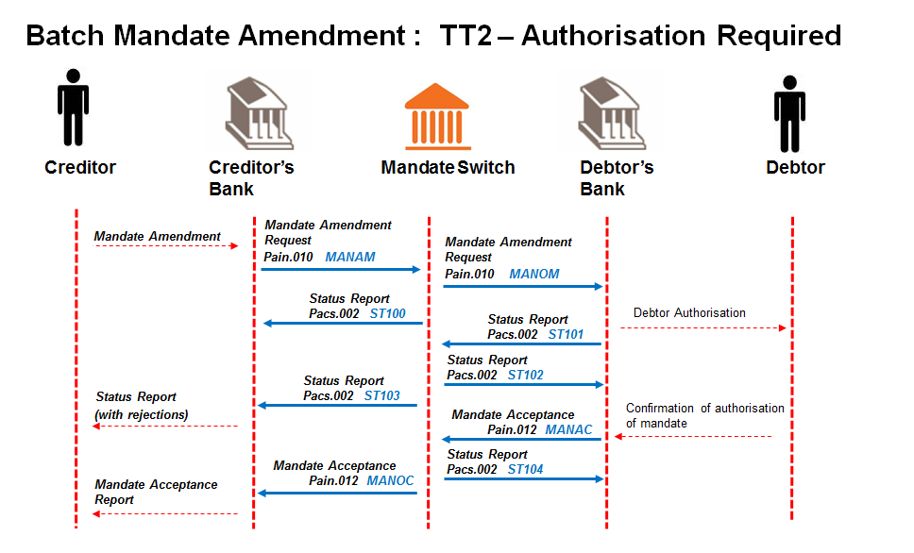

* + 1. **Creditor sends mandate amendment requests to Creditor Bank; containing the unique mandate reference numbers of the mandates that it needs to amend.**

Message format to be determined by the Creditor Bank, but message sent to Creditor Bank must contain all the data elements needed to create the mandate amendment requests (pain.010). Must indicate that Authorisation is required

* + 1. **The Creditor Bank sends mandate amendment requests** (pain.010) **to ACH.**

Creditor bank validates the Creditor and confirms that he is in good standing and submits amendment requests to the ACH.

* + 1. **ACH validates the mandate amendment requests and sends status report** (pacs.002) **to Creditor Bank.**
    2. **The ACH validates the mandate amendment requests** (pain.010) **and forwards it to the Debtor Bank.**
    3. **The Debtor Bank sends a status report (with upfront rejections and amendments requiring authorisation)** (pacs.002) **to ACH.**
    4. **ACH sends this status report** (pacs.002) **to Creditor Bank.**
    5. **ACH replies with status report (**pacs.002**) to Debtor Bank.**
    6. **The Debtor Bank validates and processes the mandate amendment requests.**

The Debtor Bank compares the mandate information stored in the mandate register with the corresponding unique mandate reference numbers.

As well as a notification of all mandate reference numbers that do not match the original request as per the mandate register.

* + 1. **The successful and unsuccessful amendments to mandates are then submitted to the ACH as part of the mandate acceptance report** (pain.012)**.**

Re-authorisation is required from the Debtor depending on the data element to be amended as part of the Debtor’s mandate authorised (refer to Appendix DD).

The rules per Batch Use Case (TT2) defined for AC will apply

The Debtor Bank would update all successful amendment requests in the mandate register and the change would be noted as part of the audit log.

* + 1. **ACH replies with status report (**pacs.002**) to Debtor Bank.**
    2. **ACH forwards mandate acceptance report** (pain.012) **to Creditor Bank.**
    3. **Creditor Bank engages with Creditor.**

Message format of mandate response to Creditor to be determined by the Creditor Bank.

** Status Reports will be sent by the ACH to Creditor and Debtor Banks in the case of Batch Amendments. Debtor Bank will also make use of Status Reports for upfront validation in the case of Batch Amendments.

**IMPORTANT NOTE:** The Mandatory and Optional fields for the Amendment Request are in the ISO20022 message layouts in Section 12 below.

Amendments requiring authorisation and upfront rejections will be returned in the pacs.002 message status report ST101.

**Amendment Rule:** Only elements that have changed need be included in mandate amendment requests.

**Suspension Rule**: Any Suspended Mandate requires re-authorisation prior to being set Active again.

**Additional Clarification Notes**

*The following additional batch amendment scenarios have been identified:*

1. Batch Mandate Transfer

This scenario typically occurs when a Creditor Loan Book is purchased by another Creditor.

The re-authentication process would not have to be repeated by the new Creditor for the existing Debtor mandates.

2. Change of Creditor Bank

This scenario typically occurs when the Creditor Bank name and/or bank account details changes.

The re-authentication process would not have to be repeated by the new Creditor for the existing Debtor mandates.

The transfer is completed through a process between the new Creditor Bank, the ACH and the respective Debtor Banks.

3. Change of System Operator

This scenario typically occurs when the Creditor nominates a new System Operator to submit Payment Instructions to its Creditor Bank.

Where the change of System Operator / third party payment provider results in a change of Creditor Bank then the process as detailed in the “Change of Creditor Bank” scenario is to be followed.

N.B the mandates register will need to be updated via an amendment message but no re-authorisation is required from Debtor

## Cancellation of a Mandate

**Description -** This scenario captures the process where changes in the contractual relationship between the User and the Payer could require the cancellation of the electronic mandate stored in the mandate register prior to maturity.

**Business scenario applicable –** The User no longer needs to collect payments from the Payer for the remainder of their original mandated period; OR: The User and Payer come to a mutual agreement to no longer proceed with a particular service being provided.

**IMPORTANT NOTE:** Cancellation of mandates could be done in Real Time or Batch dependant on the Creditor. Cancellations of mandates are only applicable for transactions prior to settlement or that are already in tracking. This must be effective before the start of the next day’s tracking requests.

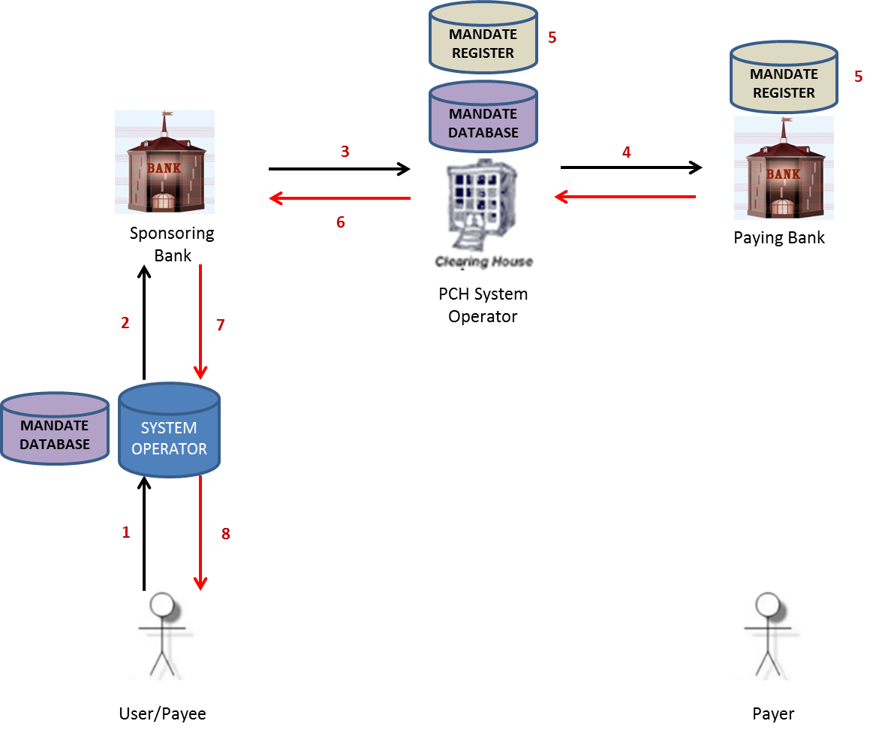

**Mandate Cancellation (Real Time):**

**Technical Requirements:**

* Online delivery mechanisms

The following delivery mechanisms will be available for online delivery of ISO 20022 messages between participants and the ACH:

* MQ (set as sync)
* Web services https
* TCP/IP

**Messages used**:

* Mandate Cancellation Request (pain.011)
* Mandate Acceptance Report (pain.012)
* Status Report (pacs.002) for Mandate Messages

**Processing Windows:**

| Message | Service Code | Originating | Receiving | Start Time | End Time | Extra |
| --- | --- | --- | --- | --- | --- | --- |
| **Pain.011** | MANCN | Creditor Bank | ACH | 03:00 | 21:00 |  |
| **Pain.011** | MANCN | ACH | Debtor Bank | 03:00 | 21:00 |  |
|  |  |  |  |  |  |  |
| **Pain.012** | MANIR | Debtor Bank | ACH | 03:00 | 21:00 |  |
| **Pain.012** | MANIR | ACH | Creditor Bank | 03:00 | 21:00 |  |
|  |  |  |  |  |  |  |
| **Pacs.002** | STMVF | ACH | Creditor Bank | 03:00 | 21:00 |  |
| **Pacs.002** | STAVF | ACH | Debtor Bank | 03:00 | 21:00 |  |
|  |  |  |  |  |  |  |
| **Pacs.002** | STMDF | Debtor Bank | ACH | 03:00 | 21:00 |  |
| **Pacs.002** | STMDF | ACH | Creditor Bank | 03:00 | 21:00 |  |

**Real-time Timout Sessings**

The following time-out settings shall apply to the sets of real-time message flows for the initiating, receiving and responding parties and the ACH. A set of message flows is defined as the pair of messages that make up the initial request and immediate relevant response.

|  |  |  |  |  |  |  |
| --- | --- | --- | --- | --- | --- | --- |
| **Real-time Mandate Cancellation** | |  |  |  |  |  |
|  | | | **Time Out Setting (s)** | | | **Note** |
| **Debtor Authorization Required Code** | **Initiating Service** | **Response Service** | **Initiation Party** | **Receiving and Responding Party** | **ACH** |
| N/A | MANCN | MANIR | 60 | 50 | 140 | The debtor bank must send back the pacs.002 response within 50s. |
| N/A | MANCN | STMVF | 60 | 50 | N/A | ACH is the receiving and responding party in this flow and must send the pacs.002 response within 50s. |
| N/A | MANCN | STMDF | 60 | 50 | 140 | The debtor bank must send back the pacs.002 response within 50s. |

**Mandate Cancellation Process (Real Time):**

* + 1. 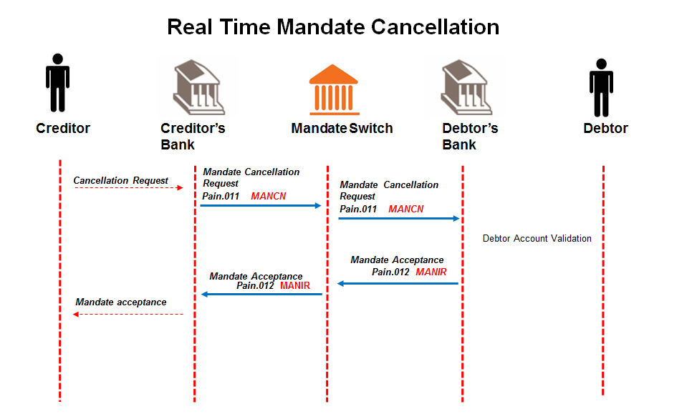**Creditor sends mandate cancellation request** **to Creditor Bank; containing the unique mandate reference number of the mandate that it needs to cancel.**

Message format to be determined by the Creditor Bank, but message sent to Creditor Bank must contain all the data elements needed to create the mandate initiation request (pain.011).

* + 1. **The Creditor Bank sends mandate cancellation request** (pain.011) **to ACH.**

Creditor bank validates the Creditor and confirms that he is in good standing and submits cancellation request to the ACH.

* + 1. **The ACH validates the mandate cancellation request** (pain.011) **and forwards it to the Debtor Bank.**
    2. **The Debtor Bank validates and processes the mandate cancellation request** (pain.011)**.**

The Debtor Bank compares the mandate information stored with the corresponding unique mandate reference number, and updates the Mandate Register accordingly.

* + 1. **The Debtor Bank submits the Mandate acceptance report** (pain.012) **to the ACH.**

This will advise the successful and unsuccessful status of the mandate cancellation request.

* + 1. **The Debtor Bank engages with the Payer.**

Message format of the notification for mandate cancellation to Payer to be determined by the Debtor Bank.

* + 1. **ACH forwards mandate acceptance report** (pain.012) **to Creditor Bank.**
    2. **The Creditor Bank engages with the Creditor.**

Message format of the mandate cancellation response to Creditor to be determined by the Creditor Bank.

**Mandate Cancellation (Batch):**

**Technical Requirements:**

The following data delivery mechanisms will be available for the delivery of ISO 20022 messages in Batch between participants and the ACH:

* ConnectDirect;
* XCOM;
* Web-based https (secure FTP) upload via extranet over dedicated connections; and
* SWIFTNet FileAct.

gzip is to be used for file compression & decompression

**Messages used**:

* Mandate Cancellation Request (pain.011)
* Mandate Acceptance Report (pain.012)
* Status Report (pacs.002) for Mandate Messages

**Processing Windows:**

| Message | Service Code | Originating | Receiving | Start Time | End Time | Extra |
| --- | --- | --- | --- | --- | --- | --- |
| **Pain.011** | MANCN | Creditor Bank | ACH | 03:00 | 20:00 |  |
| **Pain.011** | MANCO | ACH | Debtor Bank | 03:00 | 20:30 |  |
|  |  |  |  |  |  |  |
| **Pain.012** | MANAC | Debtor Bank | ACH | 03:00 | 21:00 |  |
| **Pain.012** | MANOC | ACH | Creditor Bank | 03:00 | 21:30 |  |
|  |  |  |  |  |  |  |
| **Pacs.002** | ST101 | Debtor Bank | ACH | 03:00 | 21:00 |  |
| **Pacs.002** | ST103 | ACH | Creditor Bank | 03:00 | 21:30 |  |
|  |  |  |  |  |  |  |
| **Pacs.002** | ST100 | ACH | Creditor Bank | 03:00 | 20:30 |  |
| **Pacs.002** | ST102 | ACH | Debtor Bank | 03:00 | 21:30 |  |
| **Pacs.002** | ST104 | ACH | Debtor Bank | 03:00 | 21:30 |  |
|  |  |  |  |  |  |  |

**Mandate Cancellation Process (Batch):**

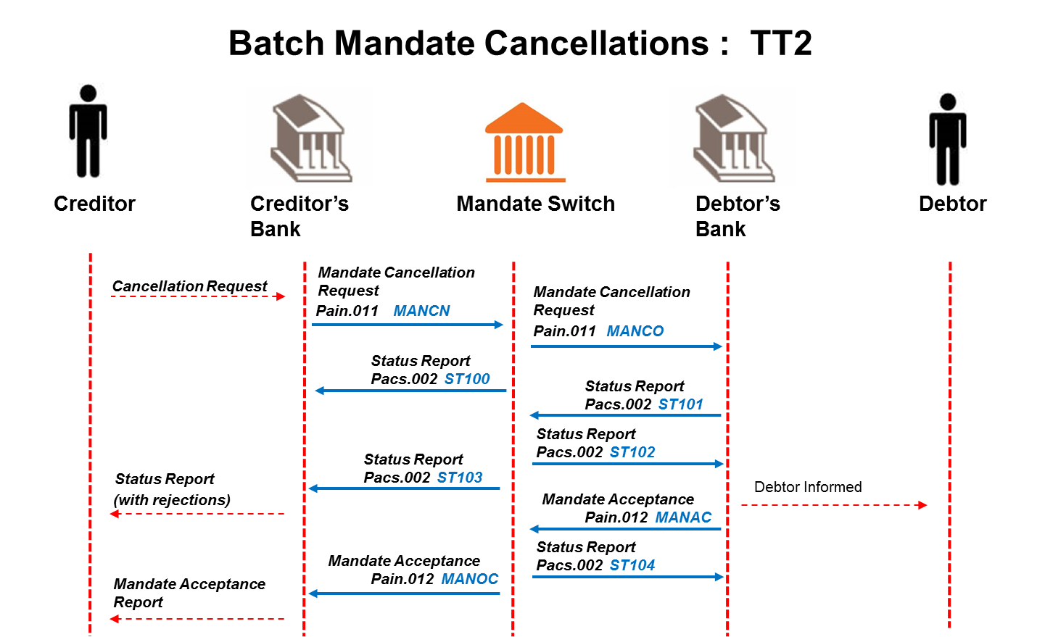

* + 1. **Creditor sends mandate cancellation requests to Creditor Bank; containing the unique mandate reference numbers of the mandates that it needs to cancel.**

Message format to be determined by the Creditor Bank, but messages sent to Creditor Bank must contain all the data elements needed to create the mandate initiation requests (pain.011).

* + 1. **The Creditor Bank sends mandate cancellation requests** (pain.011) **to ACH.**

Creditor bank validates the Creditor and confirms that he is in good standing and submits cancellation requests to the ACH.

* + 1. **ACH validates requests and sends status report** (pacs.002) **to Creditor Bank.**
    2. **The ACH forwards the mandate cancellation requests** (pain.011) **to the Debtor Bank.**
    3. **The Debtor Bank validates and processes the mandate cancellation requests** (pain.011)**.**

The Debtor Bank compares the mandate information stored with the corresponding unique mandate reference number, and updates the Mandate Register accordingly.

* + 1. **The Debtor Bank submits the Mandate acceptance report** (pain.012)to the ACH.

This is to advise on the successful and unsuccessful status of the mandate cancellation request.

* + 1. **The Debtor Bank engages with the Payer.**

Message format of the notification for mandate cancellation to Payer to be determined by the Debtor Bank.

* + 1. **ACH replies with status report (****pacs.002****) to Debtor Bank.**
    2. **ACH forwards mandate acceptance report** (pain.012) **to Creditor Bank.**
    3. **The Creditor Bank engages with the Creditor.**

Message format of the mandate cancellation response to Creditor to be determined by the Creditor Bank.

**IMPORTANT NOTE:** The Mandatory and Optional fields for the Cancellation Request are in the ISO20022 layouts in Section 12 below

## Suspension of Mandate

Debtors instruct Debtor Bank to stop future debit instructions (i.e. suspend the mandate)

These requests with one or more request transactions containing the unique mandate reference number/s of the mandate/s are forwarded to Creditor Banks for resolution by the Creditor.

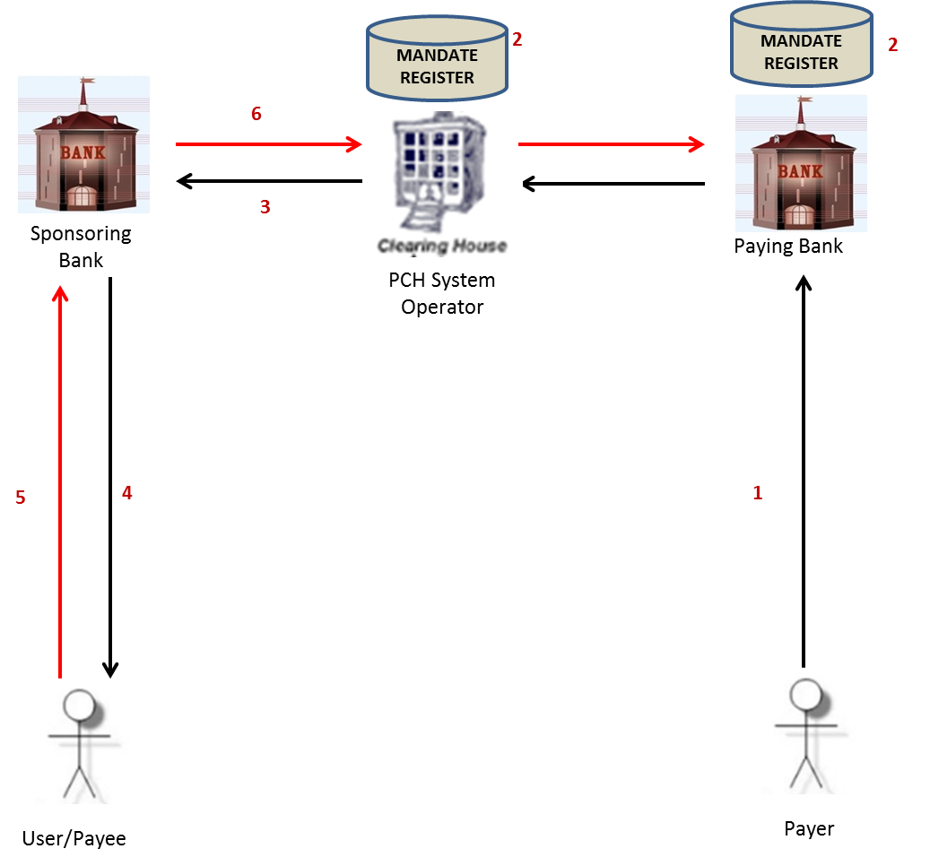

**Note:**

The Mandate Suspension (camt.055) messages will only be sent in batch as and when the banks are ready

Mandate Information must automatically be suspended by the Paying Bank no later than 8:00 am on the next Processing Day.

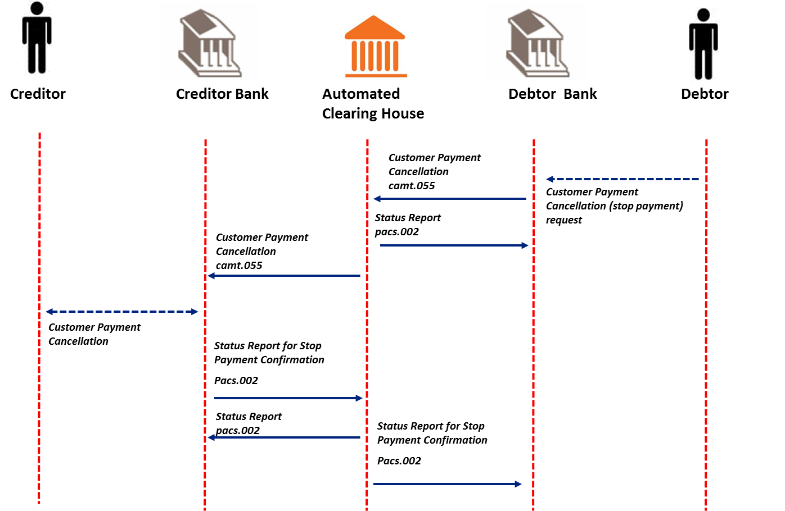

**Technical Requirements:**

The following data delivery mechanisms will be available for the delivery of ISO 20022 messages in Batch between participants and the ACH:

* ConnectDirect;
* XCOM;
* Web-based https (secure FTP) upload via extranet over dedicated connections; and
* SWIFTNet FileAct.

gzip is to be used for file compression & decompression

**Messages used**:

* Customer Payment Cancellation Request (camt.055) (instruction to Suspend Mandate)
* Status Report **(**pacs.002**)**
* Status Report for Mandate Suspension Confirmations **(**pacs.002**)**

**Processing Windows:**

**Suspension of Mandate**

|  |  |  |  |  |  |  |
| --- | --- | --- | --- | --- | --- | --- |
| Message | Service Code | Originating | Receiving | Start Time | End Time | Extra |
| **Camt.055** | SPINP | Debtor Bank | ACH | 08:00 | 16:00 |  |
| **Camt.055** | SPOUT | ACH | Creditor Bank | 08:00 | 17:00 |  |
|  |  |  |  |  |  |  |
| **Pacs.002** | SRINP | Creditor Bank | ACH | 08:00 | 18:00 |  |
| **Pacs.002** | SROUT | ACH | Debtor Bank | 08:00 | 19:00 |  |
|  |  |  |  |  |  |  |
| **Pacs.002** | ST007 | ACH | Creditor Bank | 08:00 | 18:30 |  |
| **Pacs.002** | ST008 | ACH | Debtor Bank | 08:00 | 16:30 |  |
|  |  |  |  |  |  |  |

**Note: -** Mandates process 7 days a week

Direct Debit Mandate Suspension Process

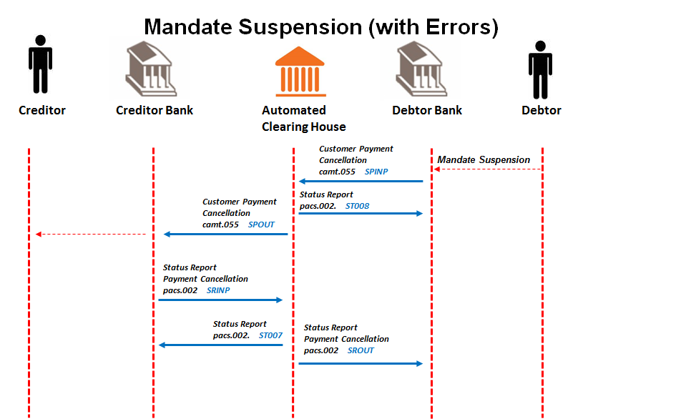

* + 1. Debtor requests customer mandate suspension (camt.055) at Debtor Bank

Debtor stops future direct debit instructions to account at Debtor Bank.

* + 1. Debtor Bank sends customer mandate suspension (camt.055) to ACH

Debtor Bank sends notification to stop all future Payment Instructions to the ACH. The mandate is suspended by the Debtor Bank indefinitely and no future collections will be processed by the Debtor Bank; unless suspension to mandate is lifted.

* + 1. ACH sends status reports (pacs.002) to Debtor Bank

The ACH validates request to suspend mandate messages.

Validation results are reported to Debtor Banks in status report messages.

* Files that fail validation are reported in in status report messages (pacs.002) with a service identification code.
* Request to modify payment messages which fail validation are reported) in status report messages (pacs.002) with a service identification code.
  + 1. ACH sends customer mandate suspension (camt.055) to Creditor Bank

The ACH sends Mandate Suspension notification messages to Creditor Bank for all Payment Instructions.

* + 1. Creditor Bank presents mandate suspension to Creditor.

If the notification is to stop all payments, the mandate is suspended on the mandate database

* + 1. Creditor Bank sends confirmation of Mandate Suspension (pacs.002) to ACH
    2. ACH forwards confirmation of Mandate Suspension (pacs.002) to Debtor Bank
    3. Creditor investigates customer payment cancellation request (Mandate Suspension)

**IMPORTANT NOTE:** After an investigation has taken place; the Creditor will send an amendment message for re-authorisation by the Debtor or a cancellation message of the mandate

Mandate suspension by Debtor will be best effort in stopping current payment instruction

**Additional Clarification Note:**

“The ability to stop a payment is the legal right that a payer has.

The right to suspend mandates apply to either single or multiple future dated payment instruction Payment Instructions.

In AC, Mandate Suspensions must result in a notification to the Creditor Bank and ultimately the Creditor.

If additional business processes are included before a Mandate Suspension is affected, these need to be clearly stated in the Terms of Conditions to the Creditor, in plain language, understandable to the payer. ”

SteerCo Resolution: Mandate Suspensions are allowed on all future transactions, if the customer claims contract expired or cancelled then future payments can be stopped.

## Request for Mandate Information

**Description:** This scenario captures the process whereby the Creditor wants to verify the mandate information that is stored on the Mandate Register. The originator of the Mandate needs to initiate the Request for Mandate Information.

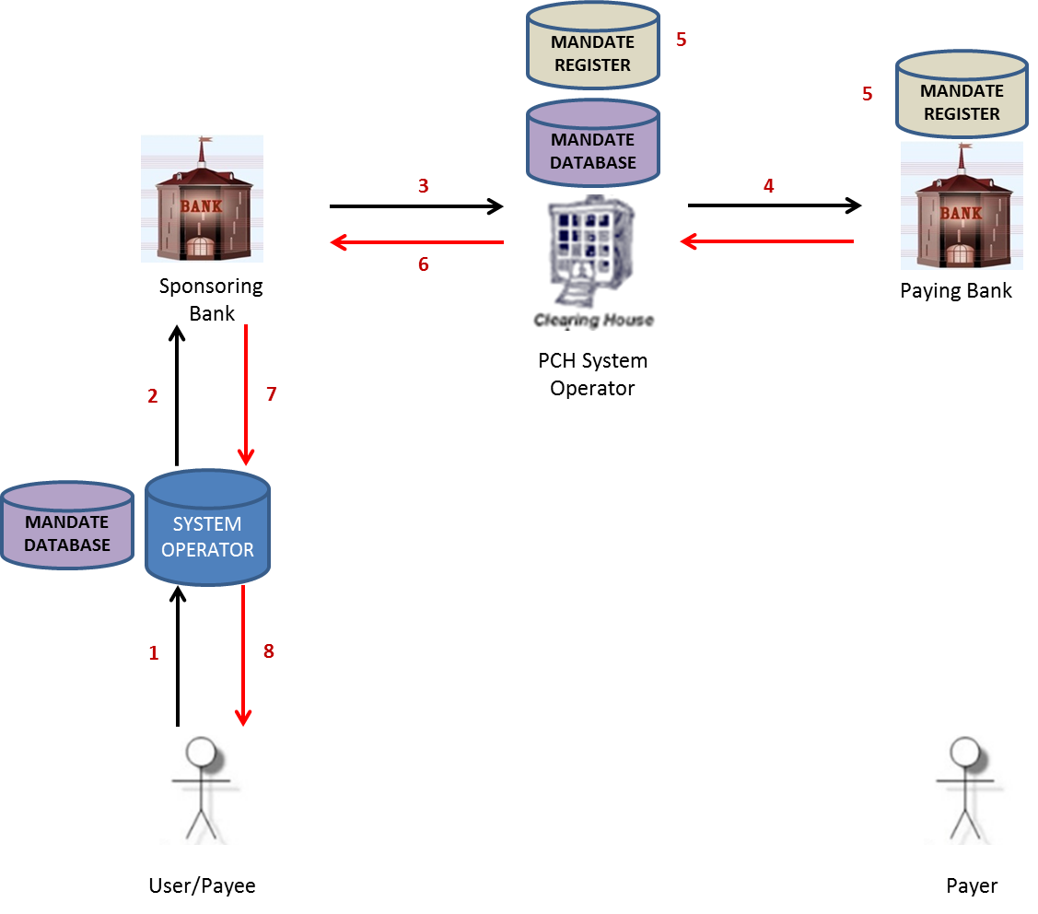

**Note:** - Will contain Mandates as identified by the Mandate Reference Number with status of Active, Cancelled and Suspended. Any mandates with a Pending or Rejected status will not be returned to the creditor bank as the set will be marked as not found.

**Technical Requirements:**

The following data delivery mechanisms will be available for the delivery of ISO 20022 messages in Batch between participants and the ACH:

* ConnectDirect;
* XCOM;
* Web-based https (secure FTP) upload via extranet over dedicated connections; and
* SWIFTNet FileAct.

gzip is to be used for file compression & decompression

**Messages used:**

* Mandate Information Request (mdte.001)
* Mandate Information Response (mdte.002)
* Status Report (pacs.002) for Mandate Messages

**Processing Windows:**

| Message | Service Code | Originating | Receiving | Start Time | End Time | Extra |
| --- | --- | --- | --- | --- | --- | --- |
| **mdte.001** | MANRI | Creditor Bank | ACH | 08:00 | 18:00 | Day 0 |
| **mdte.001** | MANRO | ACH | Debtor Bank | 08:00 | 19:00 | Day 0 |
|  |  |  |  |  |  |  |
| **mdte.002** | MANRT | Debtor Bank | ACH | 08:00 | 18:00 | Latest Day 1 |
| **mdte.002** | MANRF | ACH | Creditor Bank | 08:00 | 19:00 | Latest Day 1 |
|  |  |  |  |  |  |  |
| **Pacs.002** | ST105 | ACH | Creditor Bank | 08:00 | 18:30 | Day 0 |
| **Pacs.002** | ST106 | ACH | Debtor Bank | 08:00 | 18:30 | Latest Day 1 |
|  |  |  |  |  |  |  |

**Request for Mandate Information Process (N.B is a Batch process):**

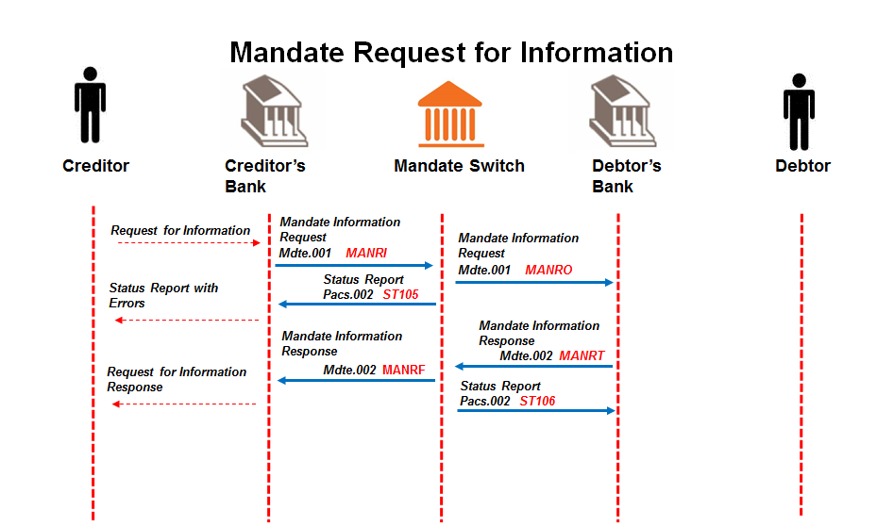

* + 1. **The Creditor creates a batch mandate information request** **with one or more request transactions containing the unique mandate reference number/s of the mandate/s that it needs to confirm the information of, and sends it to the Creditor Bank.**

Message format to be determined by the Creditor Bank, but messages sent to Creditor Bank must contain all the data elements needed to create the mandate initiation requests (mdte.001).

* + 1. **The Creditor Bank forwards the batched mandate information request** (mdte.001) **to the ACH.**

Creditor bank validates the Creditor and confirms that he is in good standing and submits batched mandate information request to the ACH.

* + 1. **The ACH validates the batched mandate information request** (mdte.001) **and sends status report (**pacs.002**)** **to the Creditor Bank.**
    2. **ACH sends valid batch mandate information request** (mdte.001) **to the Debtor Bank.**
    3. **The Debtor Bank validates and processes the batched mandate information request** (mdte.001)**.**

The Debtor Bank compares the mandate information stored in the mandate register with the corresponding unique mandate reference numbers, as well as a notification of all mandate reference numbers that do not match the original request as per the mandate register. All necessary information will be included in the response message.

* + 1. **The Debtor Bank submits the mandate information response** (mdte.002) **to the ACH.**
    2. **ACH replies with status report (**pacs.002**) to Debtor Bank.**
    3. **ACH forwards mandate information response** (mdte.002) **to Creditor Bank.**
    4. **The Creditor Bank engages with the Creditor.**

Message format of the request for information responses to Creditor to be determined by the Creditor Bank.

**IMPORTANT NOTE:** at a minimum the Creditor would be allowed to request information on any mandate that was initially sent in the mandate initiation request (pain.009) and registered at the Debtor Bank

These mandatory fields are listed in Appendix.

The Debtor Bank would need to at least validate the Creditor identification (Creditor Abbreviated Short Name) as an initial file validation to be allowed to provide this information.

Response to Request for Information (mdte.002) can be returned by Debtor Bank on Day 0, but must be returned by end of Day 1.

Any mandates with a Pending or Rejected status will not be returned to the creditor bank as these will be marked as not found.

## Mark-Off File

**Description:** In order to assist with keeping the mandate data base at the Creditor and Debtor Bank in sync debtor banks must resubmit all pain.012 responces that were sent the previous day.

* + 1. Contextual Diagram:

The following describes the high level business process flow for the mark-off file.

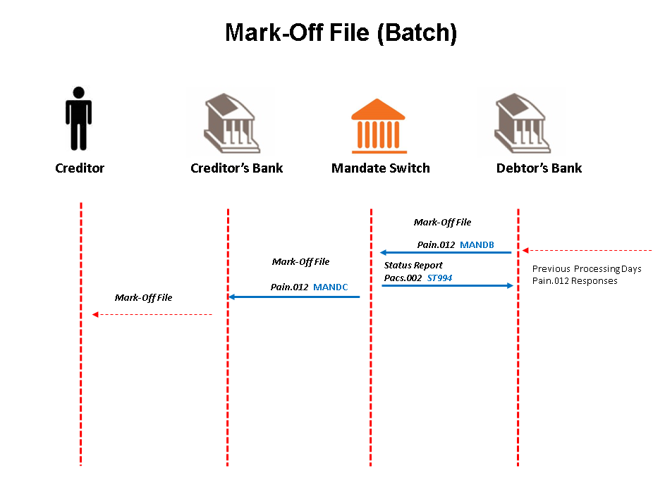

**Use Case 1: Debtor Bank Submits Mark-Off File to ACH:**

User case 1 describes process and requirements for the debtor bank to submit the mark-off file to the ACH.

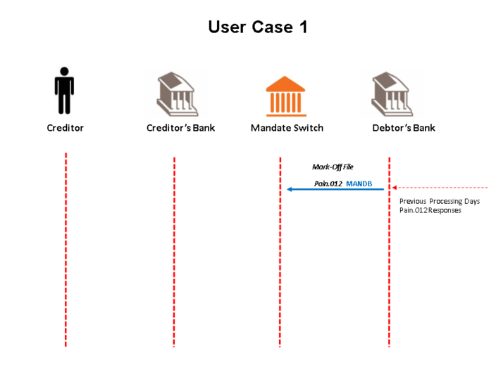

**Use Case 1: Related Functional requirements**

The following requirements relate to use case as defined in business process flow above.

|  |  |  |  |
| --- | --- | --- | --- |
| **FR #** | **Function Requirement Description** | **Actors** | **FR Business Rules** |
| ACMARK_REQ01 | The mark-off file layout shall be based on the current pain.012 file layout. File layout to be provided in the TRS. | Debtor Bank |  |
| ACMARK_REQ02 | The sub services name for the mark-off file shall be MANDB. | Debtor Bank |  |
| ACMARK_REQ03 | Transaction details for Pain.012s generated for the previous processing day shall be included in the mark-off file. | Debtor Bank |  |
| ACMARK_REQ04 | Only transaction details with Transmission Number 1 shall be included in the file. | Debtor Bank |  |
| ACMARK_REQ05 | Pain.012s for all following business processes shall be included in the mark-off file:  - Real-time and **NONE** migrated batch responses to mandate initiation requests.  - Real-time and batch responses to mandate amendment requests.  - Real-time and batch responses to mandate cancellation requests. | Debtor Bank |  |
| ACMARK_REQ06 | All transactional information provided in the mark-off file shall as per the original generated Pain.012. | Debtor Bank |  |
| ACMARK_REQ07 | The header information provided in the mark-off file shall be as specified in the TRS in MyStandards. | Debtor Bank |  |
| ACMARK_REQ08 | The maximum number of transaction records allowed per mark-off file is 20000. | Debtor Bank |  |
| ACMARK_REQ09 | The mark-off file shall contain only responses to interbank requests. | Debtor Bank |  |
| ACMARK_REQ10 | In the case where no pain.012 transactions were generated for the previous day then no file shall be send. | Debtor Bank |  |

**Use Case 2: ACH Validates Mark-Off File**

Use case 2 describes the process of the mark-off file validation at the ACH.

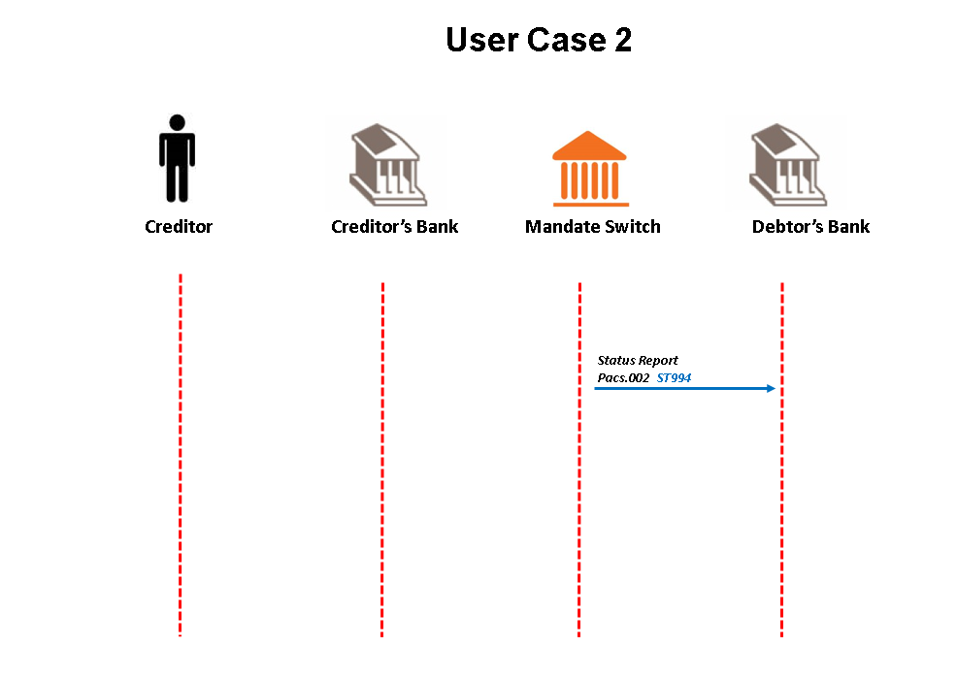

**Use Case 2: Related Functional requirements**

The following requirements relate to use case as defined in business process flow above.

|  |  |  |  |
| --- | --- | --- | --- |
| **FR #** | **Function Requirement Description** | **Actors** | **FR Business Rules** |
| ACMARK_REQ11 | Upon receipt of the mark-off file the ACH shall validate the group header information and Creditor Branch Number provided in the file. | ACH | Refer to the latest TRS in MyStandards |
| ACMARK_REQ12 | Should any information provided fail according to validation rules the ACH shall reject the file and return the relevant information to the debtor bank in a status report. | ACH |  |
| ACMARK_REQ13 | The status report file layout shall use the current layout for the ST104 subservice. Refer to TRS in MyStandards for details. | ACH |  |
| ACMARK_REQ14 | The status report shall have the subservice name ST994. | ACH |  |
| ACMARK_REQ15 | The debtor bank shall be able to receive the ST994 file. Note how the debtor bank consumes and processes the file further it up to them. | Debtor bank |  |

**Use Case 3: ACH Forwards the Mark-Off File to the Creditor Bank**

Use case 3 describes the process of the ACH forwarding the mark-off file to the creditor bank.

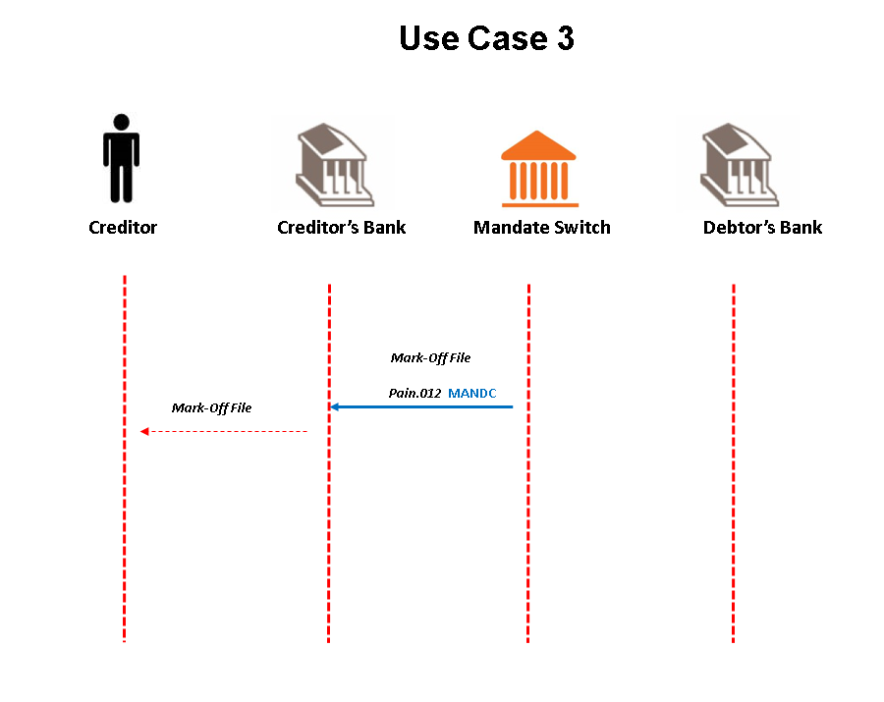

**Use Case 2: Related Functional requirements**

The following requirements relate to use case as defined in business process flow above.

|  |  |  |  |
| --- | --- | --- | --- |
| **FR #** | **Function Requirement Description** | **Actors** | **FR Business Rules** |
| ACMARK_REQ16 | The ACH shall batch all transactions together for a specific Creditor Bank and send it to the Creditor Bank in a mark-off file. | ACH |  |
| ACMARK_REQ17 | The mark-off file layout shall be based on the current pain.012 file layout. File layout to be provided in the TRS. | ACH |  |
| ACMARK_REQ18 | The sub services name for the mark-off file shall be MANDC. | ACH |  |
| ACMARK_REQ19 | The maximum number of transaction records per mark-off file shall be 20000. Creditor banks may request the ACH to reduce this amount. | ACH |  |
| ACMARK_REQ20 | The creditor banks shall be able to receive the file. Note it is up to the Creditor Bank to decide on how to consume and process the file further. | Creditor Bank |  |

**Generic Functional Requirements**

The following generic requirements have been defined.

|  |  |  |  |
| --- | --- | --- | --- |
| **FR #** | **Function Requirement Description** | **Actors** | **FR Business Rules** |
| ACMARK_REQ21 | All parties shall adhere to the agreed processing window timings. (Refer to Section 6.3 for details) | ALL |  |

**Processing Window Timings:**

The following processing window timings shall be adhered to.

The following window timings shall be as follows for both week days and weekend processing.

| Message | Service Code | Originating | Receiving | Start Time | End Time | Extra |
| --- | --- | --- | --- | --- | --- | --- |
| Pain.012 | MANDB | Debtor | ACH | 03h00 | 9h00 |  |
| Pacs.002 | ST994 | ACH | Debtor | 03h00 | 9h30 |  |
| Pain.012 | MANDC | ACH | Creditor | 03h00 | 10h00 |  |

# Payment

All collections will carry mandate identification information as part of the Payment Instruction. This information includes creditor name, creditor agent(s), the unique mandate reference number and contract reference.

With the introduction of the new ISO 20022 message structure, a single message type will be used for all Direct Debits, with data element content indicating particular Payment Instruction attributes associated with each service type.

**IMPORTANT NOTE:** the AC TRS WG decided that it would not be feasible to use the current 180byte message standard and thus Direct Debit/Payment Instruction (Collection) would use the ISO20022 message layout.

Additional Rules for validations have been added to Appendix D and Appendix G.

**IMPORTANT NOTE:**  the AC Payment Stream value for item limit needs to be parameterized to align to the changing NPS item limits

## Collections

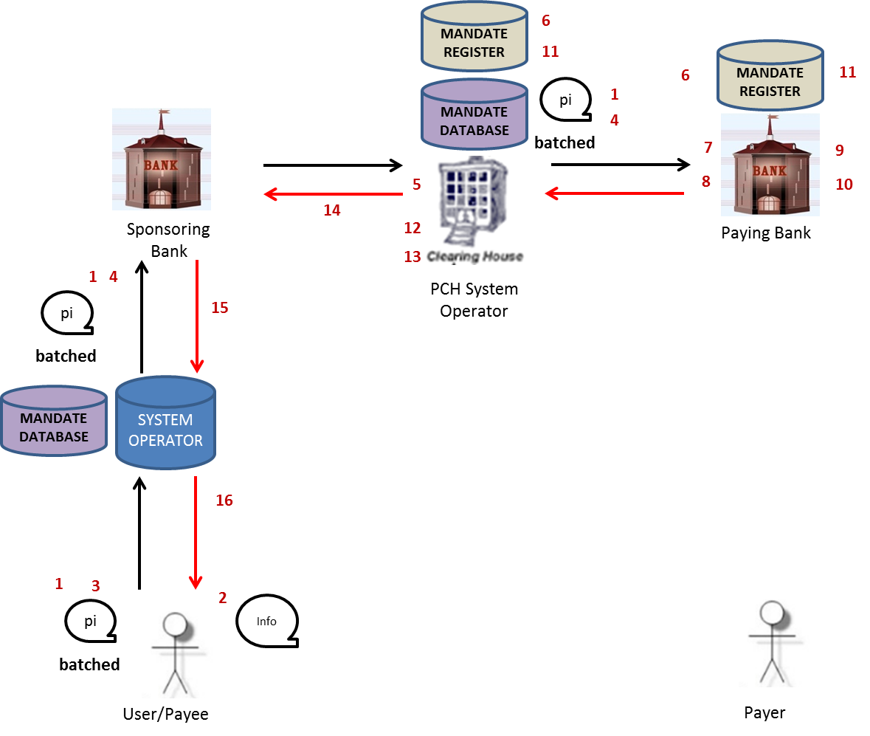

Direct debit requests may originate from the Creditor Bank.

Direct debits requests are sent via the ACH to Debtor Banks, and are ultimately applied to Debtor’s accounts.

Responses to direct debits requests are returned via the ACH to Creditor Banks’.

Successful debits are applied to interbank settlements.

Direct debits may instruct Debtor Banks’ to hold and reapply debit requests to accounts periodically (as indicated in transactions) until successful or until the requested period expires. This is termed “tracking”.

Debtor Banks must randomise on-us and off-us debits as well as debits still in tracking before applying to Debtor accounts.

**Technical Requirements:**

The following data delivery mechanisms will be available for the delivery of ISO 20022 messages in Batch between participants and the ACH:

* ConnectDirect;
* XCOM;
* Web-based https (secure FTP) upload via extranet over dedicated connections; and
* SWIFTNet FileAct.

gzip is to be used for file compression & decompression

**Message Layout used for ISO 20022**:

* Direct Debit (pacs.003)
* Status report (pacs.002) – Pacs Payment Message
* Status report (pacs.002) – Debit Response confirmation

**Processing Windows:**

**Collections – Weekdays**

| Message | Service Code | Originating | Receiving | Start Time | End Time | Extra |
| --- | --- | --- | --- | --- | --- | --- |
| **Pacs.003** | DDINP | Creditor Bank | ACH | 08:00 | 18:00 | Day 0 |
| **Pacs.003** | DDOUT | ACH | Debtor Bank | 08:00 | 19:00 | Day 0 |
|  |  |  |  |  |  |  |
| **Pacs.002** | DRINP | Debtor Bank | ACH | 23:30 | 18:00 | Day 1 |
| **Pacs.002** | DROUT | ACH | Creditor Bank | 23:30 | 19:00 | Day 1 |
|  |  |  |  |  |  |  |
| **Pacs.002** | ST002 | ACH | Creditor Bank | 08:00 | 18:30 | Day 0 |
| **Pacs.002** | ST006 | ACH | Debtor Bank | 23:30 | 18:30 | Day 1 |
|  |  |  |  |  |  |  |

**Collections – Weekends & Public Holidays**

| Message | Service Code | Originating | Receiving | Start Time | End Time | Extra |
| --- | --- | --- | --- | --- | --- | --- |
| **Pacs.003** | DDINP | Creditor Bank | ACH | 08:00 | 13:00 | Day 0 |
| **Pacs.003** | DDOUT | ACH | Debtor Bank | 08:00 | 14:00 | Day 0 |
|  |  |  |  |  |  |  |
| **Pacs.002** | DRINP | Debtor Bank | ACH | 23:30 | 13:00 | Day 1 |
| **Pacs.002** | DROUT | ACH | Creditor Bank | 23:30 | 14:00 | Day 1 |
|  |  |  |  |  |  |  |
| **Pacs.002** | ST002 | ACH | Creditor Bank | 08:00 | 13:30 | Day 0 |
| **Pacs.002** | ST006 | ACH | Debtor Bank | 23:30 | 13:30 | Day 1 |
|  |  |  |  |  |  |  |

**Tracking Response SLAs**

The following requirirements must be applied with regards to the tracking respnce SLAs:

|  |  |
| --- | --- |
| **Reference** | **Business Requirement** |
| FRT_001 | For 0 (Zero) day tracking, Paying banks must respond with final responses by 5AM on the Action Date. Final fate responses e.g. 00, Account closed, successful, insufficient funds must be included in the final response to Sponsoring Banks |
| FRT_002 | In instances of (minimal and full credit) tracking, Paying banks must respond by 5AM on the Action date for first responses e.g. 99, successful, terminal hold on account |
| FRT_003 | For minimal credit tracking, Paying banks must respond with a final response after the SSV Credit run on (i) the last day of credit tracking or (ii) successful presentment, whichever is the earlier e.g., successful, insufficient funds, terminal hold on account |
| FRT_004 | For full credit tracking, Paying banks must track a Payer’s account until the final credit run for a calendar day. Final responses must be sent after the SSV credit run on (i) the last day of credit tracking or (ii) successful presentment, whichever is the earlier e.g., successful, Insufficient funds, terminal hold on account |

**Direct Debits (Collections) Process:**

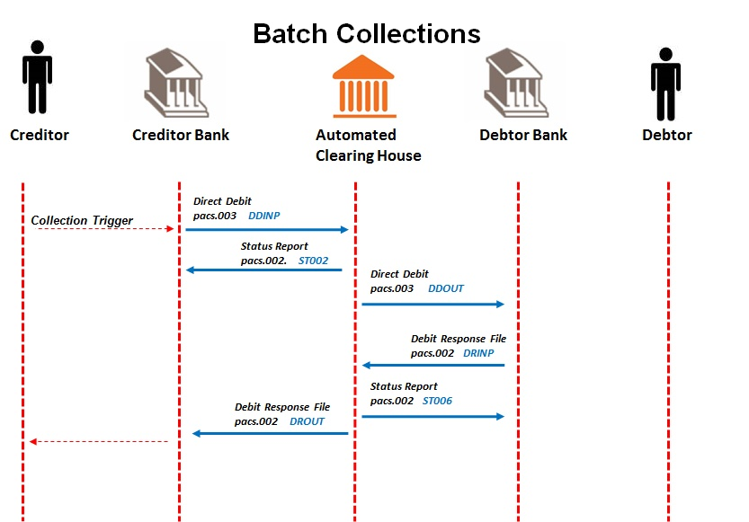

* + 1. Creditor submits direct debit message to Creditor Bank

Message format to be determined by the Creditor Bank, but messages sent to Creditor Bank must contain all the data elements needed to create the mandate initiation requests (pacs.003).

* + 1. Creditor Banks send direct debits (pacs.003) to ACH.

Direct debits must be submitted to the ACH 1 day in Advance.

* + 1. ACH sends status reports ([pacs.002](#Status_Report_Payment_Message)) to Creditor Banks. ([pacs.002](#Status_Report_Payment_Message))
    2. The ACH validates direct debits.

Validation results are reported to Creditor Bank in status report messages.

* Files that fail validation are reported in status report messages (pacs.002) with a service identification code.
* Direct debits which fail validation are reported in status report messages (pacs.002) with a service identification code.
  + 1. ACH sends direct debits (pacs.003) to Debtor Banks.

If the action date is not set to the next day’s processing date, the ACH will reject these direct debits. ACH will send the file with transactions one business day prior to Action date.

Direct debits are posted to Debtor Banks on action date-1 (7 day processing) or action date-n (for 6 day processing and public holidays) as required by banks.

Direct debits delivered to the ACH are posted to Debtor Banks’ as soon as output files/messages match number of transactions specified by banks (ACH will trickle feeds AC transactions) or on time basis (e.g. settlement windows) independent on file size.

* + 1. Debtor Banks send status report for debit responses (pacs.002) to ACH.

Debtor Bank send debit responses in status report messages (pacs.002) with a service identification code to the ACH.

The contents of the response could include positive and/or negative information, including tracking responses.

If original record was in tracking, and a recall is successful, then there will not be a pacs.002 response returned for the pacs.003, but rather a camt.029.

Settlement will be calculated by the ACH on positive responses.

* + 1. ACH sends status reports to Debtor Banks (pacs.002).

The ACH validates debit responses.

Validation results are reported to Debtor Bank in status report messages.

* Files that fail validation are reported in status report messages (pacs.002) with a service identification code.
* Debit responses which fail validation are reported in status report messages (pacs.002) with a service identification code.

Only successful direct debit responses are applied to settlement.

* + 1. ACH sends status reports for debit responses (pacs.002) to Creditor Banks

The ACH sends debit responses in status report messages (pacs.002) with a service identification code.

Tracking responses are reported to Creditor Bank in status report messages (pacs.002) with a service identification code.

* + 1. Creditor Banks engages with Creditor.

Message format of the collection responses to Creditor to be determined by the Creditor Bank.

**IMPORTANT NOTE:** Batched Tracking Responses Final Fate will be part of the Direct Debit responses

**IMPORTANT NOTE:** User is allowed to send through direct debit message on a mandate once it has been authorised by the Debtor.

Direct debit message will be validated against the mandate in place and not on an amendment pending authorisation by Debtor; i.e. the Active mandate will be validated on collection.

First responses are expected back by 05:00 each day

Cycle day must match the collection day, if adjustment date is “N”; action date is the processing date. Cycle Day is taken from Cycle Date (CCYY-MM-DD)

Pending status is used for the transactions "in tracking" (i.e. response code 99) only

Creditor bank can use bank number & abbreviated short name to determine the creditor (no user codes in AC)

**IMPORTANT NOTE:** Paying Bank needs to monitor negative information and report:

* 7 consecutive failed transactions (Unpaids) and suspension of mandate will be triggered and alert to Creditor of suspension of mandate (part of the Debtor Bank rules to adhere to)

---- as agreed at workshop 25/5/2016 to be the most practical way of technically implementing the 4 consecutive payment cycle rule ----

* only 2 presentments per payment cycle for the same Mandate are allowed and will be reported on by Debtor Banks

## Settlement Process

* + 1. Settlement:
* Inter-bank settlement is calculated on successful debits.
* Authenticated Collections will have a service name: “ACSET” and sub-service name: “ACSETTLE”
* Each window totals will balance to files and messages received and processed during that time period
* Settlement reports (SV01/2/3, etc.) will be made available (as per current settlement methods)

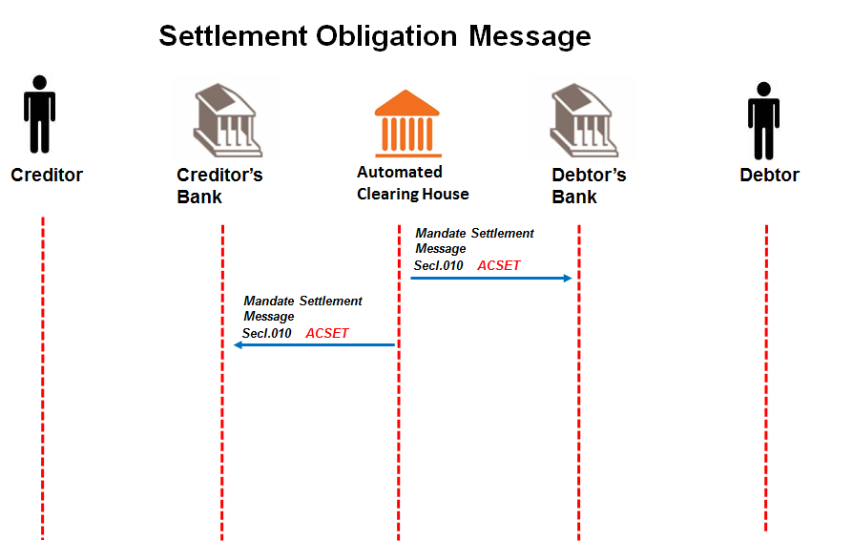

* + 1. Settlement Obligation Reports from Authenticated Collection System

At the end of each settlement window, the Authenticated Collections system sends secl.010 Settlement Obligation Report Messages to each participating bank. This message contains values of settlement instructions that will be passed to settlement accounts nominated at SARB for Authenticated Collections. This message also contains details of values used to calculated banks’ final settlement obligations. The purpose of this message is to allow banks to electronically reconcile successful sent and received collections for a settlement window.

Settlement Instructions and Notifications

BankservAfrica sends MT298 Settlement Instruction Messages to the SARB SAMOS system in order to effect a batch settlement at the close of each settlement window.

BankservAfrica sends each authenticated collections participating bank MT298 Settlement Notification (SN) Messages allowing banks to see their settlement obligation.

Once SAMOS system has processed settlement instructions for a settlement window, MT900 Debit Confirmation messages are sent to paying Banks and MT910 Credit Confirmations are sent to beneficiary Banks. The figures listed in MT900 and MT910 messages can be reconciled to figures sent from BankservAfrica in MT298 Settlement Notification Messages and in secl.010 Settlement Obligation Report Messages.

**Processing Windows:**

Start of Transmission will be sent out at 09:00 on weekdays and Saturdays

End of Transmission will be sent out at 20:00 on weekdays and 14:00 on Saturdays

Settlement records will be created and sent out at the following times:

**Settlement– Weekdays**

| Message | Service Code | Originating | Receiving | Start Time | End Time | Extra |
| --- | --- | --- | --- | --- | --- | --- |
| **The Settlement Messages below will include the settlement totals for Collections processed between 23:30 and 09:00** | | | | | | |
| **Secl.010** | ACSET | ACH | Creditor Bank | 09:00 | 10:00 | Window 1- Settle 10:00 |
| **Secl.010** | ACSET | ACH | Debtor Bank | 09:00 | 10:00 | Window 1- Settle 10:00 |
| **The Settlement Messages below will include the settlement totals for Collections processed between 09:00 and 15:00** | | | | | | |
| **Secl.010** | ACSET | ACH | Creditor Bank | 15:00 | 16:00 | Window 2- Settle 16:00 |
| **Secl.010** | ACSET | ACH | Debtor Bank | 15:00 | 16:00 | Window 2- Settle 16:00 |
| **The Settlement Messages below will include the settlement totals for Collections processed between 15:00 and 18:00** | | | | | | |
| **Secl.010** | ACSET | ACH | Creditor Bank | 18:00 | 21:00 | Window 3- Settle 21:00 |
| **Secl.010** | ACSET | ACH | Debtor Bank | 18:00 | 21:00 | Window 3- Settle 21:00 |
|  | | | | | | |

**Settlement – Saturday**

| Message | Service Code | Originating | Receiving | Start Time | End Time | Extra |
| --- | --- | --- | --- | --- | --- | --- |
| **The Settlement Messages below will include the settlement totals for Collections processed between 23:30 and 08:00** | | | | | | |
| **Secl.010** | ACSET | ACH | Creditor Bank | 08:00 | 09:00 | Window 1- Settle 09:00 |
| **Secl.010** | ACSET | ACH | Debtor Bank | 08:00 | 09:00 | Window 1- Settle 09:00 |
| **The Settlement Messages below will include the settlement totals for Collections processed between 08:00 and 13:00** | | | | | | |
| **Secl.010** | ACSET | ACH | Creditor Bank | 13:00 | 15:00 | Window 2- Settle 15:00 |
| **Secl.010** | ACSET | ACH | Debtor Bank | 13:00 | 15:00 | Window 2- Settle 15:00 |
| **The Settlement Messages below will include the settlement totals for Collections processed between 13:00 and 15:00** | | | | | | |

**Settlement – Sunday and Public Holiday**

| Message | Service Code | Originating | Receiving | Start Time | End Time | Extra |
| --- | --- | --- | --- | --- | --- | --- |
| **Settlement will be accrued into first Settlement window of the next Business Day** | | | | | | |

**Note: –** There is no settlement to SARB on Sundays and Public Holidays. These settlements will be accumulated into the next available settlement to the SARB.

## Cancellations (Recalls)

Cancellations (Recalls) are only applicable for transactions prior to settlement or in Tracking where no final fate has been provided.

Cancellations (Recalls) may be batched for single or multiple transactions.

**Clarification Note:** ACH confirms that any debit payment instructions that are still at the ACH and have not been submitted to the Debtor Bank can be recalled from the ACH (in flight) as per AC process described below.

**Technical Requirements:**

The following data delivery mechanisms will be available for the delivery of ISO 20022 messages in Batch between participants and the ACH:

* ConnectDirect;
* XCOM;
* Web-based https (secure FTP) upload via extranet over dedicated connections; and
* SWIFTNet FileAct.

gzip is to be used for file compression & decompression

**Messages used in ISO 20022 layouts**:

* Payment Cancellation (camt.056)
* Status report (pacs.002)
* Resolution of Investigation (camt.029) – Cancellation response

**Processing Windows:**

**Cancellations / Reversals – Weekdays**

|  |  |  |  |  |  |  |
| --- | --- | --- | --- | --- | --- | --- |
| Message | Service Code | Originating | Receiving | Start Time | End Time | Extra |
| **Camt.056** | CLINP | Creditor Bank | ACH | 08:00 | 16:00 |  |
| **Camt.056** | CLOUT | ACH | Debtor Bank | 08:00 | 17:00 |  |
|  |  |  |  |  |  |  |
| **Camt.029** | RIINP | Debtor Bank | ACH | 08:00 | 18:00 |  |
| **Camt.029** | RIOUT | ACH | Creditor Bank | 08:00 | 19:00 |  |
|  |  |  |  |  |  |  |
| **Pacs.002** | ST004 | ACH | Creditor Bank | 08:00 | 16:30 |  |
| **Pacs.002** | ST009 | ACH | Debtor Bank | 08:00 | 18:30 |  |
|  |  |  |  |  |  |  |

**Cancellations / Reversals – Weekends & Public Holidays**

| Message | Service Code | Originating | Receiving | Start Time | End Time | Extra |
| --- | --- | --- | --- | --- | --- | --- |
| **Camt.056** | CLINP | Creditor Bank | ACH | 08:00 | 10:00 |  |
| **Camt.056** | CLOUT | ACH | Debtor Bank | 08:00 | 11:00 |  |
|  |  |  |  |  |  |  |
| **Camt.029** | RIINP | Debtor Bank | ACH | 08:00 | 12:00 |  |
| **Camt.029** | RIOUT | ACH | Creditor Bank | 08:00 | 13:00 |  |
|  |  |  |  |  |  |  |
| **Pacs.002** | ST004 | ACH | Creditor Bank | 08:00 | 10:30 |  |
| **Pacs.002** | ST009 | ACH | Debtor Bank | 08:00 | 12:30 |  |
|  |  |  |  |  |  |  |

**Direct Debits Cancellation (Recall of Collections) Process:**

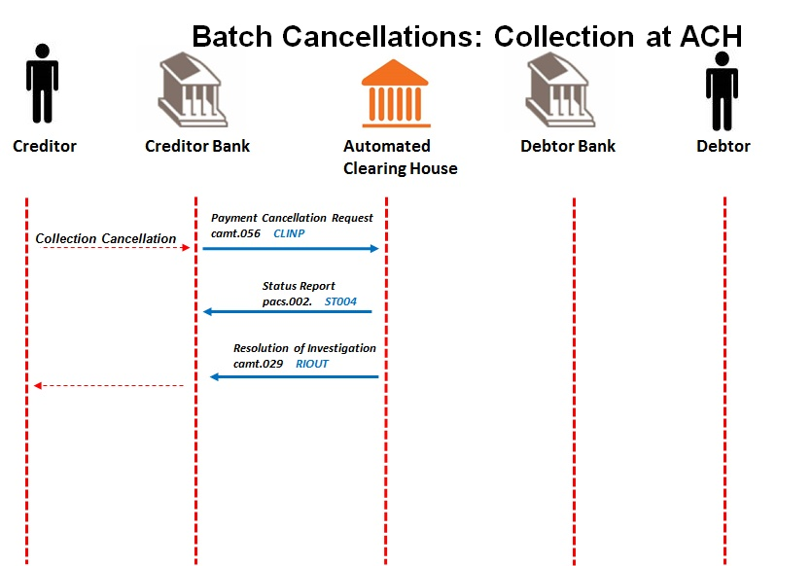

* + 1. Creditor sends direct debit payment cancellation request/s to Creditor Bank.

Message format to be determined by the Creditor Bank, but messages sent to Creditor Bank must contain all the data elements needed to create the mandate initiation requests (camt.056).

* + 1. Creditor sends direct debit payment cancellation request/s (camt.056) to ACH.

Creditor Bank validates the Creditor.

Creditor banks send direct debit payment cancellations to the ACH.

Direct Debit payment cancellation messages may contain cancellations for direct debits for more than one direct debit input message. These cancellation requests (previously known as recalls) could identify individual direct debits transactions.

The mandate reference number for any original direct debit has to also be included as part of the transaction message.

**Direct Debit Payment cancellations requests may be submitted to the ACH at any time after original direct debits have been received.**

* + 1. ACH sends status reports (pacs.002) to Creditor Banks for batch recalls.

The ACH acknowledges receipt of direct debit payment cancellation requests.

The ACH matches cancellations against original direct debit requests.

A separate status message is sent per direct debit input message.

Validation results are reported to Creditor Bank in status report messages.

* Files that fail validation are reported in status report messages (pacs.002) with a service identification code.
* Cancellation messages which fail validation are reported in status report messages (pacs.002) with a service identification code.

* + 1. Direct Debits still at the ACH

The ACH determines if direct debits to be cancelled are still at the ACH or have been dispatched to Debtor Banks.

* + 1. ACH sends resolution of investigation messages (camt.029) to Creditor Bank.

If direct debits are still at the ACH, the ACH terminates further processing of matched direct debits and sends notifications of withdrawn direct debits to Creditor Banks with status code <Sts><Conf> CNCL (Cancellation is Successful) and <TxCxlSts> ACCR (Cancellation is accepted).

If original debit cannot be found, the ACH terminates further processing of matched direct debits and sends notifications of withdrawn direct debits to Creditor Banks with <Sts><Conf> RJCR (Rejected cancellation request) and <TxCxlSts> RJCR (Cancellation request is rejected)

* + 1. Creditor Bank engages with Creditor as per resolution of investigation messages for cancellation request.

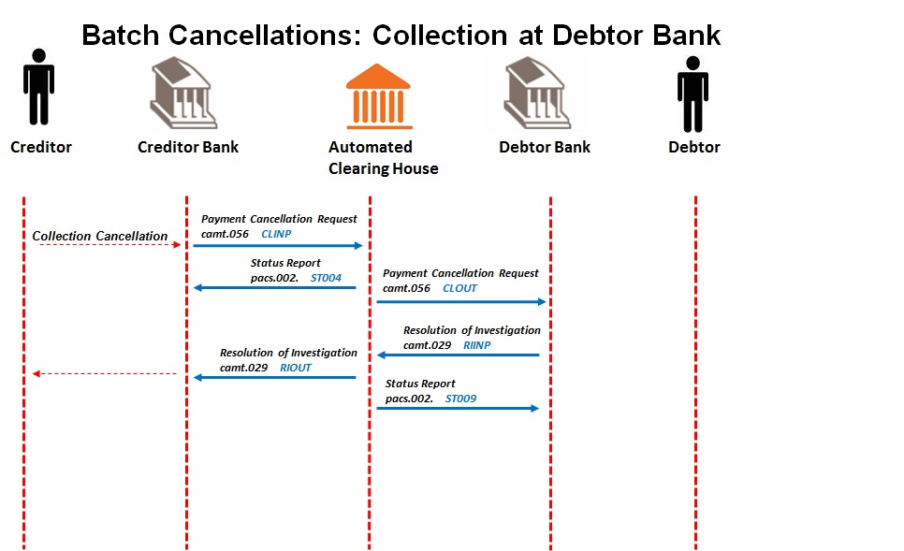

* + 1. Creditor sends direct debit payment cancellation request/s to Creditor Bank.

Message format to be determined by the Creditor Bank, but messages sent to Creditor Bank must contain all the data elements needed to create the mandate initiation requests (camt.056).

* + 1. Creditor sends direct debit payment cancellation request/s (camt.056) to ACH.

Creditor Bank validates the Creditor.

Creditor banks send debit payment cancellations to the ACH.

Debit payment cancellation messages may contain cancellations for direct debits from more than one direct debit input message. These cancellation requests (previously known as recalls) could identify individual debits, or entire batches of debits. When batches of debits are to be cancelled, the ACH uses batch header information to identify original direct debits.

The mandate reference number for any original direct debit has to also be included as part of the transaction message.

**Direct Debit Payment cancellations may be delivered to the ACH at any time after original debits have been received.**

* + 1. ACH sends status reports (pacs.002) to Creditor Banks for batch recalls.

The ACH acknowledges receipt of direct debit payment cancellation requests.

The ACH matches direct debit cancellations against original direct debit batches or direct debit requests.

A separate status message is sent per direct debit input message.

Validation results are reported to Creditor Bank in status report messages.

Files that fail validation are reported in status report messages (pacs.002) with a service identification code.

* Cancellation messages which fail validation are reported in status report messages (pacs.002) with a service identification code.
  + 1. ACH sends direct debit payment cancellations (camt.056) to Debtor Banks

Direct Debit cancellations that were not found in the ACH warehouse are sent to Debtor Banks.

If direct debit cancellation batches are submitted to the ACH, individual debit cancellation requests will be sent to Debtor Banks.

* + 1. Debtor Bank send resolution of investigation messages (camt.029) to ACH

Debtor Bank match direct debit cancellation requests to original direct debit transactions. Matched and unmatched direct debit cancellations are reported in resolution of investigation messages with original transaction details.

**Note**: The Debtor Bank must ensure that the Payment Cancellations (Recalls) are applied prior to processing any Payment Instructions, including those in Credit Tracking by no later than the next Processing Day

* + 1. ACH sends status reports (pacs.002) to Debtor Banks for resolution of investigation in the case of batch recalls

The ACH validates resolution of investigation messages.

Validation results are reported to Debtor Bank in status report messages.

* Files that fail validation are reported in status report messages (pacs.002) with a service identification code.
* Resolution of investigation messages which fail validation are reported in status report messages (pacs.002) with a service identification code.
  + 1. ACH sends resolution of investigation messages (camt.029) to Creditor Bank

The ACH sends resolution of investigation messages to Creditor Bank. If original record was in tracking, and camt.029 is successful, then there will not be a pacs.002 response returned for the pacs.003.

* + 1. Creditor Bank engages with Creditor as per resolution of investigation messages for cancellation request.

# Post Payment (After Clearing and Settlement)

## 8.1 Disputes

Direct debits that have been processed can be disputed by Debtors at the Debtor Bank.

Note: Refer to Rules extract on Disputes in Appendix F, for information.

**IMPORTANT NOTE:** Transactions that are disputed within 40 days of the debit collection processed will be reversed immediately if the dispute is found to be legitimate; and transactions disputed over 40 days of the debit collection processed can have a processing delay of a maximum of 2 days (as per Bank's internal production system OR as per recovering transaction records that have been archived).

**\*\*\*The AC interbank dispute process is a single transaction flow and not categorised in under or over 40 days \*\*\*\***

Note: To determine the legitimacy of a dispute and the reversibility of collection, refer to Rules extract on Disputes in Appendix F,

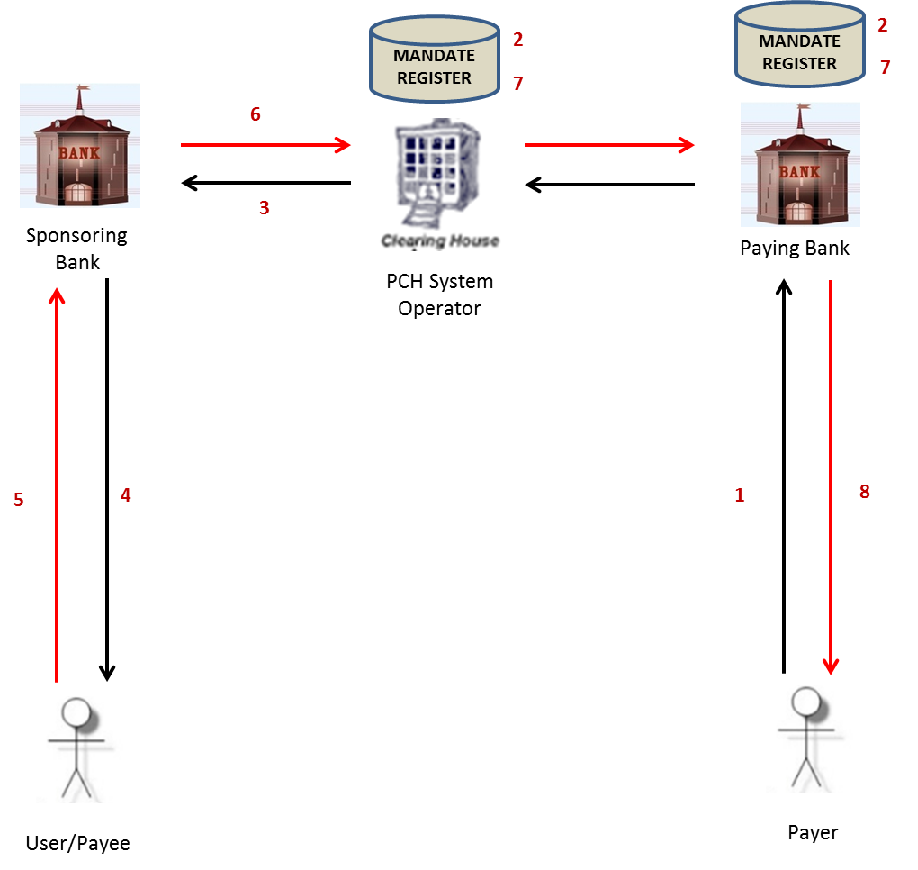

**Technical Requirements:**

The following data delivery mechanisms will be available for the delivery of ISO 20022 messages in Batch between participants and the ACH:

* ConnectDirect;
* XCOM;
* Web-based https (secure FTP) upload via extranet over dedicated connections; and
* SWIFTNet FileAct.

gzip is to be used for file compression & decompression

**Messages used for ISO 20022 layouts**:

* Payment Return (pacs.004)
* Status report (pacs.002)

**Disputes – Weekdays (excluding Public Holidays)**

|  |  |  |  |  |  |  |
| --- | --- | --- | --- | --- | --- | --- |
| Message | Service Code | Originating | Receiving | Start Time | End Time | Extra |
| **Pacs.004** | RTINP | Debtor Bank | ACH | 08:00 | 18:00 |  |
| **Pacs.004** | RTOUT | ACH | Creditor Bank | 08:00 | 19:00 |  |
|  |  |  |  |  |  |  |
| **Pacs.002** | ST003 | ACH | Debtor Bank | 08:00 | 18:30 |  |

**Disputes – Saturdays (excluding Public Holidays)**

|  |  |  |  |  |  |  |
| --- | --- | --- | --- | --- | --- | --- |
| Message | Service Code | Originating | Receiving | Start Time | End Time | Extra |
| **Pacs.004** | RTINP | Debtor Bank | ACH | 08:00 | 13:00 |  |
| **Pacs.004** | RTOUT | ACH | Creditor Bank | 08:00 | 14:00 |  |
|  |  |  |  |  |  |  |
| **Pacs.002** | ST003 | ACH | Debtor Bank | 08:00 | 13:30 |  |

* 1. **Direct Debit Dispute Process:**

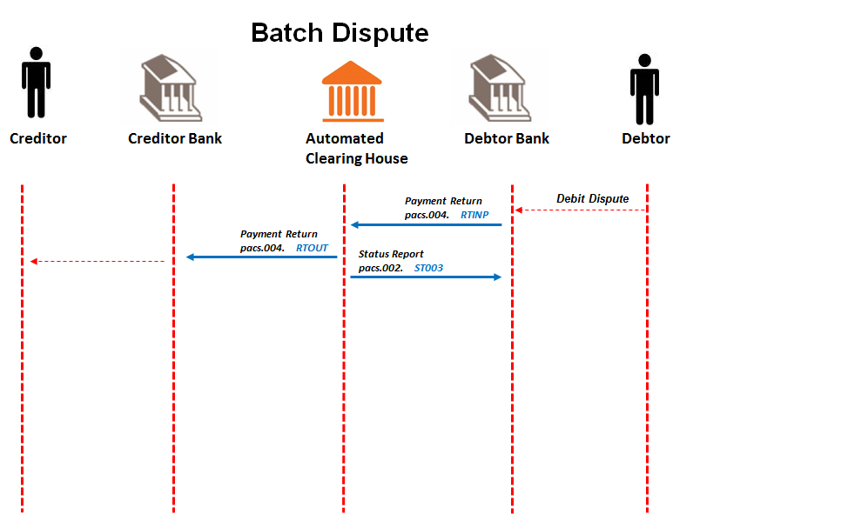

* + 1. Debtor Bank lodges dispute.

Debtor disputes debit that was processed to bank account.

* + 1. Successfully disputed debits result in Debtor Bank generation of payment return message (pacs.004) to ACH.

Debtor Bank posts return payment to relevant Debtor account.

* + 1. ACH sends status report message (pacs.002) to Debtor Bank.

Validation results are reported to Debtor Banks in status report messages.

* Files that fail validation are reported in status report messages (pacs.002) with a service identification code.
* Payment return messages which fail validation are reported in status report messages (pacs.002) with a service identification code.
  + 1. ACH sends payment return message (pacs.004) to Creditor Bank
    2. Creditor Bank engages with Creditor

Creditor Bank will recoup funds as per agreements with Creditor.

# Bank Error

## Cancellations of Direct Debits (Reversals)

Creditor Banks request reversal of direct debits (collections) after settlement date in order to correct Bank Errors.

**\*\*\*\* PASA authorisation is required for this process \*\*\*\***

**This process should be run on an exception ad-hoc basis after PASA authorisation has been obtained, and differs from the normal Cancellation / Recall process in that financial reversals (pacs.004) messages are included. This process can only be used in the event of a Bank Error as identified to PASA.**

**IMPORTANT NOTE:**

Duplicates by the Debtor Banks are an anomaly as well and will be handled as it is currently; participant to load a production incident with PASA and due process followed.

Successful direct debits that are reversed via a bank error, the reversed debit and the reversal must

not allow for a dispute action.

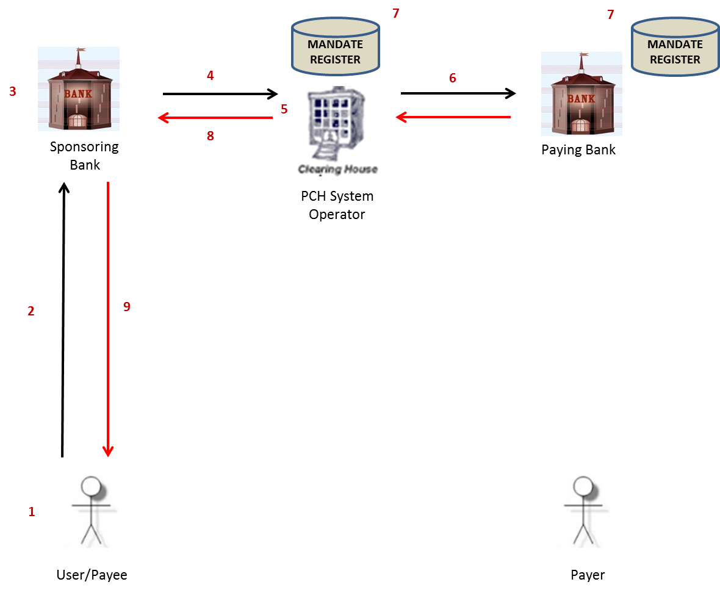

**Technical Requirements:**

The following data delivery mechanisms will be available for the delivery of ISO 20022 messages in Batch between participants and the ACH:

* ConnectDirect;
* XCOM;
* Web-based https (secure FTP) upload via extranet over dedicated connections; and
* SWIFTNet FileAct.

gzip is to be used for file compression & decompression

**Messages used**:

* Payment Cancellation (camt.056)
* Resolution of Investigation (camt.029) – Cancellation response
* Payment Return (pacs.004)
* Status report **(**pacs.002**)** for error messages

**Processing Windows (ad hoc – based upon PASA approval)**:

Times to be agreed with industry after PASA approval for this service

**Bank Error – Cancellations / Reversals – Weekdays**

|  |  |  |  |  |  |  |
| --- | --- | --- | --- | --- | --- | --- |
| Message | Service Code | Originating | Receiving | Start Time | End Time | Extra |
| **Camt.056** | BEINP | Creditor Bank | ACH | 08:00 | 16:00 |  |
| **Camt.056** | BEOUT | ACH | Debtor Bank | 08:00 | 17:00 |  |
|  |  |  |  |  |  |  |
| **Pacs.004** | REINP | Debtor Bank | ACH | 08:00 | 18:00 |  |
| **Pacs.004** | REOUT | ACH | Creditor Bank | 08:00 | 19:00 |  |
|  |  |  |  |  |  |  |
| **Camt.029** | RBINP | Debtor Bank | ACH | 08:00 | 18:00 |  |
| **Camt.029** | RBOUT | ACH | Creditor Bank | 08:00 | 19:00 |  |
|  |  |  |  |  |  |  |
| **Pacs.002** | ST901 | ACH | Creditor Bank | 08:00 | 16:30 |  |
| **Pacs.002** | ST902 | ACH | Debtor Bank | 08:00 | 18:30 |  |
| **Pacs.002** | ST903 | ACH | Debtor Bank | 08:00 | 18:30 |  |
|  |  |  |  |  |  |  |

**Bank Error – Cancellations / Reversals – Weekends & Public Holidays**

| Message | Service Code | Originating | Receiving | Start Time | End Time | Extra |
| --- | --- | --- | --- | --- | --- | --- |
| **Camt.056** | BEINP | Creditor Bank | ACH | 08:00 | 10:00 |  |
| **Camt.056** | BEOUT | ACH | Debtor Bank | 08:00 | 11:00 |  |
|  |  |  |  |  |  |  |
| **Pacs.004** | REINP | Debtor Bank | ACH | 08:00 | 12:00 |  |
| **Pacs.004** | REOUT | ACH | Creditor Bank | 08:00 | 13:00 |  |
|  |  |  |  |  |  |  |
| **Camt.029** | RBINP | Debtor Bank | ACH | 08:00 | 12:00 |  |
| **Camt.029** | RBOUT | ACH | Creditor Bank | 08:00 | 13:00 |  |
|  |  |  |  |  |  |  |
| **Pacs.002** | ST901 | ACH | Creditor Bank | 08:00 | 10:30 |  |
| **Pacs.002** | ST902 | ACH | Debtor Bank | 08:00 | 12:30 |  |
| **Pacs.002** | ST903 | ACH | Debtor Bank | 08:00 | 12:30 |  |
|  |  |  |  |  |  |  |

**NB. Bank Errors: Participants will manage as best effort to a maximum of 48 hours.**

Direct Debits Bank Error Cancellation (Reversal) Process:

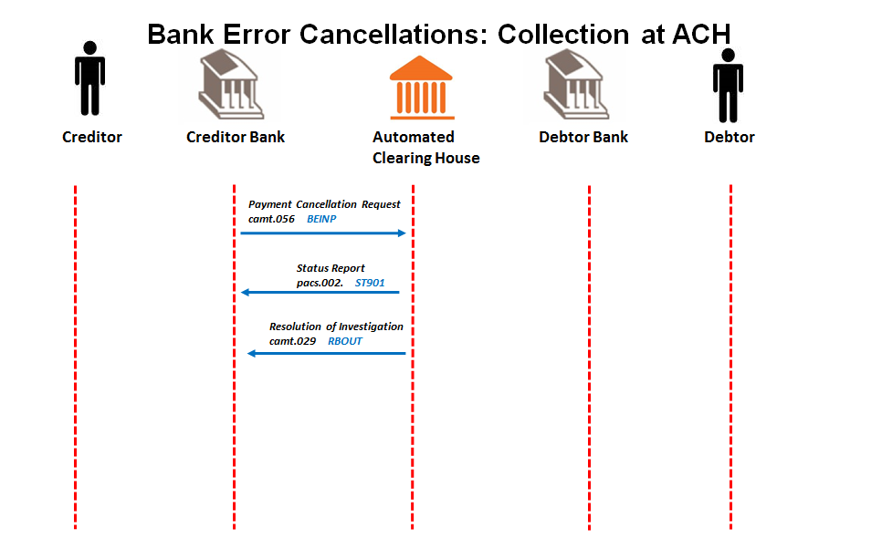

* + 1. Creditor Banks send payment cancellations (camt.056) to ACH

Debit payment cancellation messages may contain cancellations for direct debits from more than one direct debit input message. These cancellation requests (for error corrections) will only identify individual debits

When batches of debits are to be cancelled, the ACH uses batch header information to identify original direct debits.

The mandate reference number for any original direct debit has to also be included as part of the transaction message.

Payment cancellations may be delivered to the ACH only after the authorisation of PASA.

* + 1. ACH sends status report (pacs.002) to Creditor Bank

The automated clearing house validates payment cancellations and matches cancellations against original debit batches or debit requests.

Validation results are reported to Creditor Banks in status report messages.

* Files that fail validation are reported in status report messages (pacs.002) with a service identification code.
* Payment Cancellation messages which fail validation are reported in status report messages (pacs.002) with a service identification code.
  + 1. ACH sends resolution of investigation (camt.029) messages to Creditor Banks
    2. Creditor Banks engage and reconcile with their Creditors where required, with successful and negative response.

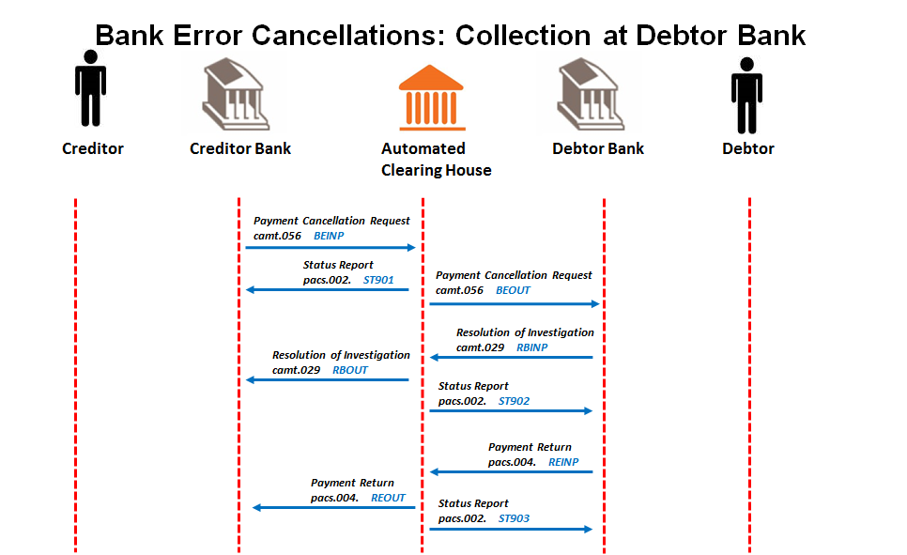

* + 1. Creditor Banks send payment cancellations (camt.056) to ACH

Debit payment cancellation messages may contain cancellations for direct debits from more than one direct debit input message. These cancellation requests (for error corrections) will identify individual debits. The mandate reference number for any original direct debit has to also be included as part of the transaction message.

Payment cancellations may be delivered to the ACH only after the authorisation of PASA.

* + 1. ACH sends status reports (pacs.002) to Creditor Bank

The automated clearing house validates payment cancellations and matches cancellations against original debit batches or debit requests.

Validation results are reported to Creditor Banks in status report messages.

* Files that fail validation are reported in status report messages (pacs.002) with a service identification code.
* Cancellation messages which fail validation are reported in status report messages (pacs.002) with a service identification code.
  + 1. ACH sends payments cancellations (camt.056) to Debtor Banks.

If debit cancellation batches (of individual debit cancellation requests) are submitted to the ACH, individual debit cancellation requests will be sent to the affected Debtor Banks.

**9.1.8.a Debtor Banks send payment returns (**pacs.004**) to ACH**

Debtor Banks match debit cancellation requests to original debit transactions.

Debits already processed to debtor accounts are returned in payment return messages.

**Note**: The Paying Bank must process the System Error Correction file on the same day as received and respond by no later than the next Processing Day.

**9.1.8.b Debtor Banks send cancellation confirmations (**camt.029 **to ACH**

Debtor Banks match debit cancellation requests to original debit transactions.

Debits not yet processed or cancellations that cannot be applied are reported in resolution of investigation messages with original transaction details.

**Note**: The Paying Bank must process the System Error Correction file on the same day as received and respond by no later than the next Processing Day.

* + 1. ACH sends status report (pacs.002) to Debtor Bank

The ACH validates payment return and resolution of investigation messages and matches returns and responses to original payment cancellations.

Validation results are reported to Debtor Banks in status report messages.

* Files that fail validation are reported in status report messages (pacs.002) with a service identification code.
* Payment Return messages which fail validation are reported in status report messages (pacs.002) with a service identification code.
  + 1. ACH sends payment return messages (pacs.004) and resolution of investigation (camt.029) messages to Creditor Banks
    2. Creditor Banks engage and reconcile with their Creditors where required, with successful and negative response.

# Alternative Scenarios

* 1. RealTime Pre Payments Alternative Cases

***GENERAL***

* A real time transaction is one that completes back to originator (request and response) within a maximum time of 60 seconds.
* 60 seconds is the agreed to time for the initial setting, but may change subject to testing
* Real time messages already have a unique identifier at message level. There is only one mandate per message in real time.
* The application time out for real time transactions is 60 seconds. Each leg of the transaction must be less than 8 seconds (to be confirmed in test), and in total add up to the 60 seconds. The originator of message must be the time keeper.
* The ACH will only use status reports (pacs.002) to respond to originator of messages.
* The Debtor Bank or Creditor Bank will either reply with status reports (pacs.002) or mandate acceptance report (pain.012) depending on originating message type.
* Creditor banks must reply with status report messages (pacs.002) for acceptance messages (pain.012).

* + 1. TT1 Delayed Authorisation - Mandate Initiation

**Alternative Case 1:**

**Mandate initiation request from Creditor fails at Creditor Bank (Bad User List).**

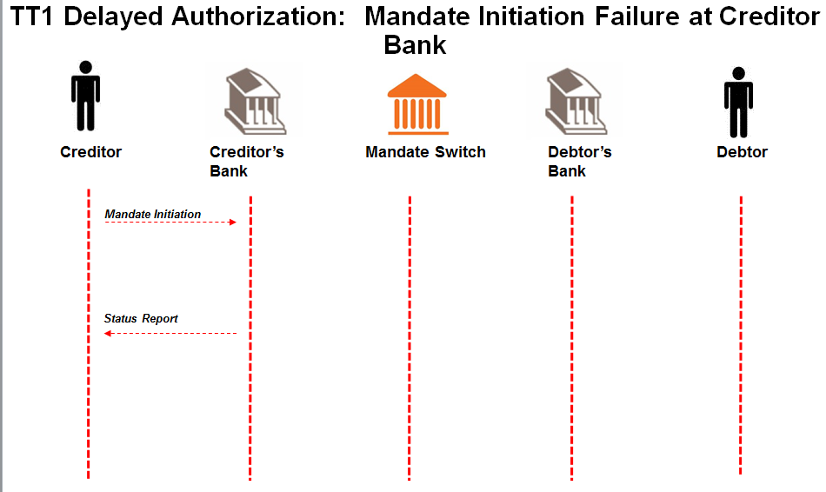

## Creditor sends mandate initiation request to Creditor Bank and is rejected.

Message format to be determined by the Creditor Bank, but message sent to Creditor Bank must contain all the data elements needed to create the mandate initiation request (pain.009).

## Creditor Bank engages with Creditor.

Message format of mandate response to Creditor to be determined by the Creditor Bank.

**Mandate initiation request process terminated.**

**Alternative Case 2:**

**Mandate initiation request (****pain.009****) from Creditor Bank fails validation at ACH.**

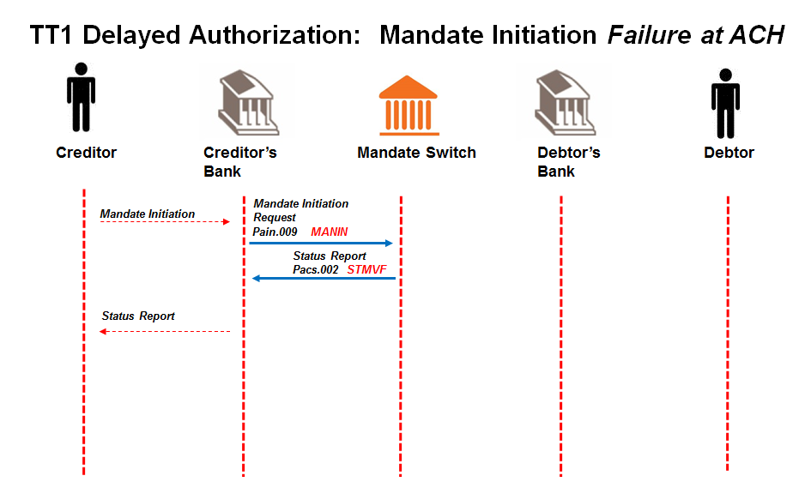

## Creditor sends mandate initiation request to Creditor Bank.

Message format to be determined by the Creditor Bank, but message sent to Creditor Bank must contain all the data elements needed to create the mandate initiation request (pain.009).

**Creditor Bank sends mandate initiation request** [**(****pain.009**](#_Mandate_Initiation_(pain.009))**) to ACH.**

Creditor Bank validates the Creditor and confirms that he is in good standing and submits mandate initiation request to the ACH.

**ACH validates mandate initiation request (****pain.009****) and responds to Creditor Bank with rejected status (pacs.002).**

ACH performs the following minimum validation:

* Message structure
* Member banks
* Date check

## Creditor Bank engages with Creditor.

Message format of mandate response to Creditor to be determined by the Creditor Bank.

**Mandate initiation request process terminated.**

**Alternative Case 3:**

**Mandate initiation request (****pain.009****) from ACH fails validation at Debtor Bank.**

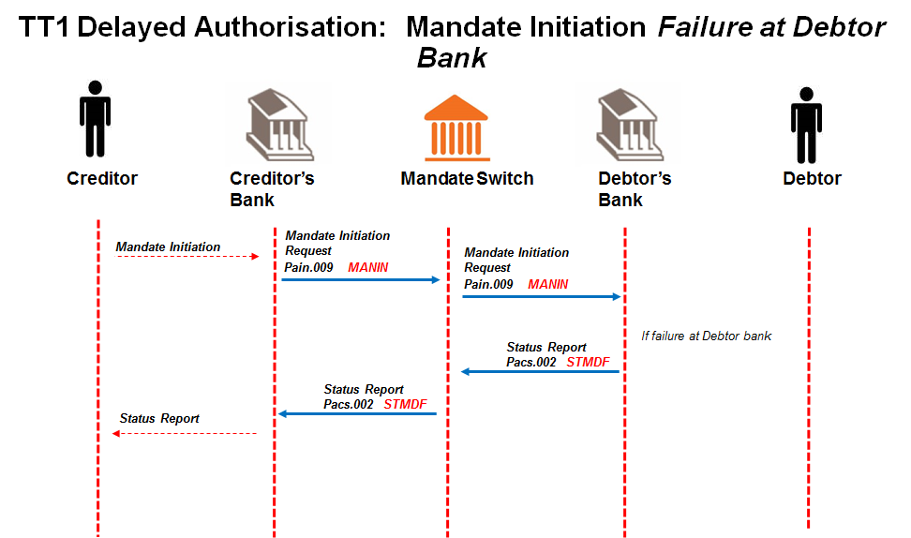

## Creditor sends mandate initiation request to Creditor Bank.

Message format to be determined by the Creditor Bank, but message sent to Creditor Bank must contain all the data elements needed to create the mandate initiation request (pain.009).

**Creditor Bank sends mandate initiation request** [**(****pain.009**](#_Mandate_Initiation_(pain.009))**) to ACH.**

Creditor Bank validates the Creditor and confirms that he is in good standing and submits mandate initiation request to the ACH.

**ACH sends valid mandate initiation request (****pain.009****) to Debtor Bank.**

**Debtor Bank validates mandate initiation request (**[**pain.009**](#_Mandate_Initiation_Request_1)**).**

Debtor Bank performs the following minimum validation:

* the account is a valid account for AC;
* the account is “open” and “active” (not frozen; closed etc.);
* the Debtor’s ID number matches the account details provided;
* *Optional requirement*: if the Debtor Bank uses the mobile service as the authorisation channel, check if the supplied number matches the mobile number of the Debtor as registered by the Debtor Bank. It is at the Debtor Bank’s discretion to use this number for alternate communication but the Debtor Bank will use their registered Payer’s details for authorisation of the mandate.

**Debtor Bank responds with a status report (****pacs.002****) to ACH with status rejected.**

**ACH forwards status report (****pacs.002****) to Creditor Bank.**

## Creditor Bank engages with Creditor as per status of mandate.

Message format of status of mandate to Creditor to be determined by the Creditor Bank.

**Mandate initiation request process terminated.**

**Alternative case 4:**

**Mandate Initiation acceptance message (pain.012) fails at ACH.**

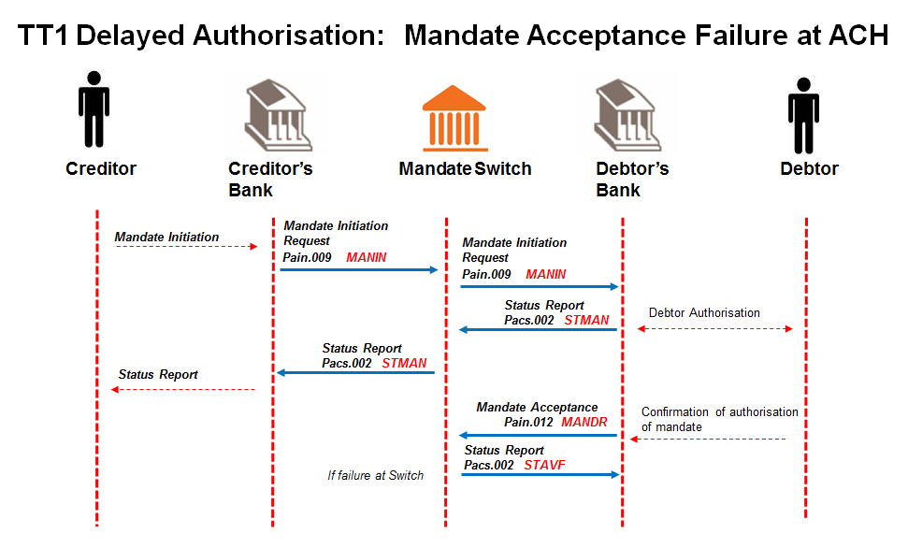

## Creditor sends mandate initiation request to Creditor Bank.

Message format to be determined by the Creditor Bank, but message sent to Creditor Bank must contain all the data elements needed to create the mandate initiation request (pain.009).

## Creditor Bank sends mandate initiation request [(pain.009](#_Mandate_Initiation_(pain.009))) to ACH.

Creditor Bank validates the Creditor and confirms that he is in good standing and submits mandate initiation request to the ACH.

## ACH sends valid mandate initiation request (pain.009) to Debtor Bank.

## Debtor Bank validates mandate initiation request (pain.009).

Debtor Bank performs the following minimum validation:

* the account is a valid account for AC;
* the account is “open” and “active” (not frozen; closed etc.);
* the Debtor’s ID number matches the account details provided;
* *Optional requirement*: if the Debtor Bank uses the mobile service as the authorisation channel, check if the supplied number matches the mobile number of the Debtor as registered by the Debtor Bank. It is at the Debtor Bank’s discretion to use this number for alternate communication but the Debtor Bank will use their registered Payer’s details for authorisation of the mandate.

## Debtor Bank responds with a status report (pacs.002) to ACH with status accepted.

The message from Debtor Bank is a confirmation and acknowledgment that validations as per 5.1.5 have been successful and engagement with Debtor has been initiated.

The initial response (Status Report) to Creditor Bank needs to be a real time response; only the Debtors’ authorisation response can be delayed as the response to the Debtor Bank is at the Debtor’s discretion.

## ACH forwards status report (pacs.002) to Creditor Bank.

## Creditor Bank engages with Creditor as per status of mandate.

Message format of status of mandate to Creditor to be determined by the Creditor Bank.

## Debtor Bank engages with the Debtor via their chosen authorisation channel.

Method of communicating with the Debtor is to be determined by the Debtor bank.

## Debtor responds to authorisation request from Debtor Bank.

Debtor’s response could be either positive or negative.

## Debtor Bank updates Mandate Register on positive response from Debtor.

Once Debtor authorises mandate, Debtor Bank creates unique mandate reference number per mandate initiation request to include in mandate response.

## Debtor Bank responds with mandate acceptance report (pain.012) to ACH.

Debtor Bank responds with mandate acceptance report to ACH with “authorised” (AAUT) or “not authorised” (NAUT) Debtor responses indicated in the “Authentication Status Indicator”.

This indicates the outcome of the mandate authentication process between Debtor Banks and their clients.

**The Debtor Bank must immediately generate the mandate acceptance report and reply to the ACH once the Debtor responds, without delay**. The mandate acceptance report will contain the unique mandate reference number.

## ACH validates mandate acceptance request (pain.012) and responds to Debtor Bank with a rejected status (pacs.002).

ACH performs the following minimum validation:

* Message structure
* Member banks
* Date check

**Debtor Bank corrects error and re-submits the mandate acceptance report (****pain.012****) to the ACH.**

**Alternative case 5:**

**Mandate Status Report (pacs.002) is not matched to Mandate Initiation acceptance message (pain.012) at ACH.**

## Creditor sends mandate initiation request to Creditor Bank.

Message format to be determined by the Creditor Bank, but message sent to Creditor Bank must contain all the data elements needed to create the mandate initiation request (pain.009).

## Creditor Bank sends mandate initiation request [(pain.009](#_Mandate_Initiation_(pain.009))) to ACH.

Creditor Bank validates the Creditor and confirms that he is in good standing and submits mandate initiation request to the ACH.

## ACH sends valid mandate initiation request (pain.009) to Debtor Bank.

## Debtor Bank validates mandate initiation request (pain.009).

Debtor Bank performs the following minimum validation:

* the account is a valid account for AC;
* the account is “open” and “active” (not frozen; closed etc.);
* the Debtor’s ID number matches the account details provided;
* *Optional requirement*: if the Debtor Bank uses the mobile service as the authorisation channel, check if the supplied number matches the mobile number of the Debtor as registered by the Debtor Bank. It is at the Debtor Bank’s discretion to use this number for alternate communication but the Debtor Bank will use their registered Payer’s details for authorisation of the mandate.

## Debtor Bank responds with a status report (pacs.002) to ACH with status accepted.

The message from Debtor Bank is a confirmation and acknowledgment that validations as per 5.1.5 have been successful and engagement with Debtor has been initiated.

The initial response (Status Report) to Creditor Bank needs to be a real time response; only the Debtors’ authorisation response can be delayed as the response to the Debtor Bank is at the Debtor’s discretion.

## ACH forwards status report (pacs.002) to Creditor Bank.

## Creditor Bank engages with Creditor as per status of mandate.

Message format of status of mandate to Creditor to be determined by the Creditor Bank.

## Debtor Bank engages with the Debtor via their chosen authorisation channel.

Method of communicating with the Debtor is to be determined by the Debtor bank.

## Debtor responds to authorisation request from Debtor Bank.

Debtor’s response could be either positive or negative.

## Debtor Bank updates Mandate Register on positive response from Debtor.

Once Debtor authorises mandate, Debtor Bank creates unique mandate reference number per mandate initiation request to include in mandate response.

## Debtor Bank sends to the ACH the mandate acceptance message (pain.012)

## ACH forwards mandate acceptance report (pain.012) to Creditor Bank.

## Creditor Bank engages with Creditor.

Message format of mandate response to Creditor to be determined by the Creditor Bank.

## Creditor Bank responds with a status report (pacs.002) to ACH as receipt of mandate acceptance report (pain.012).

**ACH is unable to match status report to mandate acceptance message**

**Debtor bank times out. Debtor bank resends original mandate acceptance message.**

**Alternative Case 6:**

**Debtor Bank is offline and thus unable to send end of day mandate acceptance report** (**pain.012**), **as per the mandate initiation request** (**pain.009**) **to ACH.**

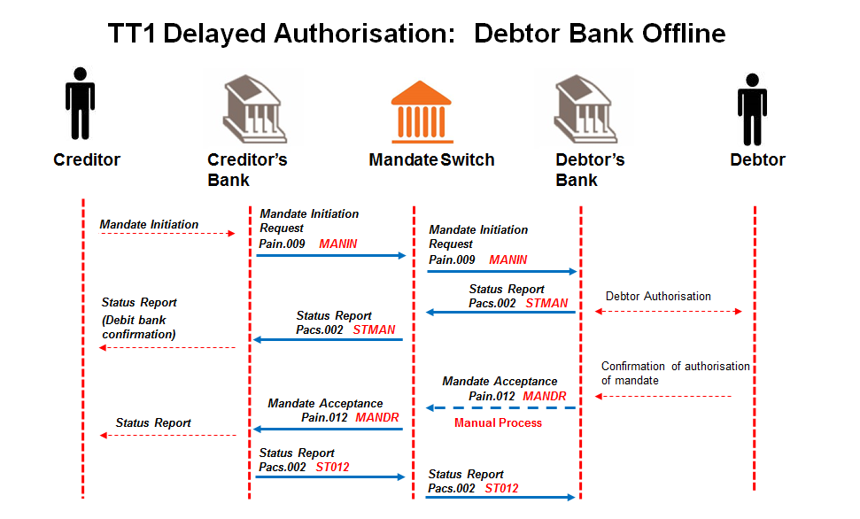

## Creditor sends mandate initiation request to Creditor Bank.

Message format to be determined by the Creditor Bank, but message sent to Creditor Bank must contain all the data elements needed to create the mandate initiation request (pain.009).

## Creditor Bank sends mandate initiation request (pain.009) to ACH.

Creditor Bank validates the Creditor and confirms that he is in good standing and submits mandate initiation request to the ACH.

## ACH sends valid mandate initiation request (pain.009) to Debtor Bank.

## Debtor Bank validates mandate initiation request (pain.009).

Debtor Bank performs the following minimum validation:

* the account is a valid account for AC;
* the account is “open” and “active” (not frozen; closed etc.);
* the Debtor’s ID number matches the account details provided;
* *Optional requirement*: if the Debtor Bank uses the mobile service as the authorisation channel, check if the supplied number matches the mobile number of the Debtor as registered by the Debtor Bank. It is at the Debtor Bank’s discretion to use this number for alternate communication but the Debtor Bank will use their registered Payer’s details for authorisation of the mandate.

## Debtor Bank responds with a status report (pacs.002) to ACH with status accepted.

The message from Debtor Bank is a confirmation and acknowledgment that validations as per 5.1.5 have been successful and engagement with Debtor has been initiated.

The initial response (Status Report) to Creditor Bank needs to be a real time response; only the Debtors’ authorisation response can be delayed as the response to the Debtor Bank is at the Debtor’s discretion.

## ACH forwards status report (pacs.002) to Creditor Bank.

## Creditor Bank engages with Creditor as per status of mandate.

Message format of status of mandate to Creditor to be determined by the Creditor Bank.

## Debtor Bank engages with the Debtor via their chosen authorisation channel.

Method of communicating with the Debtor is to be determined by the Debtor bank.

## Debtor responds to authorisation request from Debtor Bank.

Debtor’s response could be either positive or negative.

## Debtor Bank updates Mandate Register on positive response from Debtor.

Once Debtor authorises mandate, Debtor Bank creates unique mandate reference number per mandate initiation request to include in mandate response.

## Debtor Bank is off line and must provide ACH with mandate acceptance report (pain.012) by end of processing day via other media depending on the scenario as per escalation and PASA BCP (Business Continuity Policy).

## ACH forwards mandate acceptance report (pain.012) to Creditor Bank.

## Creditor Bank engages with Creditor.

Message format of mandate response to Creditor to be determined by the Creditor Bank.

## Creditor Bank responds with a status report (pacs.002) to ACH as receipt of mandate acceptance report (pain.012).

## ACH forwards status report (pacs.002) to Debtor Bank as receipt of mandate acceptance report (pain.012).

**Alternative Case 7:**

**Creditor Bank does not receive status report (pacs.002) on the original mandate initiation request (pain.009) (The Debtor Bank sent the response to the ACH and ACH sent it to the Creditor Bank but the Creditor Bank did not receive response) and times out after 60 secs (app level timeout)**

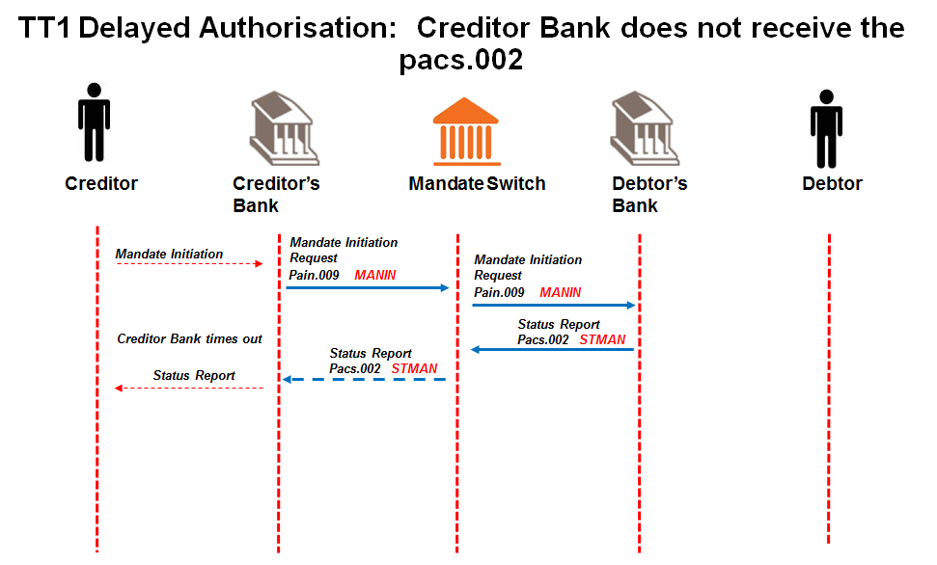

**Creditor Bank resends mandate initiation request** [**(****pain.009**](#_Mandate_Initiation_(pain.009))**) to ACH.**

Creditor Bank validates the Creditor and confirms that he is in good standing and submits mandate initiation request to the ACH.

**ACH sends valid mandate initiation request (****pain.009****) to Debtor Bank.**

**Debtor Bank receives the resubmitted mandate initiation request (****pain.009****) (duplicate of original request received)**

**The Debtor Bank responds with the original status report (pacs.002).**

**The ACH forwards the status report (****pacs.002****) to Creditor Bank, but Creditor Bank does not receive.**

*On Creditor request, Creditor Bank is allowed to resubmit the mandate initiation request up to 3 times and if no response message is received from the Debtor Bank the Creditor Bank needs to raise an alert to required AC participants.*

*The Creditor Bank will decide on the alert required when resubmissions have been exhausted, e.g. manual process-ops call.*

* *After 3 resubmissions of the mandate initiation request (pain.009), a cancellation message must be sent by the Creditor Bank and only then upon Creditor request a new mandate initiation request (pain.009) can be submitted.*
* *The message resubmissions are indicated by a transmission counter tag in messages which contain values 1 (for the original message), 2, 3 & 4 (for the resubmitted messages).*

**OR**

* + *send a cancellation message*

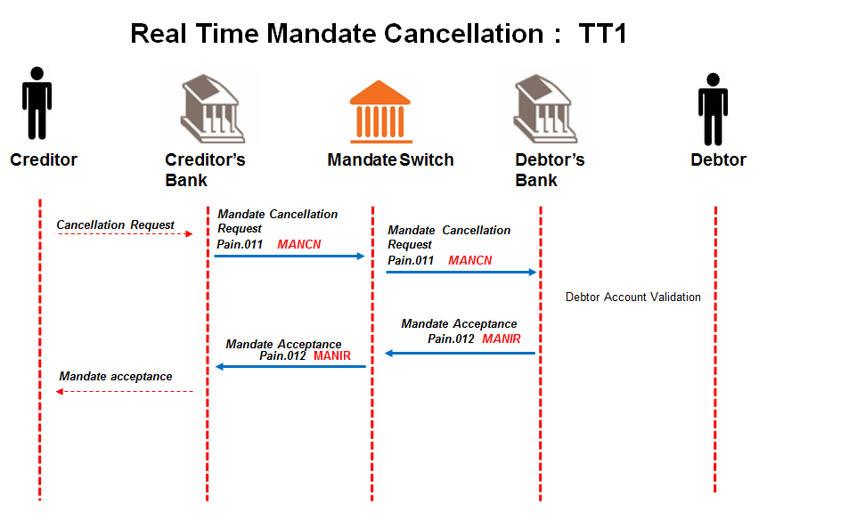

**Creditor sends mandate cancellation request** **to Creditor Bank; containing the unique mandate reference number of the mandate that it needs to cancel.**

Message format to be determined by the Creditor Bank, but message sent to Creditor Bank must contain all the data elements needed to create the mandate initiation request (pain.011).

**The Creditor Bank sends mandate cancellation request (****pain.011****) to ACH.**

Creditor bank validates the Creditor and confirms that he is in good standing and submits cancellation request to the ACH.

**The ACH validates the mandate cancellation request (****pain.011****) and forwards it to the Debtor Bank.**

**The Debtor Bank validates and processes the mandate cancellation request (****pain.011****).**

Debtor Bank receives *mandate cancellation request*(pain.011) and must complete the following steps:

* + Debtor Bank must cancel the mandate request sent to the Debtor if it is in a pending status or active status;

**The Debtor Bank submits the Mandate acceptance report (****pain.012****) to the ACH.**

This will advise the successful and unsuccessful status of the mandate cancellation request.

**The Debtor Bank engages with the Payer.**

Message format of the notification for mandate cancellation to Payer to be determined by the Debtor Bank.

**ACH forwards mandate acceptance report (****pain.012****) to Creditor Bank.**

**The Creditor Bank engages with the Creditor.**

Message format of the mandate cancellation response to Creditor to be determined by the Creditor Bank.

*On Creditor request, Creditor Bank is allowed to resubmit the mandate cancellation request up to 3 times and if no response message is received from the Debtor Bank the Creditor Bank needs to raise an alert to required AC participants.*

*The Creditor Bank will decide on the alert required when resubmissions have been exhausted, e.g. manual process-ops call.*

**After 3 retries (4 attempts in total), and Creditor bank still times out, the Creditor bank contacts the ACH to resolve the problem manually.**

**Alternative Case 8:**

**Debtor Bank does not receive status report (pacs.002) on the original mandate acceptance report (pain.012) and times out after 60 secs (app level timeout)**

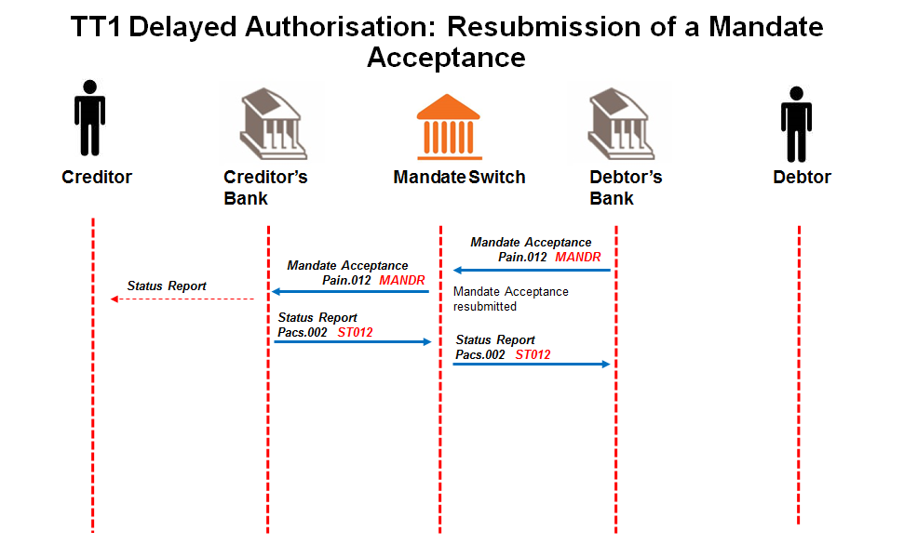

## Debtor Bank resubmits mandate acceptance report (pain.012) to ACH.

Debtor Bank responds with mandate acceptance report to ACH with “authorised” (AAUT) or “not authorised” (NAUT) Debtor responses indicated in the “Authentication Status Indicator”.

This indicates the outcome of the mandate authentication process between Debtor Banks and their clients.

## ACH forwards mandate acceptance report (pain.012) to Creditor Bank.

## The Creditor Bank must respond with status report (pacs.002) that was sent already (will just advise the Debtor Bank of receipt of the mandate acceptance report)

## ACH forwards status report (pacs.002) to Debtor Bank as receipt of mandate acceptance report (pain.012).

## Debtor bank never receives status report (pacs.002).

## Debtor bank times out after 60 seconds. Debtor Bank resend mandate acceptance report to ACH.

*Debtor Bank is allowed to resubmit the mandate acceptance report up to 3 times and if no response message is received from the Creditor Bank the Debtor Bank needs to raise an alert to required AC participants.*

*The Debtor Bank will decide on the alert required when resubmissions have been exhausted, e.g. manual process-ops call.*

*The message resubmissions are indicated by a transmission counter tag in messages which contain values 1 (for the original message), 2, 3 & 4 (for the resubmitted messages).*

**Alternative Case 9:**

**When Creditor attempts to log a duplicate mandate.**

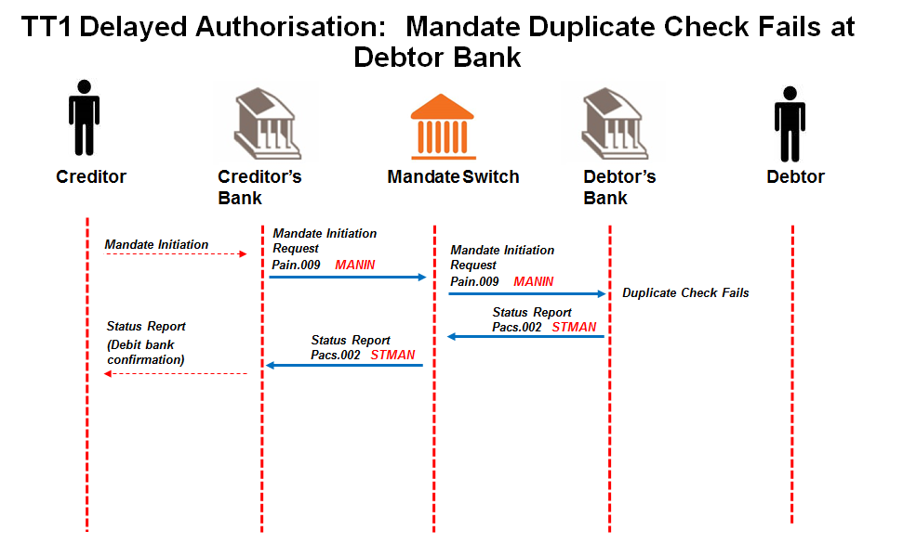

## Creditor sends mandate initiation request to Creditor Bank.

Message format to be determined by the Creditor Bank, but message sent to Creditor Bank must contain all the data elements needed to create the mandate initiation request (pain.009).

## Creditor Bank sends mandate initiation request [(pain.009](#_Mandate_Initiation_(pain.009))) to ACH.

Creditor Bank validates the Creditor and confirms that he is in good standing and submits mandate initiation request to the ACH.

## ACH validates mandate initiation request (pain.009) and responds to Creditor Bank with (pacs.002).

ACH performs the following minimum validation:

* Message structure
* Member banks
* Date check

## ACH sends valid mandate initiation request (pain.009) to Debtor Bank.

## Debtor Bank validates mandate initiation request (pain.009).

Debtor Bank performs the following minimum validation:

* Duplicate checking must take place at Debtor Bank as per specified fields added in the processing rules of the mandate initiation request.

## Debtor Bank responds with status report (pacs.002) to ACH with status rejected.

## ACH forwards status report (pacs.002) to Creditor Bank.

## Creditor Bank engages with Creditor.

Message format of mandate response to Creditor to be determined by the Creditor Bank.

**Alternative Case 10:**

**Debtor Bank receives authorisation from Debtor for a mandate after end of day authorisation period.**

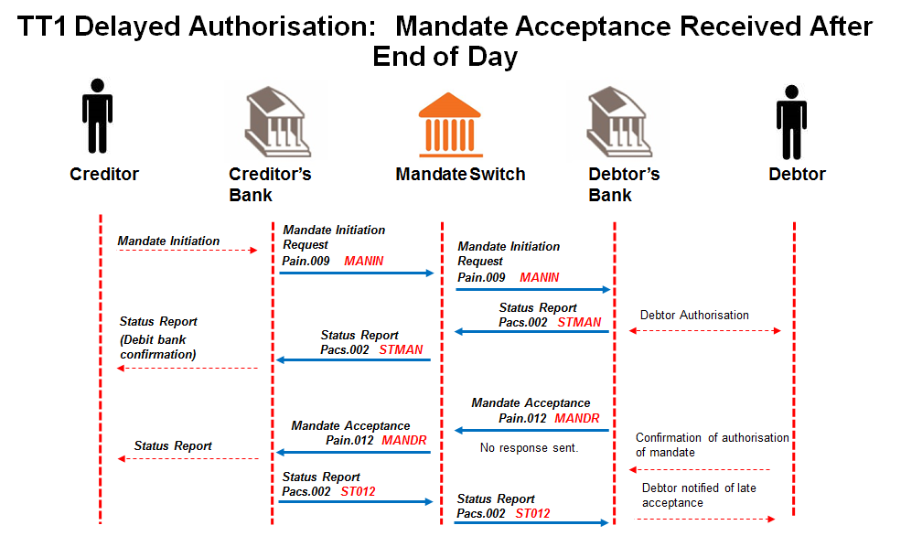

## Creditor sends mandate initiation request to Creditor Bank.

Message format to be determined by the Creditor Bank, but message sent to Creditor Bank must contain all the data elements needed to create the mandate initiation request (pain.009).

## Creditor Bank sends mandate initiation request [(pain.009](#_Mandate_Initiation_(pain.009))) to ACH.

Creditor Bank validates the Creditor and confirms that he is in good standing and submits mandate initiation request to the ACH.

## ACH validates mandate initiation request (pain.009) and responds to Creditor Bank with (pacs.002).

ACH performs the following minimum validation:

* Message structure
* Member banks
* Date check

## ACH sends valid mandate initiation request (pain.009) to Debtor Bank.

## Debtor Bank validates mandate initiation request (pain.009).

Debtor Bank performs the following minimum validation:

* the account is a valid account for AC;
* the account is “open” and “active” (not frozen; closed etc.);
* the Debtor’s ID number matches the account details provided;
* *Optional requirement*: if the Debtor Bank uses the mobile service as the authorisation channel, check if the supplied number matches the mobile number of the Debtor as registered by the Debtor Bank. It is at the Debtor Bank’s discretion to use this number for alternate communication but the Debtor Bank will use their registered Payer’s details for authorisation of the mandate.

## Debtor Bank engages with the Debtor via their chosen authorisation channel.

Method of communicating with the Debtor is to be determined by the Debtor bank.

## Debtor Bank responds with a status report (pacs.002) to ACH.

The message from Debtor Bank is a confirmation and acknowledgment that validations have been successful and engagement with Debtor has been initiated.

The initial response (Status Report) to Creditor Bank needs to be a real time response; only the Debtors’ authorisation response can be delayed as the response to the Debtor Bank is at the Debtor’s discretion.

## ACH forwards status report (pacs.002) to Creditor Bank.

## Creditor Bank engages with Creditor as per status of mandate.

Message format of status of mandate to Creditor to be determined by the Creditor Bank.

## Debtor Bank responds with mandate acceptance report (pain.012) to ACH.

On Expiration (End of Day) - the Debtor Bank will change the status of all mandate initiation requests that the Debtor has not responded to, from “Pending” to “No Responses”. Debtor Bank will reply in real time with mandate acceptance report messages with all outstanding authorisations from Debtors to ACH.

## ACH forwards mandate acceptance report (pain.012) to Creditor Bank.

## Creditor Bank engages with Creditor.

Message format of mandate response to Creditor to be determined by the Creditor Bank.

**Creditor Bank responds with a status report (****pacs.002****) to ACH as receipt of mandate acceptance report (****pain.012****).**

**ACH forwards status report (****pacs.002****) to Debtor Bank as receipt of mandate acceptance report (****pain.012****).**

## Debtor responds to authorisation request from Debtor Bank after End of Day.

**Debtor Bank notifies Debtor to take up with Creditor as mandate cannot be created.**

* + 1. TT1 and TT3 Real-time Authorisation – Mandate Initiation

**Alternative Case 1:**

**Mandate initiation request from Creditor fails at Creditor Bank (Bad User List).***See TT1 delayed Authorisation alternative Case 1 for details.*

**Alternative Case 2:**

**Mandate initiation request (****pain.009****) from Creditor Bank fails validation at ACH.**

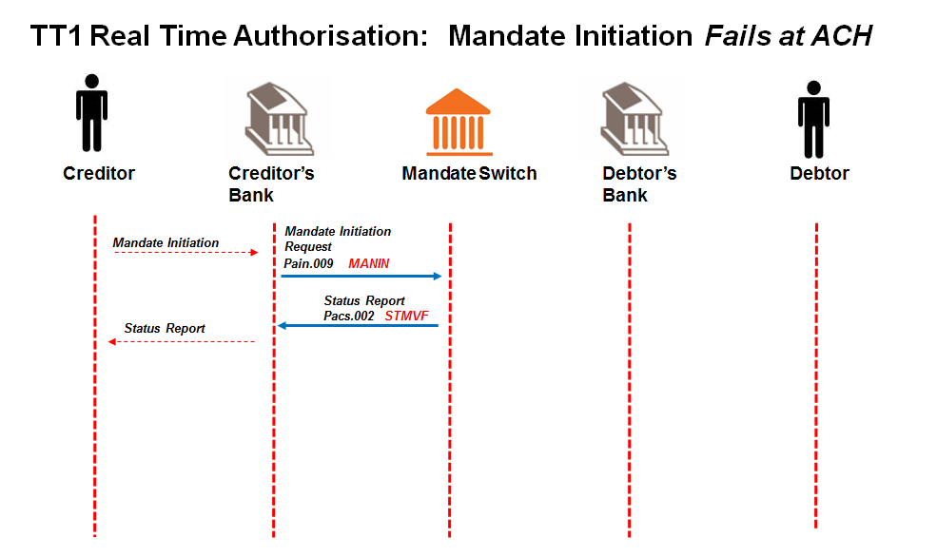

## Creditor sends mandate initiation request to Creditor Bank.

Message format to be determined by the Creditor Bank, but message sent to Creditor Bank must contain all the data elements needed to create the mandate initiation request (pain.009) and must include a request for real time authorisation.

**Creditor Bank sends mandate initiation request (****pain.009****) to ACH.**

Creditor Bank validates the Creditor and confirms that he is in good standing and submits mandate initiation request to the ACH.

**ACH validates mandate initiation request (****pain.009****).**

ACH performs the following minimum validation:

* Message structure
* Member banks
* Date check

**ACH sends negative status report (****pacs.002****) with reason for failure to Creditor Bank**

**Creditor Bank sends negative response to Creditor.**

**Mandate initiation request process terminated.**

**Alternative Case 3:**

**Mandate initiation request (****pain.009****) from ACH fails validation at Debtor Bank.**

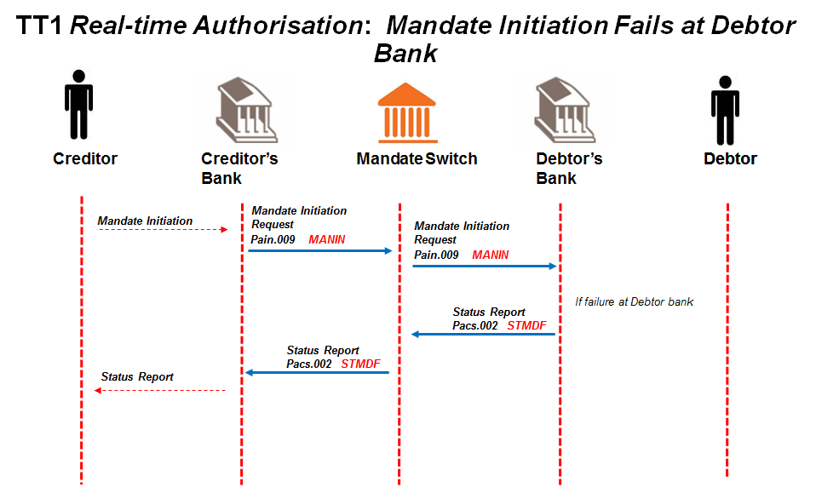

## Creditor sends mandate initiation request to Creditor Bank.

Message format to be determined by the Creditor Bank, but message sent to Creditor Bank must contain all the data elements needed to create the mandate initiation request (pain.009) and must include a request for real time authorisation.

**Creditor Bank sends mandate initiation request (****pain.009****) to ACH.**

Creditor Bank validates the Creditor and confirms that he is in good standing and submits mandate initiation request to the ACH.

**ACH validates mandate initiation request (****pain.009****) and responds to Creditor Bank.**

ACH performs the following minimum validation:

* Message structure
* Member banks
* Date check

**ACH sends valid mandate initiation request (****pain.009****) to Debtor Bank.**

**Debtor Bank validates mandate initiation request (****pain.009****).**

Debtor Bank performs the following minimum validation:

* the account is a valid account for AC;
* the account is “open” and “active” (not frozen; closed etc.);
* the Debtor’s ID number matches the account details provided;
* if the Debtor Bank uses the mobile service as the authorisation channel, check if the supplied number matches the mobile number of the Debtor as registered by the Debtor Bank. It is at the Debtor Bank’s discretion to use this number for alternate communication but the Debtor Bank will use their registered Payer’s details for authorisation of the mandate.

**Debtor Bank sends negative status report (****pacs.002****) with reason for failure to ACH.**

**ACH sends negative status report (****pacs.002****) to Creditor Bank.**

## Creditor Bank engages with Creditor.

Message format of mandate response to Creditor to be determined by the Creditor Bank.

**Alternative case 4:**

**Mandate Initiation acceptance message (pain.012) fails at ACH.**

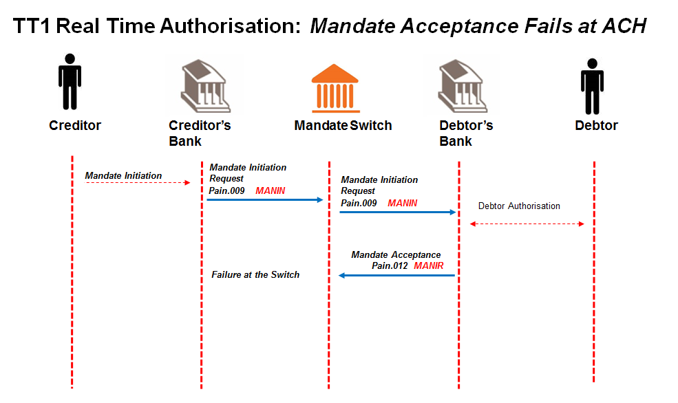

## Creditor sends mandate initiation request to Creditor Bank.

Message format to be determined by the Creditor Bank, but message sent to Creditor Bank must contain all the data elements needed to create the mandate initiation request (pain.009) and must include a request for real time authorisation.

**Creditor Bank sends mandate initiation request (****pain.009****) to ACH.**

Creditor Bank validates the Creditor and confirms that he is in good standing and submits mandate initiation request to the ACH.

**ACH validates mandate initiation request (****pain.009****) and responds to Creditor Bank.**

ACH performs the following minimum validation:

* Message structure
* Member banks
* Date check

**ACH sends valid mandate initiation request (****pain.009****) to Debtor Bank.**

**Debtor Bank validates mandate initiation request (****pain.009****).**

Debtor Bank performs the following minimum validation:

* the account is a valid account for AC;
* the account is “open” and “active” (not frozen; closed etc.);
* the Debtor’s ID number matches the account details provided;
* if the Debtor Bank uses the mobile service as the authorisation channel, check if the supplied number matches the mobile number of the Debtor as registered by the Debtor Bank. It is at the Debtor Bank’s discretion to use this number for alternate communication but the Debtor Bank will use their registered Payer’s details for authorisation of the mandate.

## Debtor Bank updates Mandate Register on positive response from Debtor.

Once Debtor authorises mandate, Debtor Bank creates unique mandate reference number per mandate initiation request to include in mandate response.

**Debtor Bank responds with mandate acceptance report (****pain.012****) to ACH.**

Debtor Bank responds with mandate acceptance report to ACH with “authorised” (AAUT) or “not authorised” (NAUT) Debtor responses indicated in the “Authentication Status Indicator”.

This indicates the outcome of the mandate authentication process between Debtor Banks and their clients.

**The Debtor Bank must immediately generate the mandate acceptance report and reply to the ACH**. The mandate acceptance report will contain the unique mandate reference number.

**The mandate acceptance report (****pain.012****) fails at the ACH. No action is taken by the ACH.**

**Creditor bank times out. Creditor bank resends original pain message.**

*On Creditor request, Creditor Bank is allowed to resubmit the mandate initiation request up to 3 times and if no response message is received from the Debtor Bank the Creditor Bank needs to raise an alert to required AC participants.*

*The Creditor Bank will decide on the alert required when resubmissions have been exhausted, e.g. manual process-ops call.*

*Only after 3 resubmissions of the mandate initiation request (pain.009), must a cancellation message must be sent by the Creditor Bank and only then upon Creditor request a new mandate initiation request (pain.009) can be submitted.*

*The message resubmissions are indicated by a transmission counter tag in messages which contain values 1 (for the original message), 2, 3 & 4 (for the resubmitted messages). Debtor Bank will perform duplicate checking and reply with the original response.*

**After 3 retries (4 attempts in total), and Creditor bank still times out, the Creditor bank contacts the ACH to resolve the problem manually.**

**Alternative case 5:**

**Mandate Initiation acceptance message (pain.012) is not matched to the mandate initiation (pain.009) at the ACH.**

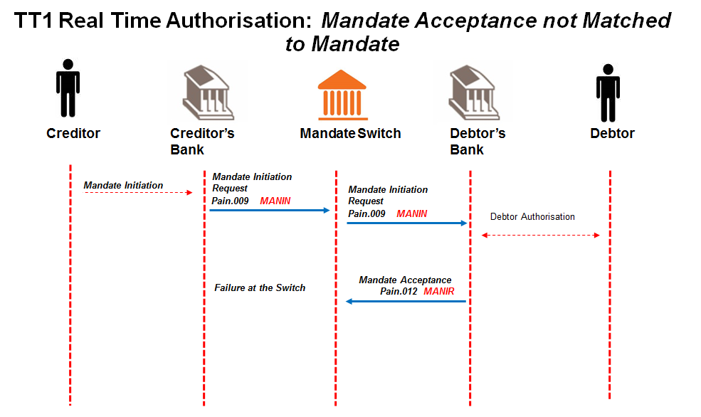

## Creditor sends mandate initiation request to Creditor Bank.

Message format to be determined by the Creditor Bank, but message sent to Creditor Bank must contain all the data elements needed to create the mandate initiation request (pain.009).

## Creditor Bank sends mandate initiation request [(pain.009](#_Mandate_Initiation_(pain.009))) to ACH.

Creditor Bank validates the Creditor and confirms that he is in good standing and submits mandate initiation request to the ACH.

## ACH sends valid mandate initiation request (pain.009) to Debtor Bank.

## Debtor Bank validates mandate initiation request (pain.009).

Debtor Bank performs the following minimum validation:

* the account is a valid account for AC;
* the account is “open” and “active” (not frozen; closed etc.);
* the Debtor’s ID number matches the account details provided;

## Debtor Bank updates Mandate Register on positive response from Debtor.

Debtor Bank creates unique mandate reference number per mandate initiation request to include in mandate response.

## Debtor Bank responds with mandate acceptance report (pain.012) to ACH.

Debtor Bank responds with mandate acceptance report to ACH.The mandate acceptance report will contain the unique mandate reference number.

**ACH is unable to match mandate acceptance message to mandate initiation request**

**Creditor bank times out. Creditor bank resends original pain message.**

*On Creditor request, Creditor Bank is allowed to resubmit the mandate initiation request up to 3 times and if no response message is received from the Debtor Bank the Creditor Bank needs to raise an alert to required AC participants.*

*The Creditor Bank will decide on the alert required when resubmissions have been exhausted, e.g. manual process-ops call.*

*Only after 3 resubmissions of the mandate initiation request (pain.009), must a cancellation message must be sent by the Creditor Bank and only then upon Creditor request a new mandate initiation request (pain.009) can be submitted.*

*The message resubmissions are indicated by a transmission counter tag in messages which contain values 1 (for the original message), 2, 3 & 4 (for the resubmitted messages). Debtor Bank will perform duplicate checking and reply with the original response.*

**After 3 retries (4 attempts in total), and Creditor bank still times out, the Creditor bank contacts the ACH to resolve the problem manually.**

**Alternative Case 6:**

**When Creditor attempts to log a duplicate mandate**

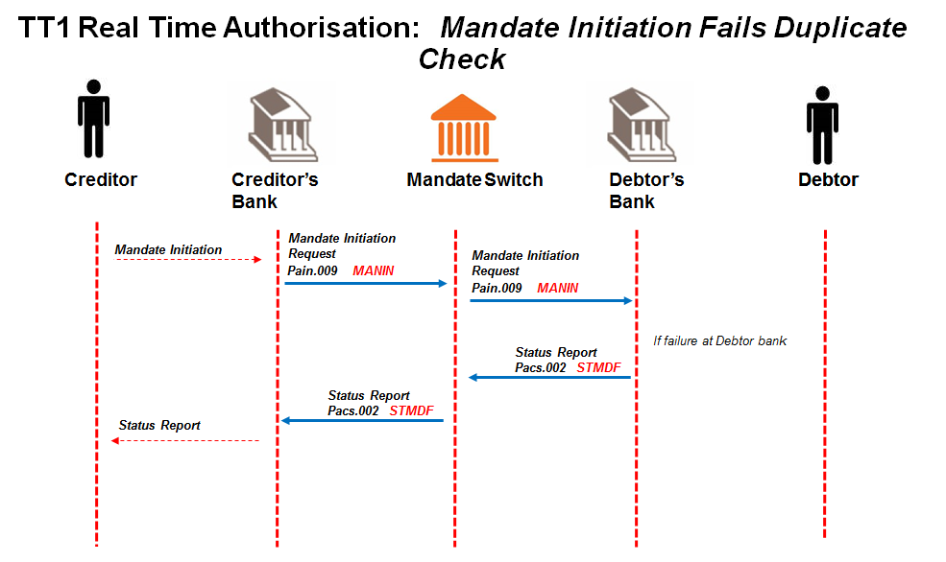

## Creditor sends mandate initiation request to Creditor Bank.

Message format to be determined by the Creditor Bank, but message sent to Creditor Bank must contain all the data elements needed to create the mandate initiation request (pain.009) and must include a request for real time authorisation.

## Creditor Bank sends mandate initiation request (pain.009) to ACH.

Creditor Bank validates the Creditor and confirms that he is in good standing and submits mandate initiation request to the ACH.

## ACH validates mandate initiation request (pain.009) and responds to Creditor Bank.

ACH performs the following minimum validation:

* Message structure
* Member banks
* Date check

## ACH sends valid mandate initiation request (pain.009) to Debtor Bank.

## Debtor Bank validates mandate initiation request for duplicates (pain.009).

## Debtor Bank sends negative status report (pacs.002) with reason for failure to ACH.

## ACH sends negative status report (pacs.002) to Creditor Bank.

## Creditor Bank engages with Creditor.

Message format of mandate response to Creditor to be determined by the Creditor Bank.**TT1 Real Time (USSD) Alternative cases**

-----the following alternate scenarios apply to TT1 when utilising the USSD option -----

**Alternative Case 7:**

**When Creditor requests a USSD authentication and provides the cell number (code 0229) and the Debtor Bank uses USSD for authentication. If the Cellphone number included in the message is not a registered number, the mandate initiation is rejected. A pacs.002 is sent to Creditor Bank with error code 910004 (Account open and active, incorrect contact details (0229)**

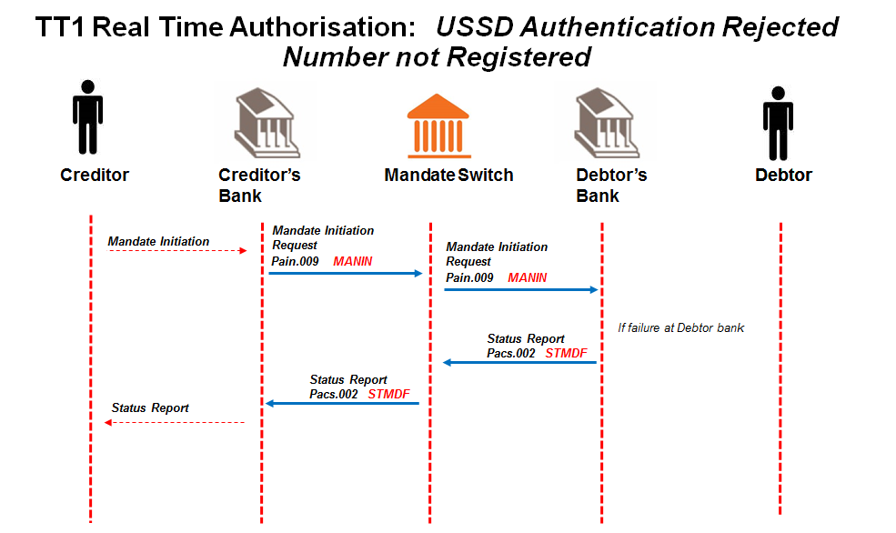

## Creditor sends mandate initiation request to Creditor Bank.

Message format to be determined by the Creditor Bank, but message sent to Creditor Bank must contain all the data elements needed to create the mandate initiation request (pain.009) and must include a request for real time authorisation.

## Creditor Bank sends mandate initiation request (pain.009) to ACH.

Creditor Bank validates the Creditor and confirms that he is in good standing and submits mandate initiation request to the ACH. The Debtor Authentication Required field contains 0229.

## ACH validates mandate initiation request (pain.009) and responds to Creditor Bank.

ACH performs the following minimum validation:

* Message structure
* Member banks
* Date check

## ACH sends valid mandate initiation request (pain.009) to Debtor Bank.

## Debtor Bank validates mandate initiation request for registered cell phone number (pain.009).

## The cell phone number is not registered at the debtor bank and the debtor bank fails the mandate initiation.

## Debtor Bank sends negative status report (pacs.002) with reason for failure to ACH.

Error code 910004 (Account open and active, incorrect contact details (0229) to be used.

## ACH sends negative status report (pacs.002) to Creditor Bank.

**Alternative Case 8:**

**When Creditor requests a USSD authentication and provides the cell number (authorisation code 0229) and the Debtor Bank uses USSD for authentication. If the USSD session times out, the mandate initiation is rejected with a pain.012 message with mandate reason code TO01 (Mandate Maintenance Message Time Out). The message from the Creditor Bank must time out after 120 seconds.**

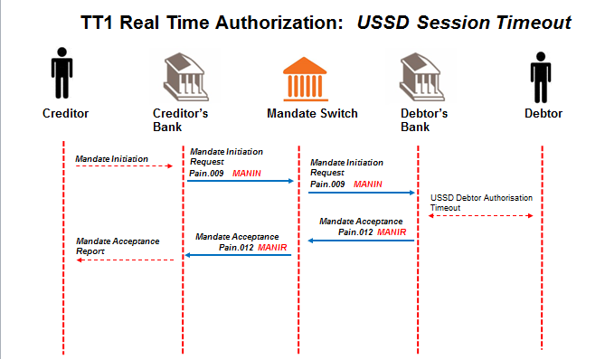

## Creditor sends mandate initiation request to Creditor Bank.

Message format to be determined by the Creditor Bank, but message sent to Creditor Bank must contain all the data elements needed to create the mandate initiation request (pain.009) and must include a request for real time authorisation.

## Creditor Bank sends mandate initiation request (pain.009) to ACH.

Creditor Bank validates the Creditor and confirms that he is in good standing and submits mandate initiation request to the ACH. The Debtor Authentication Required field contains 0229.

## ACH validates mandate initiation request (pain.009) and responds to Creditor Bank.

ACH performs the following minimum validation:

* Message structure
* Member banks
* Date check

## ACH sends valid mandate initiation request (pain.009) to Debtor Bank.

## Debtor Bank validates mandate initiation request (pain.009).

Debtor Bank performs the following minimum validation:

* the account is a valid account for AC;
* the account is “open” and “active” (not frozen; closed etc.);
* the Debtor’s ID number matches the account details provided;
* if the Debtor Bank uses the mobile service as the authorisation channel, check if the supplied number matches the mobile number of the Debtor as registered by the Debtor Bank. It is at the Debtor Bank’s discretion to use this number for alternate communication but the Debtor Bank will use their registered Payer’s details for authorisation of the mandate.

## Debtor Bank engages with the Debtor via USSD and times out.

Method of communicating with the Debtor is to be determined by the Debtor bank, but for real time non face-to-face authentication, debtor banks must at least support a basic USSD technology using mobile phones. . The channel chosen must cater for an immediate/real time request and response message from Debtor and contain the data elements specified in Appendix B that are required for authorisation.

If the cell number in the message matches the registered cell number at the Paying Bank and the message contains an authorisation code of 0229, authorisation will be sent to Payer.

## Payer does not respond to authorisation request

The payer does not respond to the USSD authorisation request in the allotted time.

## Debtor Bank responds with mandate acceptance report (pain.012) to ACH.

Debtor Bank responds with mandate acceptance report to ACH with mandate reason code TO01 (Mandate Maintenance Message Time Out).

**After 3 retries (4 attempts in total), and Creditor bank still times out, the Creditor bank contacts the ACH to resolve the problem manually.**

**Alternative Case 9:**

**When Creditor requests a USSD authentication (code 0230) and the Debtor Bank uses USSD for authentication. If the Cell phone number included in the message is not a registered number, the Debtor Bank must use the registered cell number for authentication.**

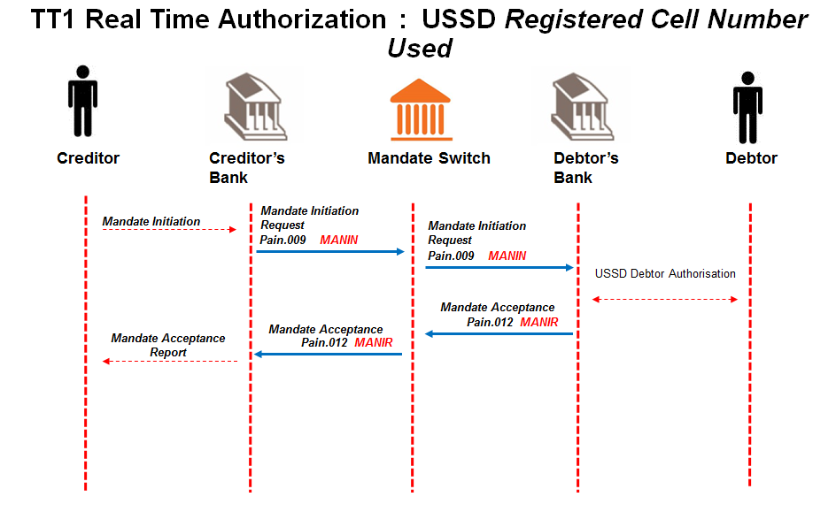

## Creditor sends mandate initiation request to Creditor Bank.

Message format to be determined by the Creditor Bank, but message sent to Creditor Bank must contain all the data elements needed to create the mandate initiation request (pain.009) and must include a request for real time authorisation.

**Creditor Bank sends mandate initiation request (****pain.009****) to ACH.**

Creditor Bank validates the Creditor and confirms that he is in good standing and submits mandate initiation request to the ACH. The Debtor Authentication Required field contains 0230.

**ACH validates mandate initiation request (****pain.009****) and responds to Creditor Bank.**

ACH performs the following minimum validation:

* Message structure
* Member banks
* Date check

**ACH sends valid mandate initiation request (****pain.009****) to Debtor Bank.**

**Debtor Bank validates mandate initiation request (****pain.009****).**

Debtor Bank performs the following minimum validation:

* the account is a valid account for AC;
* the account is “open” and “active” (not frozen; closed etc.);
* the Debtor’s ID number matches the account details provided;
* if the Debtor Bank uses the mobile service as the authorisation channel, check if the supplied number matches the mobile number of the Debtor as registered by the Debtor Bank. It is at the Debtor Bank’s discretion to use this number for alternate communication but the Debtor Bank will use their registered Payer’s details for authorisation of the mandate.

## Debtor Bank engages with the Debtor via USSD.

Method of communicating with the Debtor is to be determined by the Debtor bank, but for real time non face-to-face authentication, debtor banks must at least support a basic USSD technology using mobile phones. . The channel chosen must cater for an immediate/real time request and response message from Debtor and contain the data elements specified in Appendix B that are required for authorisation.

0230 - If the cell number in the message does not match the registered cell number at the Paying Bank and the message contains an authorisation code of 0230, authorisation will be sent to Payer using the registered cell number.

**Debtor Bank responds with mandate acceptance report (****pain.012****) to ACH.**

Debtor Bank responds with mandate acceptance report to ACH with “authorised” (AAUT) or “not authorised” (NAUT) Debtor responses indicated in the “Authentication Status Indicator”.

This indicates the outcome of the mandate authentication process between Debtor Banks and their clients.

**ACH forwards mandate acceptance report (****pain.012****) to Creditor Bank.**

## Creditor Bank engages with Creditor.

**Alternative Case 10:**

**When Creditor requests a USSD authentication (code 0230) and the Debtor Bank uses USSD for authentication. During the mandate initiation process, the client may request a new transaction. The creditor sends a cancellation message (pain.011) with a mandate reason code MICN (Cancellation of a Mandate initiation) followed by a new pain.009.**

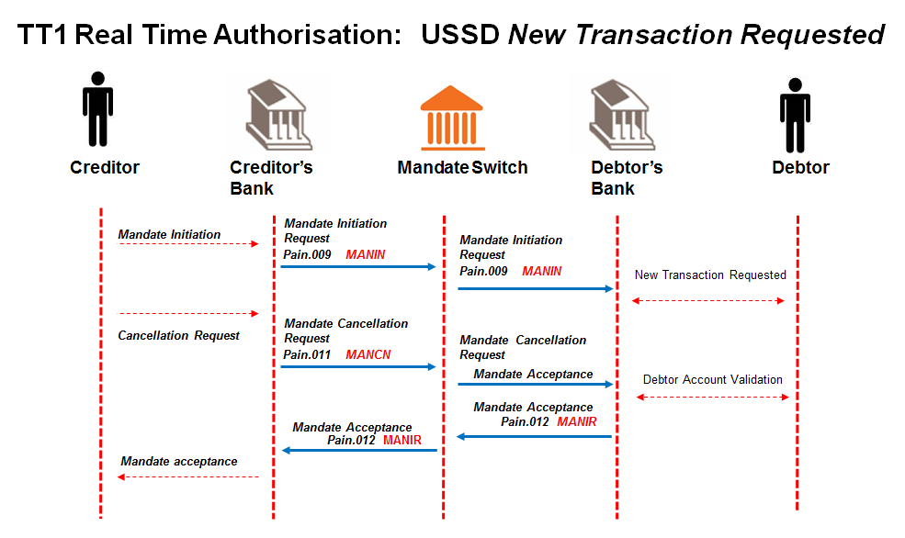

## Creditor sends mandate initiation request to Creditor Bank.

Message format to be determined by the Creditor Bank, but message sent to Creditor Bank must contain all the data elements needed to create the mandate initiation request (pain.009) and must include a request for real time authorisation.

**Creditor Bank sends mandate initiation request (****pain.009****) to ACH.**

Creditor Bank validates the Creditor and confirms that he is in good standing and submits mandate initiation request to the ACH. The Debtor Authentication Required field contains 0230.

**ACH validates mandate initiation request (****pain.009****) and responds to Creditor Bank.**

ACH performs the following minimum validation:

* Message structure
* Member banks
* Date check

**ACH sends valid mandate initiation request (****pain.009****) to Debtor Bank.**

**Debtor Bank validates mandate initiation request (**[**pain.009**](#_Mandate_Initiation_Request_1)**).**

Debtor Bank performs the following minimum validation:

* the account is a valid account for AC;
* the account is “open” and “active” (not frozen; closed etc.);
* the Debtor’s ID number matches the account details provided;
* if the Debtor Bank uses the mobile service as the authorisation channel, check if the supplied number matches the mobile number of the Debtor as registered by the Debtor Bank. It is at the Debtor Bank’s discretion to use this number for alternate communication but the Debtor Bank will use their registered Payer’s details for authorisation of the mandate.

## Debtor Bank engages with the Debtor via USSD.

Method of communicating with the Debtor is to be determined by the Debtor bank, but for real time non face-to-face authentication, debtor banks must at least support a basic USSD technology using mobile phones. . The channel chosen must cater for an immediate/real time request and response message from Debtor and contain the data elements specified in Appendix B that are required for authorisation.

If the cell number in the message does not match the registered cell number at the Paying Bank and the message contains an authorisation code of 0230, authorisation will be sent to Payer using the registered cell number.

## Debtor requests new transaction.

**Creditor sends mandate cancellation request** **to Creditor Bank; containing the unique mandate reference number of the mandate that it needs to cancel.**

Message format to be determined by the Creditor Bank, but message sent to Creditor Bank must contain all the data elements needed to create the mandate initiation request (pain.011).

**The Creditor Bank sends mandate cancellation request (****pain.011****) to ACH.**

Creditor bank validates the Creditor and confirms that he is in good standing and submits cancellation request to the ACH.

**The ACH validates the mandate cancellation request (****pain.011****) and forwards it to the Debtor Bank.**

**The Debtor Bank validates and processes the mandate cancellation request (****pain.011****).**

The Debtor Bank compares the cancellation request to the most recent mandate initiation request. Regardless of the matching outcome, the debtor bank responds with a mandate acceptance report.

**The Debtor Bank submits the Mandate acceptance report (****pain.012****) to the ACH.**

The mandate acceptance message reports the successful and unsuccessful status of the mandate cancellation request.

**The Debtor Bank engages with the Payer.**

Message format of the notification for mandate cancellation to Payer to be determined by the Debtor Bank.

**ACH forwards mandate acceptance report (****pain.012****) to Creditor Bank.**

**The Creditor Bank engages with the Creditor.**

**Alternative Case 11:**

**When Creditor requests a USSD authentication (code 0230) and the Debtor Bank uses USSD for authentication. If the USSD session times out, the mandate initiation is rejected with a pain.012 message with mandate reason code TO01 (Mandate Maintenance Message Time Out). The message from the Creditor Bank must time out after 120 seconds.**



## Creditor sends mandate initiation request to Creditor Bank.

Message format to be determined by the Creditor Bank, but message sent to Creditor Bank must contain all the data elements needed to create the mandate initiation request (pain.009) and must include a request for real time authorisation.

## Creditor Bank sends mandate initiation request (pain.009) to ACH.

Creditor Bank validates the Creditor and confirms that he is in good standing and submits mandate initiation request to the ACH. The Debtor Authentication Required field contains 0230.

## ACH validates mandate initiation request (pain.009) and responds to Creditor Bank.

ACH performs the following minimum validation:

* Message structure
* Member banks
* Date check

## ACH sends valid mandate initiation request (pain.009) to Debtor Bank.

## Debtor Bank validates mandate initiation request (pain.009).

Debtor Bank performs the following minimum validation:

* the account is a valid account for AC;
* the account is “open” and “active” (not frozen; closed etc.);
* the Debtor’s ID number matches the account details provided;
* if the Debtor Bank uses the mobile service as the authorisation channel, check if the supplied number matches the mobile number of the Debtor as registered by the Debtor Bank. It is at the Debtor Bank’s discretion to use this number for alternate communication but the Debtor Bank will use their registered Payer’s details for authorisation of the mandate.

## Debtor Bank engages with the Debtor via USSD and times out.

Method of communicating with the Debtor is to be determined by the Debtor bank, but for real time non face-to-face authentication, debtor banks must at least support a basic USSD technology using mobile phones. . The channel chosen must cater for an immediate/real time request and response message from Debtor and contain the data elements specified in Appendix B that are required for authorisation.

If the cell number in the message does not match the registered cell number at the Paying Bank and the message contains an authorisation code of 0230, authorisation will be sent to Payer using the registered cell number.

## Payer does not respond to authorisation request

The payer does not respond to the USSD authorisation request in the allotted time.

## Debtor Bank responds with mandate acceptance report (pain.012) to ACH.

Debtor Bank responds with mandate acceptance report to ACH with mandate reason code TO01 (Mandate Maintenance Message Time Out).

**Creditor bank times out. Creditor bank resends original pain message.**

*On Creditor request, Creditor Bank is allowed to resubmit the mandate initiation request up to 3 times and if no response message is received from the Debtor Bank the Creditor Bank needs to raise an alert to required AC participants.*

*The Creditor Bank will decide on the alert required when resubmissions have been exhausted, e.g. manual process-ops call.*

*Only after 3 resubmissions of the mandate initiation request (pain.009), must a cancellation message must be sent by the Creditor Bank and only then upon Creditor request a new mandate initiation request (pain.009) can be submitted.*

*The message resubmissions are indicated by a transmission counter tag in messages which contain values 1 (for the original message), 2, 3 & 4 (for the resubmitted messages). Debtor Bank will perform duplicate checking and reply with the original response.*

**After 3 retries (4 attempts in total), and Creditor bank still times out, the Creditor bank contacts the ACH to resolve the problem manually.**

**Alternative Case 12:**

**When Creditor requests a USSD authentication (code 0229 or 0230) and the Debtor Bank uses USSD for authentication. If there is no Cellphone number registered number at the Debtor Bank, a pacs.002 is sent to Creditor Bank with error code 910005 (Account open and active, no contact details).**

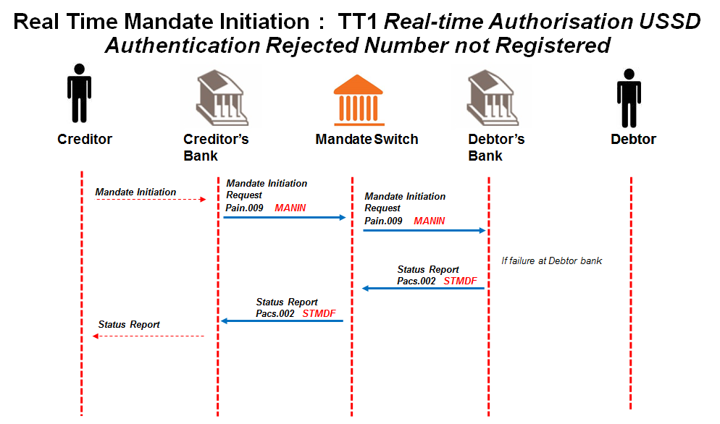

## Creditor sends mandate initiation request to Creditor Bank.

Message format to be determined by the Creditor Bank, but message sent to Creditor Bank must contain all the data elements needed to create the mandate initiation request (pain.009) and must include a request for real time authorisation.

**Creditor Bank sends mandate initiation request (****pain.009****) to ACH.**

Creditor Bank validates the Creditor and confirms that he is in good standing and submits mandate initiation request to the ACH. The Debtor Authentication Required field contains 0229 or 0230.

**ACH validates mandate initiation request (****pain.009****) and responds to Creditor Bank.**

ACH performs the following minimum validation:

* Message structure
* Member banks
* Date check

**ACH sends valid mandate initiation request (****pain.009****) to Debtor Bank.**

**Debtor Bank validates mandate initiation request for registered cell phone number (****pain.009****).**

There is no cell phone number registered at the debtor bank

**Debtor Bank sends negative status report (****pacs.002****) with reason for failure to ACH.**

Error code 910005 Account open and active, no contact details used.

**ACH sends negative status report (****pacs.002****) to Creditor Bank.**

* + 1. TT1 Delayed Authorisation - Amendment of a Mandate

**Alternative Case 1:**

**Mandate amendment request from Creditor fails at Creditor Bank.**

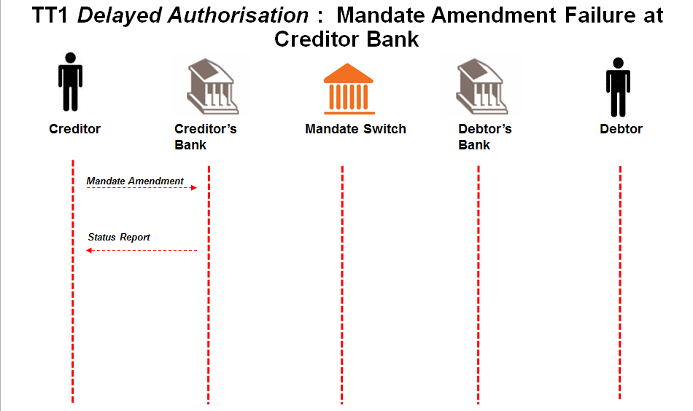

**Creditor sends mandate amendment request** **to Creditor Bank; containing the unique mandate reference number of the mandate that it needs to amend and is rejected.**

Message format to be determined by the Creditor Bank, but message sent to Creditor Bank must contain all the data elements needed to create the mandate amendment request (pain.010).

**Creditor Bank engages with Creditor.**

Message format of mandate response to Creditor to be determined by the Creditor Bank.

**Alternative Case 2:**

**Mandate Amendment request (****pain.010****) from Creditor Bank fails validation at ACH.**

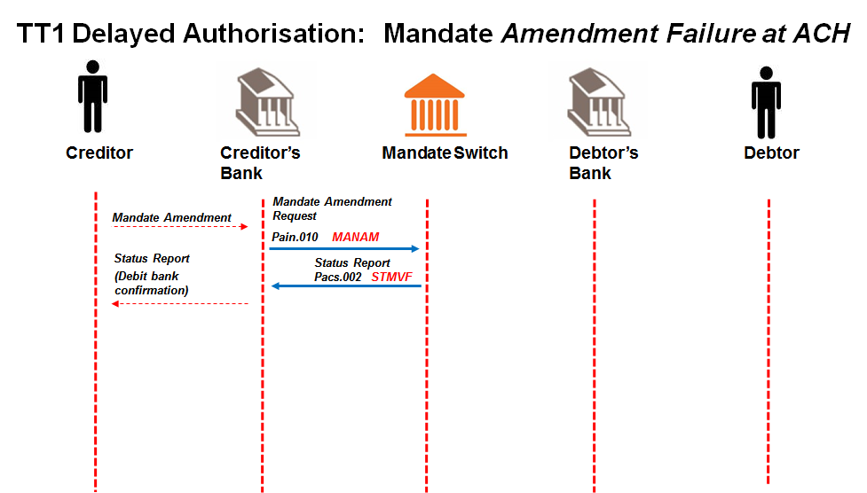

**Creditor sends mandate amendment request** **to Creditor Bank; containing the unique mandate reference number of the mandate that it needs to amend.**

Message format to be determined by the Creditor Bank, but message sent to Creditor Bank must contain all the data elements needed to create the mandate amendment request (pain.010).

**The Creditor Bank sends mandate amendment request (****pain.010****) to ACH.**

Creditor bank validates the Creditor and confirms that he is in good standing and submits amendment request to the ACH.

**The ACH validates the mandate amendment request (****pain.010****) and rejects it.**

**ACH sends negative status report (****pacs.002****) with reason for failure to Creditor Bank**

**Creditor Bank engages with Creditor.**

Message format of mandate response to Creditor to be determined by the Creditor Bank.

**Mandate maintenance request process terminated.**

**Alternative Case 3:**

**Mandate amendment request (pain.010) from ACH fails validation at Debtor Bank.**

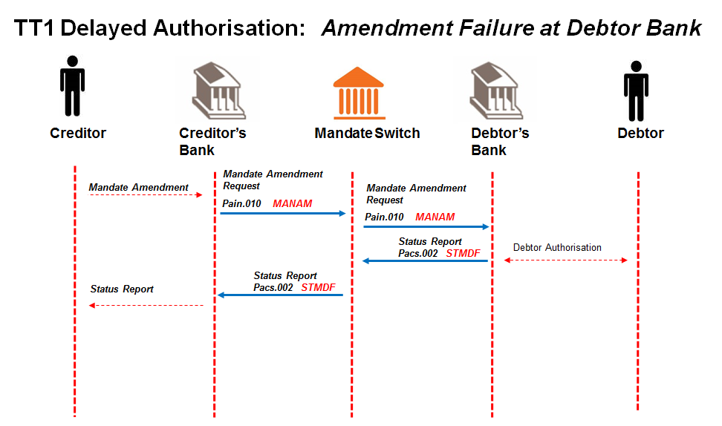

**Creditor sends mandate amendment request** **to Creditor Bank; containing the unique mandate reference number of the mandate that it needs to amend.**

Message format to be determined by the Creditor Bank, but message sent to Creditor Bank must contain all the data elements needed to create the mandate amendment request (pain.010). Must indicate that Authorisation is required

**The Creditor Bank sends mandate amendment request (****pain.010****) to ACH.**

Creditor bank validates the Creditor and confirms that he is in good standing and submits amendment request to the ACH.

**The ACH validates the mandate amendment request (****pain.010****) and forwards it to the Debtor Bank.**

**The Debtor Bank validates and processes the mandate amendment request (****pain.010****).**

Re-authorisation is required from the Debtor as defined by the data element to be amended (refer to Appendix D) and the Debtor Authentication Required code of 0227.

The rules per Real Time Use Cases (TT1, TT3 and TT4) defined for AC apply

The Debtor Bank compares the mandate information stored in the mandate register with the corresponding unique mandate reference number.

**The Debtor Bank sends negative status report (****pacs.002****) to ACH**

Both negative (no match to mandate) and negative (matched to mandate, but fails validation) acknowledgement responses to the mandate amendment are returned to the ACH

**\*\*\* SCR 168 – implementation date February 2018 \*\*\***

**ACH sends negative status report (****pacs.002****) to Creditor Bank.**

ACH sends on the acknowledgement responses to the Creditor Bank

**Creditor Bank engages with Creditor.**

Message format of mandate response to Creditor to be determined by the Creditor Bank.

**Mandate amendment request process terminated.**

**Alternative case 4:**

**Mandate Amendment acceptance message (pain.012) fails at ACH.**

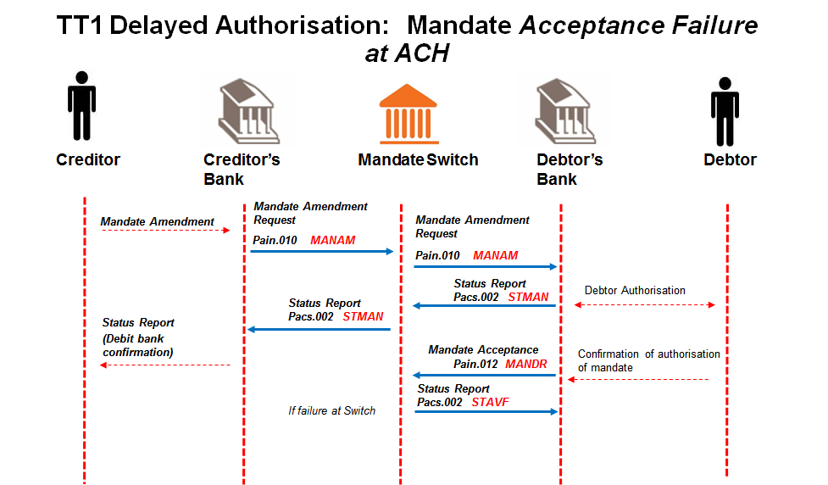

**Creditor sends mandate amendment request** **to Creditor Bank; containing the unique mandate reference number of the mandate that it needs to amend.**

Message format to be determined by the Creditor Bank, but message sent to Creditor Bank must contain all the data elements needed to create the mandate amendment request (pain.010). Must indicate that Authorisation is required

**The Creditor Bank sends mandate amendment request (****pain.010****) to ACH.**

Creditor bank validates the Creditor and confirms that he is in good standing and submits amendment request to the ACH.

**The ACH validates the mandate amendment request (****pain.010****) and forwards it to the Debtor Bank.**

**The Debtor Bank validates and processes the mandate amendment request (****pain.010****).**

Re-authorisation is required from the Debtor as defined by the data element to be amended (refer to Appendix D ) and the Debtor Authentication Required code of 0227.

The rules per Real Time Use Cases (TT1, TT3 and TT4) defined for AC apply

The Debtor Bank compares the mandate information stored in the mandate register with the corresponding unique mandate reference number.

**The Debtor Bank sends a status report (****pacs.002****) to ACH.**

Both negative (no match to mandate) and positive (matched to mandate) acknowledgement responses to the mandate amendment are returned to the ACH

**ACH sends this status report (****pacs.002****) to Creditor Bank.**

ACH sends on the acknowledgement responses to the Creditor Bank

**Debtor authorises, declines or time elapses on the amendment request**

**The successful or unsuccessful amendment to the mandate is then submitted to the ACH as part of the mandate acceptance report (****pain.012****).**

When authorised by the Debtor, the Debtor Bank would update the successful amendment request in the mandate register and the change would be noted as part of the audit log.

**ACH rejects mandate acceptance report (****pain.012****).**

**ACH sends status report (****pacs.002****) with reason for failure to debtor bank.**

**Debtor Bank corrects error and re-submits the mandate acceptance report (****pain.012****) to the ACH.**

**Alternative Case 5:**

**Creditor Bank does not receive status report (pacs.002)/mandate acceptance report (pain.012) on the original mandate amendment request (pain.010) (The Debtor Bank sent the response to the ACH and ACH sent it to the Creditor Bank but the Creditor Bank did not receive response) and times out after 60 secs (app level timeout)**

**Creditor Bank advises the Creditor of non-receipt of status report (pacs.002)// (pain.012) after 60 sec timeout**

**Creditor can instruct Creditor Bank to send a resubmission of the mandate amendment request**

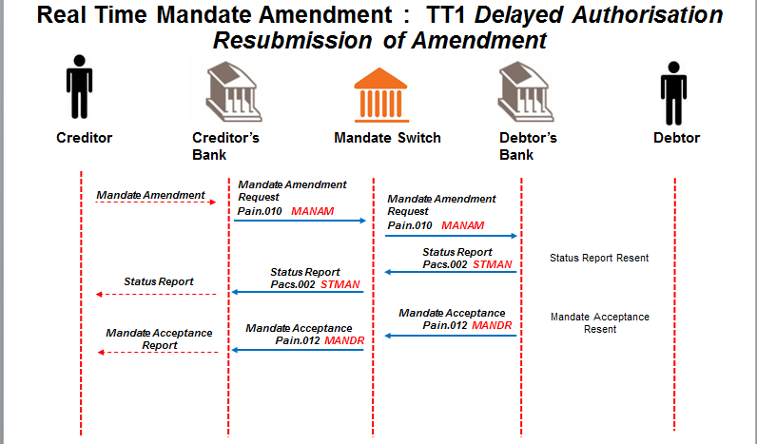

**Creditor Bank resubmits the mandate amendment request (****pain.010****) to ACH.**

**ACH sends resubmitted mandate amendment request (****pain.010****) to Debtor Bank.**

**Debtor Bank receives the resubmitted mandate amendment request (****pain.010****) (duplicate of original)**

**The Debtor Bank responds with the original status report (pacs.002) or mandate acceptance report (pain.012).**

**ACH sends status report (****pacs.002****) or mandate acceptance message (****pain.012****) to Creditor Bank.**

**Creditor Bank sends response to Creditor**

*On Creditor request, Creditor Bank is allowed to resubmit the mandate amendment request up to 3 times and if no response message is received from the Debtor Bank the Creditor Bank needs to raise an alert to required AC participants.*

*The Debtor Bank responds with the original result with the latest Request Transmission Number.*

*The Creditor Bank will decide on the alert required when resubmissions have been exhausted, e.g. manual process-ops call.*

*Only after 3 resubmissions of the mandate amendment request (pain.010), must a cancellation message must be sent by the Creditor Bank and only then upon Creditor request a new mandate amendment request (pain.010) can be submitted.*

*The message resubmissions are indicated by a transmission counter tag in messages which contain values 1 (for the original message), 2, 3 & 4 (for the resubmitted messages).*

* + 1. TT1 and TT3 Real-time Authorisation - Amendment of a Mandate

**Alternative Case 1:**

**Mandate amendment request from Creditor fails at Creditor Bank.**

*See TT1 Delayed Authorisation - Amendment of a Mandate alternate case 1 for details.*

**Alternative Case 2:**

**Mandate Amendment request (****pain.010****) from Creditor Bank fails validation at ACH.**

*See TT1 Delayed Authorisation - Amendment of a Mandate alternate case 2 for details.*

**Alternative Case 3:**

**Mandate amendment request (pain.010) from ACH fails validation at Debtor Bank.**

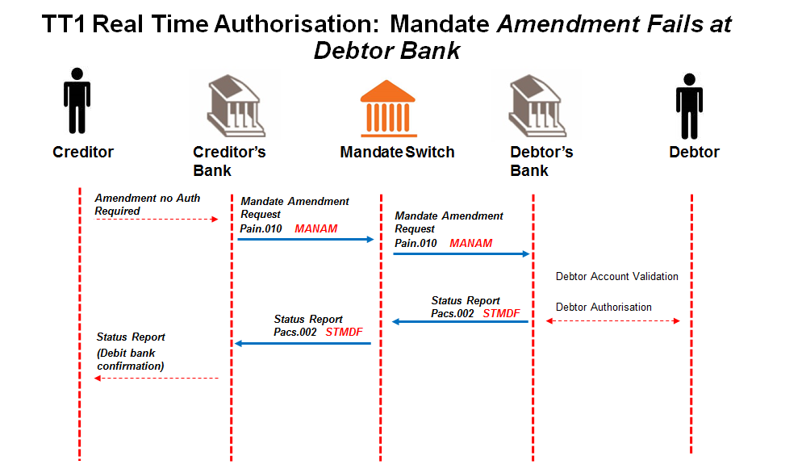

## Creditor sends mandate initiation request to Creditor Bank.

Message format to be determined by the Creditor Bank, but message sent to Creditor Bank must contain all the data elements needed to create the mandate amendment request (pain.010) and must include a request for real time authorisation.

**Creditor Bank sends mandate amendment request (**pain.010**) to ACH.**

Creditor Bank validates the Creditor and confirms that he is in good standing and submits mandate amendment request to the ACH.

**ACH validates mandate amendment request (**pain.010**) and responds to Creditor Bank.**

ACH performs the following minimum validation:

* Message structure
* Member banks
* Date check

**ACH sends valid mandate amendment request (**pain.010**) to Debtor Bank.**

**The Debtor Bank validates and processes the mandate amendment request (pain.010).**

Re-authorisation is required from the Debtor as defined by the data element to be amended (refer to Appendix D) and the Debtor Authentication Required code of 0227.

The rules per Real Time Use Cases (TT1, TT3 and TT4) defined for AC apply

The Debtor Bank compares the mandate information stored in the mandate register with the corresponding unique mandate reference number.

**The Debtor Bank sends negative status report (pacs.002) to ACH (negative reason code would be used if Creditor sends another amendment for mandate)**

Both negative (no match to mandate) and positive (matched to mandate) acknowledgement responses to the mandate amendment are returned to the ACH

**ACH forwards status report (**pacs.002**) to Creditor Bank.**

## Creditor Bank engages with Creditor.

Message format of mandate response to Creditor to be determined by the Creditor Bank.

**Alternative case 4:**

**Mandate Amendment acceptance message (pain.012) fails at ACH.**

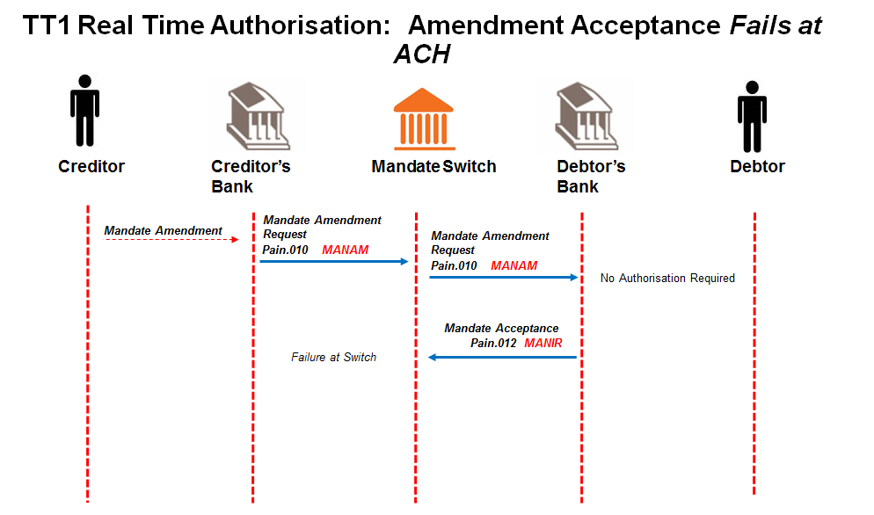

**Creditor sends mandate amendment request** **to Creditor Bank; containing the unique mandate reference number of the mandate that it needs to amend.**

Message format to be determined by the Creditor Bank, but message sent to Creditor Bank must contain all the data elements needed to create the mandate amendment request (pain.010). Must indicate that Authorisation is required

**The Creditor Bank sends mandate amendment request** (pain.010) **to ACH.**

Creditor bank validates the Creditor and confirms that he is in good standing and submits amendment request to the ACH.

**The ACH validates the mandate amendment request** (pain.010) **and forwards it to the Debtor Bank.**

**The Debtor Bank validates and processes the mandate amendment request** (pain.010)**.**

Re-authorisation is required from the Debtor as defined by the data element to be amended (refer to Appendix D ) and the Debtor Authentication Required code of 0227.

The rules per Real Time Use Cases (TT1, TT3 and TT4) defined for AC apply

The Debtor Bank compares the mandate information stored in the mandate register with the corresponding unique mandate reference number.

**The successful or unsuccessful amendment to the mandate is then submitted to the ACH as part of the mandate acceptance report** (pain.012)**.**

When authorised by the Debtor, the Debtor Bank would update the successful amendment request in the mandate register and the change would be noted as part of the audit log.

**ACH rejects mandate acceptance report** (pain.012)**.**

**Creditor bank times out. Creditor bank resends original pain message.**

*On Creditor request, Creditor Bank is allowed to resubmit the mandate amendment request up to 3 times and if no response message is received from the Debtor Bank the Creditor Bank needs to raise an alert to required AC participants.*

*The Creditor Bank will decide on the alert required when resubmissions have been exhausted, e.g. manual process-ops call.*

*Only after 3 resubmissions of the mandate amendment request (pain.010), must a cancellation message must be sent by the Creditor Bank and only then upon Creditor request a new mandate amendment request (pain.010) can be submitted.*

*The message resubmissions are indicated by a transmission counter tag in messages which contain values 1 (for the original message), 2, 3 & 4 (for the resubmitted messages). Debtor Bank will perform duplicate checking and reply with the original response.*

**After 3 retries (4 attempts in total), and Creditor bank still times out, the Creditor bank contacts the ACH to resolve the problem manually.**

**Alternative Case 5:**

**Creditor Bank does not receive mandate acceptance report (pain.012) on the original mandate amendment request (pain.010) (The Debtor Bank sent the response to the ACH and ACH sent it to the Creditor Bank but the Creditor Bank did not receive response) and times out after 60 secs (app level timeout)**

**Creditor Bank will advise the Creditor of non-receipt of status report (pacs.002)// (pain.012) after 60 sec timeout**

**Creditor can instruct Creditor Bank to send a resubmission of the mandate amendment request**

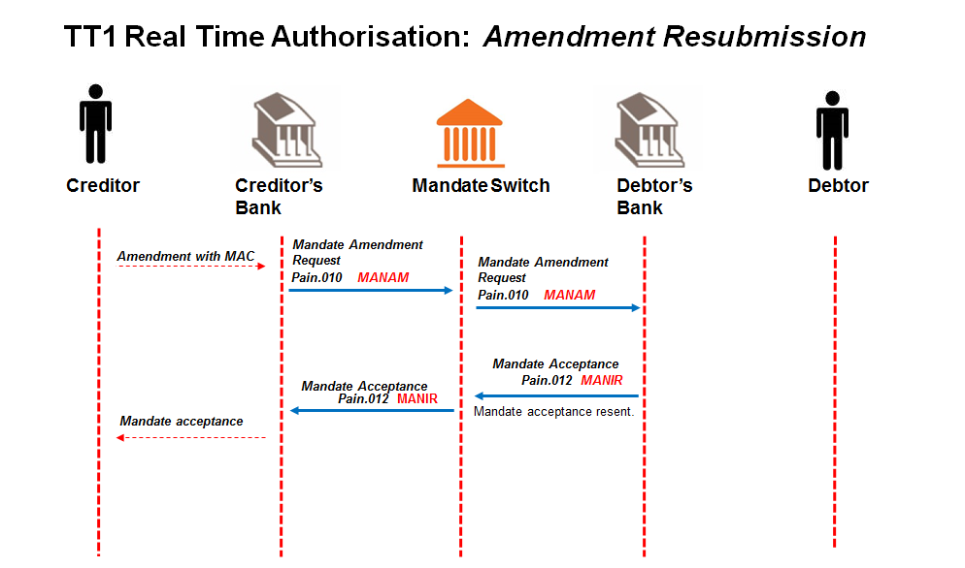

**Creditor Bank resubmits the mandate amendment request (pain.010) to ACH.**

**ACH sends resubmitted mandate amendment request (pain.010) to Debtor Bank.**

**Debtor Bank receives the resubmitted mandate amendment request (pain.010) (duplicate of original)**

**The Debtor Bank responds with the original mandate acceptance report (pain.012).**

**ACH sends mandate acceptance message (pain.012) to Creditor Bank.**

**Creditor Bank never receives mandate acceptance message.**

**Creditor bank times out. Creditor bank resends original pain message.**

*On Creditor request, Creditor Bank is allowed to resubmit the mandate amendment request up to 3 times and if no response message is received from the Debtor Bank the Creditor Bank needs to raise an alert to required AC participants.*

*The Creditor Bank will decide on the alert required when resubmissions have been exhausted, e.g. manual process-ops call.*

*Only after 3 resubmissions of the mandate amendment request (pain.010), must a cancellation message must be sent by the Creditor Bank and only then upon Creditor request a new mandate amendment request (pain.010) can be submitted.*

*The message resubmissions are indicated by a transmission counter tag in messages which contain values 1 (for the original message), 2, 3 & 4 (for the resubmitted messages). Debtor Bank will perform duplicate checking and reply with the original response.*

**After 3 retries (4 attempts in total), and Creditor bank still times out, the Creditor bank contacts the ACH to resolve the problem manually.**

**Alternative case 6:**

**Mandate Amendment acceptance message (pain.012) is not matched at the ACH.**

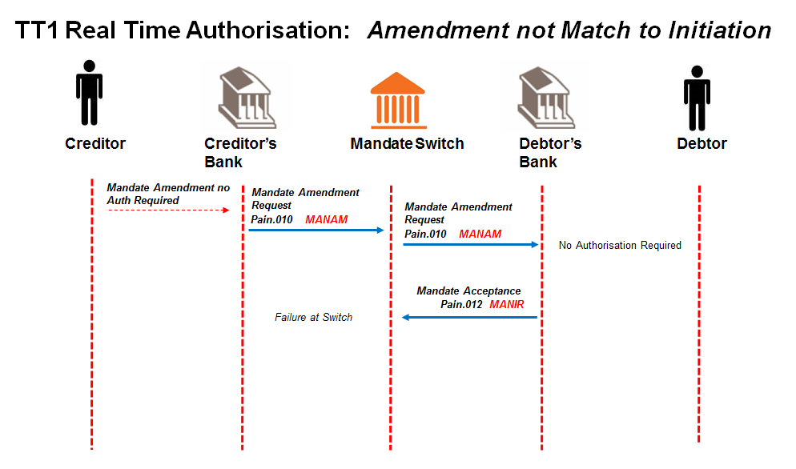

**Creditor sends mandate amendment request** **to Creditor Bank; containing the unique mandate reference number of the mandate that it needs to amend.**

Message format to be determined by the Creditor Bank, but message sent to Creditor Bank must contain all the data elements needed to create the mandate amendment request (pain.010). Must indicate that Authorisation is required

**The Creditor Bank sends mandate amendment request** (pain.010) **to ACH.**

Creditor bank validates the Creditor and confirms that he is in good standing and submits amendment request to the ACH.

**The ACH validates the mandate amendment request** (pain.010) **and forwards it to the Debtor Bank.**

**The Debtor Bank validates and processes the mandate amendment request** (pain.010)**.**

Re-authorisation is required from the Debtor as defined by the data element to be amended (refer to Appendix D ) and the Debtor Authentication Required code of 0227.

The rules per Real Time Use Cases (TT1, TT3 and TT4) defined for AC apply

The Debtor Bank compares the mandate information stored in the mandate register with the corresponding unique mandate reference number.

**The successful or unsuccessful amendment to the mandate is then submitted to the ACH as part of the mandate acceptance report (****pain.012****).**

When authorised by the Debtor, the Debtor Bank would update the successful amendment request in the mandate register and the change would be noted as part of the audit log.

**ACH unable to match mandate acceptance report (****pain.012****) to mandate amendment (pain.010).**

**Creditor bank times out. Creditor bank resends original pain message.**

*On Creditor request, Creditor Bank is allowed to resubmit the mandate amendment request up to 3 times and if no response message is received from the Debtor Bank the Creditor Bank needs to raise an alert to required AC participants.*

*The Creditor Bank will decide on the alert required when resubmissions have been exhausted, e.g. manual process-ops call.*

*Only after 3 resubmissions of the mandate amendment request (pain.010), must a cancellation message must be sent by the Creditor Bank and only then upon Creditor request a new mandate amendment request (pain.010) can be submitted.*

*The message resubmissions are indicated by a transmission counter tag in messages which contain values 1 (for the original message), 2, 3 & 4 (for the resubmitted messages). Debtor Bank will perform duplicate checking and reply with the original response.*

**After 3 retries (4 attempts in total), and Creditor bank still times out, the Creditor bank contacts the ACH to resolve the problem manually.**

* + 1. TT1 and TT3 Real-time Authorisation - Cancellation of a Mandate

**Alternative Case 1:**

**Mandate cancellation request from Creditor fails at Creditor Bank.**

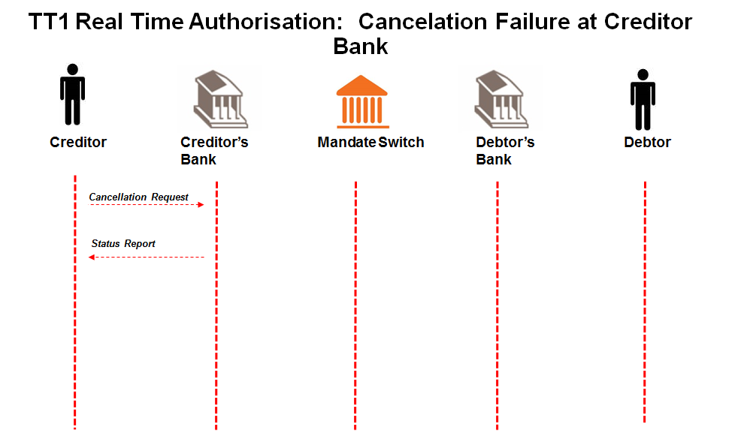

**Creditor sends mandate cancellation request** **to Creditor Bank; containing the unique mandate reference number of the mandate that it needs to cancel.**

Message format to be determined by the Creditor Bank, but message sent to Creditor Bank must contain all the data elements needed to create the mandate initiation request (pain.011).

**Creditor Bank sends negative response to Creditor.**

**Mandate cancellation request process terminated.**

**Alternative Case 2:**

**Mandate cancellation request (****pain.011****) from Creditor Bank fails validation at ACH.**

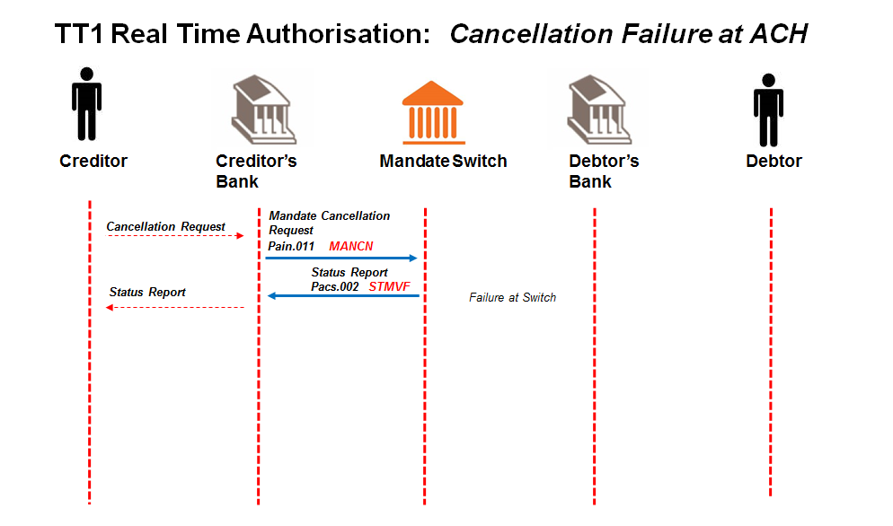

**Creditor sends mandate cancellation request to Creditor Bank; containing the unique mandate reference number of the mandate that it needs to cancel.**

Message format to be determined by the Creditor Bank, but message sent to Creditor Bank must contain all the data elements needed to create the mandate initiation request (pain.011).

**The Creditor Bank sends mandate cancellation request (pain.011) to ACH.**

Creditor bank validates the Creditor and confirms that he is in good standing and submits cancellation request to the ACH.

**The ACH validates the mandate cancellation request (pain.011). Mandate cancellation message fails or cannot be routed to debtor bank by ACH**

**ACH sends negative status report (pacs.002) with reason for failure to Creditor Bank**

**Creditor Bank sends negative response to Creditor.**

**Mandate cancellation request process terminated.**

**Alternative Case 3:**

**Mandate cancellation request (pain.011) from ACH fails validation at Debtor Bank.**

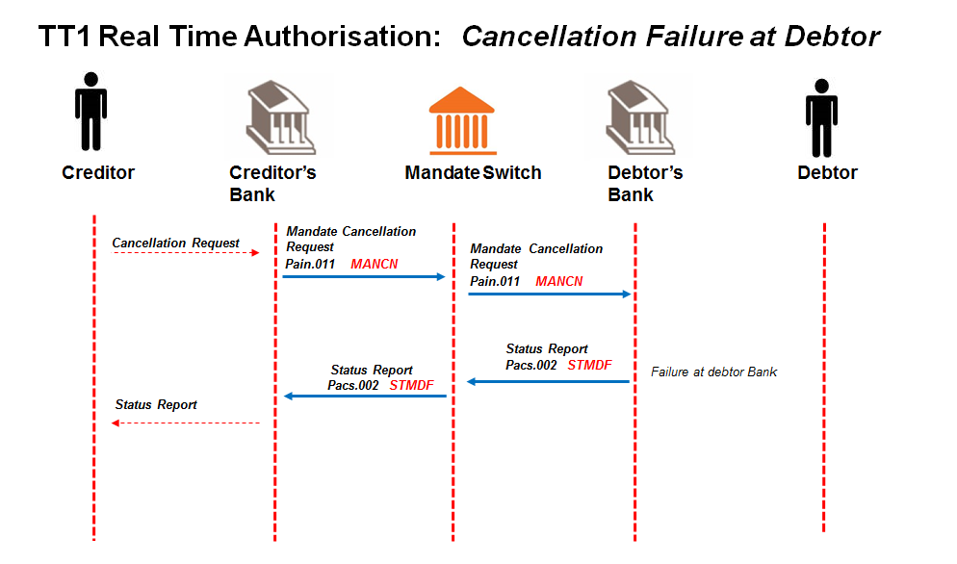

**Creditor sends mandate cancellation request to Creditor Bank; containing the unique mandate reference number of the mandate that it needs to cancel.**

Message format to be determined by the Creditor Bank, but message sent to Creditor Bank must contain all the data elements needed to create the mandate initiation request (pain.011).

**The Creditor Bank sends mandate cancellation request (pain.011) to ACH.**

Creditor bank validates the Creditor and confirms that he is in good standing and submits cancellation request to the ACH.

**The ACH validates the mandate cancellation request (pain.011) and forwards it to the Debtor Bank.**

**The Debtor Bank validates and processes the mandate cancellation request (pain.011).**

The Debtor Bank compares the mandate information stored with the corresponding unique mandate reference number.

**Mandate cancellation request fails at Debtor Bank.**

**Debtor Bank sends negative status report (pacs.002) with reason for failure to ACH.**

**ACH sends negative status report (****pacs.002****) to Creditor Bank.**

**Creditor Bank sends negative response to Creditor.**

**Mandate cancellation request process terminated.**

**Alternative case 4:**

**Mandate Cancellation acceptance message (pain.012) is not matched at ACH.**

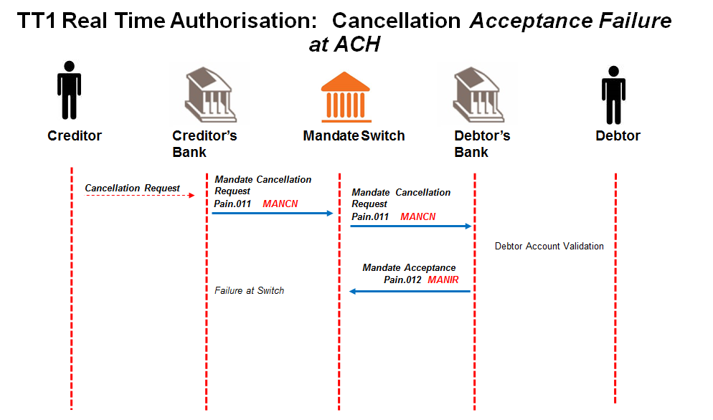

**Creditor sends mandate cancellation request to Creditor Bank; containing the unique mandate reference number of the mandate that it needs to cancel.**

Message format to be determined by the Creditor Bank, but message sent to Creditor Bank must contain all the data elements needed to create the mandate initiation request (pain.011).

**The Creditor Bank sends mandate cancellation request (pain.011) to ACH.**

Creditor bank validates the Creditor and confirms that he is in good standing and submits cancellation request to the ACH.

**The ACH validates the mandate cancellation request (pain.011) and forwards it to the Debtor Bank.**

**The Debtor Bank validates and processes the mandate cancellation request (pain.011).**

The Debtor Bank compares the mandate information stored with the corresponding unique mandate reference number, and if matched, cancels the mandate in the Mandate Register.

**The Debtor Bank submits the Mandate acceptance report (pain.012) to the ACH.**

This will advise the successful and unsuccessful status of the mandate cancellation request.

**The Debtor Bank engages with the Payer.**

The message format of the notification of mandate cancellation to Payer to be determined by the Debtor Bank.

**ACH is unable to match mandate acceptance message to mandate cancellation request**

**Real time switch at ACH ignores mandate acceptance message.**

**Creditor bank times out. Creditor bank resends original pain message.**

*On Creditor request, Creditor Bank is allowed to resubmit the mandate cancellation request up to 3 times and if no response message is received from the Debtor Bank the Creditor Bank needs to raise an alert to required AC participants.*

*The Creditor Bank will decide on the alert required when resubmissions have been exhausted, e.g. manual process-ops call.*

*The message resubmissions are indicated by a transmission counter tag in messages which contain values 1 (for the original message), 2, 3 & 4 (for the resubmitted messages). Debtor Bank will perform duplicate checking and reply with the original response.*

**After 3 retries (4 attempts in total), and Creditor bank still times out, the Creditor bank contacts the ACH to resolve the problem manually.**

**Alternative Case 5:**

**Creditor Bank does not receive cancellation acceptance (pain.012) on the original mandate cancellation request (pain.011). (The Debtor Bank sent the response to the ACH and ACH sent it to the Creditor Bank but the Creditor Bank did not receive response) and times out after 60 secs (app level timeout)**

**Creditor Bank advises the Creditor of non-receipt of cancellation acceptance (pain.012) after 60 sec timeout.**

**Creditor can instruct Creditor Bank to send a resubmission of the mandate cancellation request.**

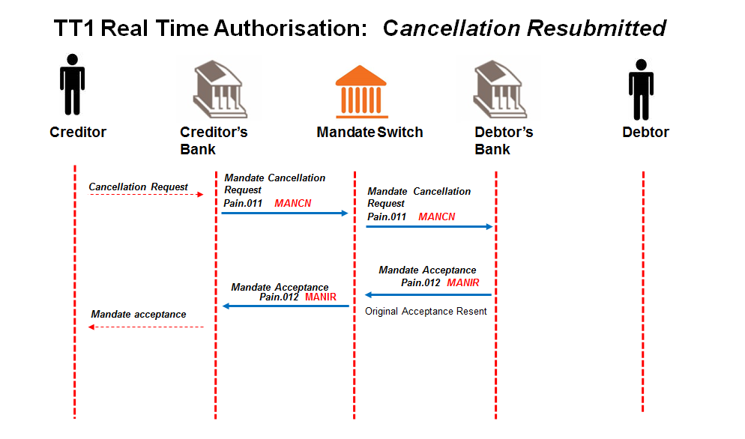

**Creditor Bank resubmits the mandate cancellation request (pain.011) to ACH.**

**ACH sends resubmitted mandate cancellation request (pain.011) to Debtor Bank.**

**Debtor Bank receives the resubmitted mandate cancellation request (pain.011) and identifies it as a duplicate of the original cancellation request.**

**The Debtor Bank responds with the original mandate acceptance report (pain.012).**

*On Creditor request, Creditor Bank is allowed to resubmit the mandate cancellation request up to 3 times and if no response message is received from the Debtor Bank the Creditor Bank needs to raise an alert to required AC participants.*

*The Creditor Bank will decide on the alert required when resubmissions have been exhausted, e.g. manual process-ops call.*

*The message resubmissions are indicated by a transmission counter tag in messages which contain values 1 (for the original message), 2, 3 & 4 (for the resubmitted messages).*

* 1. TT3 - Real Time Card Pre Payments Alternative Cases
     1. TT3 – Mandate Initiation – card

**Messaging anomalies on Debtor Authentication Request Leg as per current card processing scenarios.**

N.B. New reason codes have been added for the responses

P 39 must return “05” and the reason code will be returned within the R8 token

**Alternative Case 1:**

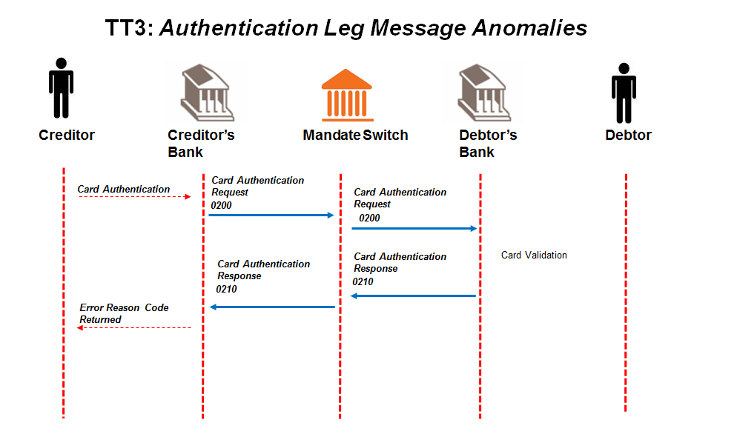

## Creditor obtains all required information for contract and mandate registration via Creditor User Interface.

Debtor is face to face with Creditor.

## Creditor initiates mandate registration process.

Debtor swipes/dips card and enters pin to authorise the mandate at Creditor.

## Debtor authentication request leg of mandate registration process is initiated.

## Creditor sends card authorisation request (0200) to Creditor Bank.

## Creditor Bank validates the Creditor and sends card authorisation request (0200) to the ACH.

Creditor Bank validates the Creditor and confirms that he is in good standing and submits card authorisation request to the ACH.

## ACH validates card authorisation request (0200).

ACH performs the following minimum validation:

* Financial institution
* BINs
* Switching codes
* Message format

## ACH sends card authorisation request (0200) to Debtor Bank.

## Debtor Bank validates card authorisation request (0200)

Debtor Bank does validation as per card, PIN, account and Debtor ID.

## Debtor Bank responds with a card acceptance response (0210) to the ACH with error reason code.

## ACH forwards the card acceptance response (0210) to Creditor Bank.

## Creditor Bank provides the Creditor with the card acceptance response (0210).

* 1. Batch Pre Payments Alternative Cases

*SCENARIOS*

* + 1. TT2 – Mandate Initiation

**Alternative Case 1:**

**Batch mandate initiation request from Creditor fails at Creditor Bank**.

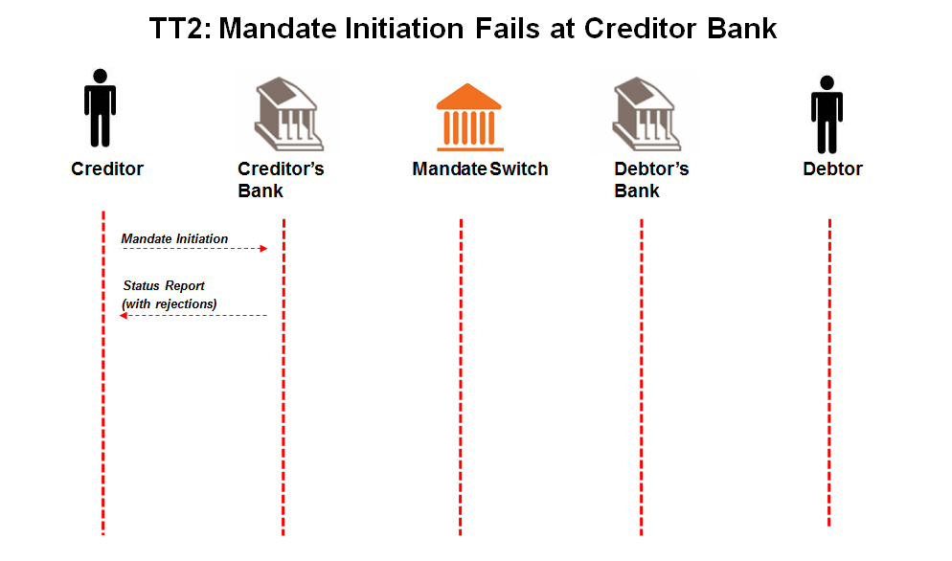

## Creditor sends batch of mandate initiation requests to Creditor Bank.

Message format to be determined by the Creditor Bank, but messages sent to Creditor Bank must contain all the data elements needed to create the mandate initiation requests (pain.009).

**Entire batch failure or individual mandate initiation request failure.**

**Creditor Bank sends negative response to Creditor**

**Batch mandate initiation request process terminated.**

**Alternative Case 2:**

**Batch Mandate initiation request (****pain.009****) from Creditor Bank fails at ACH.**

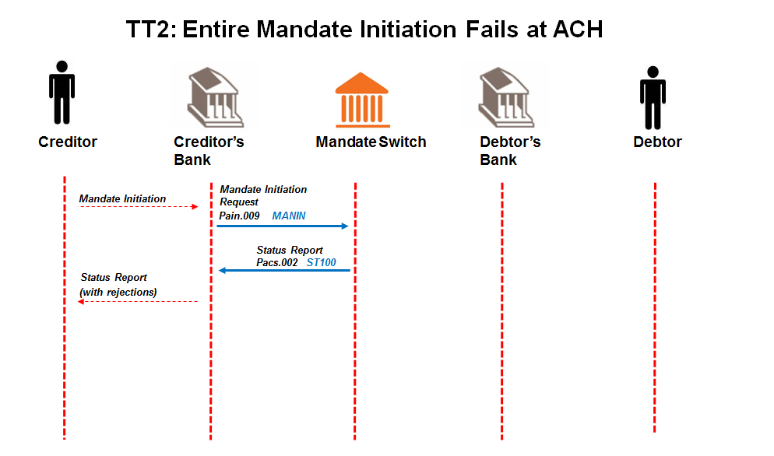

## Creditor sends batch of mandate initiation requests to Creditor Bank.

Message format to be determined by the Creditor Bank, but messages sent to Creditor Bank must contain all the data elements needed to create the mandate initiation requests (pain.009).

## Creditor Bank sends batch of mandate initiation requests (pain.009) to ACH.

Creditor Bank validates the Creditors and confirms that they are in good standing and submits batch of mandate initiation requests to the ACH.

## ACH validates requests and sends status report (pacs.002) to Creditor Bank. Entire Batch Fails.

ACH performs the following minimum validation:

* Message structure
* Member banks
* Date check

## Creditor Bank sends negative batch response to Creditor.

## Batch Mandate initiation request process terminated.

**Important note:** Banks set threshold on number of transactions rejected resulting in batch failure with ACH upfront (as per SLA)

**Alternative Case 3:**

**Individual transaction submitted in Batch Mandate initiation request (****pain.009****) from Creditor Bank fails at ACH/Debtor Bank.**

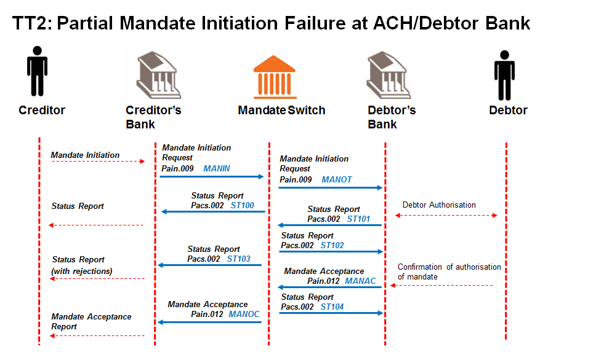

## Creditor sends batch of mandate initiation requests to Creditor Bank.

Message format to be determined by the Creditor Bank, but messages sent to Creditor Bank must contain all the data elements needed to create the mandate initiation requests (pain.009).

## Creditor Bank sends batch of mandate initiation requests (pain.009) to ACH.

Creditor Bank validates the Creditors and confirms that they are in good standing and submits batch of mandate initiation requests to the ACH.

## ACH validates requests and sends status report (pacs.002) to Creditor Bank including rejected transactions.

ACH performs the following minimum validation:

* Message structure
* Member banks
* Date check

## ACH sends valid batch mandate initiation requests (pain.009) to Debtor Banks.

## Debtor Bank validates batch mandate initiation requests (pain.009).

Debtor Bank performs the following minimum validation:

* the account is a valid account for AC,
* the account is “open” and “active” (not frozen; closed etc.);
* the Debtor’s ID number matches the account details provided.
* *Optional requirement*: if the Debtor Bank uses the mobile service as the authorisation channel, check if the supplied number matches the mobile number of the Debtor as registered by the Debtor Bank. It is at the Debtor Bank’s discretion to use this number for alternate communication but the Debtor Bank will use their registered Payer’s details for authorisation of the mandate.

## Debtor Bank responds with status report (pacs.002) to ACH including rejected transactions.

The report from Debtor Bank will provide upfront rejections as per validations that have been unsuccessful.

## ACH replies with status report (pacs.002) to Debtor Bank.

ACH validates and matches responses to original request.

## ACH forwards status report (pacs.002) to Creditor Banks.

## Creditor Bank engages with Creditor with upfront rejections provided by the Debtor Banks.

Message format of status of mandate to Creditor to be determined by the Creditor Bank.

## Debtor Bank engages with the Debtor through their chosen authorisation channel.

Method of communicating with the Debtor to be determined by the Debtor Bank, but must contain the data elements specified in Appendix B that are required for authorisation.

## Debtor responds to authorisation request from Debtor Bank.

Debtor’s response could be either positive or negative.

## Debtor Bank updates Mandate Register on positive response from Debtor.

Once Debtor authorises mandate, Debtor Bank creates unique mandate reference number per mandate initiation request to include in mandate response.

## Debtor Bank responds with batch mandate acceptance report (pain.012) to ACH.

Debtor bank responds with batch mandate acceptance report to ACH with “authorised” (AAUT) or “not authorised” (NAUT) Debtor responses, indicated in the “Authentication Status Indicator”.

This indicates the outcome of the mandate authentication process between Debtor Banks and their clients.

The batch mandate acceptance report will contain unique mandate reference numbers per mandate initiation requests.

Mandate acceptance reports will be batched in the times illustrated as per diagrams below; with an expiration of the request after 2 days beginning from the presentment of the original batch mandate initiation request i.e. cut-off on day 2 is the final response from the Debtor Bank.

## ACH responds with status report (pacs.002) to Debtor Bank.

Status report is confirmation of receipt of mandate acceptance report.

## ACH forwards batch mandate acceptance report (pain.012) per Creditor Bank.

## Creditor Bank engages with Creditor.

Message format of mandate response to Creditor to be determined

**Alternative Case 4**

**Debtor Bank unable to send final mandate acceptance report (pain.012) for original mandate initiation request (pain.009) to ACH.**

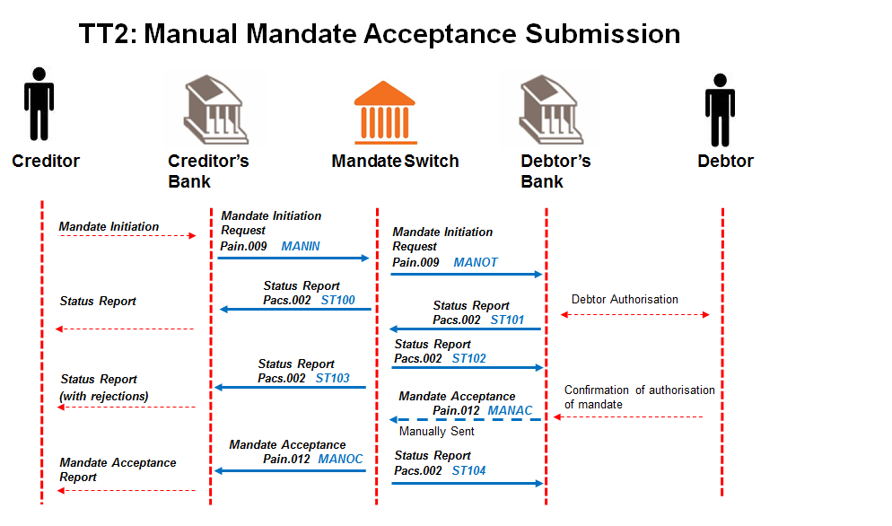

## Creditor sends batch of mandate initiation requests to Creditor Bank.

Message format to be determined by the Creditor Bank, but messages sent to Creditor Bank must contain all the data elements needed to create the mandate initiation requests (pain.009).

## Creditor Bank sends batch of mandate initiation requests (pain.009) to ACH.

Creditor Bank validates the Creditors and confirms that they are in good standing and submits batch of mandate initiation requests to the ACH.

## ACH validates requests and sends status report (pacs.002) to Creditor Bank.

ACH performs the following minimum validation:

* Message structure
* Member banks
* Date check

## ACH sends valid batch mandate initiation requests (pain.009) to Debtor Banks.

## Debtor Bank validates batch mandate initiation requests (pain.009).

Debtor Bank performs the following minimum validation:

* the account is a valid account for AC,
* the account is “open” and “active” (not frozen; closed etc.);
* the Debtor’s ID number matches the account details provided.
* *Optional requirement*: if the Debtor Bank uses the mobile service as the authorisation channel, check if the supplied number matches the mobile number of the Debtor as registered by the Debtor Bank. It is at the Debtor Bank’s discretion to use this number for alternate communication but the Debtor Bank will use their registered Payer’s details for authorisation of the mandate.

## Debtor Bank responds with status report (pacs.002) to ACH.

The report from Debtor Bank will provide upfront rejections i.e. as per validations that have been unsuccessful.

## ACH replies with status report (pacs.002) to Debtor Bank.

ACH validates and matches responses to original request.

## ACH forwards status report (pacs.002) to Creditor Banks.

## Creditor Bank engages with Creditor with upfront rejections provided by the Debtor Banks.

Message format of status of mandate to Creditor to be determined by the Creditor Bank.

## Debtor Bank engages with the Debtor through their chosen authorisation channel.

Method of communicating with the Debtor to be determined by the Debtor Bank, but must contain the data elements specified in Appendix B that are required for authorisation.

## Debtor responds to authorisation request from Debtor Bank.

Debtor’s response could be either positive or negative.

## Debtor Bank updates Mandate Register on positive response from Debtor.

Once Debtor authorises mandate, Debtor Bank creates unique mandate reference number per mandate initiation request to include in mandate response.

## Debtor Bank unable to responds with batch mandate acceptance report (pain.012) to ACH.

Debtor Bank must provide ACH with mandate acceptance messages manually by end of the processing window depending on the scenario as per escalation and PASA BCP (Business Continuity Policy).

## ACH responds with status report (pacs.002) to Debtor Bank.

Status report is confirmation of receipt of mandate acceptance report.

## ACH forwards batch mandate acceptance report (pain.012) per Creditor Bank.

## Creditor Bank engages with Creditor.

Message format of mandate response to Creditor to be determined by the Creditor Bank.

**Alternative Case 5:**

**When Creditor attempts to log a duplicate mandate.**

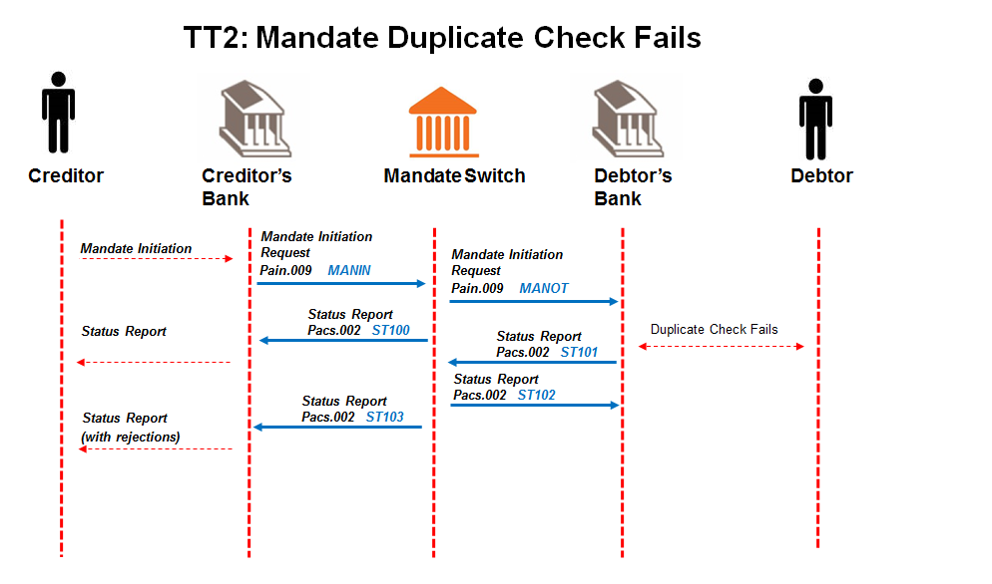

## Creditor sends batch of mandate initiation requests to Creditor Bank.

Message format to be determined by the Creditor Bank, but messages sent to Creditor Bank must contain all the data elements needed to create the mandate initiation requests (pain.009).

## Creditor Bank sends batch of mandate initiation requests (pain.009) to ACH.

Creditor Bank validates the Creditors and confirms that they are in good standing and submits batch of mandate initiation requests to the ACH.

## ACH validates requests and sends status report (pacs.002) to Creditor Bank.

ACH performs the following minimum validation:

* Message structure
* Member banks
* Date check

## ACH sends valid batch mandate initiation requests (pain.009) to Debtor Banks.

## Debtor Bank validates batch mandate initiation requests (pain.009) and duplicate check fails.

## Debtor Bank responds with status report (pacs.002) to ACH.

The report from Debtor Bank will provide upfront rejections validations that have been unsuccessful.

## ACH replies with status report (pacs.002) to Debtor Bank.

ACH validates and matches responses to original request.

## ACH forwards status report (pacs.002) to Creditor Banks.

## Creditor Bank engages with Creditor with upfront rejections provided by the Debtor Banks.

Message format of status of mandate to Creditor to be determined by the Creditor Bank.

**Alternative Case 6:**

**Debtor Bank receives authorisation from Debtor for a mandate after end of 2 day authorisation period.**

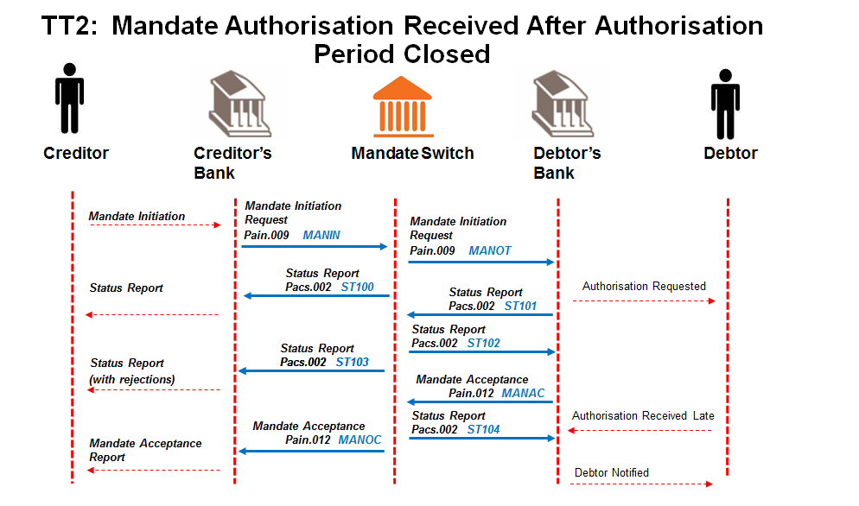

## Creditor sends batch of mandate initiation requests to Creditor Bank.

Message format to be determined by the Creditor Bank, but messages sent to Creditor Bank must contain all the data elements needed to create the mandate initiation requests (pain.009).

## Creditor Bank sends batch of mandate initiation requests (pain.009) to ACH.

Creditor Bank validates the Creditors and confirms that they are in good standing and submits batch of mandate initiation requests to the ACH.

## ACH validates requests and sends status report (pacs.002) to Creditor Bank.

ACH performs the following minimum validation:

* Message structure
* Member banks
* Date check

## ACH sends valid batch mandate initiation requests (pain.009) to Debtor Banks.

## Debtor Bank validates batch mandate initiation requests (pain.009).

Debtor Bank performs the following minimum validation:

* the account is a valid account for AC,
* the account is “open” and “active” (not frozen; closed etc.);
* the Debtor’s ID number matches the account details provided.
* *Optional requirement*: if the Debtor Bank uses the mobile service as the authorisation channel, check if the supplied number matches the mobile number of the Debtor as registered by the Debtor Bank. It is at the Debtor Bank’s discretion to use this number for alternate communication but the Debtor Bank will use their registered Payer’s details for authorisation of the mandate.

## Debtor Bank responds with status report (pacs.002) to ACH.

The report from Debtor Bank will provide upfront rejections i.e. as per 5.2.5 validations that have been unsuccessful.

## ACH replies with status report (pacs.002) to Debtor Bank.

ACH validates and matches responses to original request.

## ACH forwards status report (pacs.002) to Creditor Banks.

## Creditor Bank engages with Creditor with upfront rejections provided by the Debtor Banks.

Message format of status of mandate to Creditor to be determined by the Creditor Bank.

## Debtor Bank engages with the Debtor through their chosen authorisation channel.

Method of communicating with the Debtor to be determined by the Debtor Bank, but must contain the data elements specified in Appendix B that are required for authorisation.

## Debtor Bank responds with batch mandate acceptance report (pain.012) to ACH.

On Expiration Day (Day 2) - Debtor Bank will send a FINAL batch mandate acceptance report with all outstanding positive and negative (not authenticated and no responses) authorisations from Debtors per mandate initiation requests that were batched.

**If authorisation is not received from Debtor, Debtor Bank MUST deliver non-responses to ACH by Expiration Day (Day 2).**

## ACH responds with status report (pacs.002) to Debtor Bank.

Status report is confirmation of receipt of mandate acceptance report.

## ACH forwards batch mandate acceptance report (pain.012) per Creditor Bank.

## Creditor Bank engages with Creditor.

Message format of mandate response to Creditor to be determined by the Creditor Bank.

## Debtor responds to authorisation request from Debtor Bank after Authorisation period ends.

Debtor Bank must not register the mandate as a no response was already sent in the mandate acceptance report (pain.012).

## Debtor Bank notifies Debtor to take up with Creditor as mandate cannot be created.

* + 1. TT2 - Amendment of a Mandate (Authorisation required)

**Alternative Case 1:**

**Batch mandate amendment request from Creditor fails at Creditor Bank**.

**Creditor sends mandate amendment requests to Creditor Bank; containing the unique mandate reference numbers of the mandates that it needs to amend.**

Message format to be determined by the Creditor Bank, but message sent to Creditor Bank must contain all the data elements needed to create the mandate amendment requests (pain.010).

**Creditor Bank sends negative response to Creditor.**

**Alternative Case 2:**

**Batch Mandate amendment request (****pain.0****10) from Creditor Bank fails at ACH.**

**Creditor sends mandate amendment requests to Creditor Bank; containing the unique mandate reference numbers of the mandates that it needs to amend.**

Message format to be determined by the Creditor Bank, but message sent to Creditor Bank must contain all the data elements needed to create the mandate amendment requests (pain.010). Must indicate that Authorisation is **not** required.

**The Creditor Bank sends mandate amendment requests (****pain.010****) to ACH.**

Creditor bank validates the Creditor and confirms that he is in good standing and submits amendment requests to the ACH.

**ACH validates requests and sends status report (****pacs.002****) to Creditor Bank with rejected status.**

**Creditor Bank sends negative batch response to Creditor.**

**Alternative Case 3:**

**Batch Mandate amendment request (****pain.0****10) from Creditor Bank fails at ACH/Debtor Bank.**

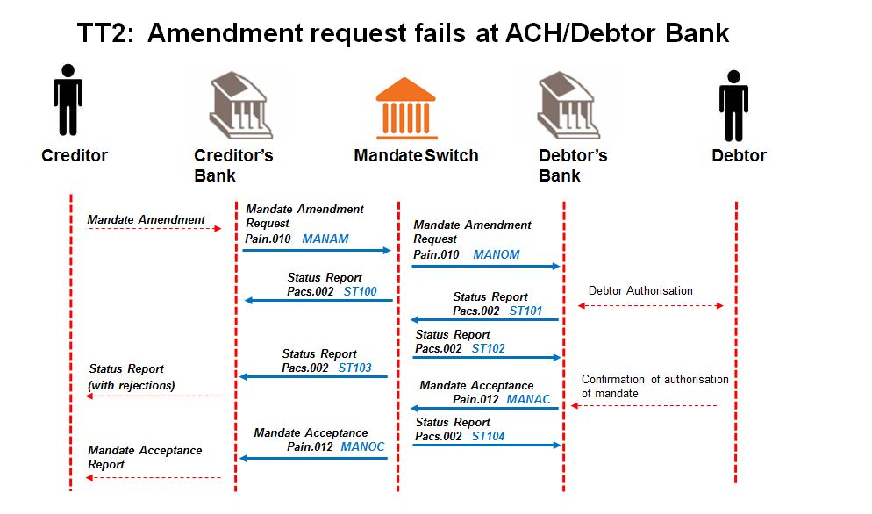

**Creditor sends mandate amendment requests to Creditor Bank; containing the unique mandate reference numbers of the mandates that it needs to amend.**

Message format to be determined by the Creditor Bank, but message sent to Creditor Bank must contain all the data elements needed to create the mandate amendment requests (pain.010). Must indicate that Authorisation is required

**The Creditor Bank sends mandate amendment requests (****pain.010****) to ACH.**

Creditor bank validates the Creditor and confirms that he is in good standing and submits amendment requests to the ACH.

**ACH validates requests and sends status report (****pacs.002****) to Creditor Bank including rejected transactions.**

**Creditor Bank engages with Creditor on rejected transactions.**

**The ACH forwards valid mandate amendment requests (****pain.010****) and to the Debtor Bank.**

**The Debtor Bank sends a status report (with upfront rejections) (****pacs.002****) to ACH.**

The Debtor Bank compares the mandate information stored in the mandate register with the corresponding unique mandate reference numbers.

As well as a notification of all mandate reference numbers that do not match the original request as per the mandate register.

**ACH sends this status report (****pacs.002****) to Creditor Bank.**

**ACH replies with status report (****pacs.002****) to Debtor Bank.**

**The Debtor Bank validates and processes the mandate amendment requests.**

Re-authorisation is required from the Debtor depending on the data element to be amended as part of the Debtor’s mandate authorised (refer to Appendix D).

The rules per Batch Use Case (TT2) defined for AC will apply

The Debtor Bank would update all successful amendment requests in the mandate register and the change would be noted as part of the audit log.

**The successful and unsuccessful amendments to mandates are then submitted to the ACH as part of the mandate acceptance report (****pain.012****).**

**ACH replies with status report (****pacs.002****) to Debtor Bank.**

**ACH forwards mandate amendment acceptance report (****pain.012****) to Creditor Bank.**

**Creditor Bank engages with Creditor.**

Message format of mandate response to Creditor to be determined by the Creditor Bank.

**Alternative Case 4:**

**Mandate Amendment Process (Batch):**

**No Authorisation Required – 0226 (with errors)**

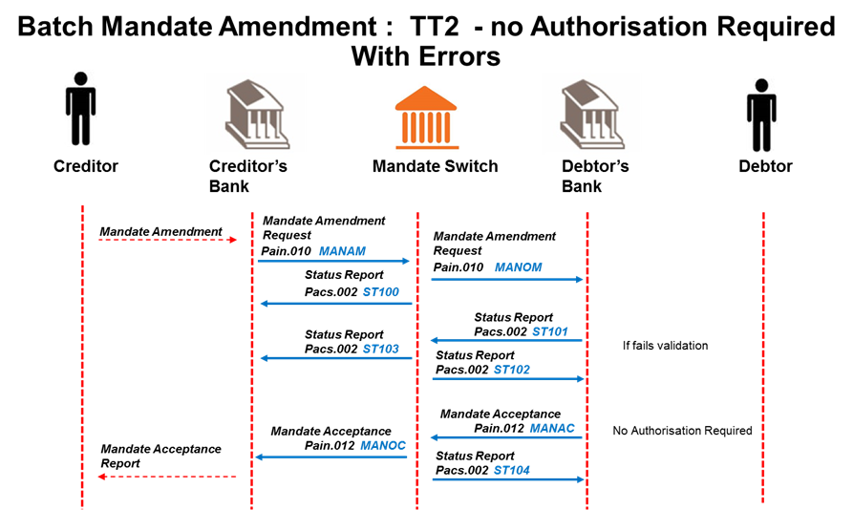

**Creditor sends mandate amendment requests to Creditor Bank; containing the unique mandate reference numbers of the mandates that it needs to amend.**

Message format to be determined by the Creditor Bank, but message sent to Creditor Bank must contain all the data elements needed to create the mandate amendment requests (pain.010). Must indicate that Authorisation is **not** required.

## 

**The Creditor Bank sends mandate amendment requests** (pain.010) **to ACH.**

Creditor bank validates the Creditor and confirms that he is in good standing and submits amendment requests to the ACH.

**ACH validates requests and sends status report (****pacs.002****) to Creditor Bank including rejected transactions.**

**Creditor Bank engages with Creditor on rejected transactions.**

**The ACH forwards valid mandate amendment requests (****pain.010****) and to the Debtor Bank.**

**The Debtor Bank validates and processes the mandate amendment requests.**

**The Debtor Bank sends a status report (with upfront rejections) (****pacs.002****) to ACH.**

The Debtor Bank compares the mandate information stored in the mandate register with the corresponding unique mandate reference numbers.

Any validation failures are returned in a pacs.002 status report.

**ACH sends this status report (****pacs.002****) to Creditor Bank.**

**ACH replies with status report (****pacs.002****) to Debtor Bank.**

**The successful amendments to mandates are then submitted to the ACH as part of the mandate acceptance report** (pain.012)**.**

The Debtor Bank would update all successful amendment requests in the mandate register and the change would be noted as part of the audit log.

**ACH replies with status report (**pacs.002**) to Debtor Bank.**

**ACH forwards mandate acceptance report** (pain.012) **to Creditor Bank.**

## 

**Creditor Bank engages with Creditor.**

Message format of mandate response to Creditor to be determined by the Creditor Bank.

**Alternative Case 5:**

**Batch Mandate amendment request (****pain.0****10) from Creditor Bank contains both 0226 (no authorisation is required) and 0227 (authorisation is required) messages**

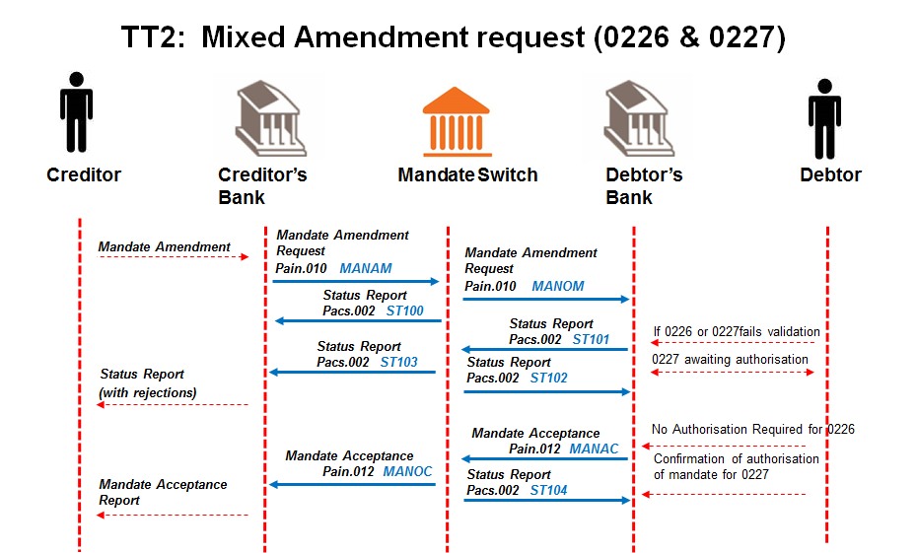

**Creditor sends mandate amendment requests to Creditor Bank; containing the unique mandate reference numbers of the mandates that it needs to amend.**

Message format to be determined by the Creditor Bank, but message sent to Creditor Bank must contain all the data elements needed to create the mandate amendment requests (pain.010). Must indicate that either authorisation is required (0226) or no authorisation is required (0227).

**The Creditor Bank sends mandate amendment requests (****pain.010****) containing both Debtor Authentication Required 0226 and 0227 to ACH.**

Creditor bank validates the Creditor and confirms that he is in good standing and submits the amendment requests to the ACH.

**ACH validates requests and sends status report (****pacs.002****) to Creditor Bank including rejected transactions.**

**Creditor Bank engages with Creditor on rejected transactions.**

**The ACH forwards valid mandate amendment requests (****pain.010****) to the Debtor Bank.**

**The Debtor Bank sends a status report of 0226 rejections and all 0227 outcomes (both valid amendments and rejections) (****pacs.002****) to ACH.**

The Debtor Bank performs validations on all amendments. The 0226 & 0227 rejections and the 0227 valid requests can be returned in a single pacs.002 file.

**ACH sends this status report (****pacs.002****) to Creditor Bank.**

**ACH replies with status report (****pacs.002****) to Debtor Bank.**

**The Debtor Bank validates and processes the mandate amendment requests.**

Re-authorisation is required from the Debtor depending on the data element to be amended as part of the Debtor’s mandate authorised (refer to Appendix D).

0227 amendment requests will be returned with both positive and negative responses. 0226 amendment requests will only be returned as positive responses (Negative responses went back in pacs.002).

The Debtor Bank would update all successful amendment requests in the mandate register and the change would be noted as part of the audit log.

**The successful (0226 & 0227) and unsuccessful (only 0227) amendments to mandates are then submitted to the ACH as part of the mandate acceptance report (****pain.012****).**

**ACH replies with status report (****pacs.002****) to Debtor Bank.**

**ACH forwards mandate amendment acceptance report (****pain.012****) to Creditor Bank.**

**Creditor Bank engages with Creditor.**

Message format of mandate response to Creditor to be determined by the Creditor Bank.

**Note:** (as per TDA discussion 28/2/2017)

Mandate Amendment Request files (pain.010), Mandate Acceptance Reports (pain.012) and Status Reports (pacs.002) may contain a mixture of 0226 and 0227 Debtor Authentication Required types

* + 1. TT2 - Cancellation of a Mandate

**Alternative Case 1:**

**Batch mandate cancellation request from Creditor fails at Creditor Bank**.

**Creditor sends mandate cancellation requests to Creditor Bank; containing the unique mandate reference numbers of the mandates that it needs to cancel.**

Message format to be determined by the Creditor Bank, but messages sent to Creditor Bank must contain all the data elements needed to create the mandate cancellation request (pain.011).

**Creditor Bank sends negative response to Creditor.**

**Alternative Case 2:**

**Batch Mandate cancellation request (****pain.0****11) from Creditor Bank fails at ACH.**

**Creditor sends mandate cancellation requests to Creditor Bank; containing the unique mandate reference numbers of the mandates that it needs to cancel.**

Message format to be determined by the Creditor Bank, but messages sent to Creditor Bank must contain all the data elements needed to create the mandate cancellation request (pain.011).

**The Creditor Bank sends mandate cancellation requests (****pain.011****) to ACH.**

Creditor bank validates the Creditor and confirms that he is in good standing and submits cancellation requests to the ACH.

**ACH validates requests, rejects the whole batch and sends status report (****pacs.002****) to Creditor Bank.**

**Creditor Bank sends negative batch response to Creditor.**

**Alternative Case 3:**

**Batch Mandate cancellation request (****pain.0****11) from Creditor Bank fails at ACH/Debtor Bank.**

**Creditor sends mandate cancellation requests to Creditor Bank; containing the unique mandate reference numbers of the mandates that it needs to cancel.**

Message format to be determined by the Creditor Bank, but messages sent to Creditor Bank must contain all the data elements needed to create the mandate cancellation request (pain.011).

**The Creditor Bank sends mandate cancellation requests (****pain.011****) to ACH.**

Creditor bank validates the Creditor and confirms that he is in good standing and submits cancellation requests to the ACH.

**ACH validates requests and sends status report (****pacs.002****) to Creditor Bank including rejections.**

**The ACH forwards the valid mandate cancellation requests (****pain.011****) to the Debtor Bank.**

**The Debtor Bank validates and processes the mandate cancellation requests (****pain.011****).**

The Debtor Bank compares the mandate information stored with the corresponding unique mandate reference number, and updates the Mandate Register accordingly.

**The debtor bank sends status report (pacs.002) to ACH with upfront rejections.**

**ACH forwards status report (pacs.002) to Creditor bank.**

**The Creditor Bank engages with the Creditor.**

**The Debtor Bank submits the Mandate cancellation acceptance report (****pain.012****) to the ACH.**

**The Debtor Bank engages with the Payer.**

This is to advise on the successful and unsuccessful status of the mandate cancellation request.

**ACH replies with status report (****pacs.002****) to Debtor Bank.**

**ACH forwards mandate cancellation acceptance report (****pain.012****) to Creditor Bank.**

**The Creditor Bank engages with the Creditor.**

* + 1. TT2 - Mandate Request for Information

**Alternative Case 1:**

**Batch Mandate request for information (**_Mandate_Initiation_Request_1**mdte.001) from Creditor Bank fails at ACH/Debtor Bank.**

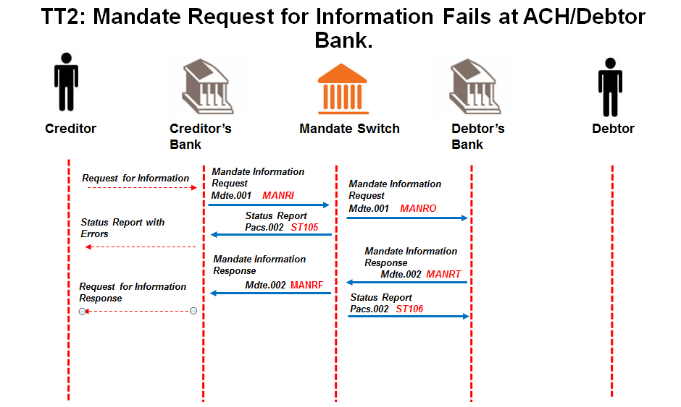

**The Creditor creates a batch mandate information request** **with one or more request transactions containing the unique mandate reference number/s of the mandate/s that it needs to confirm the information of, and sends it to the Creditor Bank.**

Message format to be determined by the Creditor Bank, but messages sent to Creditor Bank must contain all the data elements needed to create the mandate initiation requests (mdte.001).

**The Creditor Bank forwards the batched mandate information request (****mdte.001****) to the ACH.**

Creditor bank validates the Creditor and confirms that he is in good standing and submits batched mandate information request to the ACH.

**The ACH validates the batched mandate information request (****mdte.001****) and sends status report** (**pacs.002**) **to the Creditor Bank including rejections.**

**ACH sends valid batch mandate information request (****mdte.001****) to the Debtor Bank.**

**The Debtor Bank validates and processes the batched mandate information request (****mdte.001****).**

The Debtor Bank compares the mandate information stored in the mandate register with the corresponding unique mandate reference numbers, as well as a notification of all mandate reference numbers that do not match the original request as per the mandate register. All necessary information will be included in the response message.

**The Debtor Bank submits the mandate information response (****mdte.002****) to the ACH.**

**ACH replies with status report (****pacs.002****) to Debtor Bank.**

**ACH forwards mandate information response (****mdte.002****) to Creditor Bank.**

**The Creditor Bank engages with the Creditor.**

Message format of the request for information responses to Creditor to be determined by the Creditor Bank.

* 1. Payment Alternate Case Scenarios

**Payment alternate scenarios are catered for via the pacs.002 Status Report and the validation rules for pacs.003**

# BIC ISO Message Templates

BIC ISO is a messaging protocol for card originated financial transactions. BIC ISO has been adapted to carry mandate authentication elements to allow real time.

Participants using BIC ISO for real time switching will be required to support the following messages in addition to the Mandate Authentication Request and Mandate Authentication Response messages detailed in this section

* Timeout and Reversal messages
* Reconciliation Messages
* Network Management Messages

**R8 Token Notes:**

* Account number and Maximum Collection amount in the R8 token must be left padded with zeros

## Authentication Request (BIC ISO 0200 message)

The BIC ISO 200 message has been adapted for Authentication Requests.

An additional token has been added (token R8) for new fields identified by the AC TRS WG.

**Populating elements of Token R8**

The Contract Reference, Account Number, Debtor Identification and Maximum Collection Amount are mandatory fields in the token.

Account numbers must be filled to the left with zeroes

**Validations performed on Token R8**

When banks receive a 0200 message containing an R8 token, the account number and identification number of the debtor must be checked against account details held. The error codes listed in the table below must be returned in the Response Code of the R8 token.

**Table of Error Codes**

|  |  |
| --- | --- |
| 000000 | Successful |
| 910001 | Account Number is invalid |
| 910002 | Account is not matched to ID number |
| 910003 | Account Number not linked to client’s profile |
| 910099 | Message Element <Message Element Name> must not be zero or spaces |

| **AUTHENTICATION REQUEST: Message Class 0200** | | |
| --- | --- | --- |
| Field Name | Field Definition | Description |
| **Message Header** | | |
| ISO Literal | X(03) | Must contain “ISO” |
| Base24 Header | 9(09) |  |
| Product Indicator | 9(02) | Must contain **02** |
| Release Number | 9(02) | Must contain **50 or** **60** |
| Status | 9(03) |  |
| Originator Code | 9(01) |  |
| Responder Code | 9(01) |  |
| Message Type Identifier | 9(04) | BIC ISO message identifier. This field must contain **0200** |
| Primary Bit Map | HEX(16) |  |
| **Data Elements** | | |
| **P-1** Secondary Bit Map | HEX (16) | Identifies the elements |
| **P-3** Processing Code | 9 (06) | Account Type in 3rd and 4th positions |
| **P-4** Transaction Amount | 9 (12) | Must be 0 |
| **P-7** Transmission Date and Time | 9 (06) | Date and time in format (UTC) **MMDDHHMMSS** |
| **P-11** System Trace Audit Number | 9 (06) | Used for matching responses to messages |
| **P-12** Local Transaction Time | 9 (06) | Time in format **HHMMSS** |
| **P-13** Local Transaction Date | 9 (04) | Date in format **MMDD** |
| **P-14** Expiration Date | 9 (04) | Date in format **YYMM** Card expiry |
| **P-17** Capture Date | 9 (04) | Date in format **MMDD** |
| **P-18** Merchant’s Type | 9 (04) | Retailer code, type of business |
| **P-22** Point of service entry Mode | 9 (03) | Track data entry mode |
| **P-25** Point of Service Condition Code | 9 (02) | Identified the condition of the transaction. |
| **P-32** Acquiring Institution Identification Code | 9( 02) | 1 – 2 Length (must contain 02)  3 – 4 Acquiring financial institution code |
| **P-35** Track 2 Data | X (40) | Includes Primary Account Number up to 19 digits |
| **P-37** Retrieval Reference Number | X (12) | RRN, Unique message identifier |
| **P-41** Card Acceptor Terminal Identification | X (16) | Terminal ID - First 8 characters can be used in creation of transaction MAC |
| **P-42** Card Acceptor Identification Code | X (15) | Merchant (Ultimate Creditor) |
| **P-43** Card Acceptor Name/Location | X (40) | Name / Location |
| **P-48** Additional Data: Retail Data | X (40) |  |
| **P-49** Transaction Currency Code | 9 (03) | Must contain 710 |
| **P-52** PIN Data | X (16) |  |
| **P-60** POS Terminal Data | 9 (03)  X (04)  X (12) | 1 – 3 Field length, (must be 016)  4 – 7 Must contain “ACOL”  8 – 19 Internal use |
| **P-61** POS Card Issue-Category-Response Code Data | X (22) |  |
| **P-63** POS Additional Data | X (03)  X (01)  X (01)  9 (05)  9 (05)  X (01)  X (01)  X (02)  9 (05)  X (01)  X (14)  9 (19)  X (35)  9 (12)X (08)  X (06)  X (06) | 1 – 3 Length (Contains 125)  **HEADER TOKEN**  4 - Eye Catcher value ‘&’  5 – User Fld1  6 – 10 Count value 1  11 -15 Length value 122  **TOKEN HEADER**  16 Eye Catcher value ‘!’  17 User Fld1  18 – 19 Token ID value ‘R8’  20 – 24 Length value 00100  25 User Fld2  **TOKEN R8**  *Request portion*  26 – 39 Contract Reference (14 characters)  40 – 58 Account Number (19 numenric)  59 – 93 Debtor Identification  This element is mandatory and must be constructed as follows  Document type (1 character)  “P” = Passport  “I“ = ID Document  “T” = Temporary residence Id  “/” (1 character)  Identification Document No (33 characters)  94 – 105 Maximum Collection Amount (12 numeric)  ***Response portion***  105 – 113 Auth Mac  114 – 119 – Response Code  120– 125 Filler |
| **S-98** Payee | X (25) |  |
| **S-121** POS Auth Indicators- CRT Authorisation Data | X (23) |  |
| **S-123** POS Invoice Data | X (23) |  |
| **S-124** POS Batch and Shift Data | X (12) |  |
| **S-125** POS Settlement Data | X (15) |  |
| **S-126** POS Pre-Auth and Chargeback Data | X (05) |  |
|  |  |  |

Note that if the account number field in the R8 token is set to all spaces or all zeros, the default account for the selected account type should be determined by the issuer and the R8 token updated accordingly. If it is not set to all spaces or all zeros, the existing R8 processing can continue with the R8 token unchanged.

## Authentication Response (BIC ISO 0210 message)

The BIC ISO message 210 is used as an Authentication Response message and is detailed below:

| **AUTHENTICATION RESPONSE: Message Class 0210** | | |
| --- | --- | --- |
| Field Name | Field Definition | Description |
| **Message Header** | | |
| ISO Literal | X(03) | Must contain “ISO” |
| Base24 Header | 9(09) |  |
| Product Indicator | 9(02) | Must contain **02** |
| Release Number | 9(02) | Must contain **50 or** **60** |
| Status | 9(03) |  |
| Originator Code | 9(01) |  |
| Responder Code | 9(01) |  |
| Message Type Identifier | 9(04) | BIC ISO message identifier. This field must contain **0210** |
| Primary Bit Map | HEX(16) |  |
| **Data Elements** | | |
| **P-1** Secondary Bit Map | HEX (16) | Identifies the elements |
| **P-3** Processing Code | 9 (06) | Account Type in 3rd and 4th positions |
| **P-4** Transaction Amount | 9 (12) | Must be 0 |
| **P-7** Transmission Date and Time | 9 (06) | Date and time in format (UTC) **MMDDHHMMSS** |
| **P-11** System Trace Audit Number | 9 (06) | Used for matching responses to messages |
| **P-12** Local Transaction Time | 9 (06) | Time in format **HHMMSS** |
| **P-13** Local Transaction Date | 9 (04) | Date in format **MMDD** |
| **P-14** Expiration Date | 9 (04) | Date in format **YYMM** Card expiry |
| **P-17** Capture Date | 9 (04) | Date in format **MMDD** |
| **P-18** Merchant’s Type | 9 (04) | Retailer code, type of business |
| **P-22** Point of service entry Mode | 9 (03) | Track data entry mode |
| **P-25** Point of Service Condition Code | 9 (02) | Identified the condition of the transaction. |
| **P-32** Acquiring Institution Identification Code | 9( 02) | 1 – 2 Length (must contain 02)  3 – 4 Acquiring financial institution code |
| **P-35** Track 2 Data | X (40) | Includes Primary Account Number up to 19 digits |
| **P-37** Retrieval Reference Number | X (12) | RRN, Unique message identifier |
| **P-38** Authorisation Identification Code | X (06) |  |
| **P-39** Response Code | X (02) |  |
| **P-41** Card Acceptor Terminal Identification | X (16) | Terminal ID - First 8 characters can be used in creation of transaction MAC |
| **P-42** Card Acceptor Identification Code | X (15) | Merchant (Ultimate Creditor) |
| **P-43** Card Acceptor Name/Location | X (40) | Name / Location |
| **P-49** Transaction Currency Code | 9 (03) | Must contain 710 |
| **P-52** PIN Data | X (16) |  |
| **P-60** POS Terminal Data | 9 (03)  X (04)  X (12) | 1 – 3 Field length, (must be 016)  4 – 7 Must contain “ACOL”  8 – 19 Internal use |
| **P-61** POS Card Issue-Category-Response Code Data | X (22) |  |
|  |  |  |
| **P-63** POS Additional Data | X (03)  X (01)  X (01)  9 (05)  9 (05)  X (01)  X (01)  X (02)  9 (05)  X (01)  X (14)  9 (19)  X (35)  9 (12)  X (08)  X (06)  X (06) | 1 – 3 Length (Contains 125)  **HEADER TOKEN**  4 - Eye Catcher value ‘&’  5 – User Fld1  6 – 10 Count value 1  11 -15 Length value 122  **TOKEN HEADER**  16 Eye Catcher value ‘!’  17 User Fld1  18 – 19 Token ID value ‘R8’  20 – 24 Length value 00100  25 User Fld2    **TOKEN R8**  *Request portion*  26 – 39 Contract Reference (14 characters)  40 – 58 Account Number  59 – 93 Debtor Identification  94 – 105 Maximum Collection Amount  ***Response portion***  105 – 113 Auth Mac  114 – 119 – Response Code  120– 125 Filler |
| **S-98** Payee | X (25) |  |
| **S-100** Receiving Institution Identification Code | 9 (11) |  |
| **S-102** Account Identification 1 | 9 (02)  9 (19) | 1 - 2 Length (Must contain 28)  3 – 21 Account Identifier – must be numeric for file MACing (Account Identifier comprises  3-8 Branch code (optional)  9-21 account number right justified zero filled to the left) |
| **S-121** POS Auth Indicators- CRT Authorisation Data | X (23) |  |
| **S-123** POS Invoice Data | X (23) |  |
| **S-125** POS Settlement Data | X (15) |  |
| **S-126** POS Pre-Auth and Chargeback Data | 9 (02)  X (03) | 1 – 2 Length (Must contain 3)  3 – 6 Unspecified |
|  |  |  |

# ISO20022 Mandate Message Templates

**Rules**

* The date in the Message Identification must be the processing date.
* The File Number in the Message Identification must be incremented by 1 for each new message for the service from that originator.
* The File Number must start from 1 every day after cut over (24H00)
* Numeric fields must not have leading zeros
* Amounts must contain the decimal value
* All mandatory fields must be populated (not spaces or zeros)
* No spaces will be allowed before or after data populated in tags - spaces may be contained within the data. e.g.: “po__li__ce”
* If field defined as “Text” contains numbers, all leading zeros must be removed. Defined values for attributes are not to be adjusted.
* For batch files, where the Institution Identifier in the Message Identification <MsgId>  or Assignment Identification <Id> indicates it must be populated with the sender’s details, it must contain the identifier of the institution sending the message on input to BankservAfrica, and must contain the identifier of the institution receiving the message on output from BankservAfrica
* <MsgId> & <OrgnlMsgId> tags must be populated in the pattern ACH ID/ID of the service/Institution identifier of sender/Creation Date/File Number
* For all optional message elements where data was not provided or conditional message elements which did not require that data is populated, in this case the relevant XML tag must be omitted from the message.

## Mandate Initiation Request <pain.009>

**Scope**

The Mandate Initiation Request message is sent by the initiator of the request to his bank. The initiator may be the Creditor or the Creditor Bank.

If authentication is required of the Debtor Bank, the message element Local Instrument must contain the appropriate value.

**Service Codes**

This Mandate Initiation Request is used for the service codes of:

* Real Time
  + - MANIN
* Batch
  + - MANIN
    - MANOT

**Processing Rules**

Debtor Bank must perform duplicate transaction checking using the following fields:

* Debtor Account Number
* Contract Reference Number
* Creditor Abbreviated Name (Short name)
* Sequence Type

Contact Details must exist at the Debtor Bank for all Mandate Requests with a Debtor Authentication Required code of 0227, 0229 and 0230.

**Key – within the table the following abbreviations are used**

* **M = Mandatory**
* **O = Optional**
* **C = Conditional**

## Mandate Acceptance Report <pain.012> for Mandate Initiation <pain.009>

**Scope**

The Mandate Acceptance Report message is sent from the Debtor Bank to the initiator of the Mandate Request message (Creditor or Creditor Bank).

**Service Codes**

This Mandate Acceptance Report is used for the service codes of:

* Real Time
  + - MANIR
    - MANDR
* Batch
  + - MANAC
    - MANOC

**Rules**

Fields on the mandate acceptance report must reflect the original mandate maintenance message, being an initiation.

All elements stored on the database and any changes as a result of the initiation must be returned.

This message will contain at least one acceptance message.

The date in the Message Identification must be the processing date.

The File Number in the Message Identification must be incremented by 1 for each new message for the service from that originator.

The File Number must start from 1 every day after cut over (24H00)

Mandate Reference Number needs to be conditional as per Rule (If Authentication Status Indicator = NRSP or NAUT, then this field must be null only on a reply to a Mandate Initiation Request)

## Mandate Amendment Request <pain.010>

**Scope**

The Mandate Amendment Request message is sent by the initiator; Creditor or Creditor Bank.

**Service Codes**

This Mandate Amendment Request is used for the service codes of:

* Real Time
  + - * MANAM
* Batch
  + - * MANAM
      * MANOM

**Rules**

The date in the Message Identification must be the processing date.

The File Number in the Message Identification must be incremented by 1 for each new message for the service from that originator.

The File Number must start from 1 every day after cut over (24H00)

Amendment rule: Only elements that require update in the mandate register or are mandatory need be included in mandate amendment request.

**Note:-** This is only applicable when amending the mandate for Contract Reference Change (SCR 204v3 - **Contract Reference may be amended subject to no Collection having occurred**)

***Processing Rules***

*Debtor Bank must perform duplicate transaction checking using the following fields:*

* *Debtor Account Number*
* *Contract Reference Number*
* *Creditor Abbreviated Name (Short name)*
* *Sequence Type*

## Debtor bank to use error code 902204 Duplicate Request. Mandate already exists should the amendment cause a duplicate.Mandate Acceptance Report <pain.012> for Mandate Amendment <pain.010>

**Scope**

The Mandate Acceptance Report message is sent from the Debtor Bank to the initiator of the Mandate Request message (Creditor or Creditor Bank).

**Service Codes**

This Mandate Acceptance Report is used for the service codes of:

* Real Time
  + - MANIR
    - MANDR
* Batch
  + - MANAC
    - MANOC

**Rules**

Fields on the mandate acceptance report must reflect the original mandate maintenance message, being an amendment.

All elements stored on the database and any changes requested in the amendment must be returned.

This message will contain at least one acceptance message.

The date in the Message Identification must be the processing date.

The File Number in the Message Identification must be incremented by 1 for each new message for the service from that originator.

The File Number must start from 1 every day after cut over (24H00)

Mandate Reference Number needs to be conditional as per Rule (If Authentication Status Indicator = NRSP or NAUT, then this field must be null only on a reply to a Mandate Initiation Request)

## Mandate Cancellation Request <pain.011>

**Scope**

The Mandate Cancellation Request message is sent by the initiator (Creditor) of the request to the Creditor Bank.

**Service Codes**

This Mandate Cancellation Request is used for the service codes of:

* Real Time
  + - MANCN
* Batch
  + - MANCN
    - MANCO

**Rules**

The date in the Message Identification must be the processing date.

The File Number in the Message Identification must be incremented by 1 for each new message for the service from that originator.

The File Number must start from 1 every day after cut over (24H00)

## Mandate Acceptance Report <pain.012> for Mandate Cancellation <pain.011>

**Scope**

The Mandate Acceptance Report message is sent from the Debtor Bank to the initiator of the Mandate Request message (Creditor or Creditor Bank).

**Service Codes**

This Mandate Acceptance Report is used for the service codes of:

* Real Time
  + - MANIR
* Batch
  + - MANAC
    - MANOC

**Rules**

Fields on the mandate acceptance report must reflect the original mandate maintenance message, being a cancellation.

All elements stored on the database and any changes requested in the cancellation must be returned.

This message will contain at least one acceptance messageThe date in the Message Identification must be the processing date.

The File Number in the Message Identification must be incremented by 1 for each new message for the service from that originator.

The File Number must start from 1 every day after cut over (24H00)

Mandate Reference Number needs to be conditional as per Rule (If Authentication Status Indicator = NRSP or NAUT, then this field must be null only on a reply to a Mandate Initiation Request

## Status Report <pacs.002> for Status of Real Time Mandate Requests

**Scope**

This Status Report message is sent by the Debtor Bank to the mandate initiation request originator. It is used to inform the originator of an upfront validation (successful/rejection) of the mandate initiation request and to indicate that an authorisation request has been sent to the Debtor.

**Rules**

Message rules stipulate that only one Status Report message per mandate Initiation, Amendment and Cancellation request is required.

The status report message provides status information about instructions previously sent.

The date in the Message Identification must be the processing date.

The File Number in the Message Identification must be incremented by 1 for each new message for the service from that originator.

The File Number must start from 1 every day after cut over (24H00)

**Service Codes**

This Status Report is used for the service codes of:

* STMAN
* STMDF

## Status Report <pacs.002> for response to real time mandate acceptance messages <pain.012>

**Scope**

The status report message is sent by the creditor bank to acknowledge receipt of a mandate acceptance message pain.012.

This status report message is used to indicate to the debtor bank that the creditor bank has received a mandate acceptance message and that

* The message is not matched to the original mandate message or
* The mandate maintenance cycle is complete, or
* The mandate acceptance message is a duplicate

**Rules**

The date in the Message Identification must be the processing date.

The File Number in the Message Identification must be incremented by 1 for each new message for the service from that originator.

The File Number must start from 1 every day after cut over (24H00)

**Service Codes**

This Status Report is used for the service codes of:

* ST012

## Status Report <pacs.002> for Status of Batch Mandate Requests and Responses

**Scope**

This Status Report message is sent by the Debtor Bank to the mandate initiation request originator. It is used to inform the originator of an upfront validation (successful/rejection) of the mandate initiation request and to indicate that an authorisation request has been sent to the Debtor.

**Rules**

Message rules stipulate that only one Status Report message per mandate initiation request file is required.

The status report message provides status information about instructions previously sent.

The date in the Message Identification must be the processing date.

The File Number in the Message Identification must be incremented by 1 for each new message for the service from that originator.

The File Number must start from 1 every day after cut over (24H00)

**Service Codes**

This Status Report is used for the service codes of:

* ST101
* ST103

## Customer Payment Cancellation <camt.055> (Notification to Suspend Mandate)

**Scope**

This message is used indicate that a request to suspend a mandate has been initiated by the debtor and that the creditor must not initiate a debt according to a previously agreed mandate.

**Service Codes**

This Suspend Mandate message has service codes of:

* SPINP
* SPOUT

## Status Report <pacs.002> for Mandate Suspension Confirmations

**Scope**

The Status Report message is sent by the Creditor Bank via ACH to the message originator.

This usage of the pacs.002 is used to confirm the receipt of a Mandate Suspension to the originator (camt.055 Customer Payment Cancellation Request (Mandate Suspension Notification) message).

**Service Codes**

This Status Report is used for the service codes of:

* SRINP
* SROUT

## Request for Mandate Information <mdte.001>

**Scope**

The Request for Mandate Information message is sent from the Creditor requesting mandate information to the holder of mandate register.

**Service Codes**

This Mandate Request for Information has service codes of:

* MANRI
* MANRO

## Response from Mandate Information Request <mdte.002>

**Scope**

The Response from Mandate Information request message is sent to the creditor from holder of mandate database

**Service Codes**

This Mandate Response to the Request for Information has service codes of:

* MANRT
* MANRF

# ISO20022 Collection Message Templates

## Direct Debit Transaction <pacs.003>

**Scope**

The Direct Debit message is sent by the Creditor to the Debtor Bank through the Automated Clearing House. It is used to collect funds from a debtor account.

Note that the direct debit is not a financial instruction but a request for payment. The financial transaction is contained in the pacs.002 debit response.

**Service Codes**

This Direct Debit has service codes of:

* DDINP
* DDOUT

**Rules**

All collections contained in a direct debit message must be for the same settlement date as the settlement date is specified in the group header in **<IntrBkSttlmDt> -** This implies that separate files will be created by the creditor bank for 6 and 7 day processing banks.

The **<IntrBkSttlmAmt>** will contain the transaction amount requested by the creditor.

The **<IntrBkSttlmDt>** will be included on group level.

Rule 003.059 to be applied to the seventh consecutive unsuccessful debit

## Status Report <pacs.002> for Debit Responses

**Scope**

This Status Report message is sent by the Debtor Bank via the ACH to the message originator. It is used to inform the originator of a positive or negative result of debit requests.

**Rules**

Only one transaction response is required per debit request (excluding any tracking final fate). Only positive responses will result in settlement.

**Service Codes**

This Status Report is used for the service codes of:

* DRINP
* DROUT

## Payment Return <pacs.004> for Direct Debits

**Scope**

The Payment Return message is sent by a debtor bank through the Automated Clearing House to a creditor bank to undo (reverse) a direct debit previously settled. It is used to move funds from a debtor account to a creditor.

**Rules**

* Payment return messages are used for returns after settlement has occurred.
* Payment return messages may be for single or multiple instructions delivered in single or multiple files.
* Payment return messages use end-to-end transaction identifiers to reference original transactions.
* Payment messages for different payment types may not be included in the same input file.
* Payment return messages are used only for error corrections.

**Service Codes**

This Payment Return is used with the following service codes:

* Bank Error
* REINP
* REOUT
* Disputes
* RTINP
* RTOUT

## Payment Cancellation Request <camt.056> for Direct Debits

**Scope**

The Payment Cancellation Request message is used to request the cancellation of a Direct Debit.

**Service Codes**

This Payment Cancellation Request has service codes of:

* Bank Error
* BEINP
* BEOUT
* Cancellations
* CLINP
* CLOUT

**Rules**

Payment Cancellation Request messages will be sent to the Automated Clearing House for onward transmission to debtor bank.

## Resolution of Investigation <camt.029> as Response to Cancellation Message

**Scope**

This message is used to inform the resolution of a cancellation case and optionally provides details about

* Correct action taken by the case assignee

**Service Codes**

This Resolution of Investigation has service codes of:

* Bank Error
* RBINP
* RBOUT
* Cancellations
* RIINP
* RIOUT

# ISO20022 PSO Message Templates

## Status Report <pacs.002> for Real Time Mandate Messages

**Scope**

The Status Report message is sent by the Automated Clearing House to the message originator.

This usage of the pacs.002 is used to inform the originator of a positive or negative result of validation of the following mandate messages:

* Pain.009 Mandate Initiation message
* Pain.010 Mandate Amendment message
* Pain.011 Mandate Cancellation message
* Pain.012 Mandate Acceptance message

**Service Codes**

This Status Report is used for the service codes of:

* Mandate Real Time
* STMVF
* STAVF

**Rules**

The Status Report Message provides status information about instructions previously sent. Its usage will be governed by bilateral agreements between originators and the Automated Clearing House.

The date in the Message Identification must be the processing date.

The File Number in the Message Identification must be incremented by 1 for each new message for the service from that originator.

The File Number must start from 1 every day after cut over (24H00)

**Processing Rules**

Once Debtor Bank received the cancellation, must cancel the mandate request if it is in a pending status or active status;

Debtor Bank must send notification of cancellation of mandate request/mandate registered to Debtor (BRD Req 9)

Debtor Bank must reply with a pacs.002 (Reason codes and validation rejection)

## Status Report <pacs.002> for Batch Mandate Messages

**Scope**

The Status Report message is sent by the Automated Clearing House to the message originator.

This usage of the pacs.002 is used to inform the originator of a positive or negative result of validation of the following mandate messages:

* Pain.009 Mandate Initiation message
* Pain.010 Mandate Amendment message
* Pain.011 Mandate Cancellation message
* Pain.012 Mandate Acceptance message
* Mdte.001 Request for Mandate Information
* Mdte.002 Response from Mandate Information Request
* Pacs.002 Mandate confirmation status report
* Camt.055 Customer Mandate Suspension (Notification) message

If fully accepted then only group header is returned (i.e. no transaction detail), if partially accepted then only negative transaction detail is returned, if fully rejected due to % failure only the failed transactions will be shown, if fully rejected due to header error only group header error is returned

**Service Codes**

This Status Report is used for the service codes of:

* Mandate Batch
* ST100
* ST102
* ST104
* Request for Information Batch
* ST105
* ST106

**Rules**

The Status Report Message provides status information about instructions previously sent. Its usage will be governed by bilateral agreements between originators and the Automated Clearing House.

The date in the Message Identification must be the processing date.

The File Number in the Message Identification must be incremented by 1 for each new message for the service from that originator.

The File Number must start from 1 every day after cut over (24H00)

Grey shading indicates use of fields only for Batch:

* + Detailed Number of Mandates (Accepted)
  + Detailed Status (Accepted)
  + Detailed Number of Mandates (Rejected)
  + Detailed Status (Rejected)

If fully accepted then only group header is returned (i.e. no transaction detail), if partially accepted then only negative transaction detail is returned, if fully rejected due to % failure only the failed transactionstransactions will be shown, if fully rejected due to header error only group header error is returned.

**Processing Rules**

Once Debtor Bank received the cancellation, they must cancel the mandate request if it is in a pending status or active status;

Debtor Bank must send notification of cancellation of mandate request/mandate registered to Debtor (BRD Req 9)

Debtor Bank must reply with a pacs.002 (Reason codes and validation rejection)

## Status Report <pacs.002> for Payment messages

**Scope**

The Status Report message is sent by the Automated Clearing House, where applicable, to the message originator.

It is used to inform the originator of a positive or negative result of validation of a message containing a single or a batch of transactions.

This usage of the pacs.002 is used to inform the originator of a positive or negative result of validation of the following mandate messages:

* Pacs.002 Mandate Suspension Response message
* Pacs.003 Direct Debit message
* Pacs.004 Payment Return message

The ID of the Service will identify the usage of the status report. See table Service Identification Codes.

**Service Codes**

This Status Report is used for the service codes of:

* Collections
* ST002
* ST006
* Bank Error
* ST903
* Disputes
* ST003

**Rules**

The Status Report Message provides status information about instructions previously sent. Its usage will be governed by bilateral agreements between originators and the Automated Clearing House.

When multiple errors are detected at transaction level, the transaction is repeated in the payment status message with error codes associated with errors.

If control sum is incorrect, only group header is to be returned.

## Status Report <pacs.002> for Payment Exception Processing

**Scope**

The Status Report message is sent by the Automated Clearing House to the message originator.

This usage of the pacs.002 is used to inform the originator of a positive or negative result of validation of the following mandate messages:

* camt.056 Cancellation Message
* camt.029 Resolution of Investigation message

**Service Codes**

This Status Report is used for the service codes of:

* Bank Error
* ST901
* ST902
* Cancellations
* ST004
* ST009

**Rules**

The Status Report Message provides status information about instructions previously sent.

## Real Time Message rltm.800: Network Management Request

**Scope**

This is a real time network control message used for echo messages.

**File handling rules**

The network management request for an echo message must contain a 301 in the **Network Management Code** element.

**Notes:**

The element **<MbrId>** must contain a 6 digit member identifier constructed as follows:

* 21 indicates South African financial institution
* nnnn must contain the bank member number

The Member Identifier of the real time real time mandate switch is **210100**.

## Message rltm.810: Network Management Response

**Scope**

This is a real time network message used to respond to echo messages

**File handling rules**

The response to an echo is a network message with 301 in the **Network Management Code** element.

**Notes:**

The element **<MbrId>** must contain a 6 digit member identifier constructed as follows:

* 21 indicates South African financial institution
* nnnn must contain the bank member number

The Member Identifier of the real time real time mandate switch is **210100**.

## Batch Transmission Control Message

**Scope**

This is a batch transmission control message.

**File handling rules**

Received files are acknowledged with a control message with “ACK” in the Message Reference.

Rejected files are negatively acknowledged with a control message with “NAK” in the Message Reference.

## Start of Transmission Message

**Scope**

This is a start of transmission control message and initiates the service for the day.

**File handling rules**

The start of transmission is a control message with “SOT” in the Message Reference.

## End of Transmission Message

**Scope**

This End of Transmission message is the last message sent in a transmission session. It contains service controls in the form of volumes and values of transactions transmitted.

**Rules**

All transmission sessions must be terminated by an End of Transmission message.

The Number of Files **<NmbrFls>** element must contain the number of messages that have been sent since the start of transmission.

The Number of Records **<NmbrRcds>** element must contain:

* Number of records = number of mandates **<Mndt>** in pain.009 messages
* Number of records = number of mandate amendments **<UndrlygAmdmntDtls>** in pain.010 messages
* Number of records = the number of mandate cancellations **<UndrlygCxlDtls>** in pain.011 messages
* Number of records = the number of mandate acceptances **<UndrlygAccptncDtls>** in pain.012 messages
* Number of records = the number of Request for Mandate Information **<MndtRqst>** in mdte.001 messages
* Number of records = the number of Responses for Mandate Information **<MndtRspns>**in mdte.002 messages
* Number of records = sum of number of collections **<NbOfTxs>** in pacs.003 messages
* Number of records = sum of number of returns **<NbOfTxs>** in pacs.004 messages
* Number of records is the number of occurrences of **<TxInf>** Transaction Information in camt.056 messages
* Number of records is the number of occurrences of **<TxInfAndSts>**Transaction Information and Status in camt.029 messages
* Number of records = zero for secl.010 Settlement Obligation messages
* Zeroes for camt.055 messages
* Zeroes for pacs.002 messages

The Value of Records **<ValRcds>** element must contain:

* Sum of the Interbank Settlement Amount **<IntrBkSttlmAmt>** for pacs.003
* Sum of the Returned Interbank Settlement Amount **<RtrdIntrBkSttlmAmt**> for pacs.004
* Zeroes for mandate (pain.009, pain.010, pain.011, pain.012) messages
* Zeroes for mandate (camt.029, camt.055, camt.056) messages
* Zeroes for Request for Information (mdte.001, mdte.002) messages
* Zeroes for secl.010 Settlement Obligation Messages
* Zeroes for all status reports (pacs.002)

## Settlement Obligation Report <secl.010>

**Scope**

This Settlement Obligation Report is produced by the Authenticated Collections PSO and sent to clearing members to report on settlement obligations that will be submitted for settlement. This message is a notification of settlement instructions that will be passed to the settlement accounts nominated at the central bank for Authenticated Collections.

**Message Notes**

The element Institution Identifier must contain an 8 digit member identifier constructed as follows:

00 Leading zeroes

21 indicates South African financial institution

nnnn must contain the bank member number

If the Institution is the Batch Authenticated Collections Switch, the Institution Identifier must be 00210000

The date in the Message Identifier will be the processing date.

The File Number in the Message Identifier will be incremented by 1 for each new message for the service from that originator.

The File Number will start from 1 every day

# Validation Rules

## Direct Debit Message Structure Rules

Rule 003.001 – Direct Debit Structure

Direct Debits **must** contain a group header and at least one direct debit transaction. The structure must conform to the supplied XSD.

Error code is 902121: Invalid file structure

Fatal error, rejected by XML parser

Rule 003.002 – Service Identifier on Direct Debit Message Identifier

Message Identifier must contain a valid service identifier for Direct Debits.

Error Code is 901045: Invalid input service Id.

File Fatal Error

Rule 003.003 – Institution identifier on Direct Debit Message Identifier

The Institution identifier contained in the message identifier must be valid and registered for AC.

Error Code is 901001: Institution code in Message Identifier invalid

File Fatal Error

Rule 003.006 – Direct Debit Message Identifier

Message Identifiers on Direct Debits must be unique.

Error Code is 901005: Message Identifier is not unique

File Fatal Error

Rule 003.007 – Creation Date

Creation date must be present in message identifier

Error Code is 901006: Creation date missing.

File Fatal Error

Rule 003.008 – Creation Date and Time <CreDtTm>

Creation date and time must be valid and less than or equal to processing date

Error Code is 901007: Creation date and time in Group Header invalid

File Fatal Error

Rule 003.010 – Number of Transactions and Direct Debits Rule

The number of transactions in the Group Header must equal the number of occurrences of Direct Debit Transaction Information.

Error Code is 901009: Number of transaction in invalid at group level

File Fatal Error

Rule 003.012 – Transaction Controls and Control Sum

The Control Sum must equal to the total of the destination account numbers and amounts (including decimal amounts, i.e. in cents).

Error Code is 901011: Control sum is not equal to the sum of transactions and account numbers.

File Fatal Error

Rule 003.014 – Total Interbank Settlement Sum Rule

**<TtlIntrBkSttlmAmt>** must be present, and must be equal to the sum of all occurrences of **<IntrBkSttlmAmt>** in Direct Debits.

Error Code is 901013: Total interbank settlement amount does not equal sum of the transactions

File Fatal Error

**Rule 003.015 – Instructed Agent**

Instructed Agent must be a valid participant in AC.

Error Code is 901079: Instructed Agent is invalid

File Fatal Error

Rule 003.016 – Interbank Settlement Date/ Action Date

The Action Date **<IntrBkSttlmDt>** must be a valid date.

Error Code is 901015: Interbank settlement date is invalid.

File Fatal Error

Rule 003.017 – Settlement Method

The Settlement method on the Group Header must equal “CLRG”.

Error Code is 901055: Settlement Method is invalid.

File Fatal Error

Rule 003.018 – Clearing System Identifier

The Clearing System on the Group Header must be AC.

Error Code is 901016: Clearing System Identifier is invalid

File Fatal Error

Rule 003.019 – Instructing Agent

The Instructing Agent on the Group Header must be a participant of AC.

Error Code is 901017: Instructing Agent is invalid

File Fatal Error

Rule 003.020 – Unique transaction Identifier Rule

**<PmtId><TxIdTxId>** must be unique. The sequence number must start at 1 every day, and must be incremented for every subsequent transaction in that day. The ACH will use this field to check for duplicates, and duplicates will be rejected.

Error Code is 901024: Duplicate payment transaction identifier

Transaction rejection

Rule 003.021 – Tracking Period

This must be a valid Tracking Period agreed by banks.

Error Code is 901060: Tracking Period is invalid

Transaction Rejection

Rule 003.022 – Debit Sequence Type

This must be a valid Debit Sequence Type

Error Code is 901070: Invalid Debit Sequence Type

Transaction Rejection

Rule 003.023 – Entry Class

This must be a valid Entry Class.

Error Code is 901062: Invalid Entry Class

Transaction Rejection

Rule 003.024 – Interbank Settlement Amount on Transactions

Interbank Settlement amount must not be zero.

Error Code is 901148: Interbank settlement amount is zero.

File Fatal Error

Rule 003.025 – Total Interbank Settlement Rule

If the Group header **<TtlIntrBkSttlmAmt>** is present, then all occurrences of **<IntrBkSttlmAmt>** must have the same currency as the currency of **<TtlIntrBkSttlmAmt>.**

Error Code is 901063: Interbank settlement amount currencies differ

File Fatal Error

Rule 003.026 – Charge Bearer

The Charge Bearer must contain “SLEV”.

Error Code is 901033: Incorrect charge bearer content

Transaction rejection

Rule 003.027 – Cycle Date

Cycle Date must be a valid date

Error Code is 901064: Incorrect Cycle Date

Transaction rejection

Rule 003.028 – Creditor Name

The Creditor Name must not be spaces

Error Code is 901038: Creditor Name field is spaces

Transaction rejection

Rule 003.029 – Contact Details

The Contact Details for the Creditor must be populated

Error Code is 901065: The Contact Details for the Creditor are missing

Transaction rejection

Rule 003.030 – Creditor Account Number

The Creditor Account Number must be populated

Error Code is 901040: The Creditor Account details are missing

Transaction rejection

Rule 003.031 – Creditor Account Number Invalid

The Creditor Account Number must pass check digit validation test imposed by participant

Error Code is 901066: The Creditor Account number is invalid

Transaction rejection

Rule 003.032 – Creditor Bank

The Creditor Bank must be valid

Error Code is 901076: Creditor Branch is invalid

Transaction rejection previously matched to “User Branch”

Rule 003.033 – Debtor Name

The Debtor Name must not be blank or spaces

Error Code is 901035: Debtor Name may not be blank or spaces

Transaction rejection

Rule 003.034 – Debtor Account Number

The Debtor Account Number must be supplied

Error Code is 901036: Debtor account is missing

Transaction rejection

Rule 003.036 – Debtor Account Type

The Debtor Account Type must be supplied

Error Code is 901068: Debtor Account Type is invalid

Transaction rejection

Rule 003.037 – Debtor Bank

Debtor Bank must be a valid code

Error Code is 901069: Debtor Branch code is invalid

Transaction rejection

Rule 003.040 – Debit Sequence Type/ Debit Value Type/Collection Amount Relationship Rule1

If Debit Sequence Type = FRST, and Debit Value type = “FIXED”, “VARIABLE”, “USAGE BASED”, Collection Amount must be equal to First Collection Amount on mandate

Error Code is 902117: First instalment Debit Amount is not equal to First Collection Amount on Mandate

Transaction rejection

Rule 003.041 – Debit Sequence Type/Debit Value Type/Collection Amount Relationship Rule2

If Debit Sequence Type = “RCUR” and Debit Value Type = “FIXED” or “VARIABLE”, Collection Amount may not exceed Instalment Amount on mandate.

Error Code is 902115: Debit Amount exceeds Instalment Amount on Mandate

Transaction rejection

Rule 003.042 – Debit Sequence Type/Debit Value Type/Collection Amount Relationship Rule3

If Debit Sequence Type = “RCUR” and Debit Value Type = “USAGE BASED”, Collection Amount may not exceed Maximum Collection Amount on mandate.

Error Code is 902116: Debit Amount may not exceed Maximum Collection Amount on Mandate

Transaction rejection

Rule 003.043 – Debit Sequence Type/ Debit Value Type/Collection Amount Relationship Rule4

If Debit Sequence Type = “FNAL” and Debit Value type = “FIXED”, “VARIABLE”, “USAGE BASED”, then Collection Amount must not exceed Maximum Collection Amount on mandate.

Error Code is 901152: The Collection Amount may not exceed the Maximum Collection Amount

Transaction rejection

Rule 003.044 – Debit Sequence Type/First Collection Date/Cycle Date Relationship Rule

If Debit Sequence Type = “FRST”, Cycle Date must equal First Collection Date on mandate

Error Code is 902104: Debit date must equal First Collection Date on mandate

Transaction rejection

Rule 003.045 – Debit Sequence Type/Date Adjustment Rule Indicator/Collection Day/Cycle Date Relationship Rule

If Debit Sequence Type = “RCUR”, and Date Adjustment Indicator = “N”, Cycle Day must equal Collection Day on mandate or next processing day

Error Code is 902105: Invalid Collection Day

Transaction rejection

Rule 003.047 – Creditor Abbreviated Short Name in User Reference

The first 10 characters of User Reference must contain the Creditor Abbreviated Short Name.

Error Code is 902107: Invalid Creditor Abbreviated Short Name on debit

Transaction rejection

Rule 003.049 – Debtor Account Number on Mandate

The Debtor Account Number must equal to the Debtor Account Number on mandate

Error Code is 902109: Debtor account must equal Debtor Account on mandate

Transaction rejection

Rule 003.050 – Mandate Reference Number

The Mandate Id must match the Mandate Reference Number on mandate

Error Code is 902110: Mandate Id on debit must match the Mandate Reference Number on mandate

Transaction rejection

Rule 003.051 – Contract Reference in User Reference

Characters 11 to 24 of User Reference (Contract Reference) must contain Contract Reference.

Error Code is 902111: Contract Reference does not match mandate

Transaction rejection

Rule 003.052 – Debit Sequence Type/Instalment Occurrence Relationship Rule1

If Debit Sequence Type = RCUR, Instalment Occurrence must equal RCUR

Error Code is 902317: Debit Sequence Type not equal Instalment Occurrence on mandate

Transaction rejection

Rule 003.053 – Debit Sequence Type/Instalment Occurrence Relationship Rule2

If Debit Sequence Type = FRST, Instalment Occurrence must be equal to RCUR

Error Code is 902318: Debit Sequence Type not valid for Instalment Occurrence on mandate

Transaction rejection

Rule 003.054 – Debit Sequence Type/Instalment Occurrence Relationship Rule3

If Debit Sequence Type = FNAL, Instalment Occurrence must be equal to RCUR

Error Code is 902318: Debit Sequence Type not valid for Instalment Occurrence on mandate

Transaction rejection

Rule 003.055 – Debit Sequence Type/Instalment Occurrence Relationship Rule4

If Debit Sequence Type = OOFF, Instalment Occurrence must be equal to OOFF

Error Code is 902317: Debit Sequence Type not equal Instalment Occurrence on mandate

Transaction rejection

Rule 003.056 – Debit Sequence Type/Instalment Occurrence Relationship Rule5

If Debit Sequence Type = RPRE, Instalment Occurrence must be equal to OOFF or RCUR

Error Code is 902318: Debit Sequence Type not valid for Instalment Occurrence on mandate

Transaction rejection

Rule 003.057 – Usage Debit Sequence Type/Debit Value Type/Collection Amount Relationship Rule

If Debit Sequence Type = “RPRE” and Debit Value Type = “FIXED”, “VARIABLE” or “USAGE BASED”, Collection Amount may not exceed Maximum Collection Amount on mandate.

Error Code is 902116: Debit Amount may not exceed Maximum Collection Amount on Mandate

Transaction rejection

Rule 003.058 – MAC fails Validation

MAC of control sum fails validation.

Error Code is 901167: Control Sum MAC validation failure

File fatal error

Rule 003.059 – Seven consecutive unsuccessful collections

Debtor Bank must not allow more than seven consecutive unsuccessful collections.

Error Code is 901168: Seven consecutive unsuccessful collections.

Mandate suspended

Transaction rejection

Rule 003.060 – Debit Sequence Type/ Debit Value Type/Collection Amount Relationship Rule1

If Debit Sequence Type = OOFF, and Debit Value type = “FIXED”, Collection Amount must equal to Instalment Amount on mandate

Error Code is 902144: Once off Collection Amount is not equal to Instalment Amount on Mandate

Transaction rejection

Rule 003.062 – Debit Sequence Type/Date Adjustment Rule Indicator/Collection Day/Cycle Date Relationship Rule2

If Debit Sequence Type = “RPRE”, and Date Adjustment Indicator = “N”, Cycle Day must equal Collection Day on mandate or next processing day

Error Code is 902105: Invalid Collection Day

Transaction rejection

Rule 003.063 – Debit Sequence Type/Date Adjustment Rule Indicator/Collection Day/Cycle Date Relationship Rule3

If Debit Sequence Type = “FNAL”, and Date Adjustment Indicator = “N”, Cycle Day must equal Collection Day on mandate or next processing day

Error Code is 902105: Invalid Collection Day

Transaction rejection

Rule 003.064:  Invalid message identifier structure

Message identifier must have the correct structure.

Error code is 902134: Message Id Structure incorrect

File Fatal Error

Rule 003.065 – Mandate Reference Number

Mandate Reference Number must not be blank or spaces.

Error Code is 901092: Mandate Reference Number may not be blank or spaces

File Fatal Error

Rule 003.066 – Currency Code

Currency code must be “ZAR” for South Africa

Error Code is 901198: Currency Code must be “ZAR” for South Africa

Transaction rejection

Rule 003.067 – Instalment Occurrence

If Debit Sequence Type = OOFF and a successful collection was processed against this mandate, further collection instruction must not be submitted.

Error Code is 902318: Successful collection has already been processed against this mandate.

Transaction rejection

Rule 003.068 – Instalment Occurrence

If Debit Sequence Type = FRST, and a successful collection was processed against this mandate, further collection instruction must not be submitted.

Error Code is 902318: Successful collection has already been processed against this mandate.

Transaction rejection

Rule 003.999 – Element may not be Blank or Spaces

Element <Element Name> must not be blank or spaces.

Error Code is 910099: Message Element <Message Element Name> must not be spaces

Transaction rejection

## Payment Return Message Structure Rules

Rule 004.001 – Payment Return Structure

Payment Return messagesmust contain a group header and at least one payment return transaction. The structure must conform to the supplied XSD.

Error code is 902121: Invalid file structure

Fatal error, rejected by XML parser

Rule 004.002 – Service Identifier on Payment Return Message Identifier

Message Identifier must contain a valid service identifier for Payment Returns.

Error Code is 901045: Invalid input service Id.

File Fatal Error

Rule 004.003 – Institution identifier on Payment Returns Message Identifier

The Institution identifier contained in the message identifier must be valid and registered for AC.

Error Code is 901001: Institution code in Message Identifier invalid

File Fatal Error

Rule 004.006 – Payment Return Message Identifier

Message Identifiers on Payment Returns must be unique.

Error Code is 901005: Message Identifier is not unique

File Fatal Error

Rule 004.007 – Creation Date

Creation date must be present in message identifier.

Error Code is 901006: Creation date missing.

File Fatal Error

Rule 004.008 – Creation Date and Time <CreDtTm>

Creation date and time must be valid and less than or equal to processing.

Error Code is 901007: Creation date and time in Group Header invalid

File Fatal Error

Rule 004.010 – Number of Transactions and Payment Returns Rule

The number of transactions in the Group Header must equal the number of occurrences of Payment Returns Transaction Information.

Error Code is 901009: Number of transaction in invalid at group level

File Fatal Error

Rule 004.011 – Clearing System Identifier

The Clearing System on the Group Header must be AC.

Error Code is 901016: Clearing System Identifier is invalid

File Fatal Error

Rule 004.012 – Transaction Controls and Control Sum

The Control Sum must equal to the total of homing account numbers and amounts (including decimal amounts, i.e. in cents).

Error Code is 901011: Control sum is not equal to the sum of transactions and account numbers.

File Fatal Error

**Rule 004.013 – Instructed Agent**

Instructed Agent must be a valid participant in AC.

Error Code is 901079: Instructed Agent invalid

File Fatal Error

Rule 004.014 – Total Returned Interbank Settlement Sum Rule

**<TtlRtrdIntrBkSttlmAmt>** must be present and must equal the sum of all occurrences of **<RtndIntrBkSttlmAmt>** in Payment Returns.

Error Code is 901013: Total interbank settlement amount does not equal sum of the transactions

File Fatal Error

Rule 004.015 – Settlement Method

The Settlement method on the Group Header must equal to “CLRG”.

Error Code is 901055: Settlement Method is invalid.

File Fatal Error

Rule 004.016 – Instructing Agent

The Instructing Agent on the Group Header must be a valid participant in AC.

Error Code is 901017: Instructing Agent is invalid

File Fatal Error

Rule 004.017 – Unique Return Identifier Rule

The **Return Identification** must be unique. The ACH will use this field to check for duplicates, and duplicates will be rejected.

Error Code is 901024: Duplicate payment transaction identifier

Transaction rejection

Rule 004.018 – Return Identifier Sequence Rule1

The **Return Identification** sequence number must start at 1 every day.

Error Code is 901050: Sequence number does not start at 000000001

Transaction rejection

Rule 004.019 – Return Transaction identifier must match original payment Transaction identifier

The return Transaction identifier must match original direct debit Transaction identifier

Error Code is 901051: Invalid Payment Return Transaction identifier

Transaction Rejection

Rule 004.020 – Returned Interbank Settlement Amount must equal original amount

The return amount must equal to the amount on the original transaction.

Error Code is 901053: Returned interbank settlement amount not equal to original amount

Transaction Rejection

Rule 004.021 – Return Identifier Sequence Rule2

The **Return Identification** sequence number must be incremented for every subsequent return from the debtor bank on the same day.

Error Code is 901049: Sequence number is not contiguous

Transaction rejection

Rule 004.022 – Reason code for Return Transaction

The **Reason for the return transaction** must be a valid code.

Error Code is 901054: Invalid Transaction Return Reason Code

Transaction Rejection

Rule 004.023 – MAC fails Validation

MAC of control sum fails validation.

Error Code is 901167: Control Sum MAC validation failure

File fatal error

Rule 004.024:  Invalid message identifier structure

Message identifier must have the correct structure.

Error code is 902134: Message Id Structure incorrect

File Fatal Error

Rule 004.025 – Mandate Reference Number

Mandate Reference Number must not be blank or spaces.

Error Code is 901092: Mandate Reference Number may not be blank or spaces

Transaction Rejection

Rule 004.026 – Currency Code

Currency code must be “ZAR” for South Africa

Error Code is 901198: Currency Code must be “ZAR” for South Africa

Transaction Rejection

Rule 004.999 – Element may not be Blank or Spaces

Element <Element Name> must not be blank or spaces.

Error Code is 910099: Message Element <Message Element Name> must not be spaces

Transaction Rejection

## Mandate Initiation Message Element Rules

Rule 009.001 – Mandate Initiation Structure

Mandate Initiation messages must have a Group Header and a Mandate block. The structure must conform to the supplied XSD.

Error code is 902121: Invalid file structure

Fatal error, rejected by XML parser.

Rule 009.002 – Service Identifier on Mandate Initiation Message Identifier

Message Identifier must contain a valid service identifier for mandate initiation.

Error Code is 901045: Invalid input service Id.

Fatal error severity

Rule 009.003 –Institution identifier on Mandate Initiation Message Identifier

The Institution identifier contained in the message identifier must be valid and registered for AC.

Error Code is 901001: Institution code in Message Identifier invalid

Fatal error severity

Rule 009.006 – Mandate Initiation Message Identifier

Message Identifiers on mandate initiation messages must be unique.

Error Code is 901005: Message Identifier is not unique

Fatal error severity

Rule 009.007 – Creation Date

Creation date must be present in message identifier

Error Code is 901006: Creation date and time missing.

Fatal error severity

Rule 009.008 – Creation Date and Time

Creation date and time must be valid

Error Code is 901007: Creation date and time in Group Header invalid

Fatal error severity

Rule 009.010 – Instructing Agent

Instructing Agent must be a valid participant in AC.

Error Code is 901017: Instructing Agent invalid

Fatal error severity

Rule 009.011 – Tracking Indicator

The Tracking Indicator must be “T” OR “F”

Error Code is 901100: Tracking code Invalid

Severity: Mandate initiation rejected

Rule 009.012 – Debtor Authentication Required (Authorisation code)

The authorisation code must equal to 0227, 0228, 0229 or 0230.

Error Code is 901101: Invalid Authorisation Code

Severity: Mandate initiation rejected

Rule 009.013 – Instalment Occurrence may only contain “OOFF” or “RCUR”

The occurrence element must contain “OOFF” or “RCUR”

Error Code is 901102: Invalid Instalment Occurrence

Severity: Mandate initiation rejected

Rule 009.014 – Instalment Frequency

The Instalment Frequency must be contained in the table of mandate frequency codes

Error Code is 901103: Invalid Instalment Frequency

Severity: Mandate initiation rejected

Rule 009.015 – Mandate Initiation Date

The Mandate Initiation Date must be a valid date

Error Code is 901104 Invalid Mandate Initiation Date on mandate

Severity: Mandate initiation rejected

Rule 009.017 – First Collection Date Rule1

The mandate First Collection Date must be a valid date.

Error Code is 901106: Invalid First Collection Date on mandate

Severity: Mandate initiation rejected

Rule 009.018 – First Collection Date Rule2

The mandate First Collection Date must be in the future

Error Code is 901072: First Collection Date on mandate is not in the future

Severity: Mandate initiation rejected

Rule 009.020 – Instalment Amount

If debit value type is populated and is "FIXED" or "VARIABLE" then Instalment Amount must be greater than zero

Error Code is 901108: Invalid Instalment Amount on mandate

Severity: Mandate initiation rejected

Rule 009.021 – First Collection Amount

The First Collection Amount must be a valid amount

Error Code is 901109: Invalid Initial Amount on mandate

Severity: Mandate initiation rejected

Rule 009.024 – Maximum Collection Amount

The Maximum Collection Amount must be greater than zero.

Error Code is 901112: Invalid Maximum Collection Amount on mandate

Severity: Mandate initiation rejected

Rule 009.025 – Creditor Agent

The Credit Agent must be loaded at the automated clearing house.

Error Code is 901113: Invalid Creditor Agent on mandate

Severity: Mandate initiation rejected

Rule 009.026 – Creditor Account Number

The Credit Account Number must be a valid account number – to be validated by Creditor Bank only.

Error Code is 901114: Invalid Creditor Account number on mandate

Severity: Mandate initiation rejected

Rule 009.027 – Debtor Identifier

The Debtor identifier must match the character set allowed.

Error Code is 901122: Invalid Debtor identifier on mandate

Severity: Mandate initiation rejected

Rule 009.028 – Debtor Account Number

The Debtor Account Number must be a valid account number.

Error Code is 901115: Invalid Debtor Account number on mandate

Severity: Mandate initiation rejected

Rule 009.029 – Debtor Agent

The Debtor Agent must be a valid member code for AC

Error Code is 901116: Invalid Debtor Agent on mandate

Severity: Mandate initiation rejected

Rule 009.031 – Authentication Type

The Authentication Type must equal “REAL TIME” or “BATCH” or “PREAUTH”

Error Code is 901118: Invalid Authentication Type on mandate

Severity: Mandate initiation rejected

Rule 009.032 – Debit Value Type

The Debit Value Type must be populated with one of the following values:

“FIXED”

“VARIABLE”

“USAGE BASED”

Error Code is 901119: Invalid Debit Value Type on mandate

Severity: Mandate initiation rejected

Rule 009.033 – Collection Day

The Collection Day must align to the Frequency required in the table of mandate frequency.

Error Code is 901120: Invalid Collection Day on mandate

Severity: Mandate initiation rejected

Rule 009.034 – Date Adjustment Rule Indicator

The Date Adjustment Rule must contain a “Y” or “N”.

Error Code is 901121: Invalid Date Adjustment Rule Indicator on mandate

Severity: Mandate initiation rejected

Rule 009.035 – Adjustment Category

Adjustment Category must be populated for all Debit Value Types with one of the following values:

“N”- Never,

“Q”- Quarterly,

“A”- Annually,

“B”- Bi-annually or

“R”- Repo

Error Code is 901125: Invalid Adjustment Category on mandate

Severity: Mandate initiation rejected

Rule 009.036 – Adjustment Rate/Adjustment Category Relationship1

If Adjustment Category is populated and not equal to “N” or “R”, either the Adjustment Rate or the Adjustment Amount must be populated.

Error Code is 901190: Invalid Adjustment Rate or amount for category on mandate

Severity: Mandate initiation rejected

Rule 009.037 – Adjustment Amount/Adjustment Category Relationship2

If Adjustment Category is populated, and not equal to “N” or “R”, either the Adjustment Amount or the Adjustment Rate must be populated.

Error Code is 901190: Invalid Adjustment Rate or amount for category on mandate

Severity: Mandate initiation rejected

Rule 009.038 – Creditor Name

The Creditor Name must not be blank or spaces.

Error Code is 901128: Invalid Creditor Name on mandate

Severity: Mandate initiation rejected

Rule 009.039 – Debit Value Type/Adjustment Category

If the Debit Value Type is “FIXED”, then the Adjustment Category must be equal to “N”

Error Code is 901193: Invalid Adjustment Category for Debit Value Type “FIXED”

Severity: Mandate initiation rejected

Rule 009.040 – Debtor Name - may not be blank or contain spaces

The Debtor Name must be populated.

Error Code is 901147: Invalid Debtor Name on mandate

Severity: Mandate initiation rejected

Rule 009.042 – Contract Reference

The Contract Reference must not be spaces or blank

Error Code is 901131: Invalid Contract Reference on mandate

Severity: Mandate initiation rejected

Rule 009.046 – Instalment amount may not be greater than Maximum Collection Amount

The instalment amount must be less than or equal to the Maximum Collection Amount

Error Code is 901111: Instalment amount is greater than the Maximum Collection Amount

Severity: Mandate initiation rejected

Rule 009.047 – Creditor Telephone Contact Details

The Creditor Telephone Contact Details may not be spaces

Error Code is 901083: Invalid Creditor Contact Details

Severity: Mandate initiation rejected

Rule 009.048 –Maximum Collection Amount/Instalment Amount Type/Debit Value Type relationship rule

The Maximum Collection Amount cannot be greater than 1.5 times the Instalment Amount if Debit Value Type is “FIXED” or “VARIABLE”.

Error Code is 901112: Invalid Maximum Collection Amount on mandate

Severity: Mandate initiation rejected

Rule 009.049 – Instructed Agent

Instructed Agent must be a valid participant on AC

Error Code is 901079: Instructed Agent invalid

File Fatal Error

Rule 009.051: Mandate Request Transaction Identifier may not be spaces

The Mandate Request Transaction Identifier must be populated

Error code is 901163: Mandate Request Transaction Identifier is spaces

Severity: Mandate initiation rejected

Rule 009.052: Bank in Mandate Request Transaction Identifier must be a valid bank

The bank number in Mandate Request Transaction Identifier must be a valid bank

Error code is 901164: Bank in Mandate Request Transaction Identifier is invalid

Severity: Mandate initiation rejected

Rule 009.053: Date in Mandate Request Transaction Identifier must be a valid date

The date in Mandate Request Transaction Identifier must be a valid date

Error code is 901165: Date in Mandate Request Transaction Identifier is invalid

Severity: Mandate initiation rejected

Rule 009.054:  Debtor Account Type

The Debtor Account type must be a valid account type

Error code is 901068:  The Debtor Account Type is invalid

Severity: Mandate initiation rejected

Rule 009.055:  Creditor Abbreviated Short Name

The Creditor Abbreviated Short Name must not be spaces

Error code is 901170:  Creditor Abbreviated Short Name may not be spaces

Severity: Mandate initiation rejected

Rule 009.057:  Invalid message identifier structure

Message identifier must have the correct structure.

Error code is 902134: Message Id Structure incorrect

File Fatal Error

Rule 009.058:  Invalid message identifier structure

Mandate Request identifier must have the correct structure.

Error code is 902141: Mandate Request Identifier structure error

File Fatal Error

Rule 009.059:  Initiating Party

Initiating party is required

Error code is 901085:  Initiating Party may not be spaces

Severity: Mandate initiation rejected

Rule 009.060:  Request Transmission Number

Request Transmission Number must be in the range 1 to 4 on real time transactions

Error code is 902151:  Request Transmission Number must be 1,2,3, or 4

Severity: Mandate initiation rejected

Rule 009.061:  Mandate Request Transaction Identifier must be unique

Request Transaction Identifier must be unique

Error code is 902152:  Request Transaction Identifier must be unique

Severity: Mandate initiation rejected

Rule 009.062 –Maximum Collection Amount must be equal to or greater than the Instalment Amount

The Maximum Collection Amount must be equal to or greater than the Instalment Amount.

Error Code is 901112: Invalid Maximum Collection Amount on mandate

Severity: Mandate initiation rejected

Rule 009.063:  Debtor Authentication Required = 0228

If the Debtor Authentication Required is 0228, then the MAC field must be populated

Error code is 901187:  MAC is required if Debtor Authentication Required element = 0228

Severity: Mandate initiation rejected

Rule 009.064:  Message Identification/Debtor Authentication Required /Authentication Type Rule (refer Appendix H)

Relationship between Message Identification, Authentication Type and Debtor Authentication Required is incorrect

Error code is 902400: Relationship between Message Identification, Authentication Type and Debtor Authentication Required is incorrect

Severity: Mandate initiation rejected

Rule 009.065:  Debtor Authentication Required is not 0228 – MAC populated

If the Debtor Authentication Required is not 0228, then the MAC field must not be populated

Error code is 901189:  MAC must not be populated if Debtor Authentication Required element is not 0228

Severity: Mandate initiation rejected

Rule 009.066 – Adjustment Category/Adjustment Amount Relationship

If Adjustment Category is equal to “N” or “R”, neither the Adjustment Rate nor the Adjustment Amount is required.

Error Code is 901190: Invalid Adjustment Rate or amount for category on mandate

Severity: Mandate initiation rejected

Rule 009.068 – First Collection Amount/First Collection Date

If the First Collection Date is populated, then the First Collection Amount must also be populated

Error Code is 901195: If the First Collection Date is populated, then the First Collection Amount must also be populated

Severity: Mandate initiation rejected

Rule 009.069 – MAC fails Validation

Real Time Immediate MAC failure.

Error Code is 901192: MAC is invalid

File fatal error

Rule 009.070 – No contact details for 0229

If there are no contact details for 0229

Error Code is 910005: Account open and active, no contact details

Severity: Mandate initiation rejected

Rule 009.071 – Multiple Signatories not Allowed

Multiple Signatories are not allowed on this account

Error Code is 910006: Multiple signatories not allowed on account

Severity: Mandate initiation rejected

Rule 009.072 – Currency Code

Currency code must be “ZAR” for South Africa

Error Code is 901198: Currency Code must be “ZAR” for South Africa

Severity: Mandate initiation rejected

Rule 009.999 – Element may not be Blank or Spaces

Element <Element Name> must not be blank or spaces.

Error Code is 910099: Message Element <Message Element Name> must not be spaces

Severity: Mandate initiation rejected

## Mandate Amendment Message Structure Rules

Rule 010.001 – Mandate Amendment Message Structure

Mandate Amendment Requestsmust contain a group header and at least one Mandate amendment transaction. The structure must conform to the supplied XSD.

Error code is 902121: Invalid file structure

Fatal error, rejected by XML parser

Rule 010.002 – Service Identifier on Mandate Message Identification

Message Identifier must contain a valid service identifier for Mandate Amendments.

Error Code is 901045: Invalid input service Id.

File Fatal Error

Rule 010.003 – Institution identifier on Mandate Amendment Message Identifier

The Institution identifier contained in the message identifier must be valid and registered for AC.

Error Code is 901001: Institution code in Message Identifier invalid

File Fatal Error

Rule 010.006 – Mandate Amendment Message Identifier

Message Identifiers on Mandate Amendments must be unique.

Error Code is 901005: Message Identifier is not unique

File Fatal Error

Rule 010.007 – Creation Date

Creation date must be present in message identifier

Error Code is 901006: Creation date missing.

File Fatal Error

Rule 010.008 – Creation Date and Time <CreDtTm>

Creation date and time must be valid

Error Code is 901007: Creation date and time in Group Header invalid

File Fatal Error

**Rule 010.009 – Instructing Agent**

Instructing Agent must be a valid participant in AC.

Error Code is 901017: Instructing Agent invalid

File Fatal Error

Rule 010.012 – Debtor Authentication Required (Authorisation code)

The authorisation code must equal to 0226, 0227, 0228, 0229 or 0230.

Error Code is 901101: Invalid Authorisation Code

Severity: Mandate amendment rejected

Rule 010.013 – Instructed Agent

Instructed Agent must be a valid participant in AC.

Error Code is 901079: Instructed Agent invalid

File Fatal Error

Rule 010.014 – Instalment Frequency

The Instalment Frequency must be contained in the table of mandate frequency codes.

Error Code is 901103: Invalid Instalment Frequency

Severity: Mandate amendment rejected

Rule 010.017 – First Collection Date rule1

The mandate First Collection Date must be a valid date.

Error Code is 901106: Invalid First Collection Date on mandate

Severity: Mandate amendment rejected

Rule 010.018 – First Collection Date rule 2

The mandate First Collection Date must be in the future

Error Code is 901072: First Collection Date on mandate is not in the future

Severity: Mandate amendment rejected

Rule 010.020 – Instalment Amount

If debit value type is populated and is "FIXED" or "VARIABLE" then Instalment Amount must be greater than zero

Error Code is 901108: Invalid Instalment Amount on mandate

Severity: Mandate amendment rejected

Rule 010.021 – Instalment Amount

The Instalment Amount must be a valid amount

Error Code is 901109: Invalid Instalment Amount on mandate

Severity: Mandate amendment rejected

Rule 010.025 – Creditor Bank

The Credit Bank must have a valid member code for AC.

Error Code is 901113: Invalid Creditor Agent on mandate register

Severity: Mandate amendment rejected

Rule 010.026 – Creditor Account Number

The Credit Account Number must be a valid account number – to be validated by Creditor Bank only.

Error Code is 901114: Invalid Creditor Account number on mandate

Severity: Mandate amendment rejected

Rule 010.027 – Debtor Identifier

The Debtor identifier must match the character set allowed.

Error Code is 901122: Invalid Debtor identifier on mandate

Severity: Mandate amendment rejected

Rule 010.028 – Debtor Account Number

The Debtor Account Number must be a valid account number.

Error Code is 901115: Invalid Debtor Account number on mandate

Severity: Mandate amendment rejected

Rule 010.029 – Debtor Bank

The Debtor Bank must be a valid member code on AC.

Error Code is 901116: Invalid Debtor Agent on mandate

Severity: Mandate amendment rejected

Rule 010.031 – Authentication Type

The Authentication Type must equal to “REAL TIME” or “BATCH” or “PREAUTH”

Error Code is 901118: Invalid Authentication Type on mandate

Severity: Mandate amendment rejected

Rule 010.033 – Collection Day

The Collection Day must align to the Frequency required in the table of mandate frequency.

Error Code is 901120: Invalid Collection Day on mandate

Severity: Mandate amendment rejected

Rule 010.034 – Date Adjustment Rule Indicator

The Date Adjustment Rule must be “Y” or “N”.

Error Code is 901121: Invalid Date Adjustment Rule Indicator on mandate

Severity: Mandate amendment rejected

Rule 010.035 – Adjustment Category

Adjustment Category must be populated for all Debit Value Types with one of the following values:

“N”- Never,

“Q”- Quarterly,

“A”- Annually,

“B”- Bi-annually or

“R”- Repo

Error Code is 901125: Invalid Adjustment Category on mandate

Severity: Mandate amendment rejected

Rule 010.036 – Adjustment Rate

If Adjustment Category is populated and not equal to “N” or “R”, either the Adjustment Rate or the Adjustment Amount must be populated.

Error Code is 901190: Invalid Adjustment Rate or amount for category on mandate

Severity: Mandate amendment rejected

Rule 010.037 – Adjustment Amount

If Adjustment Category is populated, and not equal to “N” or “R”, either the Adjustment Amount or the Adjustment Rate must be populated.

Error Code is 901190: Invalid Adjustment Rate or amount for category on mandate

Severity: Mandate amendment rejected

Rule 010.039 – Debit Value Type/Adjustment Category

If the Debit Value Type is “FIXED”, then the Adjustment Category must be equal to “N”

Error Code is 901193: Invalid Adjustment Category for Debit Value Type “FIXED”

Severity: Mandate amendment rejected

Rule 010.040 – Debtor Name

The Debtor Name must not be blank or contains spaces.

Error Code is 901147: Invalid Debtor Name on mandate

Severity: Mandate amendment rejected

Rule 010.041 –Creditor Abbreviated Short Name

**<Debtor Bank to apply>**

Creditor Abbreviated Short Name must match that held on the Mandate Register.

Error Code is 901188: Creditor Abbreviated Short Name not matched

Severity: Mandate amendment rejected

Rule 010.042 – Contract Reference

The Contract Reference must not be blank or contain spaces.

Error Code is 901131: Invalid Contract Reference on mandate

Severity: Mandate amendment rejected

Rule 010.043 – Contract Reference post initial Collection

The Contract Reference must not be amended post the initial Collection.

Error Code is 901133: Contract Reference not permitted to be amended post the initial Collection

Severity: Mandate amendment rejected

Rule 010.045 – Mandate Amendment must be matched

The Mandate Reference Number must match the original mandate

Error Code is 901138: Mandate amendment not matched

Severity: Mandate amendment rejected

Rule 010.048 – Mandate First Collection Date may not be amended to an earlier date

Mandate First Collection Date amendment equals to today or earlier

Error Code is 901141: Mandate amendment date error

Severity: Mandate amendment rejected

Rule 010.050 – Instalment Amount may not be greater than Maximum Collection Amount

The instalment amount must be less or equal to than the Maximum Collection Amount

Error Code is 901111: Instalment amount is greater than the Maximum Collection Amount

Severity: Mandate amendment rejected

Rule 010.051 – Tracking Indicator

The Tracking Indicator must be “T” OR “F”.

Error Code is 901100: Tracking code Invalid

Severity: Mandate amendment rejected

Rule 010.052 – Mandate Amendment reason code

The amendment reason code must be a valid code.

Error Code is 901159: The mandate amendment reason code is invalid.

Severity: Mandate amendment rejected.

Rule 010.053 – Debit Value Type

The Debit Value Type must be populated with one of the following values:

“FIXED”

“VARIABLE”

“USAGE BASED”

Error Code is 901119: Invalid Debit Value Type on mandate

Severity: Mandate amendment rejected

Rule 010.055:  Debtor Account Type

If the Debtor Account type is present, the Debtor Account Type must be a valid account type

Error code is 901068:  The Debtor Account Type is invalid

Severity: Mandate amendment rejected

Rule 010.057:  Invalid message identifier structure

Message identifier must have the correct structure.

Error code is 902134: Message Id Structure incorrect

Severity: Mandate amendment rejected

Rule 010.058:  Invalid Mandate Request Transaction Identifier

Mandate Request identifier must have the correct structure.

Error code is 902141: Mandate Request Identifier structure error

Severity: Mandate amendment rejected

Rule 010.059: Mandate Request Transaction Identifier may not be spaces

The Mandate Request Transaction Identifier must be populated

Error code is 901163: Mandate Request Transaction Identifier is spaces

Severity: Mandate amendment rejected

Rule 010.060: Bank in Mandate Request Transaction Identifier must be a valid bank

The bank number in Mandate Request Transaction Identifier must be a valid bank

Error code is 901164: Bank in Mandate Request Transaction Identifier is invalid

Severity: Mandate amendment rejected

Rule 010.061: Date in Mandate Request Transaction Identifier must be a valid date

The date in Mandate Request Transaction Identifier must be a valid date

Error code is 901165: Date in Mandate Request Transaction Identifier is invalid

Severity: Mandate amendment rejected

Rule 010.062: Initiating Party

Initiating party is required

Error code is 901085: Initiating Party may not be spaces

Severity: Mandate amendment rejected

Rule 010.063:  Request Transaction Number

Request Transmission Number must be in the range 1 to 4 on real time transactions

Error code is 902151:  Request Transmission Number must be 1,2,3, or 4

Severity: Mandate amendment rejected

Rule 010.064:  Debtor Account Type/Account Number

If the Debtor Account number is present, the Debtor Account Type must be populated

Error code is 901186:  The Debtor Account Type and Account number are required on amendment

Severity: Mandate amendment rejected

Rule 010.065:  Debtor Authentication Required = 0228

If the Debtor Authentication Required is 0228, then the MAC field must be populated

Error code is 901187:  MAC is required if Debtor Authentication Required element = 0228

Severity: Mandate amendment rejected

Rule 010.066:  Message Identification/Debtor Authentication Required /Authentication Type Rule

Relationship between Message Identification, Authentication Type and Debtor Authentication Required is incorrect

Error code is 902400: Relationship between Message Identification, Authentication Type and Debtor Authentication Required is incorrect

Severity: Mandate amendment rejected

Rule 010.067 – Instalment Occurrence may only contain “OOFF” or “RCUR”

The occurrence element must contain “OOFF” or “RCUR”

Error Code is 901102: Invalid Instalment Occurrence

Severity: Mandate amendment rejected

Rule 010.068:  Debtor Authentication Required not 0228 – MAC populated

If the Debtor Authentication Required is not 0228, then the MAC field must not be populated

Error code is 901189:  MAC must not be populated if Debtor Authentication Required element is not 0228

Severity: Mandate amendment rejected

Rule 010.069 – Adjustment Category/Adjustment Amount Relationship

If Adjustment Category is equal to “N” or “R”, the Adjustment Rate or the Adjustment Amount are not required.

Error Code is 901190: Invalid Adjustment Rate or amount for category on mandate

Severity: Mandate initiation rejected

Rule 010.070:  Debtor Bank Branch Number/Account Number

If the Debtor Account number is present, the Debtor Bank Branch Number must be populated

Error code is 901191:  The Debtor Bank Branch Number and Account number are required on amendment

Severity: Mandate amendment rejected

Rule 010.072 – First Collection Amount/First Collection Date

If the First Collection Date is populated, then the First Collection Amount must also be populated

Error Code is 901195: If the First Collection Date is populated, then the First Collection Amount must also be populated

Severity: Mandate amendment rejected

Rule 010.073 – No contact details for 0227

If the no contact details for 0227

Error Code is 910005: Account open and active, no contact details

Severity: Mandate amendment rejected

Rule 010.074 – Multiple Signatories not Allowed

Multiple Signatories are not allowed on this account

Error Code is 910006: Multiple signatories not allowed on account

Severity: Mandate amendment rejected

Rule 010.075 – Currency Code

Currency code must be “ZAR” for South Africa

Error Code is 901198: Currency Code must be “ZAR” for South Africa

Severity: Mandate amendment rejected

Rule 010.076 –Maximum Collection Amount/Instalment Amount Type/Debit Value Type relationship rule

The Maximum Collection Amount cannot be greater than 1.5 times the Instalment Amount if Debit Value Type is “FIXED” or “VARIABLE”.

Error Code is 901112: Invalid Maximum Collection Amount on mandate

Severity: Mandate amendment rejected

Rule 010.077 – Maximum Collection Amount

The Maximum Collection Amount must be greater than zero.

Error Code is 901112: Invalid Maximum Collection Amount on mandate

Severity: Mandate amendment rejected

Rule 010.078 – No contact details for 0229

If there are no contact details for 0229

Error Code is 910005: Account open and active, no contact details

Severity: Mandate amendment rejected

Rule 010.079 – Invalid Amendment - Account & ID number – new mandate required

To prevent an Amendment of the Account number & ID number is the same Amendment request.

Error Code is 902154: Invalid Amendment - Account & ID number in same Amendment request – New Mandate required

Severity: Mandate amendment rejected

Rule 010.080 –Maximum Collection Amount must be equal to or greater than the Instalment Amount

The Maximum Collection Amount must be equal to or greater than the Instalment Amount.

Error Code is 901112:  Invalid Maximum Collection Amount on mandate

Severity: Mandate Amendment rejected

Rule 010.999 – Element may not be Blank or Spaces

Element <Element Name> must not be blank or spaces.

Error Code is 910099: Message Element <Message Element Name> must not be spaces

Severity: Mandate amendment rejected

## Mandate Cancellation Message Structure Rules

Rule 011.001 – Mandate Cancellation Message Structure

Mandate Cancellation Requestsmust contain a group header and at least one cancellation request. The structure must conform to the supplied XSD.

Error code is 902121: Invalid file structure

Fatal error, rejected by XML parser

Rule 011.002 – Service Identifier on Mandate Message Identification

Message Identifier must contain a valid service identifier for Mandate Cancellation

Error Code is 901045: Invalid input service Id.

File Fatal Error

Rule 011.003 – Institution identifier on Mandate Cancellation Message Identifier

The Institution identifier contained in the message identifier must be valid and registered for AC.

Error Code is 901001: Institution code in Message Identifier invalid

File Fatal Error

Rule 011.006 – Mandate Cancellation Message Identifier

Message Identifiers on Mandate Cancellations must be unique.

Error Code is 901005: Message Identifier is not unique

File Fatal Error

Rule 011.007 – Creation Date

Creation date must be present in message identifier

Error Code is 901006: Creation date missing.

File Fatal Error

Rule 011.008 – Creation Date and Time <CreDtTm>

Creation date and time must be valid

Error Code is 901007: Creation date and time in Group Header invalid

File Fatal Error

Rule 011.009 – Instructing Agent

Instructing Agent must be a valid participant in AC.

Error Code is 901017: Instructing Agent invalid

File Fatal Error

Rule 011.010 – Mandate Cancellation Reason Code

The cancellation reason code must be valid

Error Code is 901143: The Mandate Cancellation Reason Code is invalid

Severity: Mandate cancellation rejected

Rule 011.011 – Tracking Cancellation Indicator

If used must be “T” OR “F”.

Error Code is 901135: Tracking Cancellation Indicator Invalid

Severity: Mandate cancellation rejected

Rule 011.012 – Contract Reference

The contract reference must match the original mandate.

Error code is 901093: Original Contract Reference is not matched

Severity: Mandate cancellation rejection

Rule 011.013 – Creditor Bank

The Credit Bank must have a valid member code for AC.

Error Code is 901113: Invalid Creditor Agent on mandate register

Severity: Mandate cancellation rejected

Rule 011.014 – Creditor Account Number

The Credit Account Number must be a valid account number – to be validated by Creditor Bank only

Error Code is 901114: Invalid Creditor Account number on mandate

Severity: Mandate cancellation rejected

Rule 011.015 – Creditor Name

The Creditor Name must not be blank or spaces.

Error Code is 901128: Invalid Creditor Name on mandate

Severity: Mandate cancellation rejection

Rule 011.017 – Mandate Reference Number

The cancellation must be matched to the original mandate using Mandate Reference Number.

Error Code is 901145: Mandate cancellation not matched using Mandate Reference Number

Severity: Mandate cancellation rejection

Rule 011.018 – Instructed Agent

Instructed Agent must be a valid participant in AC.

Error Code is 901079: Instructed Agent invalid

File Fatal Error

Rule 011.019:  Invalid message identifier structure

Message identifier must have the correct structure.

Error code is 902134: Message Id Structure incorrect

File Fatal Error

Rule 011.020:  Invalid Mandate Request Transaction Identifier

Mandate Request identifier must have the correct structure.

Error code is 902141: Mandate Request Identifier structure error

File Fatal Error

Rule 011.021: Mandate Request Transaction Identifier may not be spaces

The Mandate Request Transaction Identifier must be populated

Error code is 901163: Mandate Request Transaction Identifier is spaces

Severity: Mandate cancellation rejection

Rule 011:022 Bank in Mandate Request Transaction Identifier must be a valid bank

The bank number in Mandate Request Transaction Identifier must be a valid bank

Error code is 901164: Bank in Mandate Request Transaction Identifier is invalid

Severity: Mandate cancellation rejection

Rule 011:023 Date in Mandate Request Transaction Identifier must be a valid date

The date in Mandate Request Transaction Identifier must be a valid date

Error code is 901165: Date in Mandate Request Transaction Identifier is invalid

Severity: Mandate cancellation rejection

Rule 011.024: Initiating Party

Initiating party is required

Error code is 901085: Initiating Party may not be spaces

Severity: Mandate cancellation rejection

Rule 011.025: Debtor name

The debtor name must be populated

Error code is 901147: Invalid debtor name on mandate

Severity: Mandate cancellation rejection

Rule 011.026: Authentication type

The authentication type must equal “REAL TIME” or “BATCH”

Error code is 901118: Invalid authentication type on mandate

Severity: Mandate cancellation rejection

**Rule 011.027:  Request Transmission Number**

Request Transmission Number must be in the range 1 to 4 on real time transactions

Error code is 902151:  Request Transmission Number must be 1,2,3, or 4

Severity: Mandate cancellation rejection

Rule 011.028 –Creditor Abbreviated Short Name

**<Debtor Bank to apply>**

Creditor Abbreviated Short Name must match that held on the Mandate Register.

Error Code is 901188: Creditor Abbreviated Short Name not matched

Severity: Mandate cancellation rejected

Rule 011.029 – Debtor Branch

The Debtor Branch must be a valid branch code for AC

Error Code is 901116: Invalid Debtor Agent on mandate

Severity: Mandate cancellation rejected

Rule 011.999 – Element may not be Blank or Spaces

Element <Element Name> must not be blank or spaces.

Error Code is 910099: Message Element <Message Element Name> must not be spaces

Severity: Mandate cancellation rejection

## Mandate Acceptance Report Message Element Rules

Rule 012.001 – Mandate acceptance message structure

Mandate acceptance messages must contain a group header and at least one mandate acceptance. The structure must conform to the supplied XSD

Error code is 902121: Invalid file structure

Fatal error, rejected by XML parser

Rule 012.002 – Service identifier on mandate acceptance message identification

Message identifier must contain a valid service identifier for Mandate Acceptance

Error code is 901045: Invalid input service ID

File fatal error

Rule 012.003 – Institution identifier on mandate amendment message identifier

The institution identifier contained in the message identifier must be valid and registered for AC.

Error code is 901001: Institution code in Message Identifier invalid

File fatal error

Rule 012.006 – Mandate acceptance message identifier

Message identifiers on mandate acceptance must be unique

Error code is 901005: Message identifier is not unique

File fatal error

Rule 012.007 – Creation date

Creation date must be present in the message identifier

Error code is 901006: Creation date missing

File fatal error

Rule 012.008 – Creation date and time <CreDtTm>

Creation date and time must be valid

Error code is 901007: Creation date and time in group header invalid

File fatal error

Rule 012.010 – Instructing agent

Instructing agent must be a valid participant in AC.

Error code is 901017: Instructing agent invalid

File fatal error

Rule 012.011 – Instructed Agent

Instructed Agent must be a valid participant in AC.

Error Code is 901079: Instructed Agent invalid

File fatal error

Rule 012.012 – Accepted indicator/ Authentication Status Indicator relationship

If the mandate acceptance is true, the Authentication Status Indicator must contain “AAUT “ or if the mandate acceptance is false the Authentication Status Indicator must contain “NAUT” or “NRSP”

Error code is 901182: Invalid Authentication Status Indicator as per Accept Indicator

Severity: Mandate acceptance rejected

Rule 012.013 – Accepted indicator

The mandate acceptance must have a correct accept indicator (“true” or “false”)

Error code is 901087: Invalid accept indicator

Severity: Mandate acceptance rejected

Rule 012.014 – Reject reason code

If mandate maintenance request is rejected, the reason code must be valid

Error code is 901086: Invalid mandate reason code

Severity: Mandate acceptance rejected

Rule 012.015 – Original contract reference

The contract reference must match the original mandate

Error code is 901093: Original Contract Reference is not matched

Severity: Mandate acceptance rejected

Rule 012.016 – Tracking Indicator

The Tracking Indicator must be “T” OR “F”.

Error Code is 901100: Tracking code Invalid

Severity: Mandate acceptance rejected

Rule 012.017 – Debtor Authentication Required (Authorisation code)

The authorisation code must equal to 0227, 0228, 0229 or 0230.

Error Code is 901101: Invalid Authorisation Code

Severity: Mandate initiation rejected

Rule 012.018 – Instalment occurrence

*The occurrence element must contain “OOFF” or “RCUR”*

Error code is 901102: Invalid instalment occurrence

Severity: Mandate acceptance rejected

Rule 012.019 – Instalment Frequency

*The Instalment Frequency must be contained in the table of mandate frequency codes*

Error code is 901103: Invalid instalment frequency

Severity: Mandate acceptance rejected

Rule 012.020 – Mandate initiation date

*The Mandate Initiation Date must be a valid date*

Error code is 901104: Invalid mandate initiation date on mandate

Severity: Mandate acceptance rejected

Rule 012.021 – First Collection Date

*The mandate First Collection Date must be a valid date.*

Error code is 901106: Invalid First Collection Date on mandate

Severity: Mandate acceptance rejected

Rule 012.022 – Instalment Amount

*If debit value type is populated and is "FIXED" or "VARIABLE" then Instalment Amount must be greater than zero*

Error code is 901108: Invalid instalment amount on mandate

Severity: Mandate acceptance rejected

Rule 012.023 – Maximum Collection Amount

*The Maximum Collection Amount must be greater than zero.*

Error code is 901112: Invalid maximum collection amount on mandate

Severity: Mandate acceptance rejected

Rule 012.024 – Creditor Bank

*The Credit bank must be loaded at the automated clearing house.*

Error code is 901113: Invalid creditor agent on mandate

Severity: Mandate acceptance rejected

Rule 012.026 – Debtor identifier

*The Debtor identifier must match the character set allowed.*

Error code is 901122: Invalid debtor identifier on mandate

Severity: Mandate acceptance rejected

Rule 012.028 – Debtor Bank

*The Debtor Agent must be a valid member code for AC*

Error code is 901116: Invalid debtor agent on mandate

Severity: Mandate acceptance rejected

Rule 012.029 – Authentication Status Indicator

The Authentication Status Indicator must contain “NAUT”, “AAUT” or “NRSP”.

Error Code is 901117: Invalid Authentication Status Indicator on mandate

Severity: Mandate amendment rejected

Rule 012.030 – Debit value type

The debit value type must equal “FIXED”, “VARIABLE” or “USAGE BASED”

Error code is 901084: Invalid debit value type

Severity: Mandate acceptance rejected

Rule 012.031 – Collection Day

The collection day must equal the Collection Day submitted on the original request

Error code is 901120: Invalid collection day on mandate

Severity: Mandate acceptance rejected

Rule 012.032 – Date adjustment rule indicator

*The Date Adjustment Rule must contain a “Y” or “N”.*

Error code is 901121: Invalid date adjustment rule indicator on mandate

Severity: Mandate acceptance rejected

Rule 012.033 – Adjustment category

*Adjustment Category must be populated for all Debit Value Types with one of the following values:*

*“N”- Never,*

*“Q”- Quarterly,*

*“A”- Annually,*

*“B”- Bi-annually or*

*“R”- Repo*

Error code is 901125: Invalid adjustment category on mandate

Severity: Mandate acceptance rejected

Rule 012.036 – Mandate Reference Number

The Mandate Reference Number must be completed if the Authentication Status Indicator = “AAUT”.

Error code is 901162: Mandate Reference Number is required

File fatal error

Rule 012.043 – Mandate Authentication Date

If provided, the mandate authentication date must be a valid date

Error code is 902112: Mandate Authentication Date is invalid

Severity: Mandate acceptance rejected

Rule 012.044:  Invalid message identifier structure

Message identifier must have the correct structure.

Error code is 902134: Message Id Structure incorrect

File fatal error

Rule 012.045: Initiating Party

Initiating party is required

Error code is 901085: Initiating Party may not be spaces

Severity: Mandate acceptance rejected

Rule 012.046: Mandate Request Transaction Identifier may not be spaces

Request Transmission Number must be present on real time transactions

Error code is 901163:  Mandate Request Transaction Identifier is spaces

Severity: Mandate acceptance rejected

Rule 012.047:  Creditor Abbreviated Short Name

The Creditor Abbreviated Short Name must not be spaces

Error code is 901170:  Creditor Abbreviated Short Name may not be spaces

Severity: Mandate acceptance rejected

Rule 012.048: Authentication type

The authentication type must equal “REAL TIME” or “BATCH” or “PREAUTH”

Error code is 901118: Invalid authentication type on mandate

Severity: Mandate acceptance rejected

Rule 012.049: Mandate Request Transaction Identifier must match the original message

The Mandate Request Transaction Identifier must match the original message Mandate Request Transaction Identifier

Error code is 901185: Mandate Request Transaction Identifier must match original message

Severity: Mandate acceptance rejected

Rule 012.050:  Request Transmission Number

Request Transmission Number must be in the range 1 to 4 on real time transactions

Error code is 902151:  Request Transmission Number must be 1,2,3, or 4

Severity: Mandate acceptance rejected

Rule 012.051: Currency Code

Currency code must be “ZAR” for South Africa

Error Code is 901198: Currency Code must be “ZAR” for South Africa

Severity: Mandate acceptance rejected

Rule 012.052 – Accepted indicator for cancellations

In case of Mandate cancellation, the accepted indicator should always be true.

Error code is 901087: Invalid accept indicator

Severity: Mandate acceptance rejeted

Rule 012.999 – Element may not be Blank or Spaces

Element <Element Name> must not be blank or spaces.

Error Code is 910099: Message Element <Message Element Name> must not be spaces

Severity: Mandate acceptance rejected

Resolution of Investigation Message Element Rules

Rule 029.001 – Resolution of Investigation Message Structure

Resolution of Investigation messages must have an Assignment Block, and an underlying block.

The structure must conform to the supplied XSD.

Error Code is 902121: Invalid file structure

File Fatal Error, rejected by XML parser.

Rule 029.002 – Assignment Identifier

The Assignment Identifier must not be spaces. This will be validated by the XSD

Error Code is 902001: Assignment Id may not be spaces

File Fatal Error

Rule 029.003 – Assignment Identifier

The Institution identifier contained in the assignment identifier must be valid and registered for AC.

Error Code is 901001: Institution code in Message Identifier invalid

File Fatal Error

Rule 029.004 – Assignment Identifier must contain valid SERVICE ID.

The ID of the service must contain a valid service identifier for input Resolution of Investigations

Error Code is 902003: Service Id on Assignment invalid

File Fatal Error

Rule 029.007 – Creation Date

Creation date must be present in assignment identifier.

Error Code is 901006: Creation date missing.

File Fatal Error

Rule 029.008 – Assigner must be a valid institution

Assigner institution code must be a valid participant in AC in AC

Error Code is 902007: Assigner identifier code invalid

File Fatal Error

Rule 029.009: Assignee agent must have valid institution code.

Assignee agent must be a valid participant in AC. On input, the assignee must be the ACH.

Error Code is 902008: Assignee identifier code invalid

File Fatal Error

Rule 029.010 – Creation date and Time <CreDtTm>

Creation date and time must be valid.

Error Code is 902009: Creation date invalid

File Fatal Error

Rule 029.015 – Originator Transaction Identifier

The Originator Transaction Identifier must match the Originator Transaction Identifier on the original transaction

Error Code is 901089: Transaction Id not matched to Originator Transaction id

Transaction rejection

Rule 029.016 – Interbank Settlement Amount

The interbank settlement amount t message must match the original interbank settlement amount

Error Code is 902026: Original interbank settlement amount does not match transaction amount

Transaction rejection

Rule 029.017 – Interbank Settlement Amount

The interbank settlement amount on the cancellation must not be zero.

Error Code is 902021: Original interbank settlement amount on ROI is zero

Transaction rejection

Rule 029.018 – Interbank Settlement Date

The interbank settlement date must be valid

Error Code is 902022: Interbank Settlement Date is invalid

Transaction rejection

Rule 029.019 – Payment Cancellation Reason Code

The Payment cancellation reason code must be a valid code.

Error Code is 902015: Payment Cancellation Code is invalid

Transaction rejection

Rule 029.020 – Assignee agent must have valid institution code.

Assignee institution code must be a valid participant in AC.

Error Code is 902008: Assignee identifier code invalid

File Fatal Error

Rule 029.021 – Mandate Reference Number

Mandate Reference Number must not be blank or spaces.

Error Code is 901092: Mandate Reference Number may not be blank or spaces

File Fatal Error

Rule 029.022:  Invalid message identifier structure

Message identifier must have the correct structure.

Error code is 902134: Message Id Structure incorrect

File Fatal error

Rule 029.023 – Original message identifier

The original message identifier must match the original mandate message identification

Error code is 901135: Original message identification is not matched

Transaction rejection

Rule 029.024 – Original message type

The original message type must match the original mandate message type

Error code is 901080: Original message type invalid

Transaction rejection

Rule 029.025 – Currency Code

Currency code must be “ZAR” for South Africa

Error Code is 901198: Currency Code must be “ZAR” for South Africa

Transaction rejection

Rule 029.999 – Element may not be Blank or Spaces

Element <Element Name> must not be blank or spaces.

Error Code is 910099: Message Element <Message Element Name> must not be spaces

Transaction rejection

## Mandate Suspension validation rules

Rule 055.001 – Mandate Suspension structure

Mandate Suspension messages must contain an assignment section and at least one Mandate Suspension. The structure must conform to the supplied XSD.

Fatal error, rejected by XML parser

Rule 055.002 – Service identifier on Mandate Suspension request

Message identifier must contain a valid service identifier for Mandate Suspension request.

Error code is 901045: Invalid input service ID

File fatal error

Rule 055.003 – Institution Identifier on Mandate Suspension message incorrect

The institution identifier contained in the message identifier must be valid and registered for AC.

Error code is 901001: Identifier code in Message Identifier invalid

File fatal error

Rule 055.006 – Mandate Suspension message identifier

Message identifiers on Mandate Suspensions must be unique

Error code is 901005: Message identifier is not unique

File fatal error

Rule 055.007 – Creation date

Creation date must be present in the message identifier

Error code is 901006: Creation date missing

File fatal error

Rule 055.008 – Creation date and time <CreDtTm>

Creation date and time must be valid and less than or equal to the processing date

Error code is 901007: Creation date and time in group header invalid

File fatal error

Rule 055.010 – Assigner

Assigner on the Assignment section must be a valid participant in AC.

Error Code is 902007: Assigner identifier code is invalid

File Fatal Error

Rule 055.011 – Assignee

Assignee on the Assignment section must be a valid participant in AC.

Error Code is 902008: Assignee identification code invalid

File fatal error

Rule 055.012 – End to End Identifier not matched

The End to End Identifier must match the End to End Identifier on the original transaction.

Error Code is 901047: End to End Id not matched to original End to End id

Mandate Suspension request rejected

Rule 055.014 – Mandate Suspension identifier

The Mandate Suspension identifier must not be spaces

Error Code is 902025: Mandate Suspension identifier invalid

Mandate Suspension request rejected

Rule 055.015 – Mandate Suspension sequence numbers

The number in the Mandate Suspension identifier must be contiguous

Error Code is 902024: Mandate Suspension sequence number error

Mandate Suspension request rejected

Rule 055.016:  Invalid message identifier structure

Message identifier must have the correct structure.

Error code is 902134: Message Id Structure incorrect

File fatal error

Rule 055.017:  Invalid Creditor Bank

The Creditor Bank supplied is invalid

Error Code is 901076: Creditor Bank is invalid

Mandate Suspension request rejected

Rule 055.018:  Invalid Reason Code

The Reason Code supplied is invalid

Error code is 901082: Invalid reason code

Mandate Suspension request rejected

Rule 055.999 – Element may not be Blank or Spaces

Element <Element Name> must not be blank or spaces.

Error Code is 910099: Message Element <Message Element Name> must not be spaces

Mandate Suspension request rejected

## Cancellation Request Message Element Rules

Rule 056.001 – Payment Cancellation Message Structure

Payment cancellation requests must contain an Assignment section and at least on payment cancellation. The structure must conform to the supplied XSD.

Error code is 902121: Invalid file structure

Fatal error, rejected by XML parser.

Rule 056.002 – Assignment Identifier must contain valid SERVICE ID.

Message identifier must contain a valid service identifier for AC.

Error Code is 902003: Service ID on Assignment is invalid

File fatal error

Rule 056.003 – Institution Identifier

The Institution identifier contained in the message identifier must be valid and registered for AC.

Error Code is 901001: Institution code in Message Identifier invalid

File Fatal Error

Rule 056.006 – Payment cancellation message identifier

Message identifiers on payment cancellations must be unique

Error code is 901005: Message identifier is not unique

File fatal error

Rule 056.007 – Creation Date

Creation date must be present in assignment identifier

Error Code is 901006: Creation date missing.

File Fatal Error

Rule 056.008 – Creation date and Time <CreDtTm>

Creation date and time must be valid.

Error Code is 901007: Creation date and time in group header invalid

File Fatal Error

Rule 056.010 – Assigner

Assigner must be a valid participant in AC.

Error Code is 902007: Assigner identifier code invalid

File fatal error

Rule 056.011 – Assignee

Assignee must be a valid participant in AC.

Error Code is 902008: Assignee identifier code invalid

File fatal error

Rule 056.014 – Number of Transactions

The number of cancellations in the Assignment section must equal the number of occurrences of cancellation transactions.

Error Code is 901009: Number of transactions in invalid at group level

File Fatal Error

Rule 056.015 – Original Transaction Identifier

The Transaction Identifier must match the Transaction Identifier on the original transaction

Error Code is 901089: Transaction Id not matched to original Transaction id

Cancellation rejection

Rule 056.016 – Interbank Settlement Amount

The interbank settlement amount on the cancellation must match the original interbank settlement amount

Error Code is 902026: Original interbank settlement amount does not match transaction amount

Cancellation rejection

Rule 056.017 – Payment Cancellation Reason Code

The payment cancellation reason code must be a valid code. If a cancellation code TECH is received from creditor, the cancellation is rejected.

Error Code is 901082: Invalid reason code

Cancellation rejection

Rule 056.018 – Assigner

The assigner in cancellation request must be a valid participant in AC.

Error Code is 902007: Assigner code is invalid

Cancellation rejection

Rule 056.019 – Assignee

The assignee in cancellation request must be a valid participant in AC.

Error Code is 902008: Assignee code is invalid

Cancellation rejection

Rule 056.020 – Mandate Reference Number

Mandate Reference Number must not be blank or spaces.

Error Code is 901092: Mandate Reference Number may not be blank or spaces

Cancellation rejection

Rule 056.021:  Invalid message identifier structure

Message identifier must have the correct structure.

Error code is 902134: Message or Assignment Id Structure incorrect

File Fatal Error

Rule 056.022 – Currency Code

Currency code must be “ZAR” for South Africa

Error Code is 901198: Currency Code must be “ZAR” for South Africa

Cancellation rejection

Rule 056.999 – Element may not be Blank or Spaces

Element <Element Name> must not be blank or spaces.

Error Code is 910099: Message Element <Message Element Name> must not be spaces

Cancellation rejection

## Mandate Download Request Rules

Rule manreq.001 – Mandate Download Request Message Structure

Mandate Download Request Message must conform to the provided message structure. The structure must conform to the supplied XSD.

Error code is 902121: Invalid file structure

Fatal error, rejected by XML parser

Rule manreq.002 – Service Identifier on Mandate Download Request

Message Identifier must contain a valid service identifier for Mandate Download.

Error Code is 901045: Invalid input service Id.

File Fatal Error

Rule manreq.003 – Institution identifier on Mandate Download Request Identifier

The Institution identifier contained in the message identifier must be valid and registered for AC.

Error Code is 901001: Institution code in Message Identifier invalid

File Fatal Error

Rule manreq.004 – Creation Date in Mandate Download Request

Creation date must be present in message identifier.

Error Code is 901006: Creation date missing.

File Fatal Error

Rule manreq.006 –Instructing Party

Instructing party must be must be a valid participant in AC.

Error Code is 901017: Instructing agent invalid

File Fatal Error

Rule manreq.007 – Instructed Party

Instructed party must be a valid participant in AC.

Error Code is 901079: Invalid Instructed Party

File Fatal Error

Rule manreq.008 – Creation Date and Time <CreDtTm>

Creation Date and Time must be valid and less than or equal to the processing date

Error Code is 901007: Creation Date and Time in Group Header invalid

File Fatal Error

Rule manreq.009 – Request Type

The mandate download request type must be a valid Mandate Request Type.

Error Code is 901088: Mandate Request type Invalid

Mandate information request rejected

Rule manreq.014 – Mandate Reference Number

If selected Mandate Reference Number must not be blank or spaces.

Error Code is 901092: Mandate Reference Number may not be blank or spaces

Mandate information request rejected

Rule manreq.015:  Invalid message identifier structure

Message identifier must have the correct structure.

Error code is 902134: Message Id Structure incorrect

File Fatal Error

Rule manreq.016 –Creditor Abbreviated Short Name

**<Debtor Bank to apply>**

Creditor Abbreviated Short Name must match that held on the Mandate Register.

Error Code is 901188: Creditor Abbreviated Short Name not matched

Mandate information request rejected

Rule manreq.017 –Creditor Bank Member ID

Creditor Bank Member ID must be a valid ID.

Error Code is 901196: Invalid Creditor Bank Member ID

Mandate information request rejected

Rule manreq.018 –Debtor Bank Member ID

Debtor Bank Member ID must be a valid ID.

Error Code is 901197: Invalid Debtor Bank Member ID

Mandate information request rejected

Rule manreq.019 – Message Identifier on Mandate Download Request must be unique

Message Identifier must be unique on Mandate Download Request

Error Code is 901005: Message Identifier is not unique

Fatal error severity

Rule manreq.999 – Element may not be Blank or Spaces

Element <Element Name> must not be blank or spaces.

Error Code is 910099: Message Element <Message Element Name> must not be spaces

Mandate information request rejected

## Response to mandate information request rules

Rule manres.001 – Mandate response structure

Response to mandate information request messages must contain a group header and at least one mandate. The structure must conform to the supplied XSD.

Error code is 902121: Invalid file structure

Fatal error, rejected by XML parser

Rule manres.002 – Service identifier on response for mandate information message identifier

Message identifier must contain a valid service identifier for mandate information responses.

Error code is 901045: Invalid input service ID

File Fatal Error

Rule manres.003 – Institution identifier on mandate response for mandate information message identifier

The institution identifier contained in the message identifier must be a valid and registered for AC.

Error code is 901001: Identifier code invalid

File Fatal Error

Rule manres.004 – Creation date

Creation date must be present in the message identifier.

Error code is 901006: Creation date missing

File fatal error

Rule manres.006 – Instructing agent

Instructing agent must be a valid participant for AC.

Error code is 901017: Instructing agent invalid

File fatal error

Rule manres.007 – Instructed agent

Instructed agent must be a valid participant for AC.

Error code is 901079: Instructed agent is invalid

File fatal error

Rule manres.008 – Creation date and time <CreDtTm>

Creation date and time must be valid and less than or equal to the processing date

Error code is 901007: Creation date and time in group header invalid

File fatal error

Rule manres.009 – Mandate reject reason code

The mandate reject reason code must be a valid reject reason code

Error code is 901086: Invalid mandate reason code

Severity: Mandate information response rejected

Rule manres.010:  Invalid message identifier structure

Message identifier must have the correct structure.

Error code is 902134: Message Id Structure incorrect

File Fatal Error

Rule manres.011 – Debtor Authentication Required (Authorisation code)

The authorisation code must equal to 0226, 0227, 0228, 0229 or 0230.

Error Code is 901101: Invalid Authorisation Code

Severity: Mandate information response rejected

Rule manres.012 – Mandate Initiation Date

The Mandate Initiation Date must be a valid date

Error Code is 901104 Invalid Mandate Initiation Date on mandate

Severity: Mandate information response rejected

Rule manres.014 – Currency Code

Currency code must be “ZAR” for South Africa

Error Code is 901198: Currency Code must be “ZAR” for South Africa

Severity: Mandate information response rejected

Rule manres.015 – Message Identifier on Mandate Information Response must be unique

Message Identifier must be unique on Mandate Information Response

Error Code is 901005: Message Identifier is not unique

Fatal error severity

Rule manres.016 – Creditor Bank Member ID

Creditor Bank Member ID must be a valid AC ID.

Error Code is 901196: Invalid Creditor Bank Member ID

Mandate information response rejected

Rule manres.018 –Debtor Bank Member ID

Debtor Bank Member ID must be a valid ID.

Error Code is 901197: Invalid Debtor Bank Member ID

Mandate information response rejected

Rule manres.999 – Element may not be Blank or Spaces

Element <Element Name> must not be blank or spaces.

Error Code is 910099: Message Element <Message Element Name> must not be spaces

Severity: Mandate information response rejected

## Response to debit request rules

Rule debres.001 – Debit response structure

Response to debit request messages must contain a group header and at least one debit response. The structure must conform to the supplied XSD.

Error code is 902121: Invalid file structure

Fatal error, rejected by XML parser

Rule debres.002 – Service identifier

Message identifier must contain a valid service identifier for debit responses

Error code is 901045: Invalid input service ID

File fatal error

Rule debres.003 – Institution identifier on debit response

The institution identifier contained in the message identifier must be a valid and registered for AC.

Error code is 901001: Identifier code in Message Identifier invalid

File fatal error

Rule debres.004 – Creation date

Creation date must be present in the message identifier

Error code is 901006: Creation date missing

File fatal error

Rule debres.006 – Instructing agent

Instructing agent must be a valid participant for AC.

Error code is 901017: Instructing agent invalid

File fatal error

Rule debres.007 – Instructed agent

Instructed agent must be a valid participant for AC.

Error code is 901079: Instructed agent is invalid

File fatal error

Rule debres.008 – Creation date and time <CreDtTm>

Creation date and time must be valid and less than or equal to the processing date

Error code is 901007: Creation date and time in group header invalid

File fatal error

Rule debres.009 – Original Transaction Identifier

The Original Transaction Identifier must match the Original Transaction Identifier on the original transaction

Error Code is 901089: Transaction89Transaction Id not matched to original Transaction id

Debit response rejection

Rule debres.010 – Interbank Settlement Amount

The interbank settlement amount on the response must match the original interbank settlement amount

Error Code is 902026: Original interbank settlement amount does not match transaction amount

Debit response rejection

Rule debres.011 – Transaction reason code

The reason code must be a valid code.

Error Code is 901082: Reason Code is invalid

Debit response rejection

Rule debres.012 – Debit response message uniqueness

Message identifiers on debit response message must be unique

Error code is 901005: Message identifier is not unique

File fatal error

Rule debres.013:  Invalid message identifier structure

Message identifier must have the correct structure.

Error code is 902134: Message Id Structure incorrect

File fatal error

Rule debres.014 – Transaction reason code

Reason code must be supplied if Payment Status Group Code is “RJCT”.

Error Code is 902153: Reason Code must be supplied

Debit response rejection

Rule debres.015 – Currency Code

Currency code must be “ZAR” for South Africa

Error Code is 901198: Currency Code must be “ZAR” for South Africa

Debit response rejection

Rule debres.016 – Transaction status/reason code

Reason code must be 900099 if Transaction Status is “PDNG”.

901082 – Invalid reason code

Debit response rejection

Rule debres.999 – Element may not be Blank or Spaces

Element <Element Name> must not be blank or spaces.

Error Code is 910099: Message Element <Message Element Name> must not be spaces

Debit response rejection

## Confirmation of Mandate Suspension validation rules

Rule stpres.001 – Mandate Suspension structure

Confirmations of Mandate Suspension messages must contain a group header and at least one confirmation. The structure must conform to the supplied XSD.

Error code is 902121: Invalid file structure

Fatal error, rejected by XML parser

Rule stpres.002 – Service identifier on confirmation is incorrect

Message identifier must contain a valid service identifier for Mandate Suspension confirmation

Error code is 901045: Invalid input service ID

File fatal error

Rule stpres.003 – Institution identifier on confirmation

The institution identifier contained in the message identifier must be valid and registered for AC.

Error code is 901001: Identifier code in Message Identifier invalid

File fatal error

Rule stpres.004 – Creation date

Creation date must be present in the message identifier

Error code is 901006: Creation date missing

File fatal error

Rule stpres.006 – Instructing agent

Instructing agent must be a valid participant for AC.

Error code is 901017: Instructing agent invalid

File fatal error

Rule stpres.007 – Instructed agent

Instructed agent must be a valid participant for AC.

Error code is 901079: Instructed agent is invalid

File fatal error

Rule stpres.008 – Creation date and time <CreDtTm>

Creation date and time must be valid and less than or equal to the processing date

Error code is 901007: Creation date and time in group header invalid

File fatal error

Rule stpres.009 – Mandate Suspension Identifier

The Original Mandate Suspension Identifier must match the Original Mandate Suspension Identifier on the original transaction

Error Code is 902027: Transaction Id not matched to original Transaction id

Mandate Suspension confirmation rejected

Rule stpres.010 – Interbank Settlement Amount

The interbank settlement amount on the confirmation must match the original interbank settlement amount

Error Code is 902026: Original interbank settlement amount does not match transaction amount

Mandate Suspension confirmation rejected

Rule stpres.011 – Reason code

The reason code must be a valid code.

Error Code is 901082: Reason Code is invalid

Mandate Suspension confirmation rejected

Rule stpres.012 – Mandate Suspension response message uniqueness

Message identifiers on Mandate Suspension response message must be unique

Error code is 901005: Message identifier is not unique

Mandate Suspension confirmation rejected

Rule stpres.013 - Invalid message identifier structure

Message identifier must have the correct structure.

Error code is 902134: Message Id Structure incorrect

File fatal error

Rule stpres.999 – Element may not be Blank or Spaces

Element <Element Name> must not be blank or spaces.

Error Code is 910099: Message Element <Message Element Name> must not be spaces

Mandate Suspension confirmation rejected

## Mandate Rejection at Debtor Bank rules for confirmation status report message

Mandate confirmation messages may be received for mandate initiations, mandate amendments and mandate cancellations.

Rule rjct.001 – Mandate rejection structure

Mandate rejection messages must contain a group header and at least one mandate rejection. The structure must conform to the supplied XSD.

Error code is 902121: Invalid file structure

Fatal error, rejected by XML parser

Rule rjct.002 – Service identifier on mandate rejection message

Message identifier must contain a valid service identifier for mandate initiations rejection.

Error Code is 901045: Invalid input service ID

File fatal error

Rule rjct.003 – Institution identifier on mandate rejection message identifier

The institution identifier contained in the message identifier must be a valid and registered for AC

Error Code is 901001: Identifier code invalid.

File fatal error

Rule rjct.006 – Mandate rejection message uniqueness

Message identifiers on mandate rejection messages must be unique.

Error code is 901005: Message identifier is not unique

File fatal error

Rule rjct.007 – Creation date

Creation date must be present in message identifier

Error code is 901006: Creation date missing.

File fatal error

Rule rjct.008 – Creation date and time

Creation date and time must be valid and less than or equal to processing date

Error code is 901007: Creation date and time in group header invalid

File fatal error

Rule rjct.010 – Instructing agent

The instructing agent must be a valid participant for AC.

Error code is 901017: Instructing agent identifier code invalid

File fatal error

Rule rjct.012 – Original message type

The original message type must match the original mandate message type

Error code is 901080: Original message type invalid

Severity: Mandate rejection rejected

Rule rjct.013 – Payment status group code

The payment status group code must be a valid status group code.

Error code is 901081: Invalid status group code

Severity: Mandate rejection rejected

Rule rjct.014 – Message rejection reason code

The message rejection reason code must be a valid reason code.

Error code is 901082: Invalid reason code

Severity: Mandate rejection rejected

Rule rjct.015 – Mandate Request Transaction Identifier

The mandate request transaction identifier must match the mandate request transaction identifier on the original mandate

Error code is 901144: Original Mandate Request Identification is not matched

Severity: Mandate rejection rejected

Rule rjct.016 – Instructed agent

Instructed agent must be a valid participant for AC.

Error code is 901079: Instructed agent is invalid

File fatal error

Rule rjct.017:  Invalid message identifier structure

Message identifier must have the correct structure.

Error code is 902134: Message Id Structure incorrect

File fatal error

Rule rjct.999 – Element may not be Blank or Spaces

Element <Element Name> must not be blank or spaces.

Error Code is 910099: Message Element <Message Element Name> must not be spaces

Severity: Mandate rejection rejected

## Responses by Creditor Bank to Real Time Mandate Acceptance Report message

Rule marres.001 – Mandate acceptance report response structure

Response to mandate acceptance report messages must contain a group header and at least one mandate acceptance report response. The structure must conform to the supplied XSD.

Error code is 902121: Invalid file structure

Fatal error, rejected by XML parser

Rule marres.002 – Service identifier on mandate acceptance report response message

Message identifier must contain a valid service identifier for mandate acceptance report response.

Error Code is 901045: Invalid Service Code

File fatal error

Rule marres.003 – Institution identifier on mandate rejection message identifier

The institution identifier contained in the message identifier must be a valid and registered for AC

Error Code is 901001: Identifier code invalid.

File fatal error

Rule marres.006 – Mandate acceptance report response message uniqueness

Message identifiers on mandate acceptance report response messages must be unique.

Error code is 901005: Message identifier is not unique

File fatal error

Rule marres.007 – Creation date

Creation date must be present in message identifier

Error code is 901006: Creation date missing.

File fatal error

Rule marres.008 – Creation date and time

Creation date and time must be valid and less than or equal to processing date

Error code is 901007: Creation date and time in group header invalid

File fatal error

Rule marres.010 – Instructing agent

The instructing agent must be a valid participant for AC.

Error code is 901017: Instructing agent identifier code invalid

File fatal error

Rule marres.011 – Original message identifier

The original message identifier must match the original mandate message identification

Error code is 902147: Original message identification is not matched

Severity: Mandate rejection rejected

Rule marres.012 – Original message type

The original message type must match the original mandate message type

Error code is 901080: Original message type invalid

Severity: Mandate rejection rejected

Rule marres.013 – Payment status group code

The payment status group code must be a valid status group code.

Error code is 901081: Invalid status group code

Severity: Mandate rejection rejected

Rule marres.014 – Mandate acceptance report response reason code

The message response reason code must be a valid reason code.

Error code is 901082: Invalid reason code

Severity: Mandate rejection rejected

Rule marres.015 – Mandate Request Transaction Identifier

The mandate request transaction identifier must match the reference on the original mandate

Error code is 901185: Mandate Request Transaction Identifier must match original message

Severity: Mandate rejection rejected

Rule marres.016 – Instructed agent

Instructed agent must be a valid participant for AC.

Error code is 901079: Instructed agent is invalid

File fatal error

Rule marres.999 – Element may not be Blank or Spaces

Element <Element Name> must not be blank or spaces.

Error Code is 910099: Message Element <Message Element Name> must not be spaces

Severity: Mandate rejection rejected

# ISO20022 TABLES

## Payment Status Group Code

This table specifies the status of a group of transactions as specified in the Message Definition Report for the pacs.002 message.

|  |  |
| --- | --- |
| **Code** | **NAME** |
| ACCP | Accepted Customer Profile |
| PART | Partially Accepted |
| RJCT | Rejected |

## Transaction Status

This table specifies the status of transactions as specified in the Message Definition Report for the pacs.002 message.

|  |  |
| --- | --- |
| **Code** | **NAME** |
| ACCP | Accepted |
| PDNG | Pending |
| RJCT | Rejected |

## External Return Reason Code – Mandates

These are used in the pain.012 reply message

| **Code** | **Name** | **Description** |
| --- | --- | --- |
| AC01 | IncorrectAccountNumber | Format of the account number specified is not correct |
| AC04 | ClosedAccountNumber | Account number specified has been closed on the Receiver's books |
| AC06 | BlockedAccount | Account specified is blocked, prohibiting posting of transactions against it. |
| AM05 | Duplication | Duplication |
| BE05 | UnrecognisedInitiatingParty | Party who initiated the message is not recognised by the end customer |
| BE06 | UnknownEndCustomer | End customer specified is not known at associated Sort/National Bank Code or does no longer exist in the books |
| DT01 | InvalidDate | Invalid date (e.g., wrong settlement date) |
| MD02 | MissingMandatoryInformationInMandate | Mandate related information data required by the scheme is missing. |
| MD07 | EndCustomerDeceased | End customer is deceased. |
| MD09 | NoMandateServiceOnCustomer | Account is not open to specified Mandates services |
| MD11 | UnrecognisedAgent | Agent to whom the message needs to be forwarded cannot be located |
| MD12 | NotUniqueMandateReference | Mandate identification is not unique to the creditor |
| MD13 | IncorrectCustomerAuthentication | There is a problem with the customer authentication |
| MD16 | RequestedByCustomer | Cancellation/amendment requested by the debtor |
| MD17 | RequestedByInitiatingParty | Cancellation/amendment requested by the creditor |
| MD18 | RequestedByInitiatingPartyAndCustomer | Cancellation/amendment requested by the creditor and the debtor |
| MS02 | NotSpecifiedReasonCustomer Generated | Reason has not been specified by end customer |
| MS03 | NotSpecifiedReasonAgentGenerated | Reason has not been specified by agent. |
| TO01 | Mandate Maintenance Message Time Out |  |

## Tracking Period

These are proprietary tracking codes that will be used in order to track debits waiting for funds. This code is on the debit request.

| **Tracking Codes** | **Tracking Description** |
| --- | --- |
| 01 | 1 Day Tracking |
| 02 | 2 Day Tracking |
| 03 | 3 Day Tracking |
| 04 | 4 Day Tracking |
| 05 | 5 Day Tracking |
| 06 | 6 Day Tracking |
| 07 | 7 Day Tracking |
| 08 | 8 Day Tracking |
| 09 | 9 Day Tracking |
| 10 | 10 Day Tracking |
| 00 | No Tracking |

Note - Tracking period must not run over multiple payment cycles. So for a weekly mandate a collection cannot have a more than 7 days of tracking.

## Debit Entry Class Codes

This is a proprietary list of direct debits types as defined for the domestic payment industry.

| **Entry Class Codes** | **Entry Class Description** |
| --- | --- |
| 0021 | Insurance Premium |
| 0022 | Pension Fund Contribution |
| 0023 | Medical Aid Fund Contribution |
| 0026 | Unit Trust Purchase |
| 0028 | Charitable or religious contributions |
| 0031 | H.P. Repayment |
| 0032 | Account Repayment |
| 0033 | Loan Repayment (other than Mortgage) |
| 0034 | Rental-Lease (other than Property) |
| 0035 | Service Charge (Maintenance of Service Agreements, etc.) |
| 0036 | Service Charge (Variable Amounts) |
| 0037 | Value Added Tax (Vat collection) |
| 0041 | Rent (Property) |
| 0042 | Bond Repayment |
| 0044 | Bank Use - Debit Transfer |
| 0046 | Bank use – Cheque Card Debits |
|  |  |

## Mandate Suspension Reason Codes

This table specifies the reason for the mandate suspension, as specified in the Mandate Cancellation Message camt.055.

| **Reason Codes** | **Reason Description** |
| --- | --- |
| CTCA | Contract Cancellation initiated by Debtor |
| CTEX | Contract Expired |
| CTAM | Contract Amended |
| MSUC | Mandate suspended seven consecutive unsuccessful collections |
| MCFC | Mandate suspended - Final collection |
| MCOC | Mandate suspended - Once Off collection |
| MASC | Mandate suspended - Account not in a state for collections |

## Mandate Cancellation Reason Codes

This table specifies the reason for the mandate cancellation request, as specified in the Mandate Cancellation Message pain.011.

| **Reason Codes** | **Reason Description** |
| --- | --- |
| MCES | Mandate Cancelled due to early settlement |
| CEXP | Contract Expired |
| MCFR | Mandate Cancellation due to Fraud |
| MICN | Cancellation of a Mandate initiation |
| MACN | Cancellation of a Mandate amendment |
| MD17 | Cancellation/amendment requested by the creditor |

## Payment Cancellation Reason Codes

This table specifies the reason for the cancellation request, as specified in the Message Definition Report for the camt.056 message.

| **Reason Codes** | **Reason Description** |
| --- | --- |
| AGNT | Agent in the payment workflow is incorrect. |
| CURR | Incorrect Currency: Currency of the payment is incorrect. |
| CUST | Requested By Customer: Cancellation requested by the Debtor. |
| CUTA | Cancel Upon Unable To Apply: Cancellation requested because an investigation request has been received and no remediation is possible. |
| DUPL | Duplicate Payment: Payment is a duplicate of another payment. |
| FRAD | Fraudulent Origin: Cancellation requested following a transaction that was originated fraudulently. The use of the Fraudulent Origin code should be governed by jurisdictions. |
| FRTR | Final Response: Tracking recalled as mandate cancelled. |
| RMTT | Remove transaction from tracking |
| TECH | Technical Problem: Cancellation requested following technical problems resulting in an erroneous transaction. |
| UPAY | Undue Payment: Payment is not justified |

## Mandate Frequency Codes

This table specifies the regularity with which debit instructions are to be created and processed as specified in the Message Definition Report for the pain.009 message.

| **Frequency Codes** | **Frequency Description** |
| --- | --- |
| WEEK | Weekly: Event takes place once a week  01(Monday)  02 (Tuesday)  03 (Wednesday)  04 (Thursday)  05 (Friday)  06 (Saturday)  07 (Sunday) |
| FRTN | Fortnightly: Event takes place once every two weeks  (01 Monday to 07 Sunday; 08 Monday to 14 Sunday ) |
| MNTH | Monthly Event: Event takes place once every month or once a month.  01-30  99 - Last Day  (for February date is 28 if previously indicated 29th) |
| QURT | Quarterly Event: Event takes place once every three months or four times a year.  01-30  99 - Last Day  (for February date is 28 if previously indicated 29th) |
| MIAN | Bi Annual: Event takes place once every six months or two times a year.  01-30  99 - Last Day  (for February date is 28 if previously indicated 29th) |
| YEAR | Annual Event: Event takes place once every year or once a year.  01-30  99 - Last Day  (for February date is 28 if previously indicated 29th) |
| ADHO | Monthly By Rule  01 - Last Monday  02 - Last Tuesday  03 - Last Wednesday  04 – Last Thursday  05 - Last Friday  06 - Last Saturday  07 - First Monday  08 - First Tuesday  09 - First Wednesday  10 – First Thursday  11 - First Friday  12 - First Saturday  14 - 2nd Last Day  99 - Last Day |

## Mandate Amendment Reason Codes

This table is the list of Mandate amendment reason codes for the pain.010 message.

| **Mandate Reason Codes** | **Reason Description** | **Clarification of Reason Codes** |
| --- | --- | --- |
| MD16 | Request by Customer | Cancellation / amendment requested by the debtor |
| MD17 | Cancellation/amendment requested by Initiating Party | If we obtain an amended or a cancelled mandate, this code is used |
| MD19 | Unsuspend a Mandate with changes | Unsuspend Mandate (with changes) |
| MD20 | Unsuspend an unchanged Mandate | Unsuspend Mandate (no change) |
| MS02 | Reason has not been specified by End Customer | Reason has not been specified by end customer |

## Local Instrument Codes

This table is the list of payment instrument identification codes, as published for ISO 20022 in the External Code Set under the tag “LocalInstrument”.

| **Local Instrument Code** | **Local Instrument Description** |
| --- | --- |
| TRF | Credit Transfer |
| DDT | Direct Debit |
| RDD | Returned Direct Debit |
| RTR | Returned Credit Transfers |
| ONCL | Overnight clearing |
| SDCL | Sameday Clearing |
| BTR | Bank Transfer |
| IAT | International Transfer |
| POP | Point of Sale |
| TEL | Telephone imitated entry |
| WEB | Internet initiated payment |
| 0000 | Business Payment |
| 0001 | Converted bank payment |
| 0002 | Standing order |
| 0004 | Pre-authorised direct debit |
| 0005 | Non pre-authorised direct debit |
| 0019 | Business to customer direct debit |
| 0058 | Business to business direct debit |
| 0085 | 2-day direct debit |
| 0089 | Urgent pre-authorised direct debit |
| 0090 | Mass payment beneficiary |
| 0091 | Mass payment ours |
| 0092 | Mass payment shared |
| 0220 | Standing authorisation general |
| 0221 | Once off authorisation |
| 0222 | Standing Authorisation companies |
| 0223 | Standing Authorisation lotteries |
| 0224 | Standing Authorisation charities |
| 0225 | Once-off tuition fees |
| 0226 | No authorisation is required as the amendment/s will be in line with initial mandate terms. |
| 0227 | Debtor authorisation is required |
| 0228 | The authorisation has been done. |
| 0229 | Authorisation is required in Real Time and cell number is required. |
| 0230 | Authorisation is required in Real Time and is processed using cell number registered at bank. |

## Investigation Status Confirmation Codes

These codes are used in Resolution of Investigation messages to indicate the status of an investigation as specified in the camt.029 message.

| **Confirmation Codes** | **Confirmation Description** | **EDO Reason Code** |
| --- | --- | --- |
| CNCL | Cancellation is successful | E8 |
| PECR | Partially executed cancellation request |  |
| RJCR | Rejected cancellation request | E9 |

## Transaction Cancellation Status

These codes are used in Resolution of Investigation messages to indicate the transaction status of an investigation as specified in the camt.029 message

| **Code Name** | **Name** | **Definition** |
| --- | --- | --- |
| RJCR | Rejected Cancellation Request | Cancellation request is rejected |
| ACCR | Accepted Cancellation Request | Cancellation is accepted. |

## Cancellation Status Reason

These codes are used in Resolution of Investigation messages to indicate the reason for an investigation as specified in the camt.029 message

| **Code Name** | **Name** | **Definition** |
| --- | --- | --- |
| LEGL | Legal Decision | Reported when the cancellation cannot be accepted because of regulatory rules. |
| AGNT | Agent Decision | Reported when the cancellation cannot be accepted because of an agent refuses to cancel. |
| CUST | Customer Decision | Reported when the cancellation cannot be accepted because of a customer decision (Creditor). |
| ARDT | Already Returned | Cancellation not accepted as the transaction has already been returned. |
| NOAS | No Answer From Customer | No response from beneficiary (to the cancellation request). |
| NOOR | No Original Transaction Received | Original transaction (subject to cancellation) never received. |
| AC04 | Closed Account Number | Account number specified has been closed on the receiver's books. |
| AM04 | Insufficient Funds | Amount of funds available to cover specified message amount is insufficient. |

Note:- As per TDA meeting 3/2/2017, It was recommended that “LEGL” be used (even if the reason code is not a perfect fit) as the rejection reason code when debit cannot be cancelled as it was already processed.

## Service Identification Codes

This table contains Service Codes to identify message streams. The Service Code will be included in the Message Identifier, in the “Id of the service” element

| **Service Codes** | **Message Type** | **Service Code Description** | **Financial** |
| --- | --- | --- | --- |
| BEINP | camt.056 | Bank Error Cancellation request Input to PSO | No |
| BEOUT | camt.056 | Outward Bank Error Cancellation Request to banks | No |
| CLINP | camt.056 | Cancellation request Input to PSO | No |
| CLOUT | camt.056 | Outward Cancellation Request to banks | No |
| DDINP | pacs.003 | Direct Debit input to PSO | No |
| DDOUT | pacs.003 | Direct debit output to banks | No |
| DRINP | pacs.002 | Input Debit Responses to PSO | Yes or No |
| DROUT | pacs.002 | Outward Debit response to Banks | Yes or No |
| MANAC | pain.012 | Mandate Acceptance Input to PSO | No |
| MANAM | pain.010 | Mandate Amendment Input | No |
| MANCN | pain.011 | Mandate Cancellation Input | No |
| MANCO | pain.011 | Mandate Cancellation Output From PSO | No |
| MANDR | pain.012 | Delayed response to mandate maintenance messages | No |
| MANIN | pain.009 | Mandate Initiation Input | No |
| MANIR | pain.012 | Immediate responses to mandate maintenance messages | No |
| MANOC | pain.012 | Mandate Acceptance Output from PSO | No |
| MANOM | pain.010 | Mandate Amendment Output from PSO | No |
| MANOT | pain.009 | Mandate Initiation Output from PSO | No |
| MANRF | mdte.002 | Response with Mandate Information output from PSO | No |
| MANRI | mdte.001 | Request for Mandate Information input to PSO | No |
| MANRO | mdte.001 | Request for Mandate Information output from PSO | No |
| MANRT | mdte.002 | Response with Mandate Information input to PSO | No |
| RBINP | camt.029 | Bank Error Resolution of Investigation input to PSO | No |
| RBOUT | camt.029 | Outward Bank Error Resolution of Investigation to banks | No |
| REINP | pacs.004 | Bank Error Debit Returns input to PSO | Yes |
| REOUT | pacs.004 | Bank Error Cancelled Debit Returns to banks | Yes |
| RIINP | camt.029 | Resolution of Investigation input to PSO | No |
| RIOUT | camt.029 | Outward Resolution of Investigations to banks | No |
| RTINP | pacs.004 | Disputed Debit Returns input to PSO | Yes |
| RTOUT | pacs.004 | Disputed Outward Debit Returns to banks | Yes |
| SPINP | camt. 055 | Mandate Suspension input to PSO | No |
| SPOUT | camt. 055 | Outward Mandate Suspension Request to banks | No |
| SRINP | pacs.002 | Mandate Suspension response input to PSO | No |
| SROUT | pacs.002 | Outward Mandate Suspensions Responses to banks | No |
| ST012 | pacs.002 | Mandate acceptance acknowledgement | No |
| STAVF | pacs.002 | Validation failure of mandate acceptance message | No |
| STMAN | pacs.002 | Mandate maintenance acknowledgment message | No |
| STMDF | pacs.002 | Validation failure of mandate maintenance message at Debtor Bank | No |
| STMVF | pacs.002 | Validation failure of mandate maintenance message | No |
| ST002 | pacs.002 | Validation Report: Rejected Direct Debits | No |
| ST003 | pacs.002 | Validation Report: Returns Validation | Yes or No |
| ST004 | pacs.002 | Validation Report: Payment Cancellation | No |
| ST006 | pacs.002 | Validation Report: Debit Responses | Yes or No |
| ST007 | pacs.002 | Validation Report: Mandate Suspension Confirmation | No |
| ST008 | pacs.002 | Validation Report: Mandate Suspension Request | No |
| ST009 | pacs.002 | Validation Report: Resolution of Investigation | No |
| ST100 | pacs.002 | Mandate Initiation/amendment/acceptance validation Creditor Bank | No |
| ST101 | pacs.002 | Mandate Information Rejection at debtor bank report: TT2 | No |
| ST102 | pacs.002 | Validation of ST101 Mandate Information Rejection report TT2 | No |
| ST103 | pacs.002 | Mandate Information Rejection report to sending bank | No |
| ST104 | pacs.002 | Mandate Initiation / amendment / acceptance validation Debtor Bank | No |
| ST105 | pacs.002 | Mandate information Creditor Bank | No |
| ST106 | pacs.002 | Mandate information Debtor Bank | No |
| ST901 | pacs.002 | Validation Report: Bank Error Cancellation | No |
| ST902 | pacs.002 | Validation Report: Bank Error Resolution | No |
| ST903 | pacs.002 | Validation Report: Bank Error Payment Return | No |

## Clearing System Identifiers

This table contains proprietary codes to identify clearing systems.

| **Confirmation Codes** | **Confirmation Description** |
| --- | --- |
| EFT | Electronic Funds Transfers |
| AC | Authenticated Collections |
| NAED | Non-authenticated Early Debits |
| AED | Authenticated Early Debits |
| RTC | Real Time Clearing |

## Table of Error Codes

The following table provides descriptions of errors to be reported in status reports (6 digit error codes for pacs.002).



**For error code list please refer the Authenticated Collection Error Codes excel spread sheet in MyStandards.**

## Debit Sequence Types

This table contains codes to identify debit sequence types.

| **Code** | **Name** | **Definition** |
| --- | --- | --- |
| FRST | First | First collection of a series of direct debit instructions. |
| OOFF | Once-Off | Direct debit instruction where the debtor's authorisation is used to initiate one single direct debit transaction. |
| RCUR | Recurring | Direct debit instruction where the debtor's authorisation is used for regular direct debit transactions initiated by the creditor. |
| RPRE | Represented | Collection used to re-present previously reversed or returned direct debit transactions. |
| FNAL | Final | Final collection of a series of direct debit instructions. |

## Account Types

This table contains codes to identify account types.

| **Account Type Code** | **Definition** |
| --- | --- |
| CACC | Current Account |
| SVGS | Saving Account |
| TRAN | Transmission Account |

## Mandate Reject Reason Codes

This table is the list of reject reason codes that used in the event that a mandate download request cannot be completed – used in mdte.002.

| **Mandate Reject Reason Code** | **Reject Reason Description** |
| --- | --- |
| MDNF | Unique Mandate Not Found |
| NMTC | Short name on Mandate Request cannot be matched |

## Mandate Status Reason Codes

This table is the list of mandate status codes

| **Mandate Status** | **Status Description** |
| --- | --- |
| ACTV | Active |
| SUSP | Suspended |
| CNCL | Cancelled |

## Network Response Codes

| **Response Code** | **Response Description** |
| --- | --- |
| 00 | Approved or Completed Successfully |
| 90 | Cut-Over is in progress |
| 92 | Member bank is not found for routing |
| 94 | Duplicate Transmission |

## Return Reason Codes

These are used in the pacs.004 payment return message

| **Code** | **Description** |
| --- | --- |
| AM02 | Not allowed amount |
| DT01 | Invalid date |

These are used in the pacs.004 payment return message for Bank Error only

|  |  |
| --- | --- |
| **Code** | **Description** |
| BE08 | Bank error |

## Message Element Name table

This table provides the abbreviated element names to be returned in the fields Message Element Name in status reports. These are the selected options:

| **Message Element** | **Message Element Name** |
| --- | --- |
| **<AdjstCtgy>** | Adjustment Category |
| **<Assgne>** | Assignee |
| **<Assgnr>** | Assigner |
| **<AthnctnTp>** | Authentication Type |
| **<Authstn>** | Authorisation (MAC) |
| **<Cdtr>** | Creditor |
| **<CdtrAcct>** | Creditor Account |
| **<CdtrAgt>** | Creditor Agent |
| **<Chnnl>** | Authentication Channel |
| **<ChrgBr>** | Charge bearer |
| **<CllctnDy>** | Collection Day |
| **<ClrSys>** | Clearing System identifier |
| **<ColltnAmt>** | Collection Amount |
| **<Conf>** | Status of Investigation |
| **<CreDtTm>** | Creation date and time |
| **<CtctDtls>** | Creditor Details |
| **<CtgyPurp>** | Category Purpose |
| **<CtrlSum>** | Control Sum |
| **<CxlId>** | Cancellation Identifier (Mandate Suspension Identifier) |
| **<CxlRsnInf>** | Cancellation Reason Code |
| **<CxlRsnInf>** | Cancellation Reason Information |
| **<CxlStsRsnInf>** | Cancellation Status Reason Code |
| **<Dbtr>** | Debtor |
| **<DbtrAcct>** | Debtor Account |
| **<DbtrAgt>** | Debtor Agent |
| **<DbVlTp>** | Debit Value Type |
| **<DtAdjRl>** | Date Adjustment Rule |
| **<EndToEndId>** | End to End transaction Identifier |
| **<FrDt>** | From Date |
| **<Frqcy>** | Frequency |
| **<FrstColltnDt>** | First Collection Date |
| **<GrpSts>** | Group Status |
| **<InitgPty>** | Initiating Party |
| **<InstdAgt>** | Instructing agent |
| **<InstgAgt>** | Instructing agent |
| **<IntrBkSttlmAmt>** | Interbank Settlement Amount |
| **<IntrBkSttlmDt>** | Interbank Settlement Date |
| **<LclInstrm>** | Local Instrument |
| **<MaxAmt>** | Maximum Collection Amount |
| **<MndtId>** | Mandate Identifier |
| **<MndtInfRqstId>** | Mandate Information Request Identifier |
| **<MndtReqId>** | Mandate Required Identifier (Contract Reference) |
| **<MndtRfNbr>** | Mandate Reference Number |
| **<MsgId>** | Message Identifier |
| **<NbOfTxs>** | Number of transactions |
| **<Nm>** | Name |
| **<Ocrncs>** | Occurrences (Sequence Type/ Instalment Occurrences) |
| **<OrgnCreDtTm>** | Original Creation Date and Time |
| **<OrgnlEndToEndId>** | Original End to End Identifier |
| **<OrgnlInfstdAmt>** | Original Instructed Amount |
| **<OrgnlIntrBkSttlmAmt>** | Original Interbank Settlement Amount |
| **<OrgnlIntrBkSttlmDt>** | Original Interbank Settlement Date |
| **<OrgnlMsgId>** | Original Message Identifier |
| **<OrgnlMsgNmId>** | Original Message Name Identifier |
| **<OrgnlTxId>** | Original Transaction Identifier |
| **<ReqdColltnDt>** | Requested collection date |
| **<RmtInf>** | Remittance Information |
| **<Rsn>** | Reason Code |
| **<RtrdIntrBkSttlmAmt>** | Returned Interbank Settlement Amount |
| **<SeqTp>** | Debit Sequence Type |
| **<Sts>** | Status of Investigation |
| **<StsRnInf>** | Status Reason Information |
| **<SttlmMtd>** | Settlement method |
| **<Tp>** | Account type |
| **<TtlIntrBkSttlmAmt>** | Total Interbank Settlement Amount |
| **<TtlRtrdIntrBkSttlmAmt>** | Total Returned Interbank Settlement Amount |
| **<TxId>** | Transaction Identifier |
| **<TxSts>** | Transaction Status |
| **<UltmCdtr>** | Ultimate Creditor |
| **<UltmDbtr>** | Ultimate Debtor |

# Appendix A – Glossary

| **ABBREVIATION** | **CLARIFICATION** |
| --- | --- |
| **AC** | Authenticated Collections |
| **ACT** | Authenticated Collections Transaction (as per AC terminology) |
| **AEDO** | Authenticated Early Debit Order |
| **BACS** | Batch Authenticated Collection System |
| **BMS** | Batch Mandate System |
| **BRD** | Business Requirement Document |
| **CR** | Credit |
| **DOA** | Debit Order Abuse |
| **DR** | Debit |
| **EDO** | Early Debit Order |
| **EFT** | Electronic Funds Transfer |
| **EFT CR** | EFT Credits |
| **EFT DR** | EFT Debits |
| **EMV** | Europay/MasterCard/Visa (standards) |
| **ISO** | International Standards Organisation |
| **MAC** | Message Authentication Code |
| **mPOS** | mobile Point Of Sale |
| **NAEDO** | Non Authenticated Early Debit Order |
| **NPS** | National Payment System |
| **NPSD** | National Payment Systems Department |
| **OTA** | Over The Air |
| **OTP** | One Time Password |
| **PASA** | Payments Association of South Africa |
| **PASA EXO** | Payments Association of South Africa Executive Office |
| **PCH** | Payment Clearing House |
| **PCH PG** | Payment Clearing House Participant Group |
| **PCI DSS** | Payment Card Industry Data Security Standard |
| **PCI PTS** | Payment Card Industry PIN Transaction Security |
| **PIN** | Personal Identification Number |
| **POS** | Point of Sale |
| **PRF** | PASA Regulatory Framework |
| **PSO** | PCH System Operator |
| **PSSF** | Payment System Stakeholder Forum |
| **RAEDO** | Remote Authenticated Early Debit Order |
| **SAMOS** | South African Multiple Option Settlement System |
| **SARB** | South African Reserve Bank |
| **SID** | SteerCo Interpretation Document |
| **SO** | System Operator |
| **SteerCo** | Steering Committee |
| **TOR** | Terms of Reference |
| **TPPP** | Third Party Payment Provider |
| **TRS** | Technical Requirements Specification |
| **TT** | Transaction Type |
| **USSD** | Unstructured Supplementary Service Data |
| **WG** | Work Group |

| **TERM** | **DEFINITION** |
| --- | --- |
| **Abbreviated Name** | means a mandatory field within the reference field reflecting the User trading name and not exceeding the first 10 characters in that field. |
| **Action Date** | date provided by the User for Collection. |
| **Agreement** | the contractual arrangement, including a loan agreement or a sales agreement, between an Accountholder and a User |
| **Alleged Fraud** | any claim made with regards to a transaction or potential transaction allegedly intended to defraud or deceit the Banks, User or Accountholders. |
| **Authenticated Collections** | a verified authorisation given by the Payer through their Paying Bank to allow the User to collect against his account at the Paying Bank in the early morning window. |
| **Authentication** | the process of authorising a debit order mandate by the Payer using an authentication method that has been endorsed by the Paying Bank. |
| **Authentication Key** | represents a means by which the Paying Bank validates/verifies that the message received has been legitimately endorsed by their Payer. (e.g. Accountholder access password, Personal Identification Number (PIN), One Time Password (OTP)). |
| **Authentication Request** | the message whereby the Sponsoring Bank, via the PSO, requests the authorisation/approval from the Payer for the debit order, using one of the recognised authentication methods. |
| **Authentication Response** | a message whereby the Paying Bank, via the PSO, provides the Sponsoring Bank with the outcome of authorisation. |
| **Authorise or Authorised** | a positive acknowledgement received by the Paying Bank from the Payer against an Authentication Request. |
| **Automated Teller Machine** | being an unattended Device or machine through which a Payer may issue PIN verified electronic Debit Payment Instructions for the purpose of, inter alia, drawing cash, making payments to third parties and obtaining account information. |
| **Bank** | a financial institution actively providing products and services commensurate with that of a ‘Bank’ as defined in the Banks Act, 1990. The term ‘Bank’ will also include any ‘Designated Clearing System Banks’ as defined by the NPS Act, 1998. |
| **Business days** | means Monday to Saturday (excluding public holidays). |
| **Calendar days** | means a period counting all days – Monday to Sunday, including Public Holidays. |
| **Card** | a payment instrument linked to a primary deposit access bank account that complies with EMV and ISO standards, and which enables a Cardholder to initiate a card Payment Instruction (magstripe and PIN or Chip and PIN). |
| **Cardholder** | means the person to whom a card has been issued by the Paying Bank. |
| **Clearing** | the exchange of Payment Instructions between the Payer's Bank and the Sponsoring Bank – as per the NPS Act. |
| **Client confidentiality** | is the principle that an institution or individual should not reveal information about their Accountholders to a third party without the consent of the Accountholder or a clear legal reason as dictated by any applicable law/s. |
| **Collection Day** | is the day included in the mandate and authorised by the Payer that the User can submit Payment Instructions for processing to the Payers account. |
| **Credit Tracking** | means a process where Payment Instructions that were not paid upon initial presentment are held over for re-presentment, if indicated by the User. Tracking may follow minimum or full credit tracking rights. |
| **Cycle Date** | means the date for which the payment was or is intended for collection. |
| **Cycle Period** | is the period of the Frequency. |
| **Debit Order Abuse (DOA) List** | a list of Users that have been identified as non-compliance as per the debit order abuse process. |
| **Debit Pull** | payment Instructions that require the recipient (or its bank) to collect funds from the Payer, effectively causing the Sponsoring Bank/collecting bank to 'pull' the funds through the payment system. |
| **Disputes** | translates into either a Dispute request or a Dispute action. |
| **Dispute Request** | means the action/enquiry by the payer to challenge the validity of a (successful) collection against their account. |
| **Dispute Action** | successful dispute request that results in a reversal of funds to the Payer. |
| **Early Collections** | collections processed in the early morning window after salary credits have been processed. |
| **Europay/MasterCard/Visa standards** | Europay, MasterCard and Visa Chip Card standards as specified in the relevant EMV Specifications that define the interactions between Chip Cards and Chip capable Devices to ensure international interoperability. |
| **Fate Message** | refers to the response to the Sponsoring Bank regarding the outcome of the presented Payment Instruction. |
| **First Collection** | used for agreements where the first instalment or premium differs (are irregular) to the rest of the normal instalments or premiums for instance with insurance agreements or where deposits are required to be made. |
| **Fixed Mandate** | used for contracts where an upfront calculated Instalment Amount is the basis for normal collection. Includes Maximum Instalment/Collection Amount used during representment to cater for late payment/arrear interest calculations. This calculated Instalment Amount due and Maximum Instalment/Collection Amount is known and authenticated by the Payer. |
| **Fraud** | means the outcome after an investigation into alleged fraud indicating deliberate deception to unlawfully gain access or potential access to money in an account of a Bank, User or Account Holder. |
| **Frequency** | used to indicate the regularity of the collection, namely: weekly, fortnightly, monthly, quarterly, annually, bi-annually, monthly by rule. In all cases, the frequency is based on a calendar.  Weekly – Monday to Sunday  Fortnightly – Monday to Sunday over 2 weeks  Monthly – first to last day of Calendar Month  Quarterly – every 3 months  Bi-annually – every 6 months Annually – starts on any day of the Calendar Year for the next 12 Calendar Months  Monthly By Rule:   |  |  | | --- | --- | | 01 - Last Monday | 02 - Last Tuesday | | 03 - Last Wednesday | 04 – Last Thursday | | 05 - Last Friday | 06 - Last Saturday | | 07 - First Monday | 08 - First Tuesday | | 09 - First Wednesday | 10 – First Thursday | | 11 - First Friday | 12 - First Saturday | | 13 - Last Day | 14 - 2nd Last Day | |
| **Full Credit Tracking** | refers to the re-presentment of a previously unsuccessful Payment Instruction due to insufficient funds which is triggered each time a Credit is processed to the account and the first attempt occurs immediately after the processing of bulk credit, and the remaining attempt each time a Credit is processed to the applicable account during the course of the day. |
| **Item limit** | means the maximum monetary value of a transaction that may be submitted by a User as governed by the PCH Rules. |
| **Initiation of mandate** | the start of the identification and authorisation process when the compulsory components required per mandate type is presented to the Payer for authentication. |
| **Instalment amount** | used for Fixed and Variable Mandate contracts where an upfront calculated repayment amount is the basis for normal collection. Usage Based - where optionally an upfront calculated repayment amount can be the basis for normal collection. |
| **Last/Final Instalment Amount** | required for Fixed and Variable mandate types. Means the last or final collection for a mandate subject to a re-presentment if last/final presentment was not collected on.  The value can be greater than or less than the Instalment Amount mandated by the Payer. |
| **Mandate** | means the /authorisation given by the Payer to the User allowing the User to initiate a Payment against the Payer’s account. |
| **Mandate Database** | contains data elements maintained by the User (or their appointed System Operators or Third Party Payment Providers) on behalf of their clients (as intermediaries) in order to generate and submit Payment Instructions. The current AEDO system provides such a mandate database. |
| **Mandate Register** | contains, as a minimum, the essential data elements required for the mandate authentication and payment validation processes. |
| **Maximum Collection Amount** | used for Fixed and Variable mandates to accommodate arrear interest during representment; where the Maximum Instalment Amount cannot exceed 1.5 times the Instalment Amount (Usage based mandates are not subject to this rule, even when the optional “instalment amount” field is provided in the mandate).  Used for Usage Based mandates and constitutes the agreed Maximum Instalment Amount that may be collected under an agreement between User and Payer.  The Maximum Collection Amount in any mandate type is known and authenticated by the Payer upfront. |
| **Minimal Credit Tracking** | refers to a credit tracking process used by the paying participant in terms of which the first presentment plus one re-presentment and/or two re-presentments are attempted per day and of which the first attempt on the day must occur immediately after the processing of bulk credit and the remaining attempt during the course of the day. |
| **Notification** | means an electronic notification by the Paying Bank to the Payer by any channel of the requested amendment |
| **Once Off collection** | used for a single collection OR an irregular collection for an underlying contract for settlement of a contract or where an arrear amount exceeds the Maximum Collection Amount. It will be used within the boundaries of a Fixed mandate type. |
| **Payer (i.e. Accountholder)** | the holder of the account at the Paying Bank on which debits will be debited upon payment of a Payment Instruction which includes natural persons and incorporated entities using an official identification number. |
| **Paying Bank** | means the party (i.e. the Accountholder’s Bank) making the payment, on behalf of the Payer, pursuant to the receipt of a Payment Instruction. |
| **Payment Clearing House** | any formal arrangement between banks whereby banks exchange Payment Instructions. |
| **Payment Instruction** | an instruction to a Bank to transfer funds or make a payment. |
| **Payment System** | a system that enables payments to be effected or facilitates the circulation of money and includes any instruments and procedures that relate to the system. |
| **Payment Cycle** | a time period relating to the start and end of the frequency of the Payment Instruction. |
| **PCH System Operator** | a person or persons appointed by each party to provide payment clearing processing services on behalf of such parties and other Banks in the PCH, which appointment is subject to the authorisation of PASA as contemplated in clause 13 of the PCH Agreement. |
| **PIN OTA** | is the terminology used in the Card environment to communicate with, download applications and manage a PIN without being connected physically to the Card. |
| **Point Of Sale** | a Point Of Sale terminal (POS terminal) is an electronic Device used to process Card type payments at Merchant locations. |
| **Processing Days** | means Monday to Saturday for 6 day processing Members, (excluding public holidays) or Monday to Sunday for 7 day processing Members (including public holidays). |
| **Public Holidays** | means non-business days as declared by the South African Government under the Public Holidays Act. |
| **Randomisation** | means the process by the Paying Bank of combining all Payment Instructions (AC, Aedo and Naedo) at account level, with no pre-determined outcome, including on-us and off-us transactions. |
| **Real Time Authentication** | 60 seconds from transaction origination (request message) totransaction completion (response message). |
| **Recurring collections** | a collection within a reoccurring/repetitive frequency as agreed between Payer and User. |
| **Represented collections** | a submission of a collection by a User for a previously unsuccessful collection. |
| **Settlement** | refers to the final and irrevocable discharge of an obligation of one bank in favour of another bank, in central bank money. |
| **Sponsoring Bank** | the Participant bank with which the User entered into a User agreement. The Sponsoring Bank may itself be a User. |
| **Mandate Suspension (previously Stop Payments)** | whereby a Payer requests the Paying Bank to stop all future AC Debit Payment Instructions related to a specific AC mandate on their account. |
| **System Operator /**  **Service Provider** | means a person appointed as agent by the collecting Bank to provide a service to a collecting Bank, which appointment is subject to the authorisation of PASA as contemplated in Clause 13 and 14 of the PCH Agreement and “Service Provider” shall have the same meaning. |
| **TPPP - Third Party Payment Providers** | there are two types of TPPP viz. Beneficiary Service Provider (BSP) and Payer Service Provider (PSP). A PSP or BSP, in terms of [SARB Directive 1 of 2007](http://www.pasa.org.za/Documents/SARB%20Directive%201%20of%202007%20Third%20Party%20Payments%20Providers.pdf), accepts money or the proceeds of Payment Instructions from two or more Payers. A TPPP acting as a BSP is typically enabled by a SO, who provides the technology but does not accept the funds into their own account for on payment to another party. All TPPPs need to be registered by a Sponsoring clearing Bank with PASA. |
| **Tracking** | refers to the re-presentment of previously unsuccessful Payment Instructions due to insufficient funds in the Payer’s account. Authorisation from Payer allows the User the ability to use the Credit Tracking. |
| **Tracking Period** | commences from Action date of Collection until a max of 10 days thereafter. |
| **Ultimate Creditor** | the ultimate party to which an amount of money is due |
| **Unidentified Debit Order** | means the Debit Order on Accountholder statement not being recognized by the Accountholder. |
| **Usage based Mandate** | used for contracts to be collected on as defined by the usage of a service provided during a payment cycle which has an amount due TO the value of a Maximum Collection Amount. This Maximum Collection Amount is known and authenticated by the Payer upfront. An Instalment Amount to be collected may also be known and authenticated by the Payer upfront. |
| **User / Merchant/ Creditor** | means a person or a body (including a bank) that submits payment related messages directly (in the case of a bank) or indirectly via a SO Bank to the PSO for processing. |
| **User Verification** | means identification of the User or originator/creditor agent by the Sponsoring Bank. |
| **Variable Mandate** | used for contracts where an upfront calculated Instalment Amount is the basis for normal collections but that can be amended by the User in relation to variables which are known and authenticated by the Payer upfront; e.g. annual increases, interest rate linked loans. Includes Maximum Instalment/Collection Amount used during representment to cater for late payment/arrear interest calculations. This calculated Instalment Amount due and Maximum Instalment/Collection Amount is known and authenticated by the Payer. |

# Appendix B – Data Elements To Be Presented To The Payer

| **Element** | **Description** | **Minimum business requirement** | **Rules for Presentment to the Payer Authorisation (final legal requirement)** |
| --- | --- | --- | --- |
| Debit Value Type =  Fixed, Variable *OR* Usage-based | Indicator to describe the mandate type. | Optional | No |
| Initial Amount | The first / initial collection value | Optional | No |
| First Collection Date | Earliest date in which the first collection can occur, also referred as commencement date | Optional | No |
| Instalment Amount | The regular collection amount | Mandatory for Variable & Fixed mandate types | Yes - for Variable & Fixed mandate types |
| Maximum Collection Amount | The maximum amount that the User/Creditor is allowed to Collect per Debit Payment Instruction within the Frequency as mandated by the Payer/Debtor. | Mandatory for Usage mandate type , optional for Variable and Fixed | Yes - for Usage mandate type |
| Adjustment Category | Refers to the ability to adjust the Instalment Amount and Maximum Collection Amount. (Never, Quarterly, Bi-annually, Annually, Repo) | Optional | No |
| Adjustment Amount | Amount that the Instalment Amount and Maximum Collection Amount can be adjusted based on Adjustment Category. This value can be negative. | Optional | No |
| Adjustment Rate | Rate that the Instalment Amount and Maximum Collection Amount can be adjusted based on Adjustment Category. This value can be negative. | Optional | No |
| Collection Day | Action day – Payer's/Creditor’s preferred recurring day for collection from bank account. Relative to Frequency. | Mandatory for presentment | Yes |
| Frequency | Frequency of collections (weekly, monthly, quarterly, annually, bi-annually, fortnightly, monthly by rule). Relative to Collection Day. | Mandatory for presentment | No |
| Date Adjustment Rule Indicator | Used to indicate that collection day could change (yes (Y)/ no (N)) | Mandatory for presentment | No |
| User/Creditor Name | Ultimate creditor name | Mandatory for presentment | No |
| User/Creditor Abbreviated Short Name | Ultimate creditor abbreviated short name to be displayed on the bank statement | Mandatory for presentment | Yes |
| Contract Reference Number | The number issued by the User/Creditor to the Payer/Debtor when a contract is concluded between both parties. Only one contract reference number per Mandate | Mandatory for presentment | Yes |
| Payer/Debtor Account Number | Account number of Payer/Debtor at Paying/Debtor Bank which will be debited as mandated | Mandatory for presentment | No |
| Tracking Indicator | Specified if tracking may be used for collections. | Mandatory for presentment | No |

# Appendix C – Required Business Data Elements Aligned To Mandate Initiation

| **Minimum Required Business data elements** | **Description** | **Data Elements matched to ISO20022** | **Mandate Request** | **Mandate Response** |
| --- | --- | --- | --- | --- |
| **Instalment Value Detail** | | | | |
| Initial Amount | The first / initial collection value | <SplmtryData><Envlp><Cnts><FrstColltnAmt> (Collection Currency + Initial Amount) | X | X |
| Instalment Amount | The regular collection amount | <ColltnAmt> (Collection Currency + Instalment Amount) | X | X |
| Maximum Collection Amount | The maximum amount that the User/Creditor is allowed to Collect per Debit Payment Instruction/Collection within the Frequency as mandated by the Payer/Debtor.  When calculating the maximum collection amount from the collection amount, the amount must be rounded as follows;  ● If the number you are rounding is followed by 5, 6, 7, 8, or 9, round the number up.  ● If the number you are rounding is followed by 0, 1, 2, 3, or 4, round the number down.  Rounding is on the 2nd decimal based on the 3rd decimal | <MaxAmt> (Collection Currency + Maximum Collection Amount) | X | X |
| Adjustment Category | Refers to the ability to adjust the Instalment Amount and Maximum Collection Amount. (Never, Quarterly, Bi-annually, Annually, Repo) | <SplmtryData><Envlp><Cnts><AdjstFrqcy | X | X |
| Adjustment Amount | Amount that the Instalment Amount and Maximum Collection Amount can be adjusted based on Adjustment Category. This value can be negative. | <SplmtryData><Envlp><Cnts><AdjstAmt>  (Adjustment Amount Currency + Adjustment  Amount) | X | X |
| Adjustment Rate | Rate that the Instalment Amount and Maximum Collection Amount can be adjusted based on Adjustment Category. This value can be negative. | <SplmtryData><Envlp><Cnts><AdjstRt> | X | X |
| Tracking Indicator | Specified if tracking may be used for collections | <Tp><SvcLvl><Prtry> | X | X |
| **Mandate Date Detail** | | | | |
| Mandate Initiation Date | Date on which mandate is first submitted for authentication | <Drtn> (Duration)  <FrDt> (Mandate Initiation Date (From Date)) | X | X |
| Mandate Authentication Date | Date on which the mandate authentication process was completed by Paying/Debtor Bank that will be indicated in the response message. Must be stored for each authentication | <MndtAthDt> |  | X |
| First Collection Date | The date on which the first collection (initial and/or instalment amount) can occur each time the mandate is authorised. | <FrstColltnDt> (First Collection Date) | X | X |
| Collection day | Action day – Payer's/Debtor’s preferred recurring day for collection from their bank account. Relative to Frequency. | <SplmtryData><Envlp><Cnts><CllctnDy> | X | X |
| Date Adjustment Rule Indicator | Used to indicated that collection day could change (yes (Y) / no (N)) | <SplmtryData><Envlp><Cnts><DtAdjRl> | X | X |
| Frequency | Frequency of collections (weekly, monthly, quarterly, annually, bi-annually, fortnightly, monthly by rule). Relative to Collection Day. | <Frqcy> (Frequency) | X | X |
| **User/Creditor Detail** | | | | |
| User/Creditor Name | Ultimate Creditor name | <Cdtr><Nm> (Creditor Name)  OR  <UltmtCdtr><Nm> | X | X |
| User/Creditor Abbreviated Short Name | Ultimate Creditor abbreviated short name to be displayed on the bank statement | <UltmtCdtr><OrgId><Othr><Id> | X | X |
| Sponsoring/ Creditor Bank | Identification of Sponsoring/Creditor Bank (member code) | <CdtrAgt><FinInstnId><ClrSysMmbId><MmbId>  (Creditor Branch Number) | X | X |
| Contract Reference Number | The number issued by the User/Creditor to the Payer/Debtor when a contract is concluded between both parties.Only one contract reference number per Mandate. | <MndtReqId> | X | X |
| **Payer/Debtor Detail** | | | | |
| Payer/Debtor Name | Individuals who is responsible for the mandate authentication and payment for the collection | <Dbtr><Nm> | X | X |
| Payer /Debtor Identification | Designated Individual’s ID Number/Passport Number | <Dbtr><Id> | X | X |
| Payer/Debtor Account Number | Account number | <DbtrAcct><Id> | X | X |
| Payer/Debtor Account Type | Account type (Cheque/Savings etc.) | <DbtrAcct><Tp><Prtry> | X | X |
| Paying/Debtor Bank | Identification of Paying/Debtor Bank (member code) | <DbtrAgt><FinInstnId><ClrSysMmbId><MmbId>  (Debtor Branch Number) | X | X |
| **General Attributes** | | | | |
| Debit Value Type =  Fixed, Variable *OR* Usage-based | Indicator to describe the mandate type. | <DbVlTp> | X | X |
| Mandate reference | Unique industry-wide reference number for the mandate, generated by the mandate initiation process (will be provided by the Paying/Debtor Bank in authorisation request) | <SplmtryData><Envlp><Cnts><MndtRfNbr> |  | X |
| *Message authentication code* | *MAC or* authenticated key/*electronic signature, if generated by authentication mechanism (TT3)* | <RfrdDoc><Nb> | X | X |
| Debtor Authentication Required | Code in User’s/Creditor’s amendment request to advise if Mandate requires authentication from Payer/Debtor, or Mandate does not require authentication from Payer/Debtor. | <LclInstrm><Prtry> (Debtor Authentication Required (Local Instrument)) | X | X |
| Authentication channel | Identifies the mechanism used by debtor for authentication | <SplmtryData><Envlp><Cnts><Chnnl> |  | X |
| Authentication Type | Indicates type of transaction; Values - Real Time, Batch or Pre-Auth | <SplmtryData><Envlp><Cnts><AthntctnTp> | X | X |

# Appendix D – Business Requirements For Data Elements For Storage, Validation On Clearing And Re-Authorisation (to manage the state of the Mandate)

| **Data Element to be Stored in Mandate Register** | **Description** | **Notification or Re-Authorise with Payer if Amended (pain.010 where Debtor Authentication Required = 0226)** | **Validate Debit Payment Instruction against Mandate (as per pacs.003)** | **Additional Rules** |
| --- | --- | --- | --- | --- |
| Instalment Value Detail | | | | |
| Initial Amount | The value of the first Payment Instruction | Re-authenticate | Yes, if provided & different to Instalment Amount)  Debit Value Type against Debit Sequence Type:  Fixed (First)  Variable (First)  Usage (First) | The initial amount may exceed or vary from instalment or Maximum Collection Amount. |
| Instalment Amount | The amount of the recurring Payment Instruction | Re-authenticate if outside Adjustment Category, and Adjustment Amount, or Adjustment Rate | Yes  Refer Validation Rules | Instalment Amount cannot exceed Maximum Collection Amount, if populated. |
| Maximum Collection Amount | The maximum amount per Payment Instruction that the User is allowed to collect as mandated by the Payer/Debtor | Notification for Fixed, Variable and Usage | Yes  Refer Validation Rules | Maximum Collection Amount can only be 1.5 times greater than the Instalment Amount for Fixed and Variable Mandate Types.  If Adjustment Category = Never, Re-authentication is required |
| Adjustment Category | Refers to the ability to adjust the category, namely, Never, Quarterly, Biannual, Annual, Repo | Re-authenticate | No |  |
| Adjustment Amount | Amount that the Instalment Amount and Maximum Collection Amount can be adjusted based on Adjustment Category. This value can be negative. | Re-authenticate.  If Variable Mandate and amount is within what was Authorised, then Notification | No |  |
| Adjustment Rate | Rate that the Instalment Amount and Maximum Collection Amount can be adjusted based on Adjustment Category. This value can be negative. | Re-authenticate.  If Variable Mandate and amount is within what was Authorised, then Notification | No |  |
| Tracking Indicator | Specified if Tracking may be used for Payment Instructions | Notification | Yes |  |
| Mandate Date Detail | | | | |
| Mandate Initiation Date | Date on which mandate is first submitted for Authorisation | No, not a changeable field | No |  |
| Mandate Authentication Date | Date on which the mandate Authentication process was completed by Paying/Debtor Bank that will be indicated in the response message. Must be stored for each Authentication | No, not a changeable field | No |  |
| First Collection Date | The date on which the First Collection (initial and/or Instalment Amount) can occur each time the Mandate Information is Authorised. | Re-authenticate | Yes |  |
| Collection Day | Payer's / Debtor’s preferred recurring day for Collection from their Bank account. | Re-authenticate | Yes | Validation can only be done on Weekly and Monthly but not on other Frequencies. |
| Date Adjustment Rule Indicator | Used to indicate that Collection Day could change (yes / no ) | Re-authenticate | Yes |  |
| Frequency | Frequency of Payment Instructions (weekly, monthly, quarterly, annually, bi-annually, fortnightly, ad hoc). | New Mandate Required | Yes | Paying / Debtor Bank will check for 2 payments per Action Date. |
| User / Creditor Detail | | | | |
| User/Creditor Name | Ultimate Creditor name | Mandate Amendment must be sent by User/Creditor and User/Creditor needs to notify Payer/Debtor | No |  |
| User/Creditor ABSN | Ultimate Creditor ABSN to be displayed on the Bank statement | Re-authenticate | Yes | Follow re-assignment process. |
| Sponsoring/ Creditor Bank | Identification of Sponsoring/Creditor Bank (member code or BIC) | No. (Mandate Amendments will be done in bulk by the new Sponsoring Bank/Creditor Bank) | No |  |
| Contract Reference Number | The number issued by the User/Creditor to the Payer/Debtor to identity the contract between the parties. Only one Contract Reference number per Mandate. | A Contract Reference may only be amended by the Ultimate Creditor, if no AC Payment Instruction was presented against the Payer’s account, alternatively on the issuance of a new mandate | N/A |  |
| Payer / Debtor Detail | | | | |
| Payer/Debtor Name | Individual’s Name who is responsible for Authorisation and payment. | User can send an Amendment request for the Mandate Database and Mandate Register to be in sync. | No |  |
| Payer /Debtor Identification | Designated Individual’s ID Number/Passport Number | Notification | No |  |
| Payer/Debtor Account Number | Account number | Notification if in same bank else New Mandate Required | Yes |  |
| Payer/Debtor Account Type | Account type (Cheque/Savings etc.) | Notification | No |  |
| Paying/Debtor Bank | Identification of Paying/Debtor Bank (member code or BIC) | New Mandate Required | Yes |  |
| General Attributes | | | | |
| Debit Value Type =  Fixed, Variable *OR* Usage-based | Indicator to describe the mandate type. | New Mandate Required | No |  |
| Mandate reference | Unique industry-wide reference number for the mandate, generated by the Mandate initiation process (will be provided by the Paying/Debtor Bank in Authorisation request) | New Mandate Required | Yes |  |
| Message Authentication Code (MAC) | Authenticated key/electronic signature, if generated by authentication mechanism | No, not a changeable field | No |  |
| Authentication indicator | Indicator in User’s /Creditor’s amendment request to advise if Mandate requires Authorisation from Payer/Debtor, or Mandate does not require Authorisation from Payer/Debtor. | No, not a changeable field | No | If Mandate Amendment - must identify if Re-Authorisation is required - if Paying/Debtor Bank needs to be Re-Authorised based on mandatory fields for re-Authorisation, but the flag is not set, then Paying/Debtor Bank rejects request |
| Authentication channel | Identifies the mechanism used by Paying/Debtor Bank to Payer/Debtor for Authorisation | No, not a changeable field | No |  |

**Note:** Notification or Re-authentication will be dependent upon the use of the “Debtor Authentication Required “ field (where 0226 = no authorisation is required and 0227 = debtor authorisation required) and dependent on the above rules.

Mandate stays authenticated if amount and date elements amendments are re-authenticated.

If Mandate Amendment received with No Authorisation Required (0226) and Authorisation is required (0227), then return error code 901199 - “Mandate requires re-authentication “

If Mandate Amendment received on a field which requires a new mandate then return error code – “902143: Amendment to the field requires a new mandate.

For all amendments requiring notification, use “0226” (No authorisation is required as the amendment/s will be in line with initial mandate terms.) in the Debtor Authentication Required field, “AAUT” in the Authentication Status Indicator field and “Notification” can be inserted in the Authentication Channel.

If the element does not appear in Appendix D, then the element is updated in the Mandate Register only (i.e. it does not require Re-authentication nor Notification)

Appendix D must be read in conjunction with the pain.010 message layout and all relevant rules.

# Appendix E – Mandate States on the Mandate Register

Debtor Banks are required to keep audit trails on all mandates in their Mandate Register. Updates/changes to mandates have to be dated.

Banks must keep mandates online for 13 months and keep mandates offline for 7 years.

When the Payment Instruction is returned “Account Closed” the Paying Bank must suspend the mandate and the User must send a mandate cancellation request.

This table below contains the various states of an AC Mandate with association action items required of the Debtor Bank.

Mandates that are archived will not be reinstated and will require a new Mandate.

| **State of AC Mandate:** | **Scenario:** | **Debtor Bank must:** |
| --- | --- | --- |
| **Pending** | Valid mandate request has been received by Debtor Bank (all initial validation passed). | Send authorisation request to Debtor.  Update mandate status to Pending. |
| **Rejected** | Debtor Bank receives mandate request which is invalid. | Send relevant response to Creditor Bank via ACH. |
| **Active** | Mandate which has been authorised by the Debtor. | Send response to Creditor Bank via ACH. |
| **Active** | Mandate which was previously suspended now has been requested unsuspended by the Creditor and has received authorisation by the Debtor. (i.e. A suspended mandate can be amended by Creditor to be become an active mandate; upon a re-authorisation from Debtor) | Send response to Creditor Bank via ACH. Update mandate status and archive previous version/state of mandate. |
| **Suspended** | Mandate Suspension has been placed on mandate by Debtor. | Send response to Creditor Bank via ACH. Update mandate status and archive previous version/state of mandate. |
| **Suspended** | Mandate need to be placed on suspension due to 7 consecutive unsuccessful collections. | Send response to Creditor Bank via ACH. Update mandate status and archive previous version/state of mandate. |
| **Suspended** | Mandate need to be placed on suspension if Final or Once off collection is successfully processed. | Send response to Creditor Bank via ACH. Update mandate status and archive previous version/state of mandate. |
| **Cancelled** | Mandate cancellation has been requested by Creditor via Creditor Bank. | Send response to Creditor Bank via ACH. Update mandate status and archive previous version/state of mandate. |

| **State of AC Mandate:** | **Condition to activate:** | **Period after which mandate is archived :** |
| --- | --- | --- |
| **Suspended** | Mandate update | 13 months |
| **Cancelled** | Mandate cancellation | 7 days |
| **Pending** | Debtor to authorise | 36 Hours |

# Appendix F – Disputes Rules

A Dispute Request in relation to a successful Payment Instruction will qualify as a Dispute Action if:

* the Dispute Request, for the full amount of the Payment Instruction, is made within 12 (twelve) months from the date the Payment Instruction was successful.

Note:

* 12 Months are calculated from when the collection request was successful collected. So in the event where a collection request goes into tracking and is successfully collected at a later date this date is to be used.
* 12 Months are calculated backwards 1 calendar year from today’s date. i.e. if today is the 01/02/2021 then dispute are only allowed to be lodged for successful collections with collection dates going as far back as 01/02/2020.

A Dispute Request in relation to a successful Payment Instruction will qualify as a Dispute Action if the Payment Instruction is a representment

**The Dispute Action Determination Calculation:**

The following method shall be used to determine the exact date on which the collection cycle starts and therefore whether a dispute action should be allowed or not.

In the case of the following AC mandate collection frequencies:

* Fortnightly
* Quarterly
* Bi Annual
* Annual

and when the date adjustment indicator is set to yes then for:

A newly registered AC Mandates the following rules must apply:

1. The collection cycle start date is determined by the action date of the first reoccurring collection that falls on the collection day of the mandate.
2. Subsequent collection cycle dates are then calculated based on the collection frequency of the mandate.
3. The first reoccurring collection to fall on the correct collection day and subsequent reoccurring collections that fall on the subsequently calculated collection cycle dates will not be subject to a dispute action.

For an amended AC mandates the following rules apply:

1. For any amendment to a mandate the existing collection cycle start date of the mandate shall be re-set to null.
2. The new collection cycle start date is determined by the action date of the first reoccurring collection, after the mandate amendment date, that falls on the collection day of the mandate.
3. Subsequent collection cycle dates are then calculated based on the collection frequency of the mandate.
4. The first reoccurring collection to fall on the correct collection day and subsequent reoccurring collections that fall on the subsequently calculated collection cycle dates will not be subject to a dispute action.

The calculation of the subsequent collection cycle dates must be done as follows for the following mandate frequencies:

Fortnightly:

The subsequent collection cycle dates must be calculated by adding 14 days to the collection cycle start date. For example, if the collection cycle start date is the 1/02/2021 then the next collection cycle date is the 15/02/2021.

Quarterly

The subsequent collection cycle dates must be calculated by adding 3 calendar months to the collection cycle start date. For example, if the collection cycle start date is the 20/02/2021 then the next collection cycle date is the 20/05/2021.

Bi Annual

The subsequent collection cycle dates shall be calculated by adding 6 calendar months to the collection cycle start date. For example, if the collection cycle start date is the 20/02/2021 then the next collection cycle date is the 20/08/2021.

Annual

The subsequent collection cycle dates shall be calculated by adding 1 calendar year to the collection cycle start date. For example, if the collection cycle start date is the 20/02/2021 then the next collection cycle date is the 20/02/2022.

**Note:** For the other frequencies Monthly, Weekly and Adhoc the rules are logical and are therefore not included in this document.

The following example illustrates the requirements list above.

For a newly created AC mandate with the following details:

Frequency: FRTN (Fortnightly)

Date Adjustment Indicator: Yes

Collection Day: 8 Monday

First RCUR collection action date occurs on Tuesday the 02/02/2021

* The RCUR collection action date is a Tuesday and does not match to the collection day on the mandate which is Monday (8) and therefore the collection cycle start date is no updated to the action date of the collection.
* A dispute action against this collection is allowed.

Second RCUR collection action date occurs on Monday the 15/02/2021.

* The RCUR collection action date is a Monday and does match to the collection day on the mandate which is Monday (8) and therefore the collection cycle start date is updated to the action date of the collection.
* A dispute action against this collection is not allowed.
* Subsequent collection cycle dates which would not allow for a dispute action of the collection are then calculated based on the fortnightly frequency to be 01/03/2021, 15/03/2021 etc.

An amendment to the mandate is then received on 17/02/2021 and the collection cycle start date is re-set to null.

The next RCUR collection action date occurs on Monday the 22/02/2021.

* The RCUR collection action date is a Monday and does match to the collection day on the mandate which is Monday (8) and therefore the collection cycle start date is updated to the action date of the collection.
* A dispute action against this collection is not allowed.
* Subsequent collection dates which would not allow for a dispute action of the collection are then calculated based on the fortnightly frequency to be 08/03/2021, 22/03/2021 etc.

**Note: Any condition not represented in the Dispute Rules (Decision Tree) is reversible.**

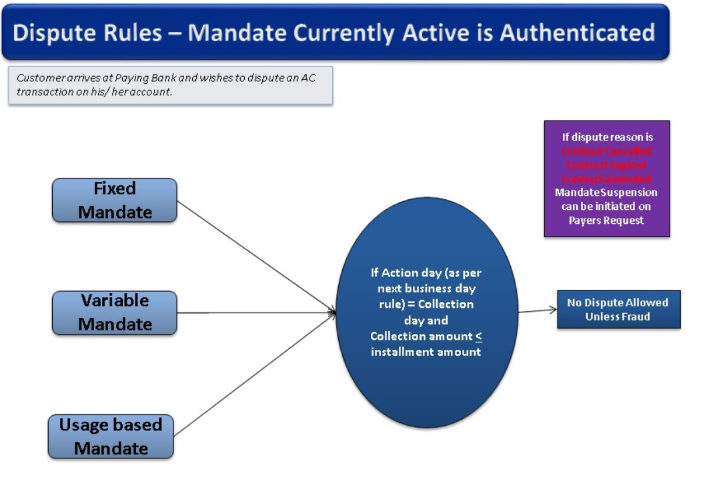

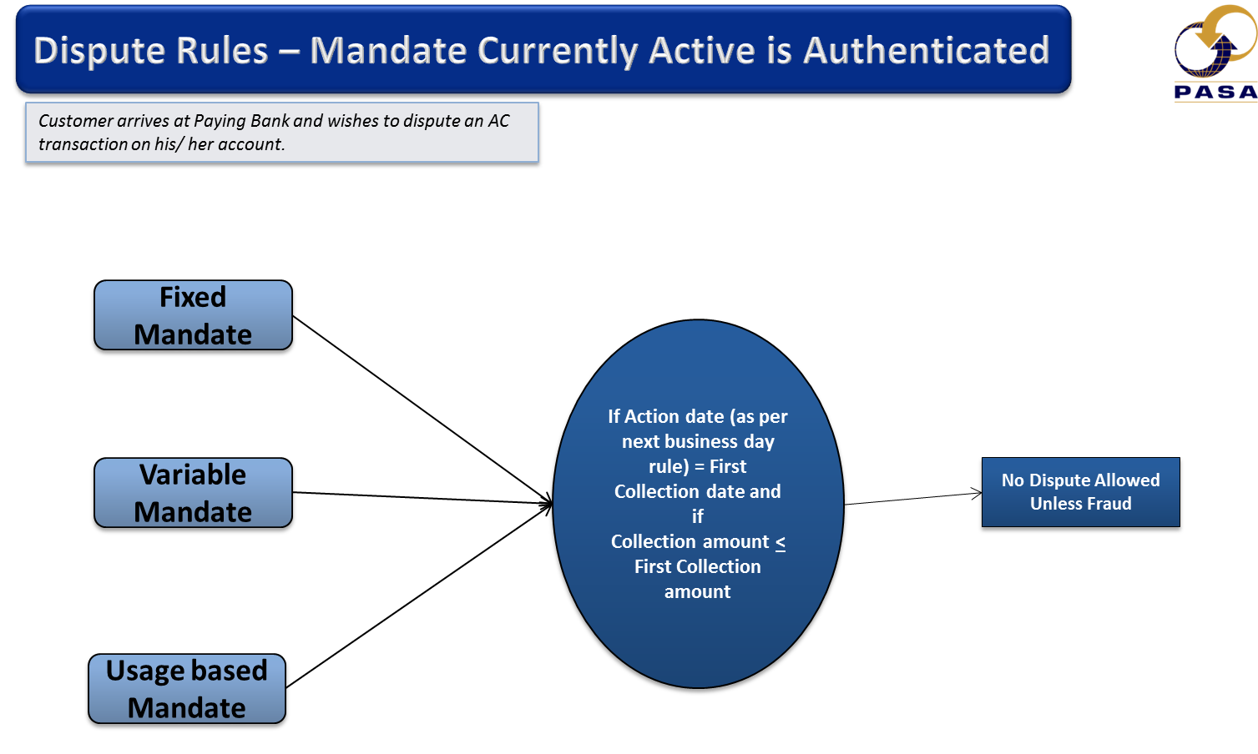

# Appendix G – Additional Rules

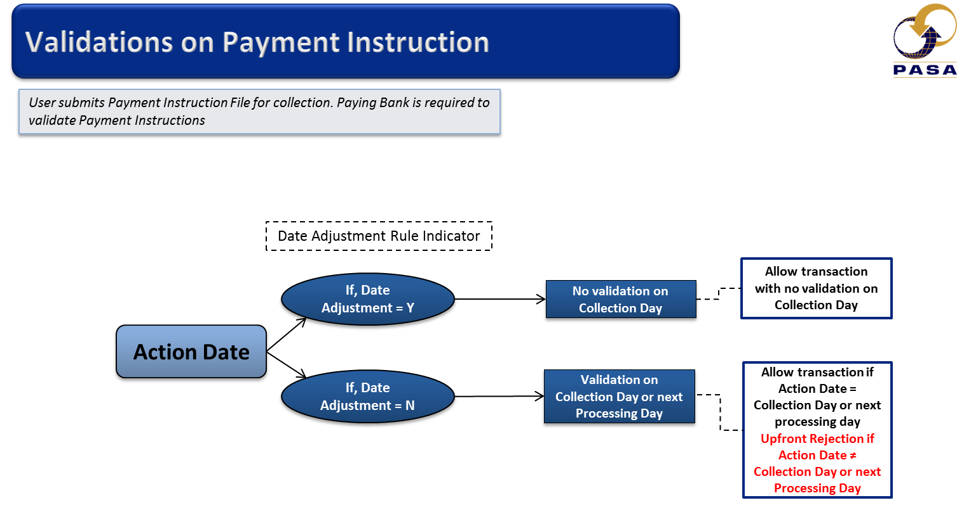

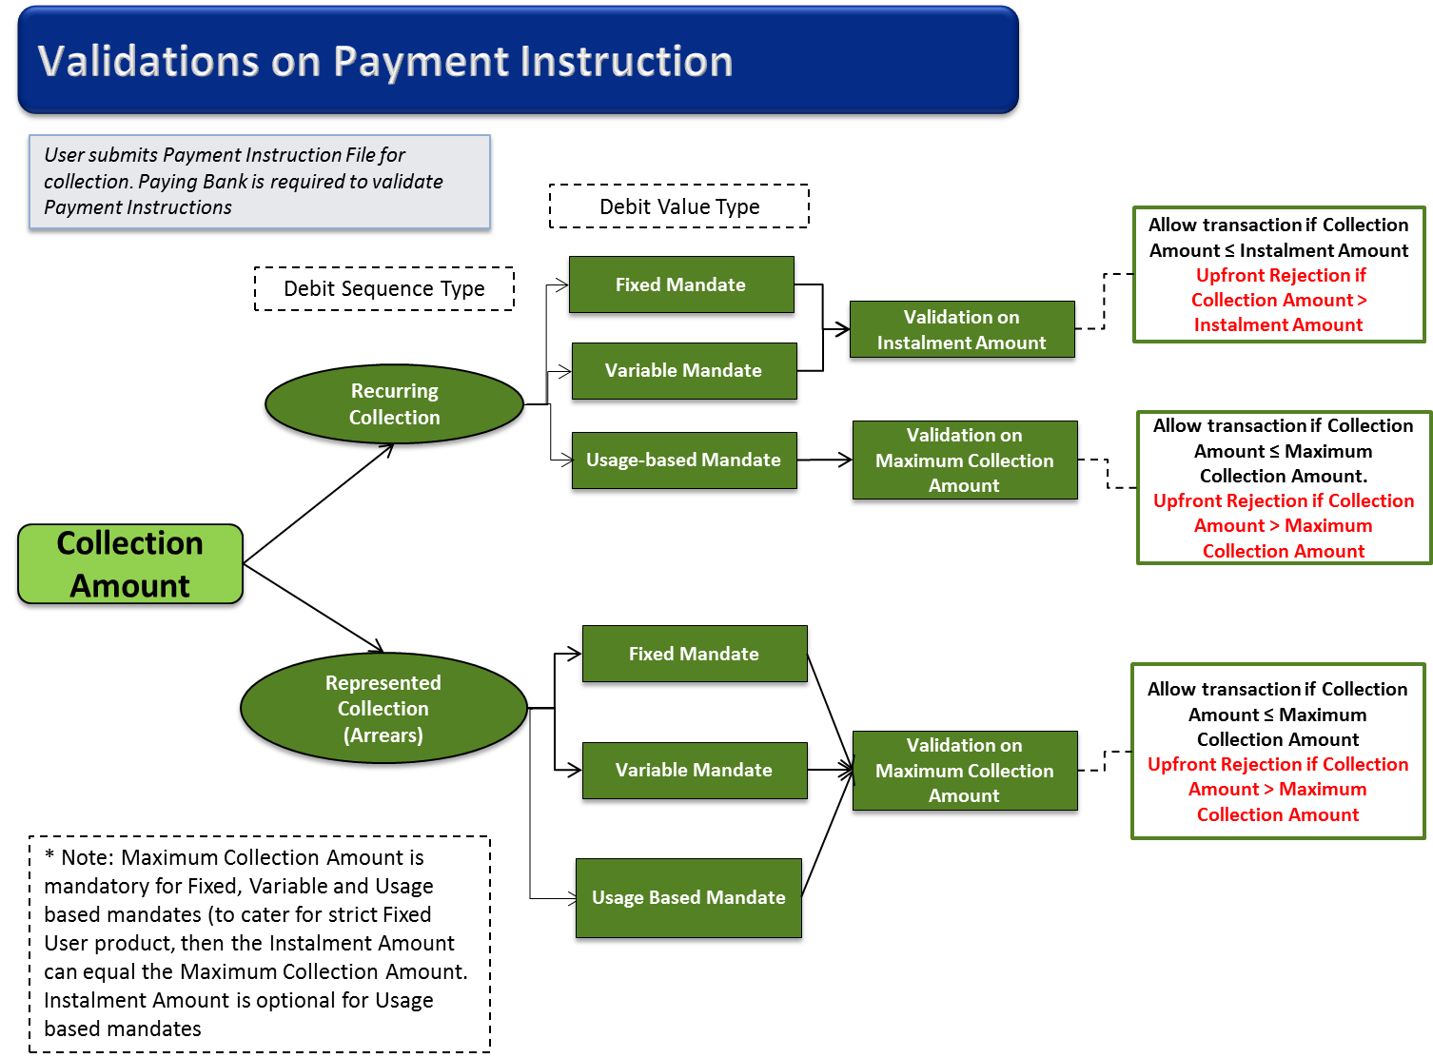

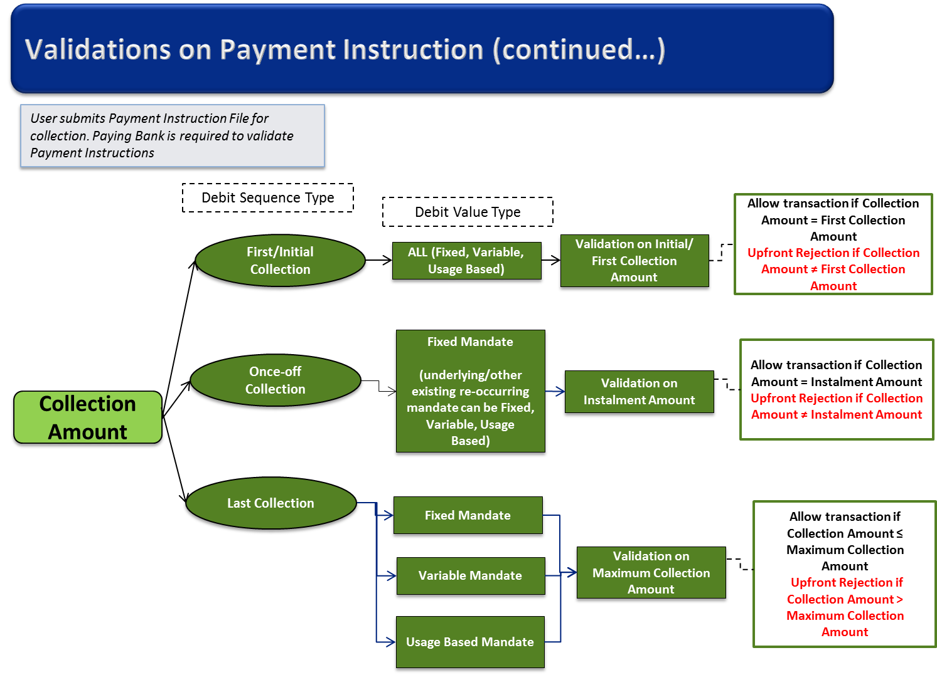

**The above Rules are represented in the Tables below:**

|  | **Date Adjustment** | **Rule** |
| --- | --- | --- |
| **Date Adjustment Rule** **Indicator** | Yes “Y” | Allow all transactions for processing irrespective of the Collection Date  *No Validation on Collection Day* |
| No “N” | Allow transaction if Action Date = Collection Day or next processing day  *Upfront Rejection if Action Date ≠ Collection Day or next Processing Day* |

| **Debit Sequence Type** | **Mandate Type** | **Rule** |
| --- | --- | --- |
| **Recurring Collection** | Fixed | Allow transaction for processing if Collection Amount ≤ Instalment Amount.  *Upfront Rejection if Collection Amount > Instalment Amount* |
| Variable | Allow transaction for processing if Collection Amount ≤ Instalment Amount.  *Upfront Rejection if Collection Amount > Instalment Amount* |
| Usage-based | Allow transaction for processing if Collection Amount ≤ Maximum Collection Amount.  *Upfront Rejection if Collection Amount**> Maximum Collection Amount* |
| **Represented Collection** | ALL | Allow transaction for processing if Collection Amount ≤ Maximum Collection Amount  *Upfront Rejection if Collection Amount > Maximum Collection Amount* |
| **First Collection** | ALL | Allow transaction for processing if Collection Amount = Initial/First Collection Amount  *Upfront Rejection if Collection Amount ≠ Initial /First Collection Amount* |
| **Last/Final Collection** | ALL | Allow transaction for processing if Collection Amount ≤ Maximum Collection Amount  *Upfront Rejection if Collection Amount > Maximum Collection Amount* |
| **Once-off** | ALL | Allow transaction for processing if Collection Amount = Instalment Amount  *Upfront Rejection if Collection Amount ≠ Instalment Amount* |

**Adjustment Amount Rules :**

**Adjustment Rules Applied to Instalment Amount and Maximum Collection Amount**

|  |  |  |  |
| --- | --- | --- | --- |
| **Adjustment Category** | **Adjustment Amount** | **Adjustment Rate** | **Adjustment Rules** |
| Never | <not set> | <not set> | All changes require authentication |
| Quarterly | X | <not set> | The rand value of the increase must be less than or equal to the Adjustment Amount. The date of the last non-authenticated adjustment to either amount must be at least three months ago. |
| Quarterly | <not set> | x% | The percentage increase must be less than or equal to the Adjustment Rate. The date of the last non-authenticated adjustment to either amount must be at least three months ago. |
| Biannual | X | <not set> | The rand value of the increase must be less than or equal to the Adjustment Amount. The date of the last non-authenticated adjustment to either amount must be at least six months ago. |
| Biannual | <not set> | x% | The percentage increase must be less than or equal to the Adjustment Rate. The date of the last non-authenticated adjustment to either amount must be at least six months ago. |
| Annual | Y | <not set> | The rand value of the increase must be less than or equal to the Adjustment Amount. The date of the last non-authenticated adjustment to either amount must be at least one year ago. |
| Annual | <not set> | y% | The percentage increase must be less than or equal to the Adjustment Rate. The date of the last non-authenticated adjustment to either amount must be at least one year ago. |
| Repo | <not set> | <not set> | The date of the adjustment must be within 90 days of the last rate change published by SARB. |

**The Repo Rate table has been removed as per simplification requirement 8/9/2016**

# Appendix H – Real Time and Batch Element Combinations

|  |  |  |  |  |
| --- | --- | --- | --- | --- |
| **Delivery** | **Message Type** | **Message Identification** | **Authentication Type** | **Debtor Authentication Required** |
| Real Time | TT1 | “100” ACH ID for REAL TIME | “REAL TIME” | 0226 = no authorisation is required |
|  |  |  |  | 0227 = debtor authorisation is required |
|  |  |  |  | 0229 = authorisation is required in Real Time and cell number is required |
|  |  |  |  | 0230 = authorisation is required in Real Time and is processed using cell number registered at bank |
|  | | | | |
| Real Time | TT3 | “100” ACH ID for REAL TIME | “PREAUTH” | 0228 = authorisation has been done |
|  | | | | |
| Batch | TT2 | “021” ACH ID for BATCH | “BATCH” | 0226 = no authorisation is required |
|  |  |  |  | 0227 = debtor authorisation is required |

# Appendix I – Participating Banks

|  |  |  |  |  |
| --- | --- | --- | --- | --- |
| BANK NAME | INSTITUTION IDENTIFIER | DEBTOR BANK / ISSUER | CREDITOR BANK / ACQUIRER | |
| Standard Bank of S.A. LTD | 210001 | Yes | | Yes | |
| Nedbank | 210002 | Yes | | Yes | |
| First Rand Bank | 210003 | Yes | | Yes | |
| S.A. Bank of Athens LTD | 210006 | Yes | | Yes | |
| African Bank | 210007 | No | | Yes | |
| Mercantile Bank | 210009 | No | | Yes | |
| Capitec Bank Limited | 210010 | Yes | | Yes | |
| ABSA | 210016 | Yes | | Yes | |
| Ubank LTD | 210019 | Yes | | Yes | |
| Bidvest Bank LTD | 210044 | Yes | | No | |
| Finbond Mutual Bank | 210055 | Yes | | Yes | |

# Appendix J – Generating a Message Authentication Code (MAC)

**Actions required of the sender of a Transmission Message**

* When transmitting a message, the following algorithm must be used to generate and include a message authentication code (MAC)
* For pacs.003 messages, obtain the sum of the debtor account numbers and amounts (must be in cents) in the message.
* For pacs.004 messages, sum the amounts in the message. The amounts must be in cents. Truncate the sum to the least significant 18 digits.
* Populate the ***<CtrlSum>*** in Group Headers of messages with the total of the sum obtained above.
* Generate a random **working key** of 16 digits under the sender’s Local Master Key (**LMK**)**.**
* If the control sum ***<CtrlSum>***  is less than 18 digits, pad the control sum with zeroes to the left to make up an 18 digit sum total for the MAC calculation. This padded number is not to be included in the <***CtrlSum>*** on the XML.
* Generate a **MAC** (8 digits) using the **working key** and the total sum obtained above using ANSI X9.9 MAC process.
* Encrypt the **working key** from the sender’s **LMK** using the Zone Control Maser Key **ZMK** key (exchanged key).
* Insert the encrypted **working key** (16 digits) and the **MAC** (8 digit MAC) into <Authstn><Prtry> element (24 digits).

**Actions performed by the receiver of a Transmission Message**

* From the Message identifier, obtain the originator of the message. Use this to obtain the sender’s Zone Control Master key (ZMK).
* Extract the encrypted **working key** from the ***<CtrlSum>*** and decrypt the **working key** using the sender’s ZMK
* For pacs.003 messages, obtain the sum of the debtor account numbers and amounts in the message. For pacs.004 messages, sum the amounts in the message. The amounts must be in cents (i.e. ignore the decimal point). Truncate the sum to the least significant 18 digits.
* If the sum is less than 18 digits, pad the sum with zeroes to the left to make up an 18 digit sum total for the MAC calculation.
* Verify the MAC in the messages to a **MAC** (8 digits) generated using the decrypted **working key** and the total sum obtained above using ANSI X9.9 MAC process.

**Example**

**Step 1**

Add account numbers with their associated amounts, taken in cents, and place this sum accumulator field

**Account Numbers            Amounts               Accumulator**

**1234567890123456789**                 **1234         1234567890123458023**

**1234567890123456                 12345           1234567890135801**

**1234567890123456789**      **12345678901.23       1234569124691346912**

**Step 2**

Add all accumulated amounts together and place the sum in the Control Sum **<CtrlSum>**

**1234567890123458023**

**1234567890135801**

**1234569124691346912**

**2470371582704940736**

Separate the least significant 18 digits for later use in an ANSI X9.9 MAC process

**2470371582704940736**

**Step 3**

Generate a Single Length DES TAK key (random working key) under your local TMK (Terminal Master Key)

Call Host Security Module with test key (e.g.: 2323232323232323)

**Step 4**

Encrypt the working key from the sender’s **LMK** using the exchanged **ZMK.**

**Step 5**

Generate a **MAC** (triple DES encryption) of the least significant 18 digits  **2470171582704940736,** using the random key 2323232323232323

Resultant MAC = **00000000AA556E65**

Select the 8 lest significant digits = **AA556E65**

**Step 6**

Insert the encrypted working key from step 4 (16-digits) and the encrypted MAC (8-digits) into the Message Authentication Code **<Authstn><Prtry>** in the pacs.003 or pacs.004 message.

|  |  |  |  |  |  |  |  |
| --- | --- | --- | --- | --- | --- | --- | --- |
| **<Authstn>** |  |  |  |  |  |  |  |
| **<Prtry>** | **Message Authentication Code**: | Text | 128 | M | 24AN | The first 16 digits will contain the encrypted working key and the last 8 digits of the MAC of the sum total of destination account numbers and amounts |  |
| </Prtry> |  |  |  |  |  |  |  |
| </Authstn> |  |  |  |  |  |  |  |

# Appendix K – Permitted Character Set

The character set for Authenticated Collections caters for both upper- and lower-case alphabetic characters.

The allowable character set is defined as follows:

|  |  |  |  |
| --- | --- | --- | --- |
| A – Z  a – z  0 – 9  .  -  *  ,  (  )  %  **-** | alphabetic (upper case)  alphabetic (lower case)  numeric  period  hyphen  asterisk  comma  left parenthesis  right parenthesis  space  percentage  minus | +  $  ;  =  @  ?  :  ~  /  _  &  ‘ | plus  dollar  semi-colon  equal  at  question mark  colon  tilde  forward slash  underscore  ampersan (XML Notation &amp)  apostrophy (XML Notation &apos) |
|  |  |  |  |

All originators of AC messages must comply with the characters set above.

**Note:-** The International Standard mobile or landline numbers consists of a "+" followed by the country code (from 1 to 3 characters) then a "-" and finally, any combination of numbers, "(", ")", "+" and "-" (up to 30 characters). Pattern \+[0-9]{1,3}-[0-9()+\-]{1,30}

# Appendix L – gzip

Gzip is to be used to compress and decompress batch files in order to reduce network bandwidth.

The gzip utility uses Lempel-Ziv (LZ77) compression techniques to reduce the size of the specified files. For each file specified, the original file is deleted and replaced with the compressed version which has the same file name as original with the file extension .gz appended. The compressed file has the same ownership modes, access time, and modification time as the original. When you do not specify any files to be compressed or specify - as a file name, gzip reads from the standard input, compresses what is read, and writes the result out to the standard output. ([www.mkssoftware.com/docs/man1/gzip.1.asp](http://www.mkssoftware.com/docs/man1/gzip.1.asp))

**Useful Commands:**

* “Gzip file.text “ will compress file.txt and create a new file.txt.gz, removing the original file.txt file
* “Gzip -d file.text.gz “ will reverse the compression process and get the original file back that you have compressed

Files sent between parties in the Authenticated Collection Interbank space must default to be compressed by the submitter and decompressed by the receiver. This should be an automated process, with automatic failover to be able to process files even if they are not compressed.

Please refer to the Interface Specification for further clarification

# Appendix M – 6 and 7 Day Collections Processing

|  |  |
| --- | --- |
| **Business days** | Monday to Saturday (excluding public holidays). |
| **Processing Days** | Monday to Saturday for 6 day processing Members, (excluding public holidays) or Monday to Sunday for 7 day processing Members (including public holidays). |

**Notes:**

* Mandates is a 7 day processing service
* Collections is a 6 or 7 day processing service, as determined by the bank
* The CIM900 contains fields that identify 6 or 7 day processing banks for Collections
* The Submitting bank must send the Debit Request file to the ACH as per 6 / 7 day processing rules (examples below)
* The Receiving bank will receive the Debit Request file 1 day prior to the processing date from the ACH
* As the date rollover occurs during the previous day, the Request files will be sent out the physical day prior to action date
* BankservAfrica will reject:
  + Any file for a 6 Day Processing Bank with Action Date not a 6 Day processing Action Date (i.e. If action date is not a processing date for the receiving bank)
  + Any file with Action Date greater than the next processing Action Date (i.e. future dated beyond next processing date)
* Reponses – All banks must be able to receive 7 days a week.
* 6 day processing bank will warehouse the responses till next business (processing) day.

**Additional Rules:**

**Rule:** All banks must be able to receive debit requests on days D-1 and D-n.

**Rule:** BankservAfrica always outputs on day of receipt. Debtor banks must perform warehousing of predated debit requests.

**Rule:** BankservAfrica must allow input on D-n for 6 day processing banks, provided the days between submission date and action date are Sundays and public holidays.

**Rule:** BankservAfrica must check for transactions submitted for 6 day processing banks, and reject any transactions which do not align with the 6 day processing allowed.

**6-day to 6-day processing banks**

* Some 6-day processing banks will submit debit requests on D-1, even on a holiday or Sunday (e.g. Sunday for Monday).
* Other 6-day processor banks are unable to submit on Sunday and public holidays. They will submit on the previous business/processing day (they will submit on D-n, where n = number of non-processing days).

**6-day to 7-day processing banks**

* 6-day processing banks can submit for multiple action days (if Sundays and public holidays) provided that they are in separate files by action date.
* 6-day processing banks can also submit D-1 if preferred.

**7-day to 6-day processing banks**

* 7-day processing banks can submit on D-1 for a 6-day processing bank for future processing days.
* 7-day processing banks must not submit for non-processing days to 6-day processing banks.

**Settlement**

* Settlement is calculated on the Settlement cycle to be included in the next processing cycle for Sundays & Public Holidays.

# Appendix N – BankservAfrica file delivery validation

BankservAfrica’s delivery system will fail an Authenticated Collections input file and send a negative acknowledgement file, NAK to the originator under the following conditions:

* Delivery performs message structure checks using the XSDs. Files failing unmarshalling processes are NAKed.
* Delivery checks the system identifier in file names. Files with invalid system identifiers are NAKed.
* Delivery uses the control sum and the working key to generate a MAC for files. If the generated MAC does not match the MAC in the header of the file, the file is NAKed.
* Delivery checks the service name in file names. Files with invalid service names are NAKed.
* Delivery check if the sending bank of the file is configured for the requested service. File input by banks not configured for the requested service are NAKed.
* Delivery checks the Test/Live indicator. Files with incorrect values in Test/Live indicators are NAKed.
* Delivery checks the file type. Files with invalid file types are NAKed.
* Delivery checks the creation date in the file names of file. Files that are not for the system’s processing date are NAKed.
* Delivery validates the file number. If it is a data file and has “000000”  as file number, delivery NAKs the file.
* SOT and EOT must have file numbers “000000”. If not, SOT or EOT files are NAKed.

**\*\*\* SCR 163 / Industry Ack & Naks – implementation date February 2018 \*\*\***

# Appendix O – Dispute Reason Codes for MIS (internal use only)

The following Dispute Reason Codes can be used internally for MIS purposes only

| **Code** | **Description** |
| --- | --- |
| MD30 | No authority to debit |
| MD32 | Debit in contravention of payer's authority |
| MD34 | Authorisation cancelled. |
| MD36 | Previously stopped via Mandate Suspension advice |
| FR01 | Fraud |
| AM01 | Zero Amount |

# Appendix P – Cancellations of inflight and registered Mandates

In flight cancellations:

A pain.011 **Cancellation Reason must equal (MICN)** to cancel an initiation message (pain.009) or

a pain.011 **Cancellation Reason must equal** (**MACN**) to cancel an amendment (pain.010).

Must be MICN for pain.009 cancellation or MACN for pain.010 cancellation



Then the <MndtRfNbr> must **be blank**



The condition is that it may be blank if the sender wishes to cancel a mandate initiation request that may be in-flight or has timed out. If it is not populated, existing mandates on the mandate register may not be cancelled.

The Mandate Request Transaction Identifier (MRTI) must be the same between the:

* pain.011 and the pain.009 – <Mndt> MRTI
* the pain.011 and the pain.010 – <Mndt> MRTI

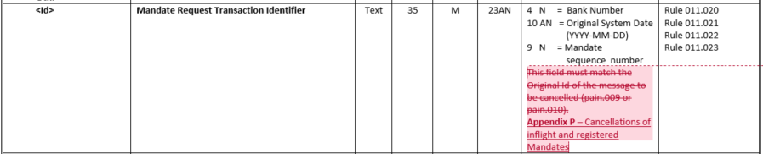

Must be same as message to be cancelled

Registered Mandate cancellations:

When a pain.011 is cancelling a registered mandate a new MRTI must be issued,



New MRTI to be created

The Mandate Reference Number (MRN) is mandatory.



Original Reference Number for the Mandate to be cancelled

MRTI Rules:

* **T**he MRTI in the PAIN.011 must be that same as that in the PAIN.009 or PAIN.010 when **cancelling an in-flight mandate**
* **A new MRTI must be issued** when cancelling an existing mandate

Return pain.012 for a pain.009

* Pain.012 where MRN is not completed and “normal” **Rejected Reason Code (e.g. MD17)**
  + Match the MRTI to pain.011

and if **Cancellation Reason = MICN – i.e. “in flight cancellation”**

* + Also match the MRTI to pain.009
* Authenticated Status to be “NRSP” or “NAUT”

Return pain.012 for a pain.010

* Pain.012 where MRN is not completed and “normal” **Rejected Reason Code (e.g. MD17)**
  + Match the MRTI to pain.011

and if **Cancellation Reason = MACN – i.e. “in flight cancellation”**

* + Also match the MRTI to pain.010

# Appendix Q – USSD Message Content by Mandate Type

The USSD message contact must adhere to the following.

1. **Usage Base Mandate**

**Required USSD Message Content:**

|  |  |  |  |
| --- | --- | --- | --- |
| **Field** | **Rules** | **Prefix/label** | **Characters** |
| Bank Name | Bank Name | To be determined by each bank. | 10 |
|  | Separator | : | 1 |
|  | **Prefix** | **DebiCheck** | **9** |
|  | Separator | space | 1 |
| Shortname | Shortname | starineyes | 10 |
|  | Separator | space | 1 |
|  | **Prefix** | **Ref** | **3** |
|  | Separator | : | 1 |
| Contract ref | Contract ref | happydays12345 | 14 |
|  | Separator | space | 1 |
| Usage based Mandate | **Prefix** | **DebitAmt** | **8** |
|  | Separator | : | 1 |
|  | Amount | R1 234 567.89 | 13 |
|  | **Prefix** | **MaxAmt** | 6 |
|  | Separator | : | 1 |
|  | Amount | R1 234 567.89 | 13 |
|  | Separator | space | 1 |
|  | Collection day | See Appendix A | 24 |
|  | Separator | Line feed | 1 |
|  | **Positive Response attribute** | **1-Approve** | **9** |
|  | Separator | Line feed | 1 |
|  | **Negative Response attribute** | **9-Decline** | **9** |
|  |  | Response answer | 0 |
|  |  | Characters used | 138 |
|  |  | Total available | 140 |

**USSD Message Approximate Layout:**

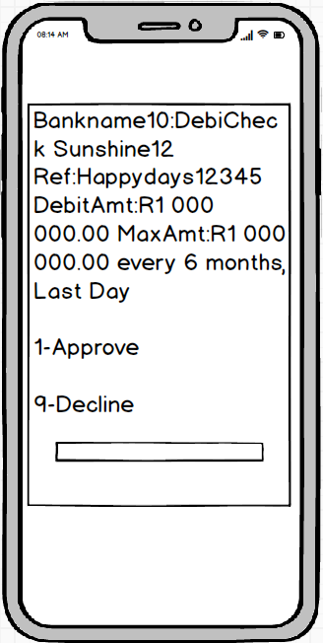 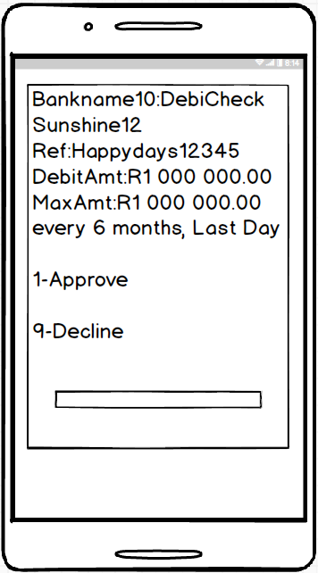

1. **Usage Base Mandate : ONLY MAX AMOUNT IS USED**

**Required USSD Message Content:**

|  |  |  |  |
| --- | --- | --- | --- |
| **Field** | **Rules** | **Prefix/label** | **Characters** |
| Bank Name | Bank Name | To be determined by each bank. | 10 |
|  | Separator | : | 1 |
|  | **Prefix** | **DebiCheck** | **9** |
|  | Separator | space | 1 |
| Shortname | Shortname | starineyes | 10 |
|  | Separator | space | 1 |
|  | **Prefix** | **Ref** | **3** |
|  | Separator | : | 1 |
| Contract ref | Contract ref | happydays12345 | 14 |
|  | Separator | space | 1 |
| Usage based Mandate | **Prefix** | **Up to MaxAmt** | 12 |
|  | Separator | : | 1 |
|  | Amount | R1 234 567.89 | 13 |
|  | Separator | space | 1 |
|  | Collection day | See Appendix A | 24 |
|  | Separator | Line feed | 1 |
|  | **Positive Response attribute** | **1-Approve** | **9** |
|  | Separator | Line feed | 1 |
|  | **Negative Response attribute** | **9-Decline** | **9** |
|  |  | Response anwer | 0 |
|  |  | Charaters used | 122 |
|  |  | Total available | 140 |

**USSD Message Approximate Layout:**

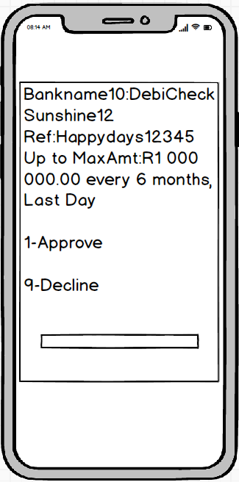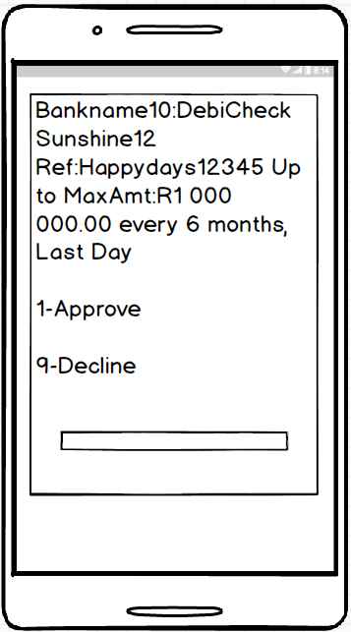

**Fixed/Variable Mandate**

**Required USSD Message Content:**

|  |  |  |  |
| --- | --- | --- | --- |
| **Field** | **Rules** | **Prefix/label** | **Characters** |
| Bank Name | Bank Name | To be determined by each bank. | 10 |
|  | Separator | : | 1 |
|  | **Prefix** | **DebiCheck** | **9** |
|  | Separator | space | 1 |
| Shortname | Shortname | starineyes | 10 |
|  | Separator | space | 1 |
|  | **Prefix** | **Ref** | **3** |
|  | Separator | : | 1 |
| Contract ref | Contract ref | happydays12345 | 14 |
|  | Separator | space | 1 |
| Fixed/Variable Mandate | **Prefix** | **DebitAmt** | **8** |
|  | Separator | : | 1 |
|  | Amount | R1 234 567.89 | 13 |
|  | Separator | space | 1 |
|  | Collection day | See Appendix A | 24 |
|  | Separator | Line feed | 1 |
|  | **Positive Response attribute** | **1-Approve** | **9** |
|  | Separator | Line feed | 1 |
|  | **Negative Response attribute** | **9-Decline** | **9** |
|  |  | Response anwer | 0 |
|  |  | Charaters used | 118 |
|  |  | Total available | 140 |

**USSD Message Approximate Layout:**

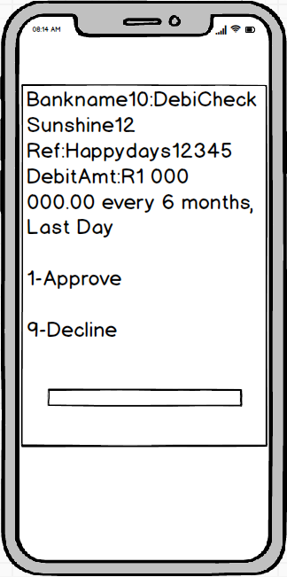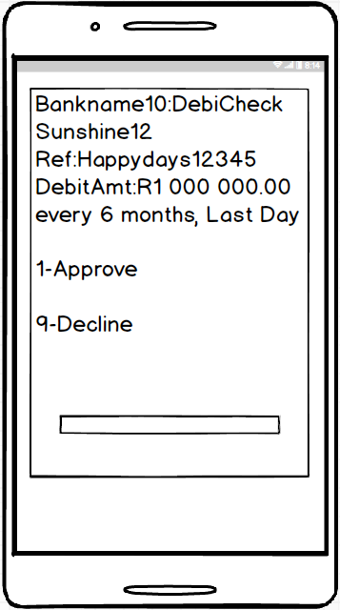

**Standard Valid “APPROVE” Response Message**

**Required Message Content and Approximate Layout:**

**Note**: The message can be sent via USSD or SMS.

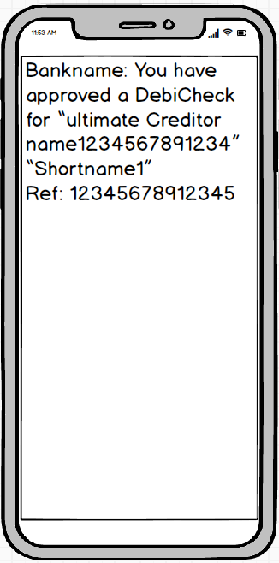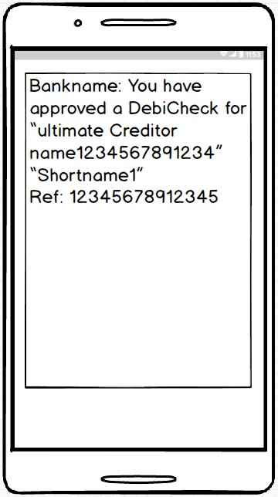

1. **Standard valid “DECLINE” response message**

**Required Message Content and Approximate Layout:**

**Note**: The message can be sent via USSD or SMS.

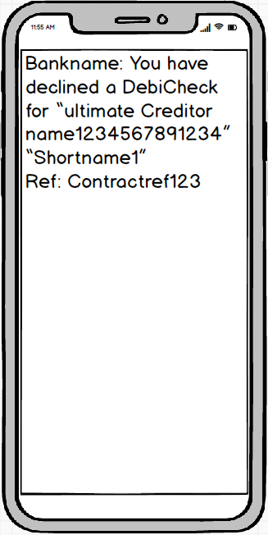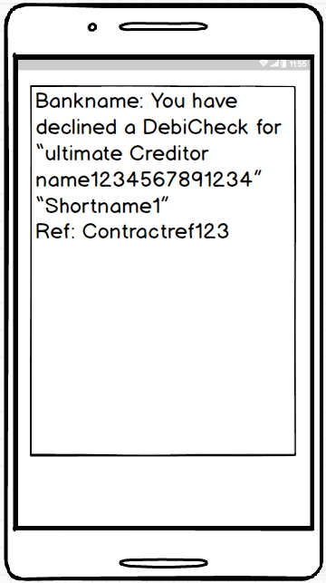

1. **Standard invalid response message**

**Required Message Content and Approximate Layout:**

**Note**: The message can be sent via USSD or SMS.

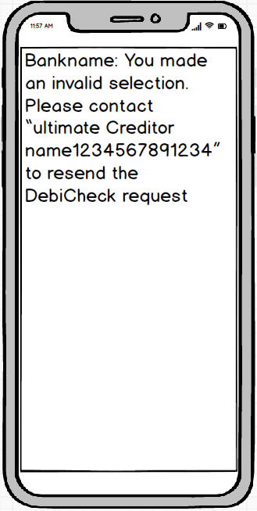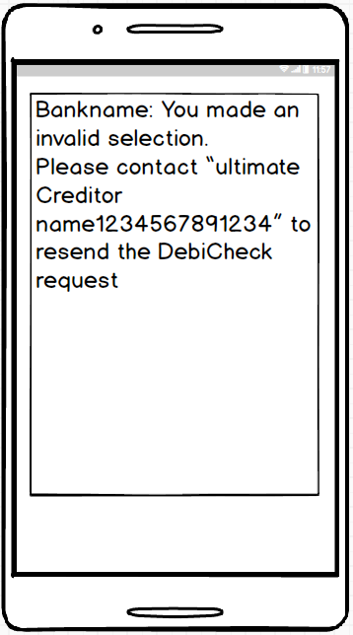

**Appendix A: Collection Day Variables**

| **Frequency** | **Comments** | **Frequency Desription** | **Collection Day** | **Wording for Frequency on PUSH USSD message (Option 1)** | **Length of Wording for Frequency on PUSH USSD message** |
| --- | --- | --- | --- | --- | --- |
| Weekly | Weekly: Event takes place once a week | 01(Monday) | 01 | Weekly on Mon | 13 |
| 02 (Tuesday) | 02 | Weekly on Tue | 13 |
| 03 (Wednesday) | 03 | Weekly on Wed | 13 |
| 04 (Thursday) | 04 | Weekly on Thu | 13 |
| 05 (Friday) | 05 | Weekly on Fri | 13 |
| 06 (Saturday) | 06 | Weekly on Sat | 13 |
| 07 (Sunday) | 07 | Weekly on Sun | 13 |
| Fortnightly | Fortnightly: Event takes place once every two weeks | (01 Monday to 07 Sunday (1st week); 08 Monday to 14 Sunday (2nd week)) | 01 | every 2nd Mon | 13 |
| 02 | every 2nd Tue | 13 |
| 03 | every 2nd Wed | 13 |
| 04 | every 2nd Thu | 13 |
| 05 | every 2nd Fri | 13 |
| 06 | every 2nd Sat | 13 |
| 07 | every 2nd Sun | 13 |
| 08 | every 2nd Mon | 13 |
| 09 | every 2nd Tue | 13 |
| 10 | every 2nd Wed | 13 |
| 11 | every 2nd Thu | 13 |
| 12 | every 2nd Fri | 13 |
| 13 | every 2nd Sat | 13 |
| 14 | every 2nd Sun | 13 |
| Monthly (ADHO) | Monthly By Rule | 01 - Last Monday | 01 | Monthly on Last Mon | 19 |
| 02 - Last Tuesday | 02 | Monthly on Last Tue | 19 |
| 03 - Last Wednesday | 03 | Monthly on Last Wed | 19 |
| 04 – Last Thursday | 04 | Monthly on Last Thu | 19 |
| 05 - Last Friday | 05 | Monthly on Last Fri | 19 |
| 06 - Last Saturday | 06 | Monthly on Last Sat | 19 |
| 07 - First Monday | 07 | Monthly on 1st Mon | 18 |
| 08 - First Tuesday | 08 | Monthly on 1st Tue | 18 |
| 09 - First Wednesday | 09 | Monthly on 1st Wed | 18 |
| 10 – First Thursday | 10 | Monthly on 1st Thu | 18 |
| 11 - First Friday | 11 | Monthly on 1st Fri | 18 |
| 12 - First Saturday | 12 | Monthly on 1st Sat | 18 |
| 14 - 2nd Last Day | 14 - 2 | Monthly, 2nd Last Day | 21 |
| 99 - Last Day | 99 | Monthly, Last Day | 17 |
| Monthly | Monthly Event: Event takes place once every month or once a month. | 01-30 (for February date is 28 if previously indicated 29th) 99 - Last Day | 01 | Monthly on the 1st | 18 |
| 02 | Monthly on the 2nd | 18 |
| 03 | Monthly on the 3rd | 18 |
| 04 | Monthly on the 4th | 18 |
| 05 | Monthly on the 5th | 18 |
| 06 | Monthly on the 6th | 18 |
| 07 | Monthly on the 7th | 18 |
| 08 | Monthly on the 8th | 18 |
| 09 | Monthly on the 9th | 18 |
| 10 | Monthly on the 10th | 19 |
| 11 | Monthly on the 11th | 19 |
| 12 | Monthly on the 12th | 19 |
| 13 | Monthly on the 13th | 19 |
| 14 | Monthly on the 14th | 19 |
| 15 | Monthly on the 15th | 19 |
| 16 | Monthly on the 16th | 19 |
| 17 | Monthly on the 17th | 19 |
| 18 | Monthly on the 18th | 19 |
| 19 | Monthly on the 19th | 19 |
| 20 | Monthly on the 20th | 19 |
| 21 | Monthly on the 21st | 19 |
| 22 | Monthly on the 22nd | 19 |
| 23 | Monthly on the 23rd | 19 |
| 24 | Monthly on the 24th | 19 |
| 25 | Monthly on the 25th | 19 |
| 26 | Monthly on the 26th | 19 |
| 27 | Monthly on the 27th | 19 |
| 28 | Monthly on the 28th | 19 |
| 29 | Monthly on the 29th | 19 |
| 30 | Monthly on the 30th | 19 |
| 99 | Monthly, Last Day | 17 |
| Quarterly | Quarterly Event: Event takes place once every three months or four times a year. | 01-30 (for February date is 28 if previously indicated 29th) 99 - Last Day | 01 | every 3 months on 1st | 21 |
| 02 | every 3 months on 2nd | 21 |
| 03 | every 3 months on 3rd | 21 |
| 04 | every 3 months on 4th | 21 |
| 05 | every 3 months on 5th | 21 |
| 06 | every 3 months on 6th | 21 |
| 07 | every 3 months on 7th | 21 |
| 08 | every 3 months on 8th | 21 |
| 09 | every 3 months on 9th | 21 |
| 10 | every 3 months on 10th | 22 |
| 11 | every 3 months on 11th | 22 |
| 12 | every 3 months on 12th | 22 |
| 13 | every 3 months on 13th | 22 |
| 14 | every 3 months on 14th | 22 |
| 15 | every 3 months on 15th | 22 |
| 16 | every 3 months on 16th | 22 |
| 17 | every 3 months on 17th | 22 |
| 18 | every 3 months on 18th | 22 |
| 19 | every 3 months on 19th | 22 |
| 20 | every 3 months on 20th | 22 |
| 21 | every 3 months on 21st | 22 |
| 22 | every 3 months on 22nd | 22 |
| 23 | every 3 months on 23rd | 22 |
| 24 | every 3 months on 24th | 22 |
| 25 | every 3 months on 25th | 22 |
| 26 | every 3 months on 26th | 22 |
| 27 | every 3 months on 27th | 22 |
| 28 | every 3 months on 28th | 22 |
| 29 | every 3 months on 29th | 22 |
| 30 | every 3 months on 30th | 22 |
| 99 | every 3 months, Last Day | 24 |
| Bi-Annually | Bi Annual: Event takes place once every six months or two times a year. | 01-30 (for February date is 28 if previously indicated 29th) 99 - Last Day | 01 | every 6 months on 1st | 21 |
| 02 | every 6 months on 2nd | 21 |
| 03 | every 6 months on 3rd | 21 |
| 04 | every 6 months on 4th | 21 |
| 05 | every 6 months on 5th | 21 |
| 06 | every 6 months on 6th | 21 |
| 07 | every 6 months on 7th | 21 |
| 08 | every 6 months on 8th | 21 |
| 09 | every 6 months on 9th | 21 |
| 10 | every 6 months on 10th | 22 |
| 11 | every 6 months on 11th | 22 |
| 12 | every 6 months on 12th | 22 |
| 13 | every 6 months on 13th | 22 |
| 14 | every 6 months on 14th | 23 |
| 15 | every 6 months on 15th | 22 |
| 16 | every 6 months on 16th | 22 |
| 17 | every 6 months on 17th | 22 |
| 18 | every 6 months on 18th | 22 |
| 19 | every 6 months on 19th | 22 |
| 20 | every 6 months on 20th | 22 |
| 21 | every 6 months on 21st | 22 |
| 22 | every 6 months on 22nd | 22 |
| 23 | every 6 months on 23rd | 22 |
| 24 | every 6 months on 24th | 22 |
| 25 | every 6 months on 25th | 22 |
| 26 | every 6 months on 26th | 22 |
| 27 | every 6 months on 27th | 22 |
| 28 | every 6 months on 28th | 22 |
| 29 | every 6 months on 29th | 22 |
| 30 | every 6 months on 30th | 22 |
| 99 | every 6 months, Last Day | 24 |
| Annually | Annual Event: Event takes place once every year or once a year. | 01-30 (for February date is 28 if previously indicated 29th) 99 - Last Day | 01 | Annually on the 1st | 19 |
| 02 | Annually on the 2nd | 19 |
| 03 | Annually on the 3rd | 19 |
| 04 | Annually on the 4th | 19 |
| 05 | Annually on the 5th | 19 |
| 06 | Annually on the 6th | 19 |
| 07 | Annually on the 7th | 19 |
| 08 | Annually on the 8th | 19 |
| 09 | Annually on the 9th | 19 |
| 10 | Annually on the 10th | 20 |
| 11 | Annually on the 11th | 20 |
| 12 | Annually on the 12th | 20 |
| 13 | Annually on the 13th | 20 |
| 14 | Annually on the 14th | 20 |
| 15 | Annually on the 15th | 20 |
| 16 | Annually on the 16th | 20 |
| 17 | Annually on the 17th | 20 |
| 18 | Annually on the 18th | 20 |
| 19 | Annually on the 19th | 20 |
| 20 | Annually on the 20th | 20 |
| 21 | Annually on the 21st | 20 |
| 22 | Annually on the 22nd | 20 |
| 23 | Annually on the 23rd | 20 |
| 24 | Annually on the 24th | 20 |
| 25 | Annually on the 25th | 20 |
| 26 | Annually on the 26th | 20 |
| 27 | Annually on the 27th | 20 |
| 28 | Annually on the 28th | 20 |
| 29 | Annually on the 29th | 20 |
| 30 | Annually on the 30th | 20 |
| 99 | Annually Month-end | 18 |
|  |  |  |  |  |  |
| Once off Mandate |  | Once off Mandate | 01 | Once-off on the 1st | 19 |
|  |  |  | 02 | Once-off on the 2nd | 19 |
|  |  |  | 03 | Once-off on the 3rd | 19 |
|  |  |  | 04 | Once-off on the 4th | 19 |
|  |  |  | 05 | Once-off on the 5th | 19 |
|  |  |  | 06 | Once-off on the 6th | 19 |
|  |  |  | 07 | Once-off on the 7th | 19 |
|  |  |  | 08 | Once-off on the 8th | 19 |
|  |  |  | 09 | Once-off on the 9th | 19 |
|  |  |  | 10 | Once-off on the 10th | 20 |
|  |  |  | 11 | Once-off on the 11th | 20 |
|  |  |  | 12 | Once-off on the 12th | 20 |
|  |  |  | 13 | Once-off on the 13th | 20 |
|  |  |  | 14 | Once-off on the 14th | 20 |
|  |  |  | 15 | Once-off on the 15th | 20 |
|  |  |  | 16 | Once-off on the 16th | 20 |
|  |  |  | 17 | Once-off on the 17th | 20 |
|  |  |  | 18 | Once-off on the 18th | 20 |
|  |  |  | 19 | Once-off on the 19th | 20 |
|  |  |  | 20 | Once-off on the 20th | 20 |
|  |  |  | 21 | Once-off on the 21st | 20 |
|  |  |  | 22 | Once-off on the 22nd | 20 |
|  |  |  | 23 | Once-off on the 23rd | 20 |
|  |  |  | 24 | Once-off on the 24th | 20 |
|  |  |  | 25 | Once-off on the 25th | 20 |
|  |  |  | 26 | Once-off on the 26th | 20 |
|  |  |  | 27 | Once-off on the 27th | 20 |
|  |  |  | 28 | Once-off on the 28th | 20 |
|  |  |  | 29 | Once-off on the 29th | 20 |
|  |  |  | 30 | Once-off on the 30th | 20 |
|  |  |  | 99 | Once-off Month-end | 18 |